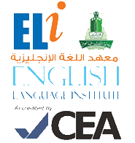
Grammar and
Vocabulary Practice
101
رؤية جامعة الملك عبد العزيز
منارة في المعرفة
تكامل في التكوين
ريادة في التنمية
رسالة جامعة الملك عبدالعزيز
الرقي بالمجتمع عبر تميز ثقافي و علمي و بحثي رائد

Student’s Name: ________________ Level: 101 Section: ___________

- Grammar Section (Units 3, 5 & 8)
Choose the correct answer:

- She likes apples, but she _______________ apple juice.
a. not like b. does not like c. likes d. like

- _______________ three books on the shelf.
a. There b. They're c. There is d. There are

- _______________ the movie we saw yesterday?
a. You like b. Do you like c. Did you like d. You liked

- Vocabulary Section (Units 2, 7 & 9)
Choose the correct answer:

- She is a nurse. She works at a _______________.
a. restaurant b. hotel c. hospital d. supermarket

- I do not like this book at all! It is very _______________.
a. cheap b. boring c. interesting d. good

- We're going to a/an _______________ to look at some new paintings.
a. football stadium b. shopping mall c. bowling alley d. art gallery

