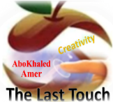

المملكة العربية السعودية
Kingdom of Saudi Arabia
Ministry of Education
------- Educational Directorate
------- Educational Schools
1st grade intermediate 2022
1st Term – Final Exam
وزارة التعليم
الإدارة العامة للتعليم بن
مدارس م ن التعليمية
الصف الاول المتوسط
الاختبار النهائي للفصل الدراسي الأول 1444هـ
Total  written | 5 spelling | 4 Vocabulary | 3 Grammar | 2 Comprehension |  | 1 Composition | Q. NO.
 |  |  |  |  |  |  | Mark Given
30 | 4 | 7 | 7 | 6 |  | 6 | Mark
 |  |  | Reviser |  |  |  | Corrector
زمن الاختبار: ساعتان
اسم الطالب: ------------------------------------ رقم الجلوس: ------------- الصف الأول المتوسط

Composition

6
1- Write a paragraph about “Your Best Friend"
* Who is your best friend? * How old is he? * Where is he from?
* What's his nationality? *What is he like? * What subjects does he like?
* What sports does he play? * Why do you like him?
…………………………………………
………………………………………………………………………………………………………………………………………………………………………………………………………………………………………………………………………………………………………………………………………………………………………………………………………………………………………………………………………………………………………………………………………………………………………………………………………………………………….

2) Comprehension

6
2- Read the following passage then answer the questions:
Flipper is a dolphin, and he is 5 years old. That is young for a dolphin. It is the age of an 18-year-old person. Flipper is a baby in human years, but he is a teen in dolphin years. Marla is old even for a turtle. She is 95 years old. Cleo the cat is one year old. In human years, she is a 15-year-old adolescent.

A- Put ( ) or ( x ):
1. Flipper is a baby in animal years. ( )
2. Marla is old even for a turtle. ( )
3. Flipper is a teen in dolphin years. ( )
4. Cleo is a 25-year-old adolescent. ( )
B- Choose the correct answer:
1. Cleo the cat is (one – two – three) years old.
2. Marla is (97 - 96 - 95) years old.
3. Flipper is (old – young – fat) for a dolphin.
4. Marla is (old – young – fat) even for a turtle.
C- Answer the following questions:
1. What is Flipper? ………………………………………………………………….
2. How old is Flipper? …………………………..………………………………………
3. What is the name of the cat? …………………………………………………..
4. What is the name of the turtle? ……………………………………………………

7
3) Grammar

A: Choose the correct answer:
1. I (am – is – are) very happy.
2. This is my brother. (Her – His – My) name is Ali.
3. English classes are (in – on – at) Mondays and Wednesdays.
4. (Who – How – What) old are you?
5. This (am – is – are) my pencil.
6. (Isn’t – Doesn’t – Don’t) touch that painting.
7. Mr. Omar is here (in – on – at) business.
8. (When – What – Where) are you from?
9. I (have – has – is) a sister.
10. Do you have (a – any – some) brothers and sisters?
B: Do as shown between brackets:
1. She is Nora. (Make Negative)
……………………………………………………………………………………………………………………………………
2. What day is today? (Answer the question)
……………………………………………………………………………………………………………………………………
3. That is --------- calculator. (Put indefinite article a / an)
……………………………………………………………………………………………………………………………………
4. She is from Saudi Arabia. (Make Yes/No Question)
……………………………………………………………………………………………………………………………………
4) vocabulary:

7
A- Write the correct number under its picture:
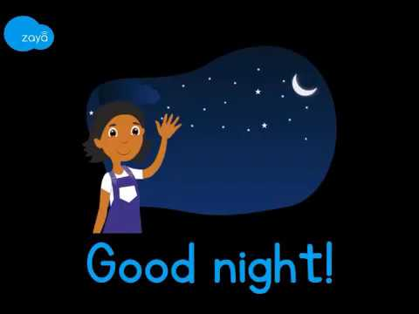
1. camera 2. parrot 3. family 4. scissors 5. reindeer 6. headphones 7. night
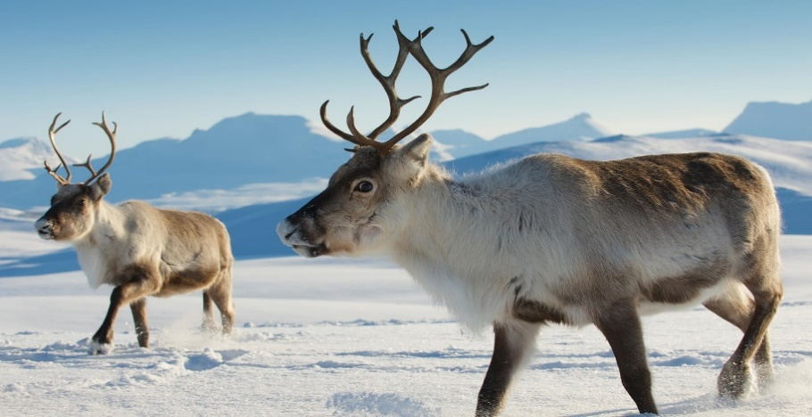
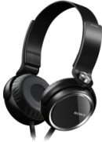

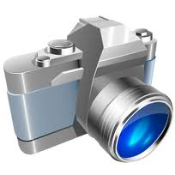
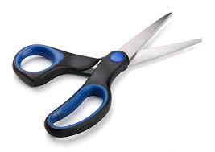

( ) ( ) ( ) ( ) ( ) ( ) ( )
B- Match the Real Talk:
1. I’ve got a. Not very much
2. Not really b. I have
3. Guess what? c. A reply to “Thank you.”
4. You’re welcome d. tell a surprise
C- Circle the correct spelling:
1. skelton - skeltan – skeleton
2. family – familiy - famliy
3. vacotion – vacation – vecation
5) Orthography:

4
A- Fill in the missing letters:
1. m__rning
b – r – o – u
2. num__ers
3. muse__m
4. wo__ld
B- Circle the odd one out:
1. morning afternoon evening school
2. father mother Jeddah sister
3. doctor Brazil Egypt Canada
4. Sunday Mom Monday Tuesday
End of Questions
Best of Luck https://t.me/abokhaledamer
ABOKHALEDAMER
0557325813

