Kingdom of Saudi Arabia 3rd Intermediate Grade

Ministry of Education Time: An hour and a half

Hifar Intermediate and Secondary School Number of papers: 3

Final Exam – Third Term - 1445 AH

1. **Guided Composition:**

**6**

Complete the following paragraph about ***How to Deal with Culture Shock*** with the

following words in the box.

practice – patient – follow – culture – gesture – learn

How to Deal with Culture Shock

Each country has its own …………….. . Here is some advice on how to deal with culture shock. First, make sure to …………….. as much as possible about traditions and respect the local customs. Watch what others do while eating and …………….. their table manners. It’s important to …………….. speaking the language, so don’t be afraid to make mistakes. If you don’t understand a …………….., it’s best to ask someone what it means. Finally, be …………….., and you’ll learn how to fit in.

**6**

1. **Reading Comprehension:**

***Read the passage and answer the questions below:***

My name is Juliette Brown. I am ten years old. I live in London with my family. I am a student at St. James’s School. We live in a small house. My mother’s name is Lizzie. She is thirty-five years old. She is a teacher. She works in a small school in London. My father’s name is Tom. He is forty-two years old. He is a doctor in a big hospital. I have got a brother, Hans. He is eight years old. I have a sister, Mary. She is six years old. We have breakfast at half past seven in the morning. My father and my mother go to work by car. I go to school on foot with my brother and sister. We come home at four o’ clock in the afternoon, we do our homework, and we play computer games, or we watch TV. We have dinner at eight o’clock in the evening together. My mother is a good cook! My favorite food is pizza! My mother likes spaghetti, Hans likes hot chocolate, my sister likes fish and chips, and my father’s favorite food is salad. At nine, we go to bed.

1. **Choose the correct answer:**
2. Lizzie is ……….…. years old.

|  |  |  |  |
| --- | --- | --- | --- |
| 1. 35 | 1. 53 | 1. 42 | 1. 24 |

1. Juliette’s father works at …………

|  |  |  |  |
| --- | --- | --- | --- |
| 1. school | 1. store | 1. hospital | 1. bank |

1. How many siblings does Juliette have?

|  |  |  |  |
| --- | --- | --- | --- |
| 1. 2 | 1. 3 | 1. 4 | 1. 5 |

1. The children go to school …………

|  |  |  |  |
| --- | --- | --- | --- |
| 1. by car | 1. by bus | 1. by bike | 1. on foot |

1. Juliette's family have dinner at …………

|  |  |  |  |
| --- | --- | --- | --- |
| 1. 8:12 | 1. 8:15 | 1. 8:00 | 1. 8:30 |

1. Mary's favorite food is …………

|  |  |  |  |
| --- | --- | --- | --- |
| 1. pizza | 1. spaghetti | 1. salad | 1. fish |

**7**

1. **Grammar:**
2. **Choose the correct answer:**
3. An oven is a machine ……… is used for cooking food.

|  |  |  |  |
| --- | --- | --- | --- |
| 1. who | 1. which | 1. when | 1. where |

1. Ahmed was walking in the park when he ……… Hameed.

|  |  |  |  |
| --- | --- | --- | --- |
| 1. see | 1. sees | 1. saw | 1. seen |

1. Have you done the dishes ………… ?

|  |  |  |  |
| --- | --- | --- | --- |
| 1. already | 1. just | 1. yet | 1. since |

1. I can't stop ………… tea and coffee.

|  |  |  |  |
| --- | --- | --- | --- |
| 1. drank | 1. drinking | 1. drinks | 1. drink |

1. The meal was ………. delicious that we ate too much.

|  |  |  |  |
| --- | --- | --- | --- |
| 1. so | 1. such | 1. so many | 1. so much |

1. He put ……….. salt that we couldn't eat it.

|  |  |  |  |
| --- | --- | --- | --- |
| 1. so | 1. such | 1. so many | 1. so much |

1. I'd rather ……. carrots for lunch.

|  |  |  |  |
| --- | --- | --- | --- |
| 1. eat | 1. eats | 1. ate | 1. eating |

1. I wish I ……….. in a big house in the city.

|  |  |  |  |
| --- | --- | --- | --- |
| 1. live | 1. lives | 1. lived | 1. living |

1. Make sure ……. off the light before you leave.

|  |  |  |  |
| --- | --- | --- | --- |
| 1. turn | 1. turned | 1. turning | 1. to turn |

1. By the time we arrived at the station, the bus ………..

|  |  |  |  |
| --- | --- | --- | --- |
| 1. leave | 1. left | 1. had left | 1. leaving |

1. **Do as shown between brackets:**
2. **(Rewrite the sentence with a two-word verb in two ways)**
3. Turn off the TV.

…………………………………….

…………………………………….

1. **(Correct the verbs)**
2. If you mix red and blue, you **(would get)** purple.

…………………………………….

1. After she **(move)** out, I found her notes.

……………………………………

1. **Vocabulary**:

**7**

1. **Write the words under the pictures:**

**nail polish – farmer – mud – chopsticks – pedal cab**

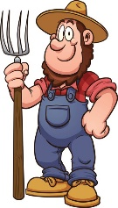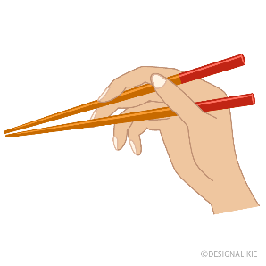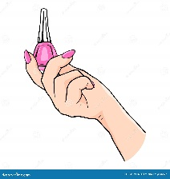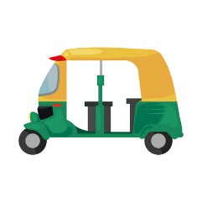

___________ ___________ ___________ ___________

1. **Choose the correct answer to fill in the blank in each question:**
2. There were two security guards ……… outside the building.

|  |  |  |  |
| --- | --- | --- | --- |
| 1. clean up | 1. on duty | 1. reliable | 1. polite |

1. **'missing home and family'** means …………..

|  |  |  |  |
| --- | --- | --- | --- |
| 1. newcomer | 1. flexible | 1. homesick | 1. frustrating |

1. Would you ………… your radio a little?

|  |  |  |  |
| --- | --- | --- | --- |
| 1. turn right | 1. turn left | 1. turn around | 1. turn down |

**4**

1. **Orthography:**
2. **Choose the correct missing letters:**
3. I caught him trying to **s__eal** my bike.

|  |  |  |  |
| --- | --- | --- | --- |
| 1. b | 1. d | 1. p | 1. t |

1. A **p__rsuasive** person is someone who gets other to do what he wants or thinks.

|  |  |  |  |
| --- | --- | --- | --- |
| 1. a | 1. e | 1. i | 1. u |

1. A **neph__w** is a son of one's brother or sister.

|  |  |  |  |
| --- | --- | --- | --- |
| 1. e | 1. i | 1. o | 1. u |

1. The twins often **bor__ow** each other's clothes.

|  |  |  |  |
| --- | --- | --- | --- |
| 1. r | 1. o | 1. a | 1. w |

1. She had to make a **choi__e** between the two dresses.

|  |  |  |  |
| --- | --- | --- | --- |
| 1. k | 1. x | 1. c | 1. s |

1. Our hotel had a **sce__ic** beauty of the countryside.

|  |  |  |  |
| --- | --- | --- | --- |
| 1. m | 1. n | 1. u | 1. w |

1. Please help me to **remo__e** the table to the corner.

|  |  |  |  |
| --- | --- | --- | --- |
| 1. f | 1. v | 1. r | 1. t |

1. She is always **punc__ual**, but her friend is always late.

|  |  |  |  |
| --- | --- | --- | --- |
| 1. h | 1. t | 1. k | 1. x |

**END OF QUESTIONS**

**BEST OF LUCK**

**Ms. Tahani AlGhamdi**

******المملكة العربية السعودية**

**Kingdom of Saudi Arabia**

**Ministry of Education**

**------- Educational Directorate**

**------- Future Educational Schools**

**3rd grade intermediate 2022**

**3rd Term – Final Exam**

**وزارة التعليم**

**الإدارة العامة للتعليم بن**

**مدارس م ن التعليمية**

**الصف الثالث المتوسط**

**الاختبار النهائي للفصل الدراسي الثالث1445**

|  |  |  |  |  |  |  |  |
| --- | --- | --- | --- | --- | --- | --- | --- |
| **Total**  **written** | **5 spelling** | **4 Vocabulary** | **3 Grammar** | **2 Comprehension** | | **1 Composition** | **Q. NO.** |
|  |  |  |  |  | |  | **Mark Given** |
| **30** | **4** | **7** | **7** | **6** | | **6** | **Mark** |
|  | | | **Reviser** | |  | | **Corrector** |
|  | |

**زمن الاختبار: ساعتان**

**اسم الطالب: ------------------------------------ رقم الجلوس: ------------- الصف الثالث المتوسط**

**6**

1) **Composition**

**1- Write a paragraph about “Your Life Story "**

**Say where you were born , raised , and educated Using the following guide words.**

**( I – born – years – live – have got – oldest – study – like – favorite - future )**

…………………………………………

………………………………………………………………………………………………………………………………………………………………………………………………………………………………………………………………………………………………………………………………………………………………………………………………………………………………………………………………………………………………………………………………………………………………………………………………………………………………….

**2) Comprehension**

**6**

**2- Read the following passage then answer the questions:**

**A cold Day**

**It is a frigid January day in York, Pennsylvania. The temperature is below freezing. Snow is starting to fall. Dr. James turns on the television to check the weather. He must leave for his work at the hospital soon. “Today is going to be very cold, ” says the TV weatherman. “Be sure to wear very warm clothes when you go outside. Also, be careful driving on the roads. Snowfall will make them slippery. In fact, if you can stay home today, do it!” Dr. James cannot stay home. Very sick people are waiting to see him at the hospital. He goes to his closet. He takes out the warmest clothes he has. He puts on a sweater, jacket, gloves, socks, boots, and a hat. He opens his front door to go to work. A gust of cold air blows inside. “Wow, it is very cold outside,” Dr. James says. He is from Miami and is not used to the cold. “The weatherman was right!” Before he can drive to work, Dr. James must clear the snow off his car. He does this very fast. He hops in the car. He shivers. His neck feels especially cold. Dr. James drives slowly to work. Everyone else is driving slowly, too. There is a lot of traffic on the road. There are cars in front of and behind him. Suddenly, the cars in front of Dr. James come to a stop. There has been an accident! Dr. James hurries from his car to check on the driver of the car that has swerved off the road. “Is everyone okay?” Dr. James asks. “Yes, yes, we are fine. We slipped on a patch of ice,” the driver says. “This would have been a good day to stay home in bed.”**

**A- Put ( T ) or ( F ):**

**1. Dr. James works as a doctor at the hospital. ( )**

**2. The weather is so hot. ( )**

**3. Dr. James decided to go to work. ( )**

**B- Choose the correct answer:**

**1. If the weather is frigid, it is very…………**

a. cold b. rainy c. windy d. slippery

**2. In what city does this story take place ?**

a. Florida b. Miami c. Pennsylvania d. York

**3. What could Dr. James have put on his neck to keep it warm ?**

a. gloves b. a scarf c. another hat d. a jacket

**3) Grammar**

**7**

**Choose the correct answer:**

**1. We were sitting in the café when a thief _____ my bag !**

a. steal b. stole c. was stealing d. stolen

**2. Jack was talking on the phone _____ he was driving .**

a. while b. that c. where d. which

**3. I _____ at the monument when someone called my name .**

a. look b. looked c. am looking d. was looking

**4. May I speak to the manager ? ( Agreeing )**

a. Certainly b. I'm sorry c. I'm afraid .. d. that’s not possible

**5. Have you ______ finished your homework ?**

a. already b. yet c. just d. already not

**6. He enjoys _____ in the high-tech computer field .**

a. work b. worked c. working d. to work

**7. I have ________homework that I can’t go out tonight .**

a. so much b. much c. so many d. that many

**8. He has ________books that he can hardly carry them .**

a. much b. so much c. that many d. so many

**9. If it rains, you ________ wet .**

a. gets b. got c. will get d. getting

**10. If Sally is late again I will ________ mad .**

a. be b. being c. been d. to be

**11. If I ________ time, I will finish that letter .**

a. to have b. have c. having d. had

**12. If I ________ rich, I would travel around the world .**

a. are b. were c. am d. is

**13. Sam suggested ________ at the station .**

a. meets b. met c. meet d. meeting

**14. I'm hoping ________ Lisa .**

a. see b. to see c. seeing d. saw

**4) vocabulary:**

**7**

**Choose the Correct Answer:**

**1.Max: Why are the police talking to Jerry? Ali: He saw a man who tried to _______ a bag.**

a. steal b. fake c. pretend d. in a hurry

**2. That diamond is not real. It is ____________________ .**

a. thief b. give direction c. fake d. steal

**3. I know you can hear me. Don’t ____________________ you can’t !**

a. give directions b. fake c. thief d. pretend

**4. Some people are always ____________. They don’t have time to talk and relax.**

a. pretend b. in a hurry c. steal d. give direction

**5. You use a toothbrush and _______________to brush your teeth .**

a. toothpaste b. hair dryer c. shampoo d. scissors

**6. You use ____________________ to cut paper .**

a. scissors b. hair dryer c. mirror d. dishwashing liquid

**7. You use a ____________________ to dry your hair when it is wet .**

a. shampoo b. toothpaste c. hairbrush d. hair dryer

**8. You use ____________________ to wash your hair .**

a. toothpaste b. shampoo c. scissors d. hairbrush

**9. It will be to your ________ to arrive early .**

a. farmer b. choice c. airshow d. benefit

**10. They went to a ________ in the mountains last summer .**

a. route b. resort c. subject d. choice

**11. He won the ________ to Harvard University .**

a. airshow b. scholarship c. subject d. pollution

**12. History is my favorite ________ at school .**

a. subject b. benefit c. environment d. farmer

**13. Give yourself a ________ and get some rest .**

a. host b. break c. chopstick d. porter

**14. I'll be fine after we ________ for a little bit .**

a. allow b. rest c. expect d. rush

**5) Orthography**:

**4**

**Choose the Correct Letters:**

**The people who live in the city are always in a hur__y.** ( r – s – t – m )

**The watches that the man was s__lling were fakes.** ( o – a – e – u )

**I hate this program. I’m going to turn it of__.** ( v – s – f – h )

**Have you taken the garbage o__t yet?** ( u – v – y – a )

**End of Questions**

**Best of Luck https://t.me/abokhaledamer**



**Total :**



**30**



# **Composition**

# 

* Write a paragraph about "**what your friend should know about you**". Use the following chart to help you in writing.

|  |
| --- |
| 1. What do you enjoy doing? |
| 1. What are some things that bother you? |
| 1. What kind of food do you like? * Examples |
| 1. When do you usually study? |

……………………………………………………………………….........................

……………………………………………………………………….........................

……………………………………………………………………….........................

……………………………………………………………………….........................

……………………………………………………………………….........................

……………………………………………………………………….........................

……………………………………………………………………….........................

……………………………………………………………………….........................

……………………………………………………………………….........................

……………………………………………………………………….........................



**Total:6 /**

**1**

**Total 6 /**

**2**

**Comprehension**

**\* Read the passage then answer the questions below :**

Kareem is eleven years old . He is in grade five . He went to the restaurant last week . The restaurant was not far from his house so he walked . At the restaurant , he ate some fresh fish and salad with lemon. The food was delicious .

While Kareem was eating , he remembered that he forgot his money . He ran quickly to the telephone and phoned his brother Ali and told him the story . After an hour , Ali came to the restaurant and gave the waiter three shekels .

___________________________________

**A)Choose the right answer :-**

1- He is in grade ……………………..

a- six b- nine c- five

2- The restaurant was not …………………….from his house . a- far b- next to c- near

3- The food was …………………….

a- delicious b- too bad c- too hot

4- He went to the restaurant last ………………………

1. Month b- year c- week

**B) Tick ( ) or ( x ) :**

1- Kareem is thirty years old . ( )

3- Ali gave the waiter three Shekels . ( )

**Grammar**

1. **Correct the underline words:**(1/2 each)

1 - Can I **asking** you a question?

…………………………………………………………………………………………………………………………………………

2- No , I haven't done them **just**.

…………………………………………………………………………………………………………………………………………

**B ) (Rewrite each sentences with a two-word verb in two ways ) :(**1/2 each)

1- Clean up the mess. ……………………………..……… ………………………………………………….

2- Put away the toys……………………………………….. ………………………………………………….

**C : Choose the correct answer :(**1/2 each)

1. The neighbor ……………….lives downstairs is very quiet .

( who – which – where )

1. If you help me, I ………………………….you.

(thanked – thanks – will thank)

1. I would like to ………………………………a room.

( books – booking – book )

1. Have you done the dishes………………………?

( yet – already – just )

1. It …………………be rain. There isn’t a cloud in the sky.

( must – can - can’t )

1. The horse ……………………pulled the carriage was black .

( who- which – where)

1. He has…………………..books that he can hardly carry them .

(so many – so much – such)

1. He can’t stand ……………………………in line.

( wait – waits - waiting )

1. May I ……………………….to the manager?

( spoken – spoke – speak)

10-……………………………… is my favorite sport.

(Swim – Swims – Swimming)

**3**

**Total 7 /**

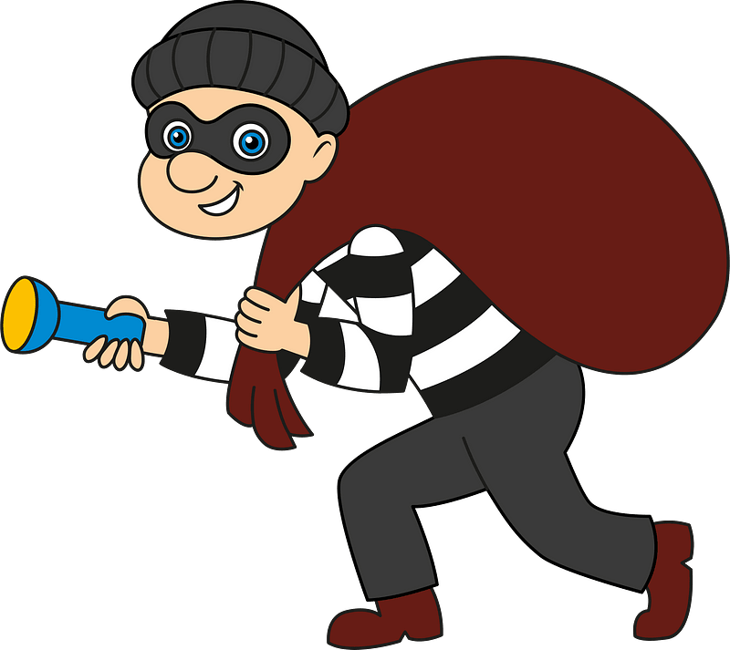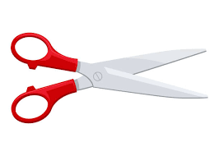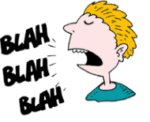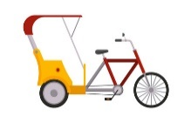

**Pedal cab thief nail polish toothpaste airshow**

**Chopsticks garbage mirror talkative scissors**

**4**

|  |  |  |  |
| --- | --- | --- | --- |
| B |  | A |  |
| To make less |  | unemployment | 1 |
| Being poor |  | poverty | 2 |
| Lack of jobs |  | loan | 3 |
| Money you borrow |  | To reduce | 4 |

**Total 7 /**

**Vocabulary**

1. **Choose the correct word to the correct picture :** (1/2 each)

…………………………… ………………………….. …………………………. ………………………… ………………………..

…………………………… ………………………….. …………………………. ………………………… ………………………..

**B ) Mach each word in column A With the meaning in column B :** (1/2 each)

**5**

**With Best Wishes**

**Total 4 /**

**Orthography**

1. **Fill in the missing letters :** (1/2 each)
2. Ti…… ( L - m - p )
3. M …… d ( u - e - r )
4. Re……ove ( n - m - d )
5. Fo……..us ( c - t - f )

**B ) Choose the odd word :** (1/2 each)

1. athletic clever friendly book

2. thief police officer work guide

3. done go eaten gotten

4. pedal cab taxi bus doctor