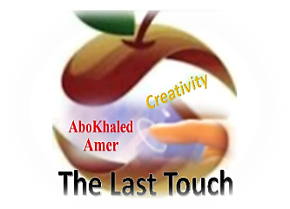

المملكة العربية السعودية
وزارة التعليم
الادارة العامة للتعليم بمنطقة ----------------
مدرسة ------------------ المتوسطة
Second Term- Second Session Test
Name: ------------------------------------------------------ Grade: 1st Inter.
ABOKHALEDAMER
0557325813
1. Write the correct number under its picture: (6M)
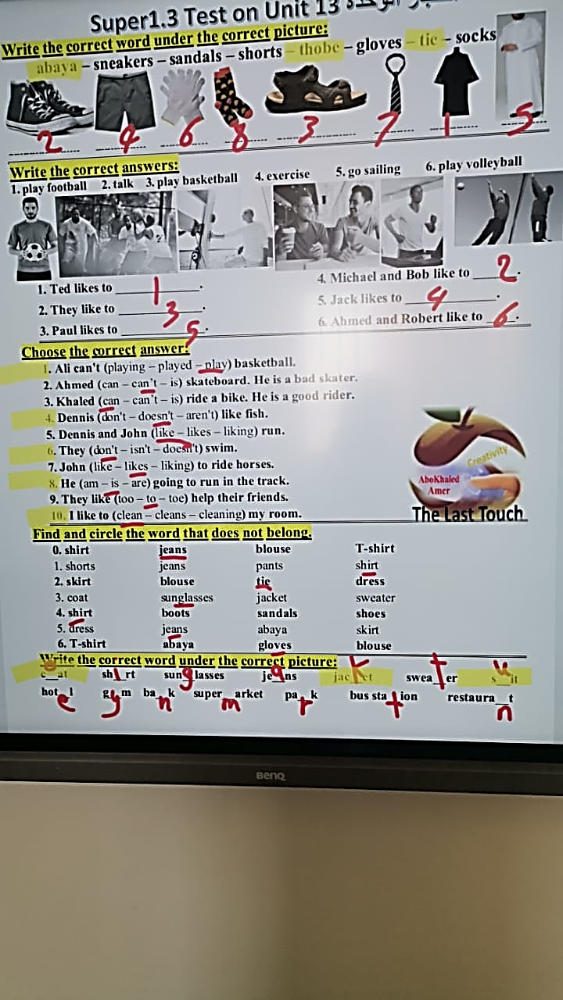
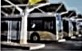
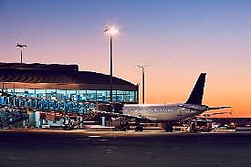
1. bus station 2. bank 3. airport 4. tie 5. abaya 6. thobe


( ) ( ) ( ) ( ) ( ) ( )
2. Match the place and things: (4M)
1. ----- park a. You can exercise.
2. ------ gym b. You can buy books.
3. ------ bookstore c. Visitors can sleep there.
4. ------ hotel d. We have a barbecue.
3. Choose the correct answer: (8M)
1. I (can – can't – don't) swim. Can you tell me how to swim?
2. She can (drive – drives – driving) a car carefully.
3. (Do – Does – Doing) you like ice cream?
4. Can you (helping – helps – help) me do my homework?
5. Does she clean the room? Yes, she (do – can – does).
6. Dennis (like – likes – liking) fish.
7. He (am – is – are) going to run in the track.
8. I to (clean – cleans – cleaning) my room.
4. Supply the missing letters: (2M)
1. Scho__l 2. resta__rant 3. c__at 4. s__it

(2) Top Goal - YouTube End of Questions https://t.me/abokhaledamer

