التاريخ:
اسم المجموعة:
ورقة المشاركة التفاعلية

.................................................................................................................................................................................................................................................................................................................................................................................................................................................................................................................................................................................................................................................................................................................................................................................................................................................................................................................................................................................................................................................................................................................................................................................................................................................................................................................................................................................................................................................................................................................................................................................................................................................................................................................................................................................................................................................................................................................................................................................................................................................................................................................................................................................................................................................................................................................................................................................................................. ..........................................................................................................................................................................................................................................

.................................................................................................................................................................................................................................................................................................................................................................................................................................................................................................................................................................................................................................................................................................................................................................................................................................................................................................................................................................................................................................................................................................................................................................................................................................................................................................................................................................................................................................................................................................................................................................................................................................................................................................................................................................................................................................................................................................................................................................................................................................................................................................................................................................................................................................................................................................................................................................................................................. ..........................................................................................................................................................................................................................................

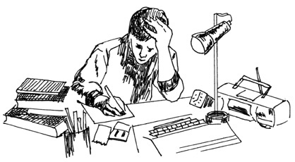

معلمة المقررأ/ عايدة العتيبي
ورقـة نشاط (1) لدرس: إعداد التقارير
اسم المجموعة: التاريخ:
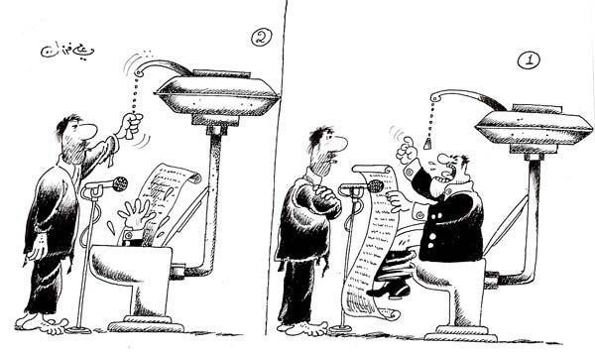
علقي على الصورة التالية.

....................................................................................................................................................................................................................................................................................................................................................................................................................................................................................................................................................................................................................................................................................................................................................................................................................................

بعد مشاهدتك للفديو المعروض استخلصي المعلومات التي تخص موضوع الدرس.
....................................................................................................................................................................................................................................................................................................................................................................................................................................................................................................................................................................................................................................................................................................................................................................................................................................
....................................................................................................................................................................................................................................................................................................................................................................................................................................................................................................................................................................................................................................................................................................................................................................................................................................
....................................................................................................................................................................................................................................................................................................................................................................................................................................................................................................................................................................................................................................................................................................................................................................................................................................
معلمة المقرر أ/ عايدة العتيبي

