Super Goal 1 - Test unit 1 & 2

Name :…………………………………………………………………… Class:…….……….

Reading
2 Marks
- Read the text and answer the questions. Write T or F at the end of each question/statement.
My name is Mariam. I am 13 years old. My birth date is in the ninth month of the year. It is on September 4th. My best friends’ names are Carla and Jane. They are 14 years old. Carla’s birth date is on June 3rd. Jane’s birth date is on March 31st. We are students in Mrs. Jenkin’s English class. Our class is on Mondays, Tuesdays, and Wednesdays.
- Mariam, Carla, and Jane are teenagers. ( )
- Mariam is a student, but Carla and Jane are not students. ( )
- Jane’s birth date is in the 11th month of the year. ( )
- Mariam’s birth date is in the 9th month of the year. ( )
Grammar
5 Marks
- Choose the best answer to fill in the blank in each question.
- Mr. Smith _____ a teacher.
a. am b. is c. his d. are
- _____ students.
a. I’m b. He’s c. Are d. They’re
- Asma and Nura are _____.
a. friend b. friends c. is friend d. are friend
- Their final test is __________ April 14th.
a. in b. on c. am d. are
- His driving test is __________ November.
a. on b. are c. in d. am

- Complete the sentences with possessive adjectives.
1.5 Marks
- He is a student. __________ name is Ahmad Saleh .
- I am a teacher, ____________ name is Rashed Alsulami .
- He`s the director. __________ name is Mr. Abdulaziz Alshehri

- Complete the question, use ( What – When – How old ).
1.5 Marks
- ________________ is your vacation? - our vacation is in May .
- __________________ are you ? - I'm fifteen .
- _________________ is the date tomorrow ? - It's 20th September .

Vocabulary
- Choose the best answer to fill in the blank in each question.
5 Marks
- See you _____, Faisal.
a. bye b. later c. night d. goodbye
- Good _____, Mr. Ali.
a. days b. meet c. hello d. evening
- Nice to _____ you, Mona.
a. meet b. name c. friend d. call
- June is the __________ month of the year.
a. Second b. first c. twelfth d. sixth
- Today is Tuesday. __________ is Wednesday.
a. Tomorrow b. Today c. Yesterday d. Month

- Write the correct word under the picture.
3 Marks
Pencil – Turtle – Calendar

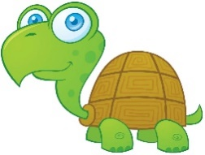
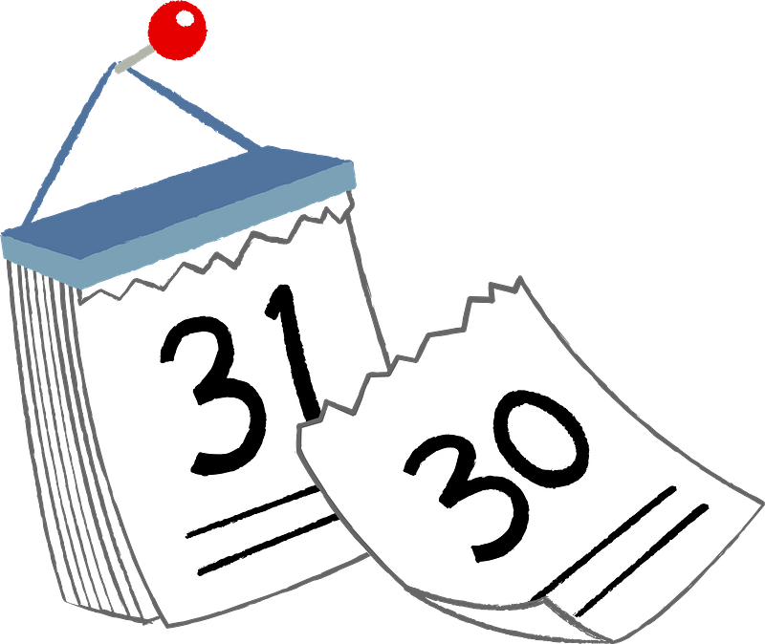

…………………………..…………………….
…………………………..…………………….

…………………………..…………………….

- Choose the correct letter.
2 Marks
- Nice to meet …ou ( v – y – r )
- He is so c….te ! ( y – u – c )

Student's Name : class:
English Language
Intermediate Grade 1st
1st period Exam
Kingdom of Saudi Arabia
Ministry of Education
………………… School

5
5
1-Read the following passage and answer the questions below:
My name is Hassan and I'm 13 years old. I'm from Jeddah. Our school fete is usually at the end of May. I always go with my cousins and we usually have fun. There are a lot of competitions, but I'm never very lucky.
1-My name is……………….
c-Khalid | b- Ali | a- Hassan
2- I'm ………. years old
c- 11 | b- 13 | a- 15
3- I'm from ………….
c- Jeddah | b- Riyadh | a- Abha
4- Our school fete is usually at the end of ………… .
c- April | b- August | a- May
5-. I always go with my ………….
c- brother | b-friends | a- cousins

2-Choose the correct answer
5
5

1- The exam is ( in – on – at )Monday.
2- You ( is – are – am ) a doctor.
3-(where – what – why ) day is today?
4- This is my friend .She (is – are -am) a teacher.
5-Please ( open – opening – opens ) your book.
6- Omar (is – are – am) a student.
7- I’m a student. (Her – My – His )name is Alan.
8-( What – How – when ) are you?
9- This is my mother. ( Her – My – His)name is Kate.
10- They are 18 years old. ( Your - Their – our ) graduation ceremony is today.

3. Do as shown between brackets.
5
5

A-( Correct )
1-What is you name? ………………
2-How are you from?………………
3-Our vacation is on the winter ………..
B-Write the negative.
1-close the door…………………………………………………………………………….
C-Write the following date.
1-2/15…………………………………………………………………………………………

5
5
4. Write the missing letter for each picture.
Pencil calendar paints scissors

……………….……
……………….……
……………….……
……………….……

5. Reorder.
1-Tuesday - Thursday - Wednesday
…………………………………………………….…..
6. Choose the correct verb
1. We( cut – color) with scissors.
2. We( read – cut ) books.

Best of luck
Your teacher:

