|  |  |
| --- | --- |
| How is your result ? | |
| sad-emoji-24oz4yx.png | C:\Users\PC\AppData\Local\Microsoft\Windows\Temporary Internet Files\Content.IE5\E3SLIG17\images_(4)[1].jpg |

Name : …………………………… Class : ………………

worksheet : ( 17 )



1 ) Match :

Goat – Fish – Jet – Ink

|  |  |  |  |
| --- | --- | --- | --- |
| ink_2958645-e1375708423415.jpg | tfd_141231_Plane 3.jpg | goat.jpg | FISHSHAPED.png |
|  |  |  |  |

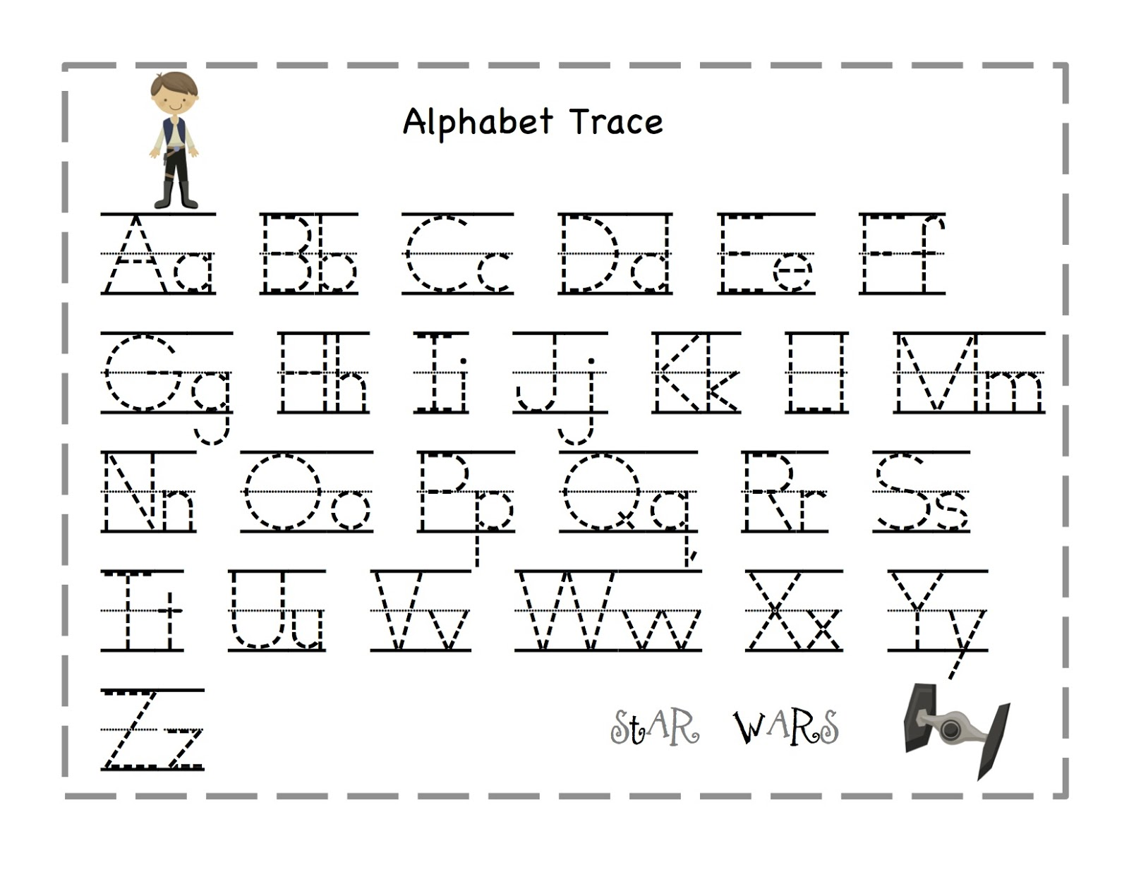

2 ) Trace :