|  |  |  |  |  |
| --- | --- | --- | --- | --- |
| **Kingdom of Saudi Arabia Ministry of Education**  **third Intermediate**  **ا**لاختبـــــــــار النهائي للصف الثاني متوســـــــــــط للفصل الدراسي الثاني | | | **English Language 2nd Intermediate Grade 2nd Term Exam 1443 -2022**  **Time: 2 hours The first session** |  |
|  | **Name/** …………………………………………………………… | **Seat No**./ ……………………… | |  |

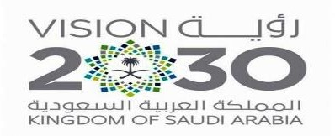

|  |  |  |  |  |
| --- | --- | --- | --- | --- |
| **Number** | **Question** | | **Student’s Mark Number** | **Student’s Mark Written** |
| **Question** | **Mark** |
| **Q1** | **Writing** | **5** |  |  |
| **Q2** | **Reading Comprehension** | **7** |  |  |
| **Q3** | **Grammar** | **8** |  |  |
| **Q4** | **Vocabulary** | **8** |  |  |
| **Q5** | **Orthography** | **2** |  |  |
| **Total Written Tasks** | | **30** |  |  |

1

***Q : 1 ( Writing )***

5

***Write a paragraph about (* yourself *) not less than 3 lines using the following words .***

***( name – age – favorite subject – hobby –food )***

*………………………………………………………………………………………………………………………………………………*

*……………………………………………………………………………………………………………………………………………………………………………………………………………………………………………………………………………………………………*

*…………………………………………………………………………………………………………………………………………………………………………………………………………………………………………………………………………………………………………..................................................................................................................................................................................................................................................................................................................................*

***Q : 2 ( Reading )***

7

**Read the following passage then answer the questions :**

Prophet Mohammad (PBUH ) was born in Makkah in 571AD. He was an orphan. His father , Abdullah, died before he was born. His mother ,Amena, died when he was achild of six . He lived with his grandfather, Abdulmuttaleb. Prophet Mohammad died in Al-Madina in 11 Hijra( 633AD).

**A – Where was prophet Mohammad born ?**

………………………………………………………………………………………………………………………….

**B – Choose the correct answer :**

1 – Prophet Mohammad was born in ( **571AD – 434AD )**

2 – His father`s name is ( **Khaled – Ahmad – Abdullah** )

3 – His mother died when he was (**a child – a young – an adult** ) 4 – He lived with his ( **aunt – uncle – grandfather** )

**C – Put ( T ) or ( F ):**

1. – His mother is Amena . ( )
2. – Prophet Mohammad died in Tabouk . ( )



2

***Q : 3 ( Grammar )***

8

**A – Choose :**

1 – I was there but I did not see **( nothing – anything )**

2 – He **should** ( **stay – staying** ) at bed.

3 – look at **( my – mine )** new ring.

4 – Ali goes ( **swim – swimming** ) three times a week.

5 – The **( biggest – most big )** burger was 5000 pounds.

6 – Are these ( **your – yours** ) socks.

7 – Ali is ( **tall – taller** ) than Imad.

8 – I have ( **so many – so much** ) books on my desk.

***Q : 4 ( vocabulary )***

8

***a – Match the words with their meanings :***

a – Witness. ( ) 1 – payment for costs of an accident.

b – Insurance. ( ) 2 – someone who saw an event.

c – Intersection. ( ) 3 – hurt from an accident.

d – Injury. ( ) 4 – Where two roads cross.

***b – Match the illness with its symptom:***

**( headache – stomachache – earache – toothache )**

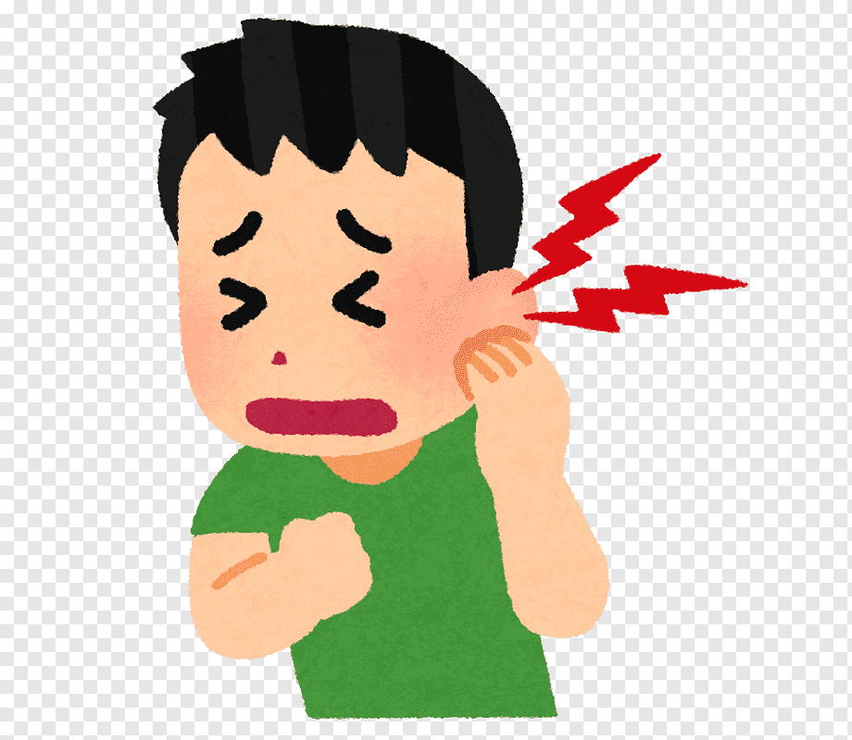   

………………………………. ………………………………… …………………………….. …………………………….

# 

3

# 

2

***Q : 5 ( Orthography )***

**A : Write the missing letter :**

**1 –** scar ……. ( f – t ) . **2 –** …..elt . ( k – b ) .

**3 –** ri…..g . ( n – s ) . **4** – neckla….e ( p – c )

**Good luck….**

# 

4