المملكة العربية السعودية  وزارة التعليم  إدارة تعليم  مكتب تعليم  مدرسة |  | اختبار مادة اللغة الإنجليزية  الصف الثالث الثانوي  الفصل الدراسي الثالث  التاريخ  الزمن

المعلم/ة | التوقيع | المراجعـ/ة | التوقيع

السؤال الأول | السؤال الثاني | السؤال الثالث | السؤال الرابع | السؤال الخامس | المجموع كتابة | المجموع رقما
6 | 6 | 6 | 6 | 6 | ثلاثون درجة | 30

اسم الطالب : |  | الصف : |  | رقم الجلوس :
استعن بالله
Total : 6 /

1- Guided Composition
Write a paragraph that describes your thoughts about '' Gossip '' :
………………………………………………………………………………………………..
………………………………………………………………………………………………..
………………………………………………………………………………………………..
………………………………………………………………………………………………..
………………………………………………………………………………………………..
………………………………………………………………………………………………..
………………………………………………………………………………………………..

2- Free Composition
Choose one of the following topics to write about :
Total : 6 /
1- Write about the importance of food to your body
2- Write an email to a friend
………………………………………………………………………………………………..
………………………………………………………………………………………………..
………………………………………………………………………………………………..
………………………………………………………………………………………………..
………………………………………………………………………………………………..
………………………………………………………………………………………………..
………………………………………………………………………………………………..

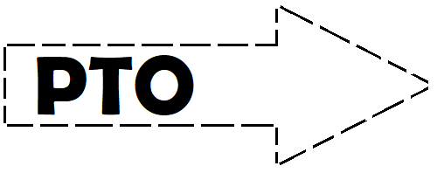
3- Comprehension
Read the text and answer the questions .

We need to eat for several reasons. Firstly, food helps us to grow. Children need to eat so as to become taller. Adults need to eat so that their bodies stay strong and so that their skin goes on growing. Secondly, we eat in order to have energy. We need strength so that we can walk, talk and lift things. Thirdly, we eat so that our bodies can go on operating. Food helps our brains to work; it helps our hearts to pump blood; it helps our eyes to see. Food contains nutrients. These are things which are important for our health. They are: proteins, carbohydrates, fats, vitamins and minerals. It is important for us to have a balanced diet. We should avoid eating too much carbohydrates and too much fat. Because our bodies will gain fat. Proteins are found in milk and eggs. Carbohydrates are found in bread and sugar. Vitamins are in fruit and vegetables. Butter and oil contain fats. Finally, minerals such as iron are important.
Total : 6 /
A- Choose the correct completion:

1- Food helps our brains to …………….
A- work B- see C- pump blood D- hear

2- Proteins are found in …………….
A- eggs B- sugar C- bread D- fruits

3- Vitamins are in …………….
A- milk B- fruit C- butter D- oil

C- Put ( √ ) or ( X )

1- Proteins are found in milk and eggs. ( )

2- We should eat too much carbohydrates ( )

3- Butter and oil contain fats. ( )

4- Grammar
Total : 6 /
A- Choose the correct words :

1- She didn't come ? She must have ………… about the meeting .
A- forget B- been forgotten C- forgotten D- forgeted

2- It was ……….. long ago that I can't remember it .
A- so B- such C- as D- soon

3- Every mother ……………….. her children are beautiful.
A- fears that B- found out that C- believes that D- force that

B- Do as shown between brackets:

1- Ali may has gotten lost. (correct the error).
……………………………………………………………………..

2- She said her sister couldn't went with her. (correct the error ) .
……………………………………………………………………..

3- I saw the man. He stole the wallet ( combine the sentences )
……………………………………………………………………..

5- Vocabulary
Total : 6 /
Name the pictures:

kimono – iceberg – nail polish – lightning – lipstick – hair comb

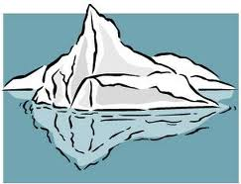 | 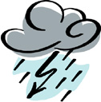 | 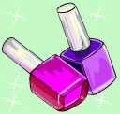 |  |  | 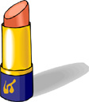

End of questions
Good luck

