We Can! Book 4 Unit 2: From Here to There

1. Listen and match pictures and words. Number the words. [Play CD1 20 or read.]

6 bicycle | 5 car | 1 truck
8 police car | 2 bus | 9 ambulance
4 motorbike | 6 train | 7 taxi

1.  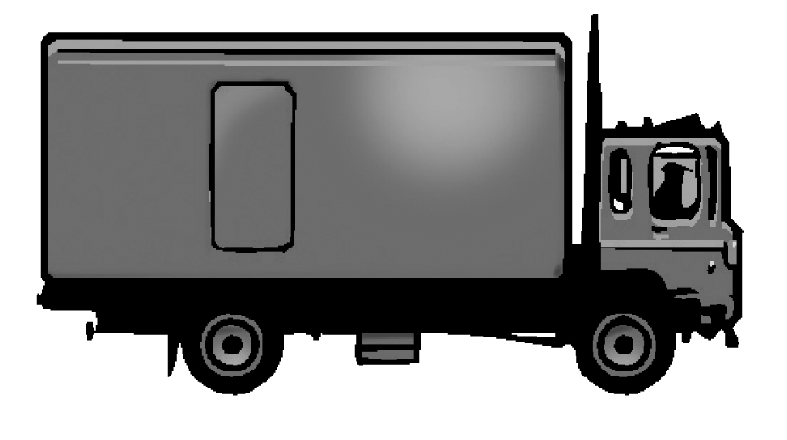 | 2.  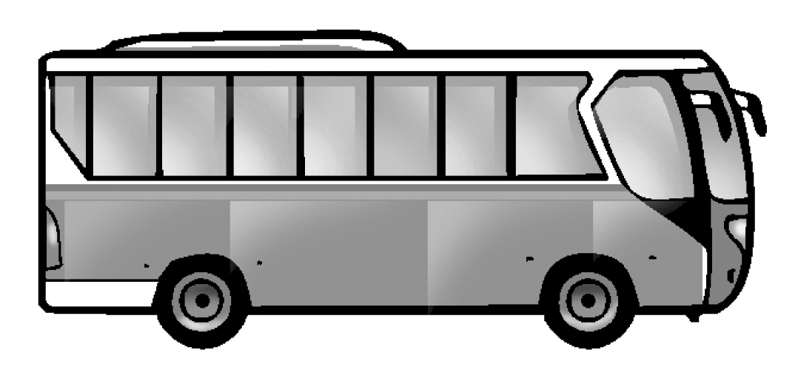 | 3.  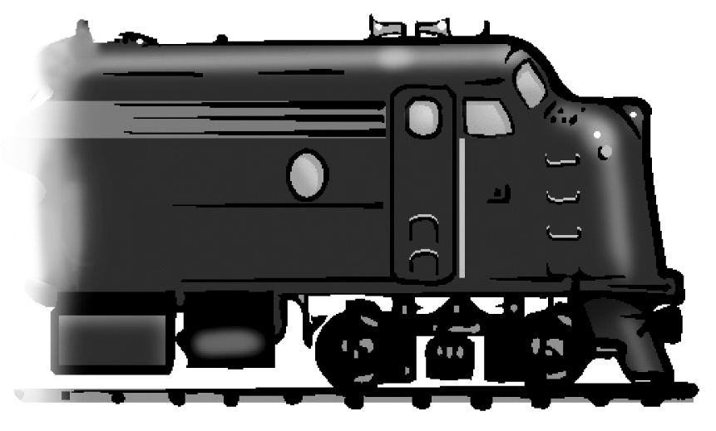
4.  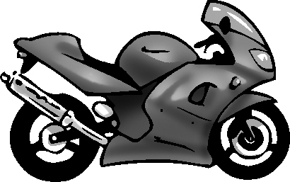 | 5.  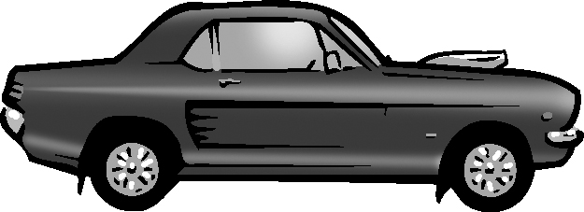 | 6.  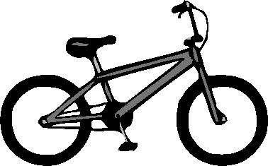
7.  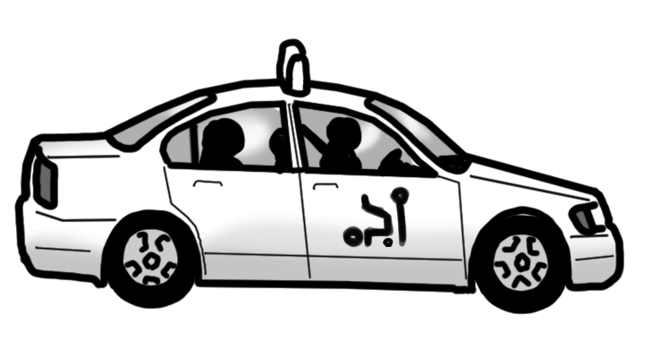 | 8.  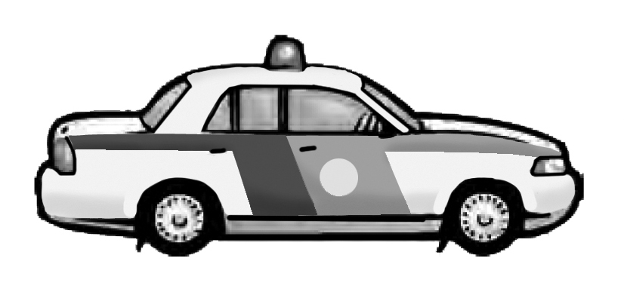 | 9.  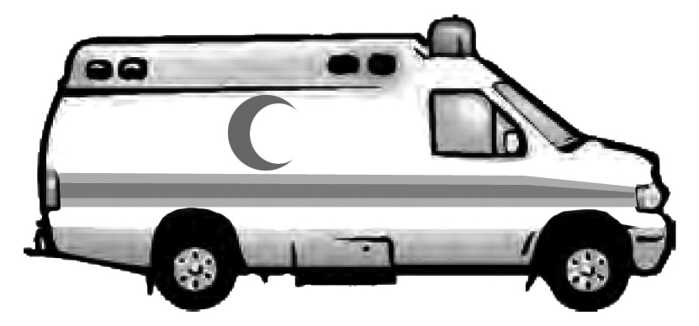

2. Look at the arrow and circle A, B, or C.

1. | 2. | 3.
A. Turn right  B.Turn left  C.Walk straight | A. Turn right  B.Turn left  C.Walk straight | A. Turn right  B.Turn left  C.Walk straight
.
3. Listen and number the missing lines.

3 When you see a green light, go, go, go.
1 When you see a red light, stop, stop, stop.
2 When you see a yellow light, wait, wait, wait.

When you see a red light,  red light, red light.  (1) ___________________ | 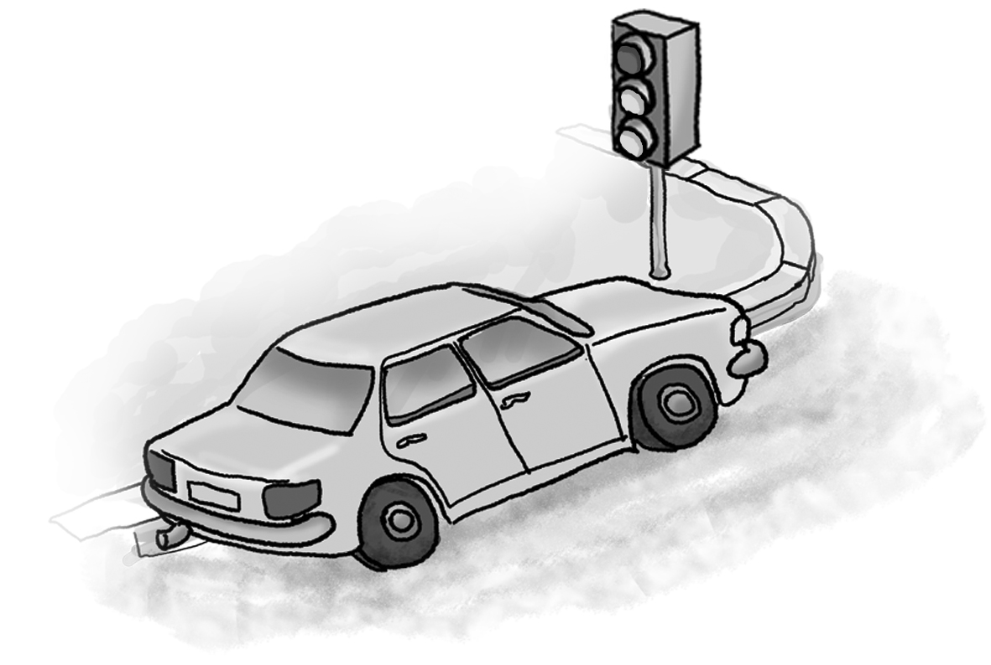
When you see a yellow light,  yellow light, yellow light.  (2) ___________________ | 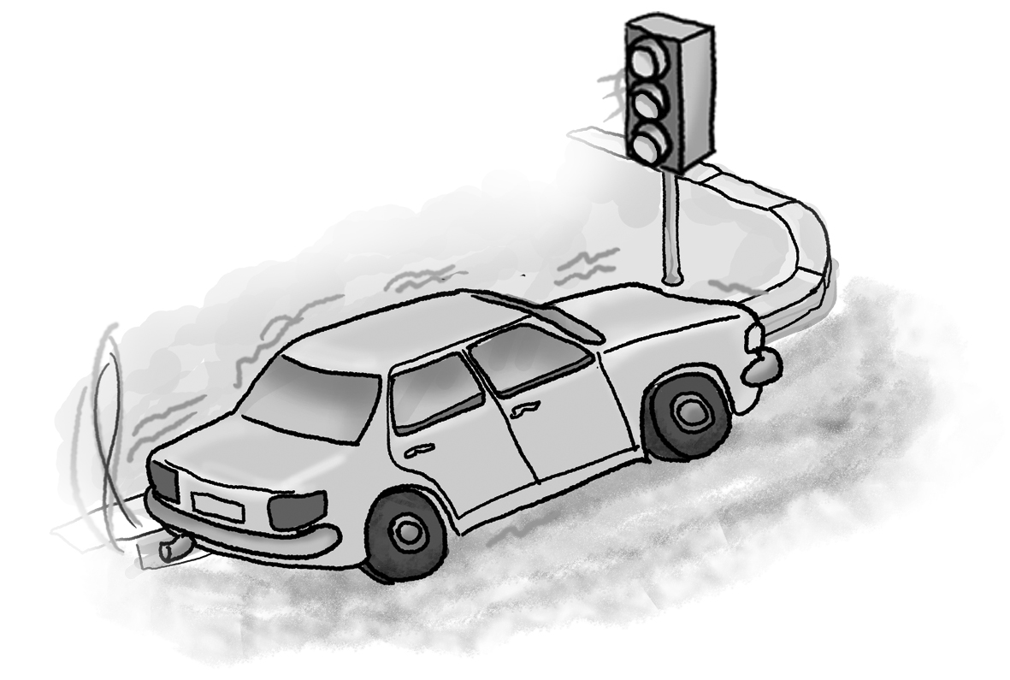
When you see a green light,  green light, green light.  (3) ___________________ | 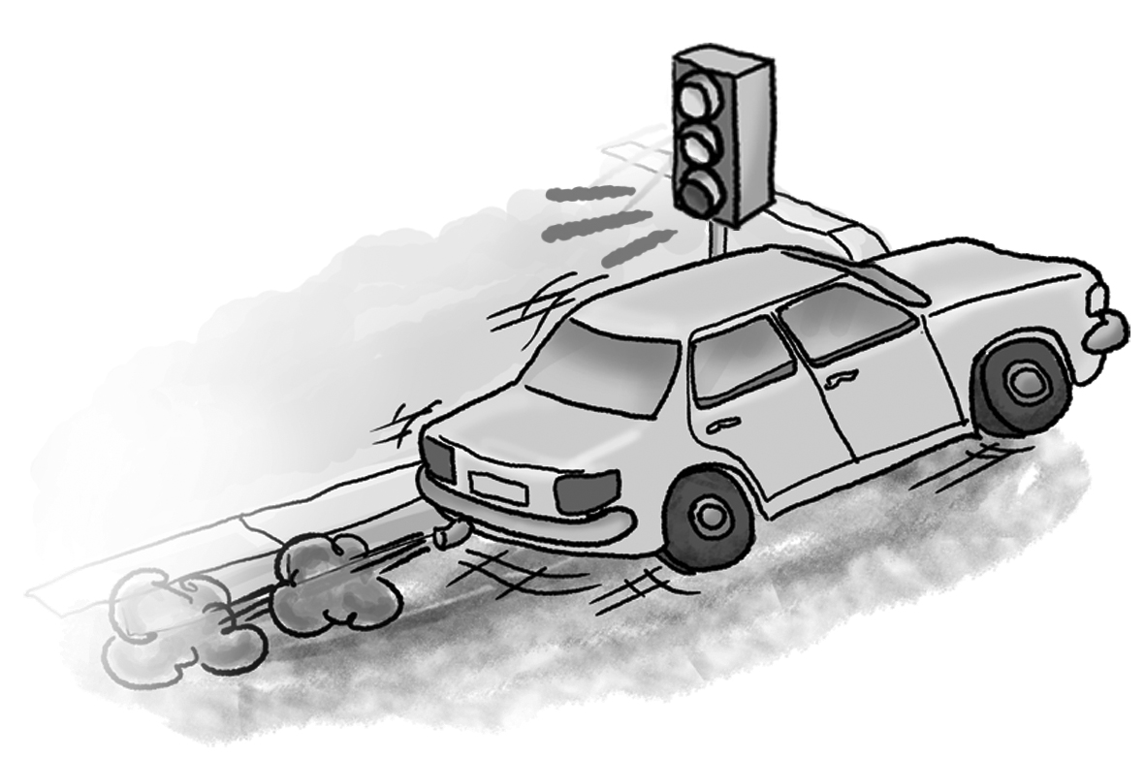
[Play CD1 17 or read.]

4. Look at the picture and write bl, cl, fl, gl, or pl.

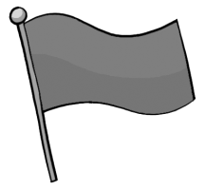 | 1. fl ag |  | 2. bl ack
 | 3. bl ue |  | 4. pl ate
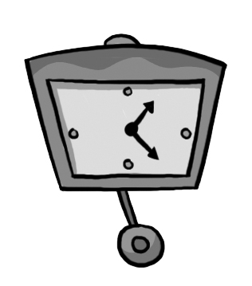 | 5. cl ock |  | 6. pl ant
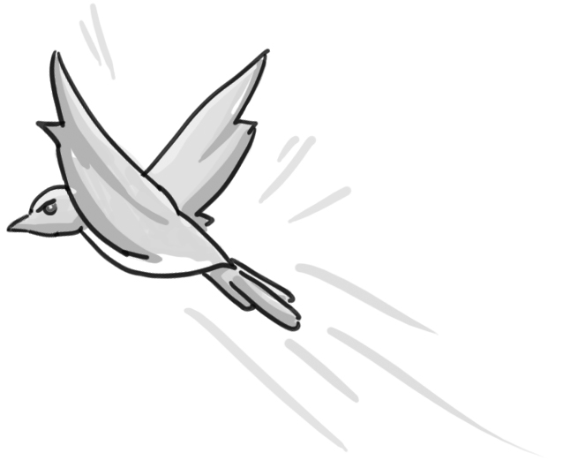 | 7. fl y | 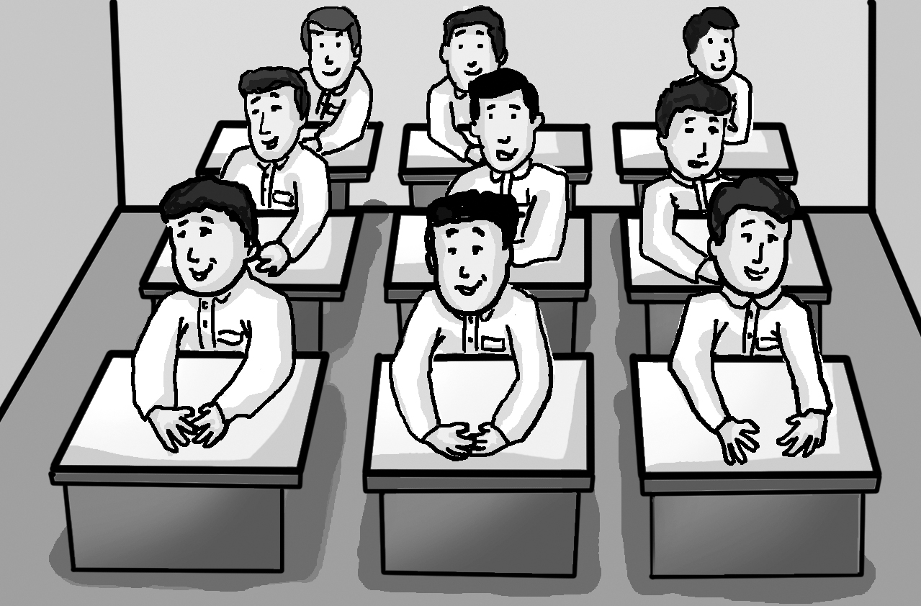 | 8. cl ass

