
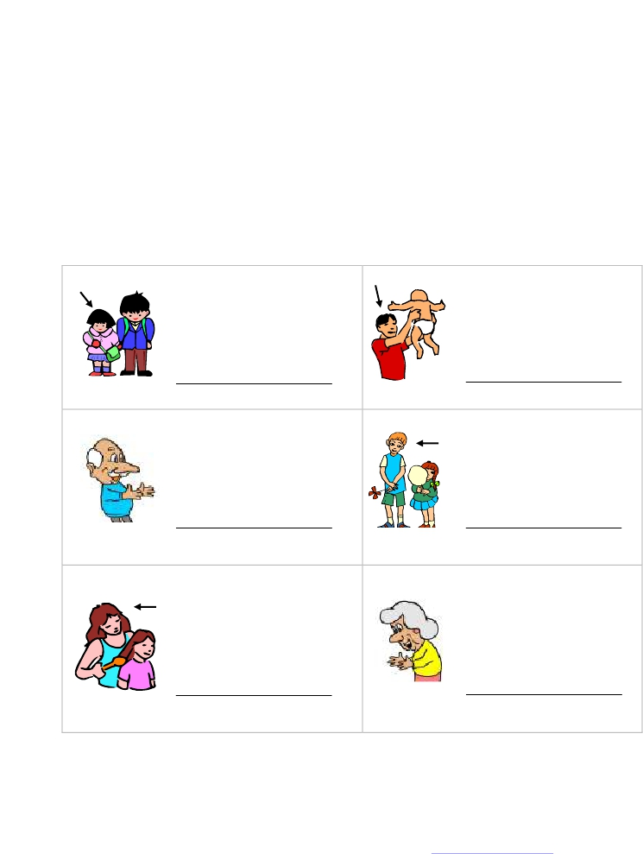
Name _______________________

Family Worksheets
Family Word Scramble Matching

Look at each family related picture and unscramble the
letters and write the name of the family member on the
line provided.

risset heftar

napgrad hortreb

ethrom dangram

