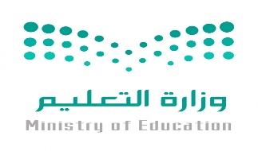
Kingdom of Saudi Arabia
Ministry of Education
………… Education Directorate............
…………..……………….. Intermediate School

Total

المجموع | تحريري | شفهي
20 | 10 | 10

Second Period Exam

Third Intermediate Grade

نموذج اجابة
__________________________________________________________________________________________
Comprehension

/ 2

Read the following then answer the questions:

Saudi Arabia is the is the largest country in West Asia and the thirteenth largest in the world. It's population is about 27 million and the official language is Arabic. Riyadh is the capital city and it's the largest city in Saudi Arabia. The kingdom tower is the tallest skyscraper in Riyadh and the 26th tallest building in the world. Jeddah is the largest city on the red sea.
A- Put (√ ) for true or ( ᵡ ) for false :

( √ ) | 1. The official language is Arabic.
( ᵡ ) | 2. The kingdom tower is the smallest skyscraper in Jeddah .

B- Choose the right answer:

east | north | west | south | 1- Saudi Arabia located in ______ Asia.
Riyadh | Jeddah | Makkah | Dammam | 2- __________ is the capital city .
___________________________________________________________________
/ 2.5
Grammar

Choose the right answer:

1- I eat _____ vegetables.
A. many B. little C. much D. nothing
2 - _________milk do you drink?
A. How many B. How much C. How often D. How old
3 - I ____ there two years ago.
A . am B. were C. have D. was
4 - He ______ studied English since third grade
A. was B. have C. is D. has
5 - Trains are ______ than buses
A. fasts B. fastest C. faster D. fast

/ 2
Vocabulary

A- Choose the best answer to fill in the blank:
1. We use water to _____ our crops.
D. put out | C. cool | B. drink | A. irrigate
.2. She cooked the pizza on the ________
D. washer | C. stove | B. printer | A. shower
3- ___________ succeed in doing something
D. accomplish | C. innovation | B. interrupt | A. miniature
4- An area on the edge of a large town or city _______ .
D. continent | C. sea | B. ocean | A. suburb
B- Put the right word under its picture:
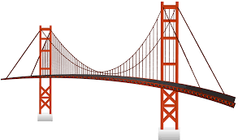 | 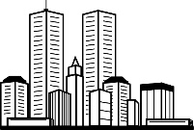 |  |  | 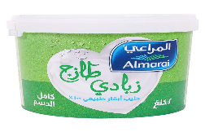
bridge | skyscrapers | printer | microwave | yogurt
skyscrapers - bridge - printer - yogurt - microwave
/ 2.5

_______________________________________________________________________________
/ 1
Orthography

Choose the correct letter:
d | t | v | 1. lap_ops have become smaller and lighter.
n | r | m | 2. Saudi Arabia has many natural resou__ces .

Good luck T.

