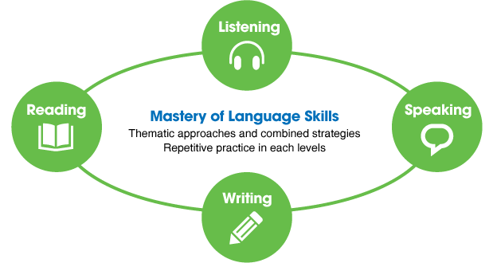
Teaching Strategies
Teaching Strategies

Listening & Speaking
1-Repetition& Drilling
2-Making &Taking Notes
3-Role Play
4-Hot Seat
5- Vocabulary Box
Writing  9-Running Dictation  10- Summarizing  11-Picture Describing | Reading  6- Scanning & Skimming  7 -Reading Circles  8- Story Telling
General Strategies
12-Discussion
13-Brain Storming
14-Games
15- The Four Corners
16-Mind Maps
17-Numbered Heads
18- jigsaw reading / speaking
19- Total Physical Response
20- collaborative learning

