

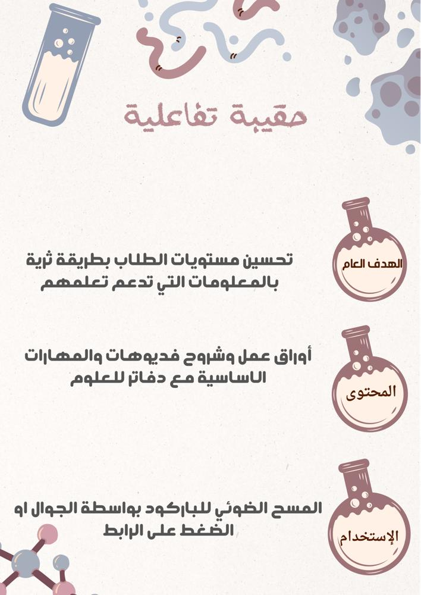

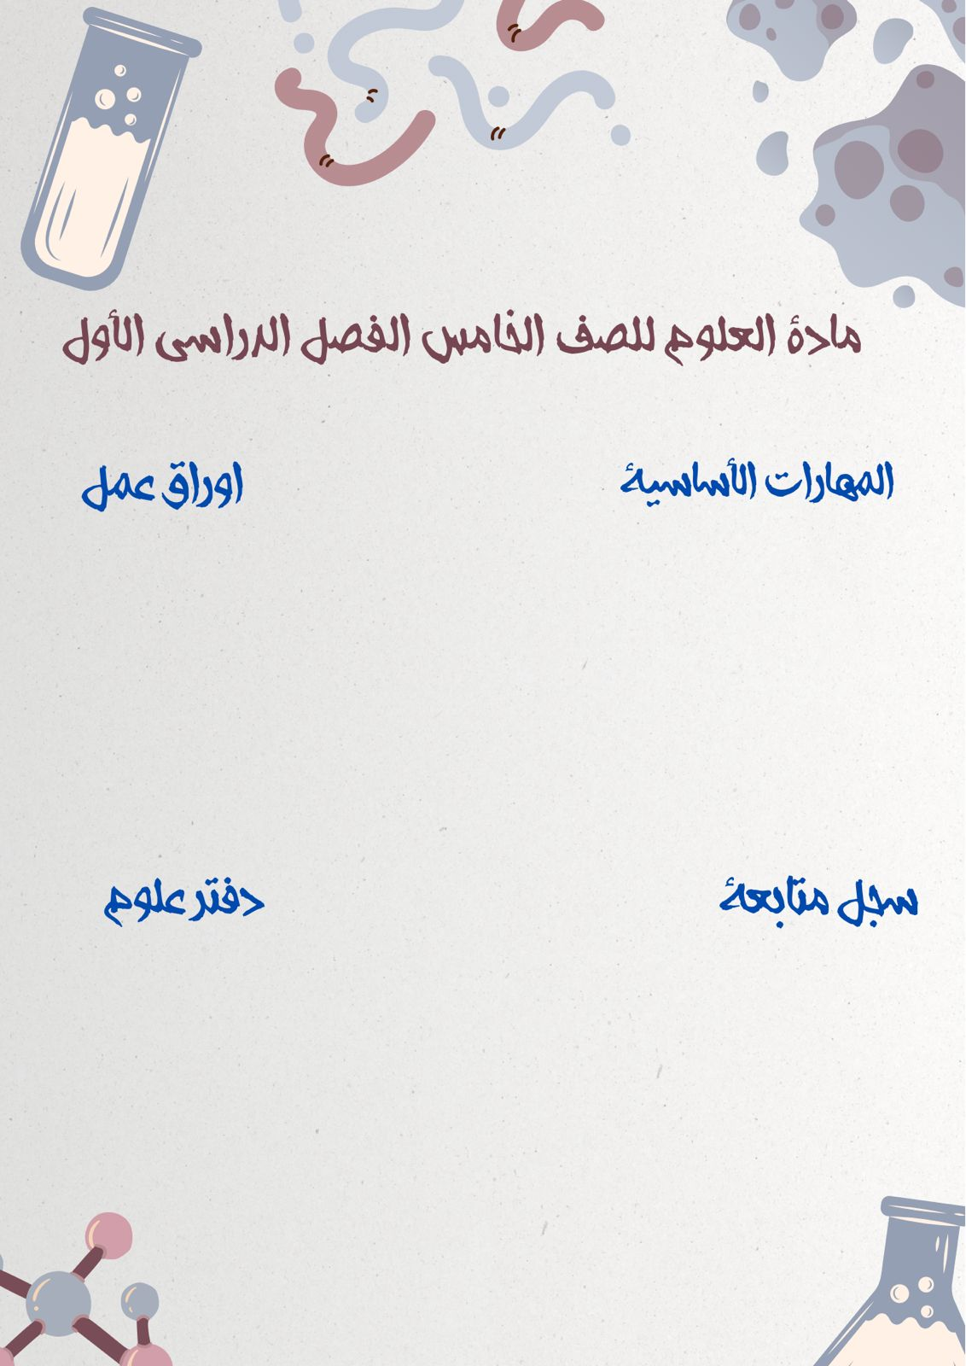

[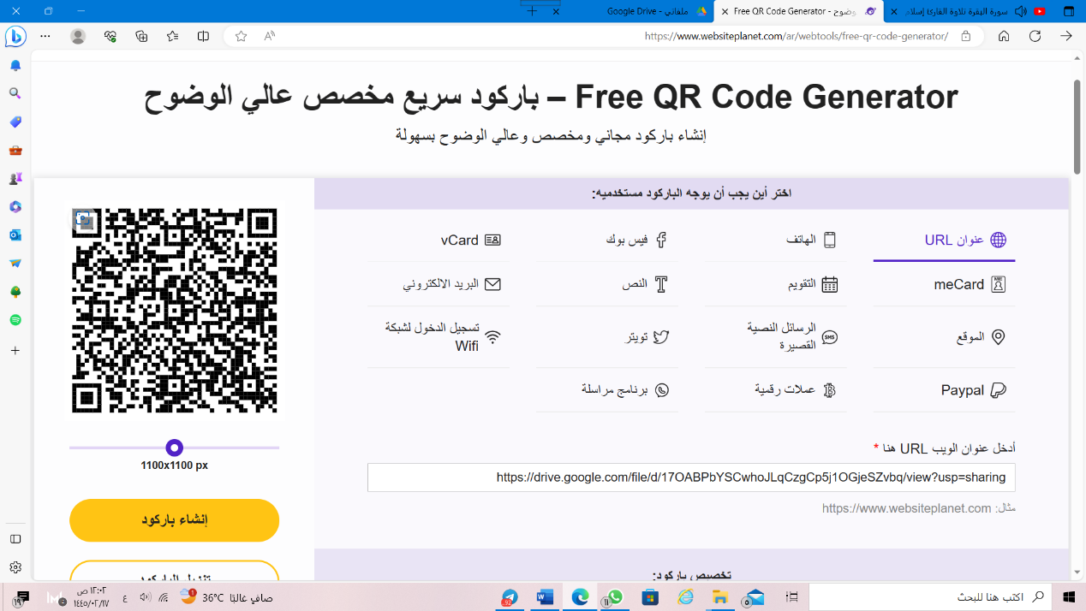](https://drive.google.com/file/d/17OABPbYSCwhoJLqCzgCp5j1OGjeSZvbq/view?usp=sharing)

[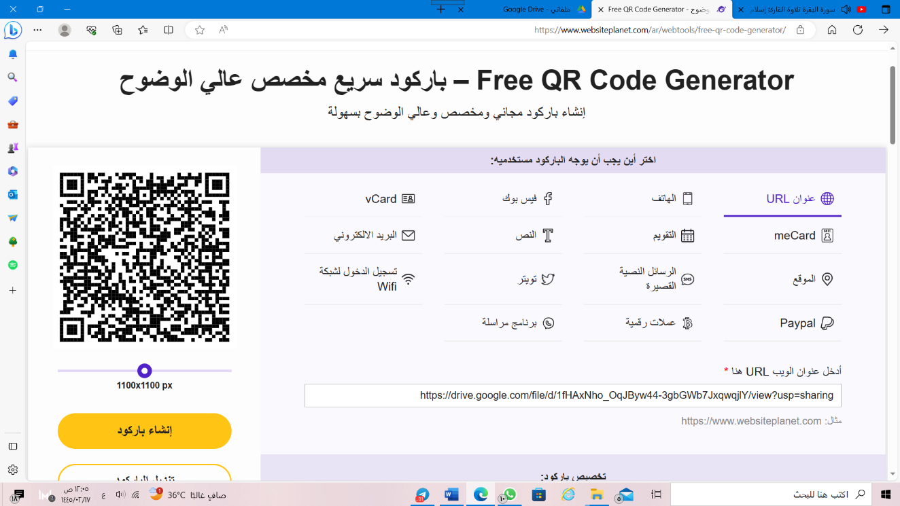](https://drive.google.com/file/d/1fHAxNho_OqJByw44-3gbGWb7JxqwqjlY/view?usp=sharing)

[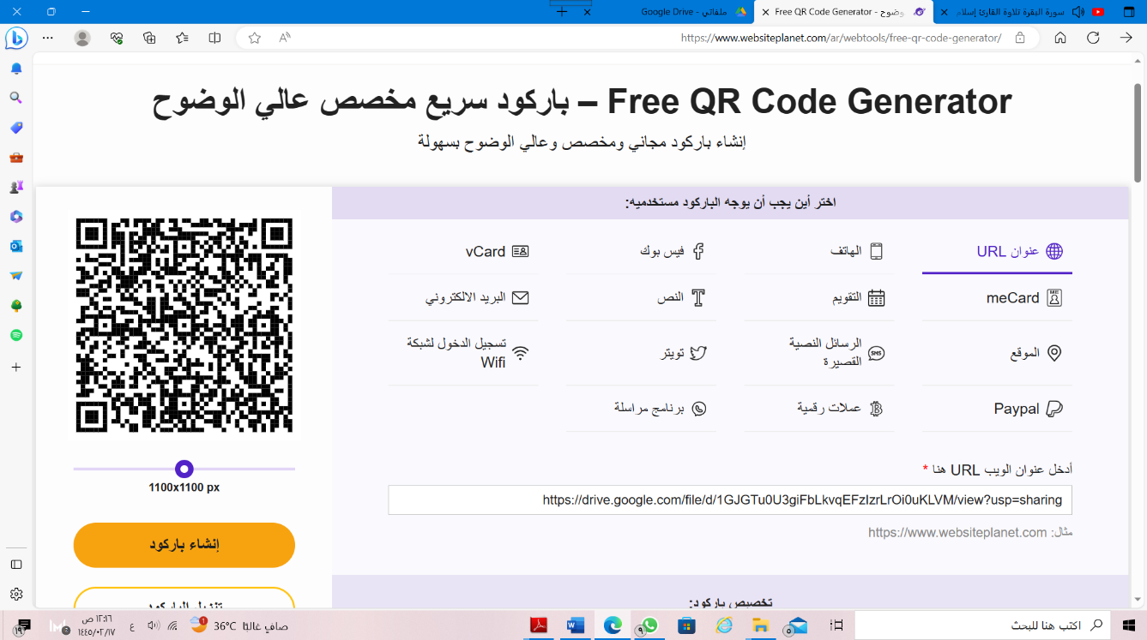](https://drive.google.com/file/d/1GJGTu0U3giFbLkvqEFzIzrLrOi0uKLVM/view?usp=sharing)[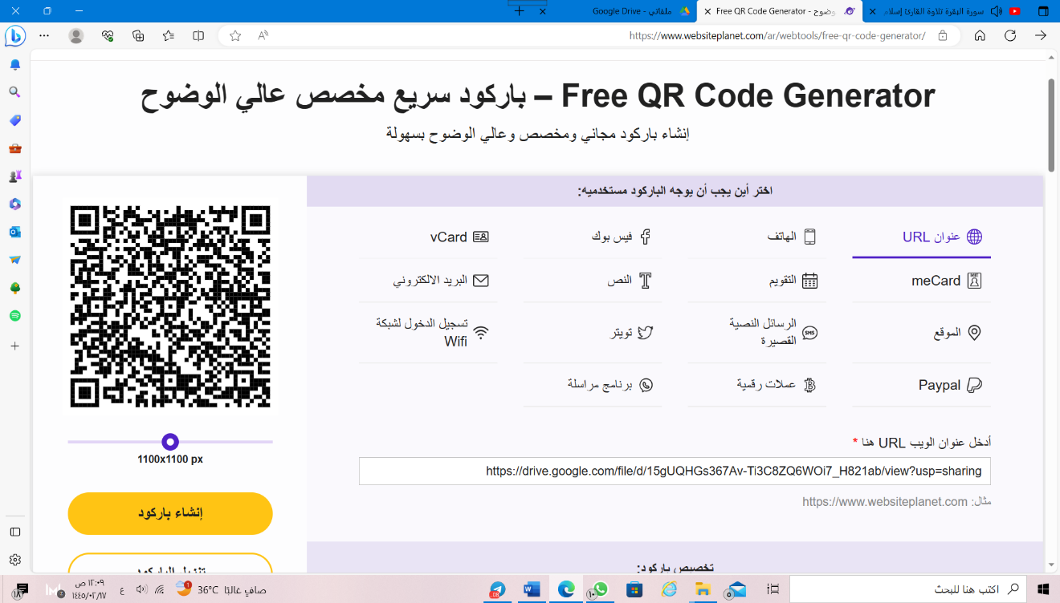](https://drive.google.com/file/d/15gUQHGs367Av-Ti3C8ZQ6WOi7_H821ab/view?usp=sharing)