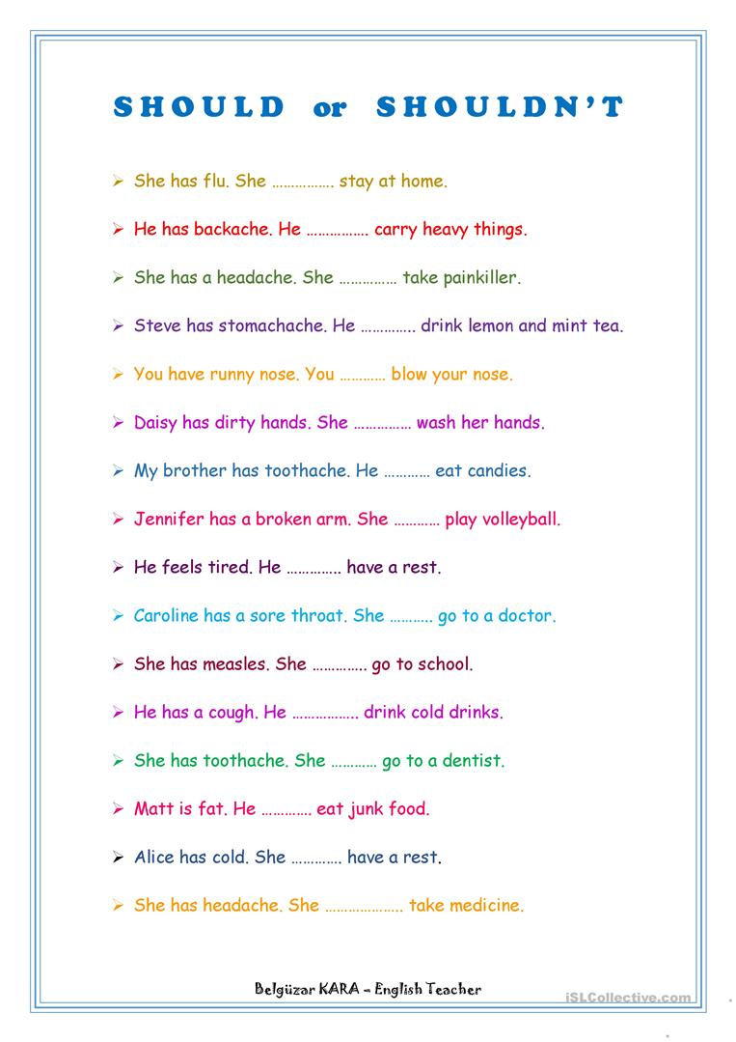

Grammar Exercises - Simple Past Tense.

Do the exercises below on the simple past tense and click on the button to check your answers.
(Before doing the exercises you may want to read the lesson on the simple past tense)

Put the verbs into the simple past:
- Last year I (go) to England on holiday.
- It (be) fantastic.
- I (visit) lots of interesting places. I (be) with two friends of mine .
- In the mornings we (walk) in the streets of London.
- In the evenings we (go) to pubs.
- The weather (be) strangely fine.
- It (not / rain) a lot.
- But we (see) some beautiful rainbows.
- Where (spend / you) your last holiday?

Write the past forms of the irregular verbs.
Infinitive |  | Simple Past
1. | meet | .
2. | drive | .
3. | speak | .
4. | put | .
5. | write | .
6. | sing | .
7. | do | .
8. | sit | .
9. | stand | .
10. | run | .

Complete the table in simple past.
Affirmative | Negative | Interrogative
He wrote a book.
 | He did not sing
 |  | Was she pretty?

Put the sentences into simple past.
- We move to a new house. →
- They bring a sandwich. →
- He doesn't do the homework. →
- They sell cars. →
- Does he visit his friends? →

Write sentences in simple past.
- Janet / miss / the bus →
- she / tidy / her room →
- Nancy / watch / not / television→
- she / read / a book →

Choose "Was“ or "Were“:
- The teacher nice.
- The students very clever.
- But one student in trouble.
- We sorry for him.
- He nice though.

