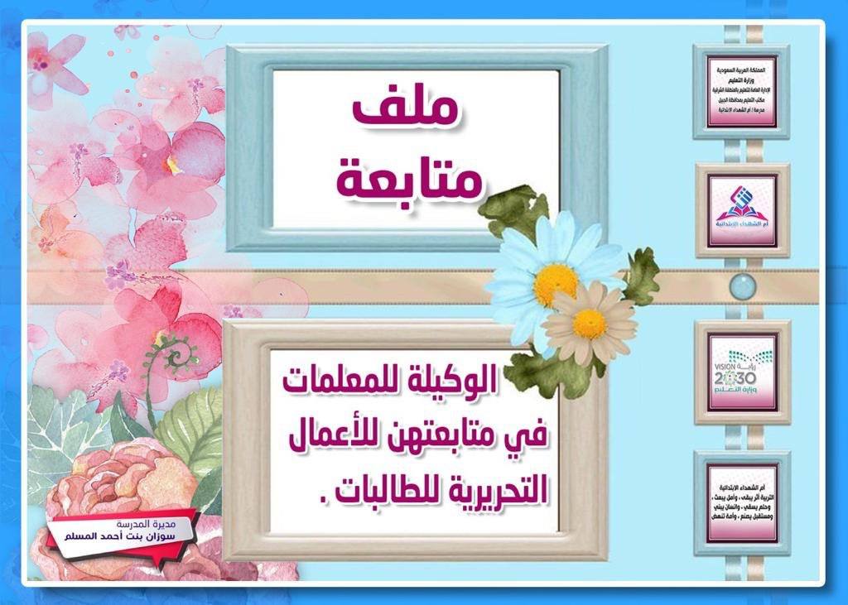

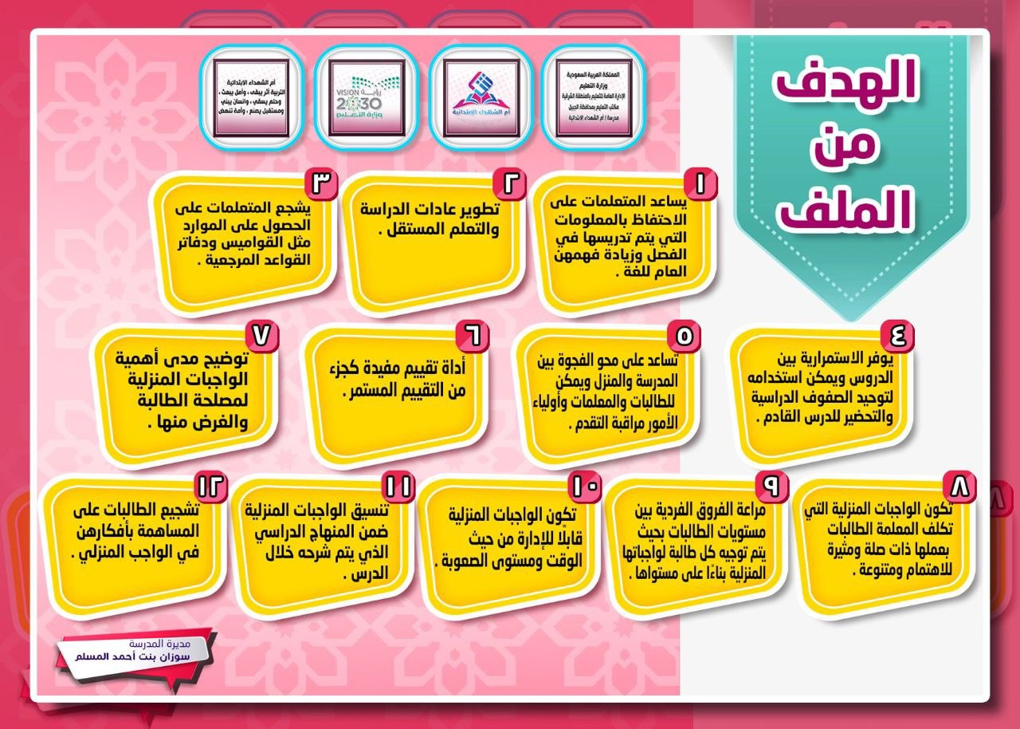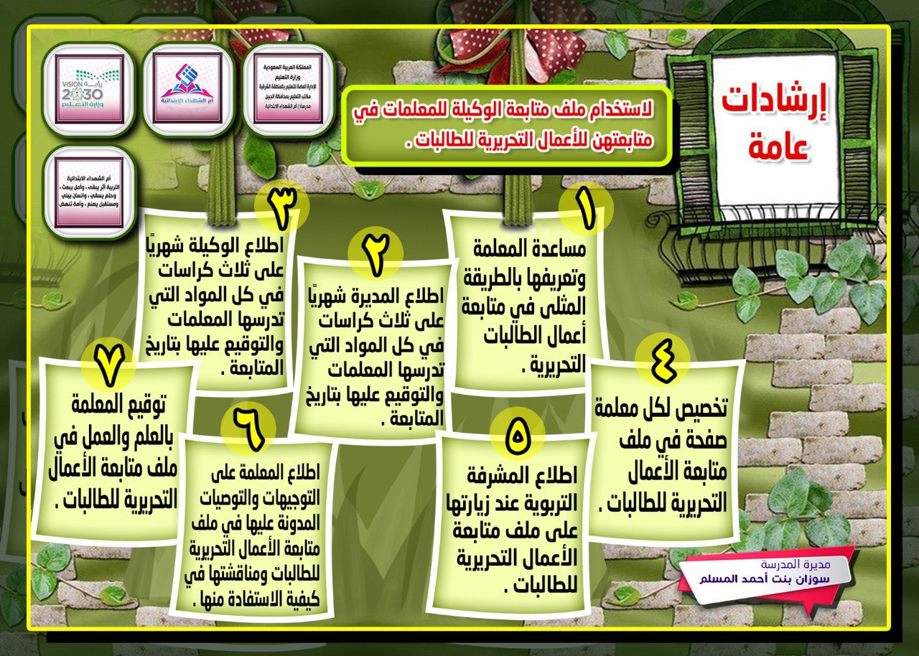*

بيان بأسماء المعلمات بالمدرسة

|  |  |  |  |  |  |  |  |  |  |
| --- | --- | --- | --- | --- | --- | --- | --- | --- | --- |
| م | اســــــــــــــم الــمـــــــوظـــــفــــــــة | ملاحظات | م | اســــــــــــــم الــمـــــــوظـــــفــــــــة | ملاحظات | م | اســــــــــــــم الــمـــــــوظـــــفــــــــة | ملاحظات | |
| 1 |  |  | **16** |  |  | **30** |  |  | |
| 2 |  |  | **17** |  |  | **31** |  |  | |
| 3 |  |  | **18** |  |  | **32** |  |  | |
| 4 |  |  | **19** |  |  | **33** |  |  | |
| 5 |  |  | **20** |  |  | **34** |  |  | |
| 6 |  |  | **21** |  |  | **35** |  |  | |
| 7 |  |  | **22** |  |  | **36** |  |  | |
| 8 |  |  | **23** |  |  | **37** |  |  | |
| 9 |  |  | **24** |  |  | **38** |  |  | |
| 10 |  |  | **25** |  |  | **39** |  |  | |
| 11 |  |  | **26** |  |  | **40** |  |  | |
| 12 |  |  | **27** |  |  | **41** |  |  | |
| 13 |  |  | **28** |  |  | **42** |  |  | |
| 14 |  |  | **29** |  |  | **43** |  |  | |
| 15 |  |  |  |  | | | | |

بيان بمتابعة الوكيلة للمعلمات في متابعتهن للأعمال التحريرية للطالبات للفصل الدراسي :.......... للعام :......١٤هـ

|  |  |  |  |  |  |  |  |  |  |  |  |  |  |  |
| --- | --- | --- | --- | --- | --- | --- | --- | --- | --- | --- | --- | --- | --- | --- |
| **م** | **اسم الطالبة** | **التاريخ** | **المادة** | **الصف** | **تم متابعة** | | **الواجبات المنزلية** | | **التصحيح** | | | | **التوصيات والتوجيهات** | **توقيع المعلمة** |
| **ملف انجاز** | **كتاب** | **عددها** | **مناسبتها** | **تتابعه** | **دقته** | **الأخطاء** | **التعزيز** |
|  |  |  |  |  |  |  |  |  |  |  |  |  |  |  |
|  |  |  |  |  |  |  |  |  |  |  |  |  |  |  |
|  |  |  |  |  |  |  |  |  |  |  |  |  |  |  |
|  |  |  |  |  |  |  |  |  |  |  |  |  |  |  |
|  |  |  |  |  |  |  |  |  |  |  |  |  |  |  |
|  |  |  |  |  |  |  |  |  |  |  |  |  |  |  |
|  |  |  |  |  |  |  |  |  |  |  |  |  |  |  |
|  |  |  |  |  |  |  |  |  |  |  |  |  |  |  |
|  |  |  |  |  |  |  |  |  |  |  |  |  |  |  |
|  |  |  |  |  |  |  |  |  |  |  |  |  |  |  |
|  |  |  |  |  |  |  |  |  |  |  |  |  |  |  |
|  |  |  |  |  |  |  |  |  |  |  |  |  |  |  |
|  |  |  |  |  |  |  |  |  |  |  |  |  |  |  |

