Name :…………………………………………………………………… Class:…….……….
Super Goal 2 - Test unit 1 & 2

Reading
2 Marks
- Read the text and answer the questions. Write T or F at the end of each question/statement.
I like to go to the sports center. I go there every weekend. At the sports center, you can do many things. For example, you can play golf or tennis. There is a pool, so you can also swim or relax by the pool. There is a beach next to the sports center. You can swim, water-ski, or windsurf in the ocean. You can also sail on windy days. There aren’t any fish near the beach, so you can’t snorkel. When I go to the sports center, I like to play volleyball on the beach. I also like to jog on the beach. I can’t swim well, so I don’t like to water-ski or windsurf.
- At the sports center, you can do many things. ( )
- You can swim in the pool or in the ocean. ( )
- People can windsurf in the pool. ( )
- You can sail on windy days in the ocean. ( )
Grammar
5 Marks
- Choose the best answer to fill in the blank in each question.
- Who _____ that girl?
a. am b. is c. are d. i
- John: _____ your friend? - Adnan: He is in the restaurant.
a. How’s b. What’s c. When’s d. Where’s
- It _____ a beautiful day today.
a. is b. are c. not d. am
- _____ in that new TV film?
a. He acting b. He is acting c. Is acting d. Is he acting
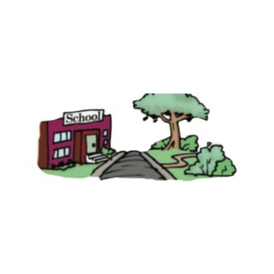
- What is he eating ? - he's ________ an apple .
a. eat b. is eat c. eating d. ate
1.5 Marks
- Use ( across from – next to – between )
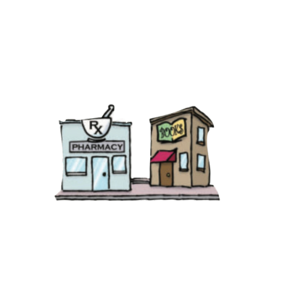
- The park is ____________________ the school .
- The bank is ______________ the post office and the restaurant .
- The pharmacy is ______________ the bookstore .

- Write the imperative sentence.
1.5 Marks
- Will you clean up this mess? ________________________________________
- Why aren’t you eating your vegetables? _______________________________
- You can’t take photographs. _________________________________________

Vocabulary
- Choose the best answer to fill in the blank in each question.
5 Marks
- Thank you !
a. You’re welcome. b. He’s from Muscat. c. That’s all right. d. Hi
- What is your country ?
a. Fine thank you b. I'm 13 years old c. Nice to meet you d. I'm from Saudi Arabia
- Many young people traveling around the world are ________ .
a. old people b. backpackers c. teachers d. business men
- What is Ali doing ? - He’s _______ soup .
a. making b. breaking c. writing d. talking
- ________ sometimes use webcams in the classroom.
a. Students b. Teachers c. Farmers d. business men

- Write the correct word under the picture.
3 Marks
coffee shop – Webcam – Turn Right

…………………………………………….

…………………………………………….
…………………………………………….

- Choose the correct letter.
2 Marks
- See you tomorr…..w. ( o – y – r )
- I don't he….r anything. ( t – a – r )

