
Super Goal 1 - English Language
First Intermediate Grade
Third Term Final Exam 1444-2023
First Round | Time: 1.5 hour

Kingdom of Saudi Arabia
Ministry of Education
………. Education Directorate
……………Intermediate School

المراجع
checker

أ /..........
الدرجة كتابه
Written
المجموع
Total / 30
المصحح
corrector

أ / راشد السلمي
Q16
Q26
Q37
Q4
4
Q57

اسم الطالب
رقم الجلوس
Composition

اللهّم لا سَهلَ إلا ما جعلتُه سَهلاً فإنكَ تَجعَلُ الحزنَ إذا شِئتَ سَهلاَ " "
Write about what you are going to do on your next vacation.
Guide words:
( enjoy – exploring – new food – activities – the weather – the place – language – relaxing – city – trip )

..................................................................................................................................................................................................................
..................................................................................................................................................................................................................
..................................................................................................................................................................................................................
..................................................................................................................................................................................................................
..................................................................................................................................................................................................................
..................................................................................................................................................................................................................
..................................................................................................................................................................................................................
..................................................................................................................................................................................................................
..................................................................................................................................................................................................................
..................................................................................................................................................................................................................

6

اقلب الصفحة
Comprehension

6

- Read the following passage and answer the questions below:

Ali usually has a relaxing Saturday. He doesn’t have work, so he always wakes up late on Saturdays—usually at 10 A.M. Then he has a cup of coffee and makes a big breakfast. He eats breakfast and then reads the news online. Sometimes he goes to visit his cousin on Saturday afternoons, and sometimes he goes for a long walk with his brother. He usually watches a football game on Saturday evenings. Sometimes he meets his family at a restaurant to have dinner. He watches TV at night, and then goes to bed at 10 P.M. so that he’s ready for work on Sunday.

A. Choose the correct answer:
- The text is about Ali’s ____________ .
a. Saturdays b. Sundays c. weekends d. Mondays
- Ali _____________ wakes up late on Saturdays.
a. never b sometimes c usually d. always
- Ali usually eats a big _____________ on Saturdays.
a. food b. breakfast c. lunch d. dinner

B. Write (T) for True or (F) for False:

4. Ali sometimes goes for a long walk with his brother .
5. Ali usually watches a football game on Saturday mornings .
6. Ali goes to bed at 10 P.M
اقلب الصفحة

7
Grammar

- Choose the correct answer

- He can’t surf, but he _____ water-ski.
a. can’t b. can c. not can d. don’t can
- Aisha: Do they like to relax on the beach? Lucy: Yes, _____.
a. they do b. do they c. not they d. they don’t
- I _____ play volleyball, but I can play tennis.
a. can b. am can c. can’t d. am can’t
- I’m not going to buy jeans. ____________ pants.
a. I’m going to buy b. I buying c. I’m going buying d. I going to buy
- Susan ____________ a dress. She’s going to wear a skirt and blouse.
a. isn’t wear b. not wearing c. isn’t going to wear d. isn’t going to wearing
- They ____________ suits. They’re going to wear jeans.
a. not wearing b. not going to wearing c. aren’t going wear d. aren’t going to wear
- _____ Bob to our house!
a. We invite b. Let invite c. Let’s invite d. Let’s us invite
- Do you _____ a film on TV tonight?
a. want to watch b. want watch c. want watching d. want to watching
- You _____ the street when the light is red.
a. mustn’t cross b. should cross not c. must not to cross d. should cross
- My grandfather _____ a car salesman.
a. was b. were c. not d. be
- Majed Ahmed Abdullah _____ in Jeddah.
a. is born b. are born c. was born d. were born
- When I was a child, I _____ a good student.
a. wasn’t be b. not c. wasn’t d. weren’t
- We didn’t go to the football game yesterday. We_____ to the museum.
a. go b. went c. are d. going
- Sally didn’t drink coffee. She _____ water.
a. is drink b. drinking c. drink d. drank

Orthography

4
- Choose the correct letters :
- You can go sho…..ping and meet friends. ( v – p – r )
- You can fly to pla…..es. ( n – o – c )
- Nawal is going to buy aba…..a ( y – o – r )
- You need warm clothes it’s …..old in Abha ( n – o – c )
- I don’t have an in…itation to the party ( y – v – r )
- Let’s get some ca…ds for the National Day ( r – o – c )
- Balad, the old pa…t of Jeddah ( y – v – r )
- Ahmed was pleased with his prese…tation ( o – t – n )

اقلب الصفحة

Vocabulary

- Choose the correct answer:

7

- You can _____ at the pool.
a. swim b. surf c. rollerblade d. sail
- My friends like to _____. They enjoy looking at underwater attractions.
a. swim b. sail c. surf d. snorkel
- He’s going to wear a shirt and a ____________.
a. shoes b. tie c. shorts d. white
- Do you need to buy new ____________ to play basketball?
a. suit b. shirt c. sneakers d. blouses
- On December 2nd, they _____ Federation of the Emirates in the UAE.
a. parades b. decorate c. celebrate d. share
- In Saudi Arabia, people fly _____ on September 23rd.
a. flags b. streets c. fireworks d. celebrations
- In old Riyadh, many houses were made from ____ bricks.
a. ruins b. town c. mud d. city
- In modern Riyadh, you can see many ______.
a. skyscrapers b. walls c. population d. areas
- Adel: What did you do last night? Ali: I went to a friend’s house and watched _____.
a. a car race b. the zoo c. a computer club d. home
- Peter: Do you have any clean clothes? Andy: Yes, I do. I did my _____ yesterday.
a. closet b. laundry c. home d. house
- Chang: What did you do yesterday? Todd: I went to the _____ and played volleyball.
a. car race b. beach c. museum d. zoo
- Sabah: What did you do yesterday? Aisha: I went to a _____. I love history.
a. restaurant b. closet c. mall d. museum

- Write the correct word under the picture.

Graduation day – Gym – calendar

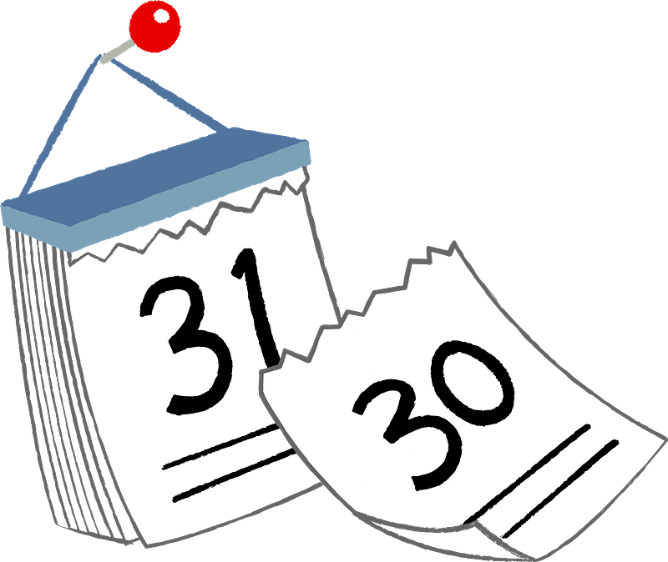
14.
13.
12.

………………………….…

………………………….…

………………………….…
انتهت الأسئلة .. ..
وبالله التوفيق والنجاح ..
الأستاذ / راشد السلمي

