We Can! Book 6 Unit 6: My Dream Vacation

1. Listen and fill in the missing words and phrases. Then read and number the pictures.

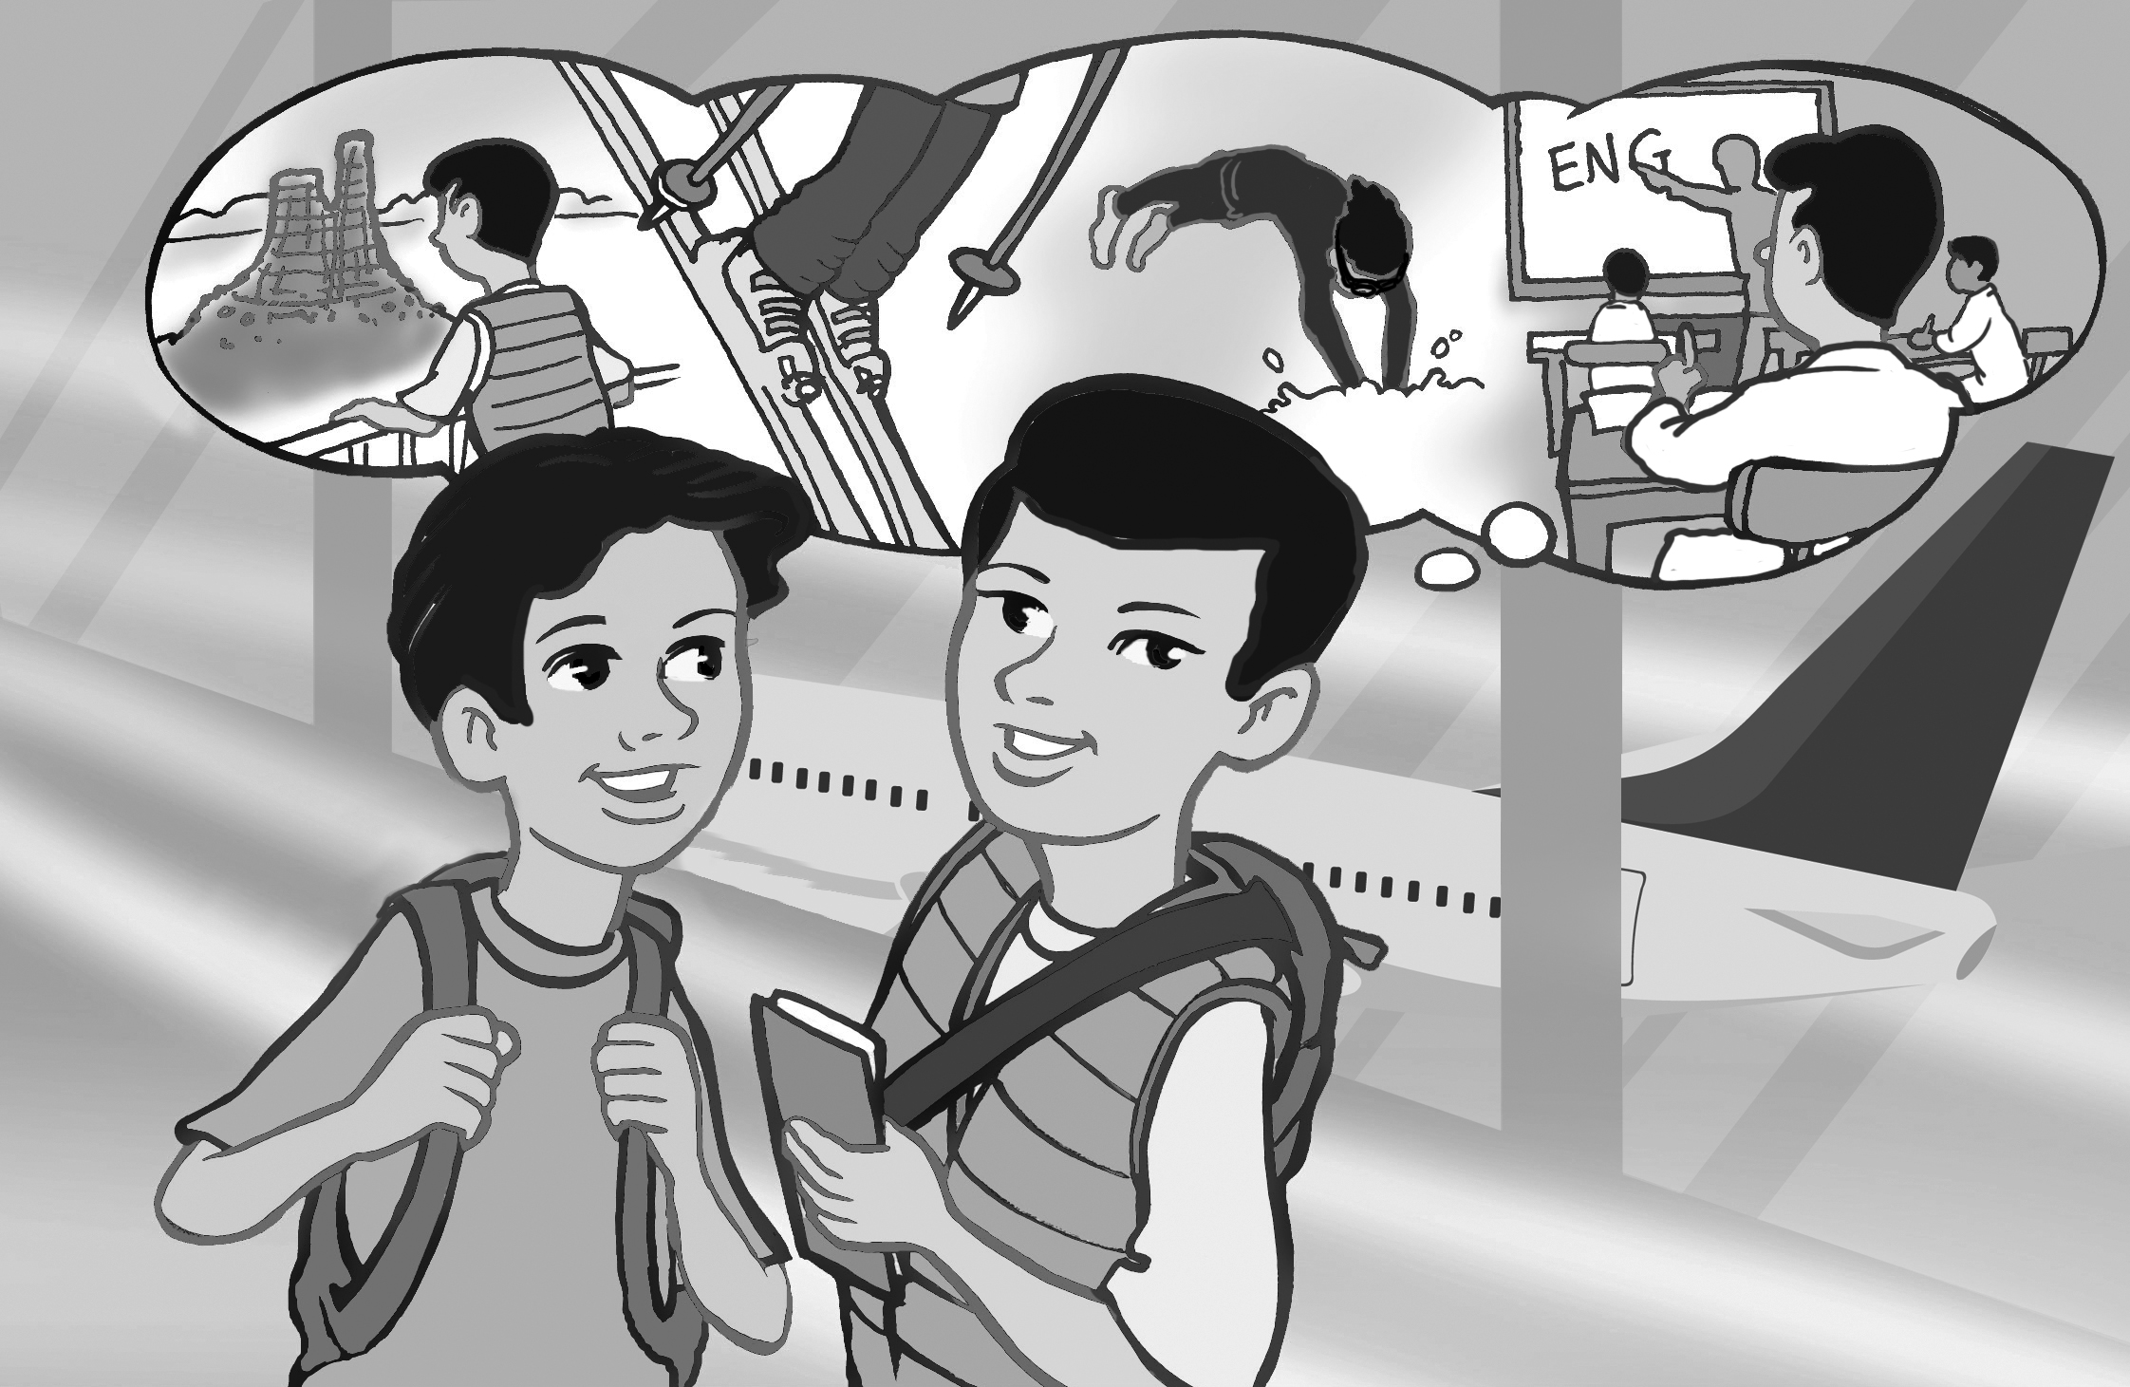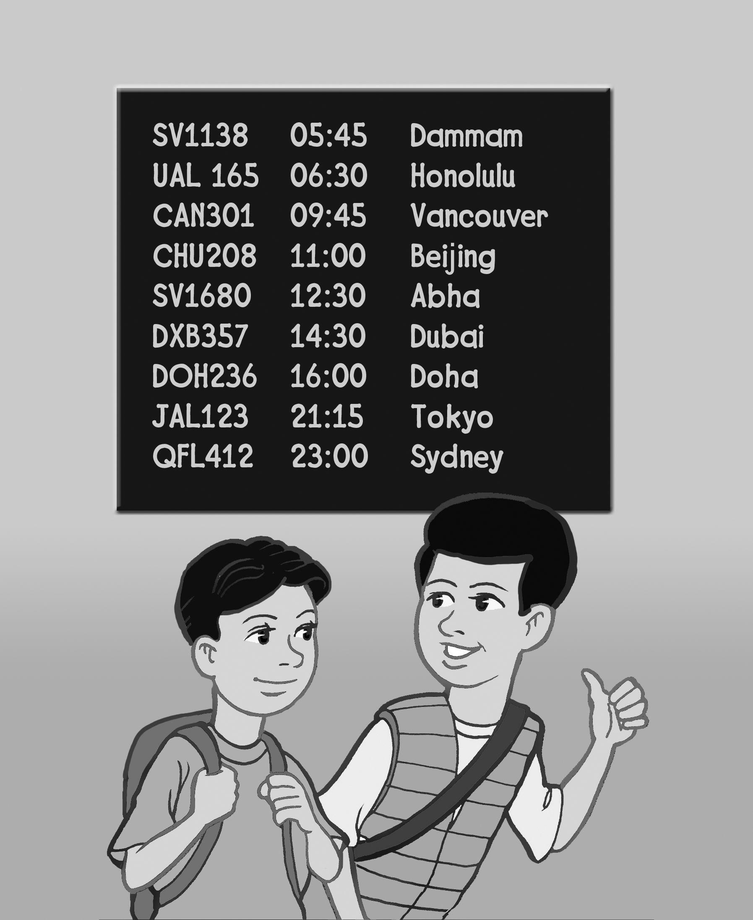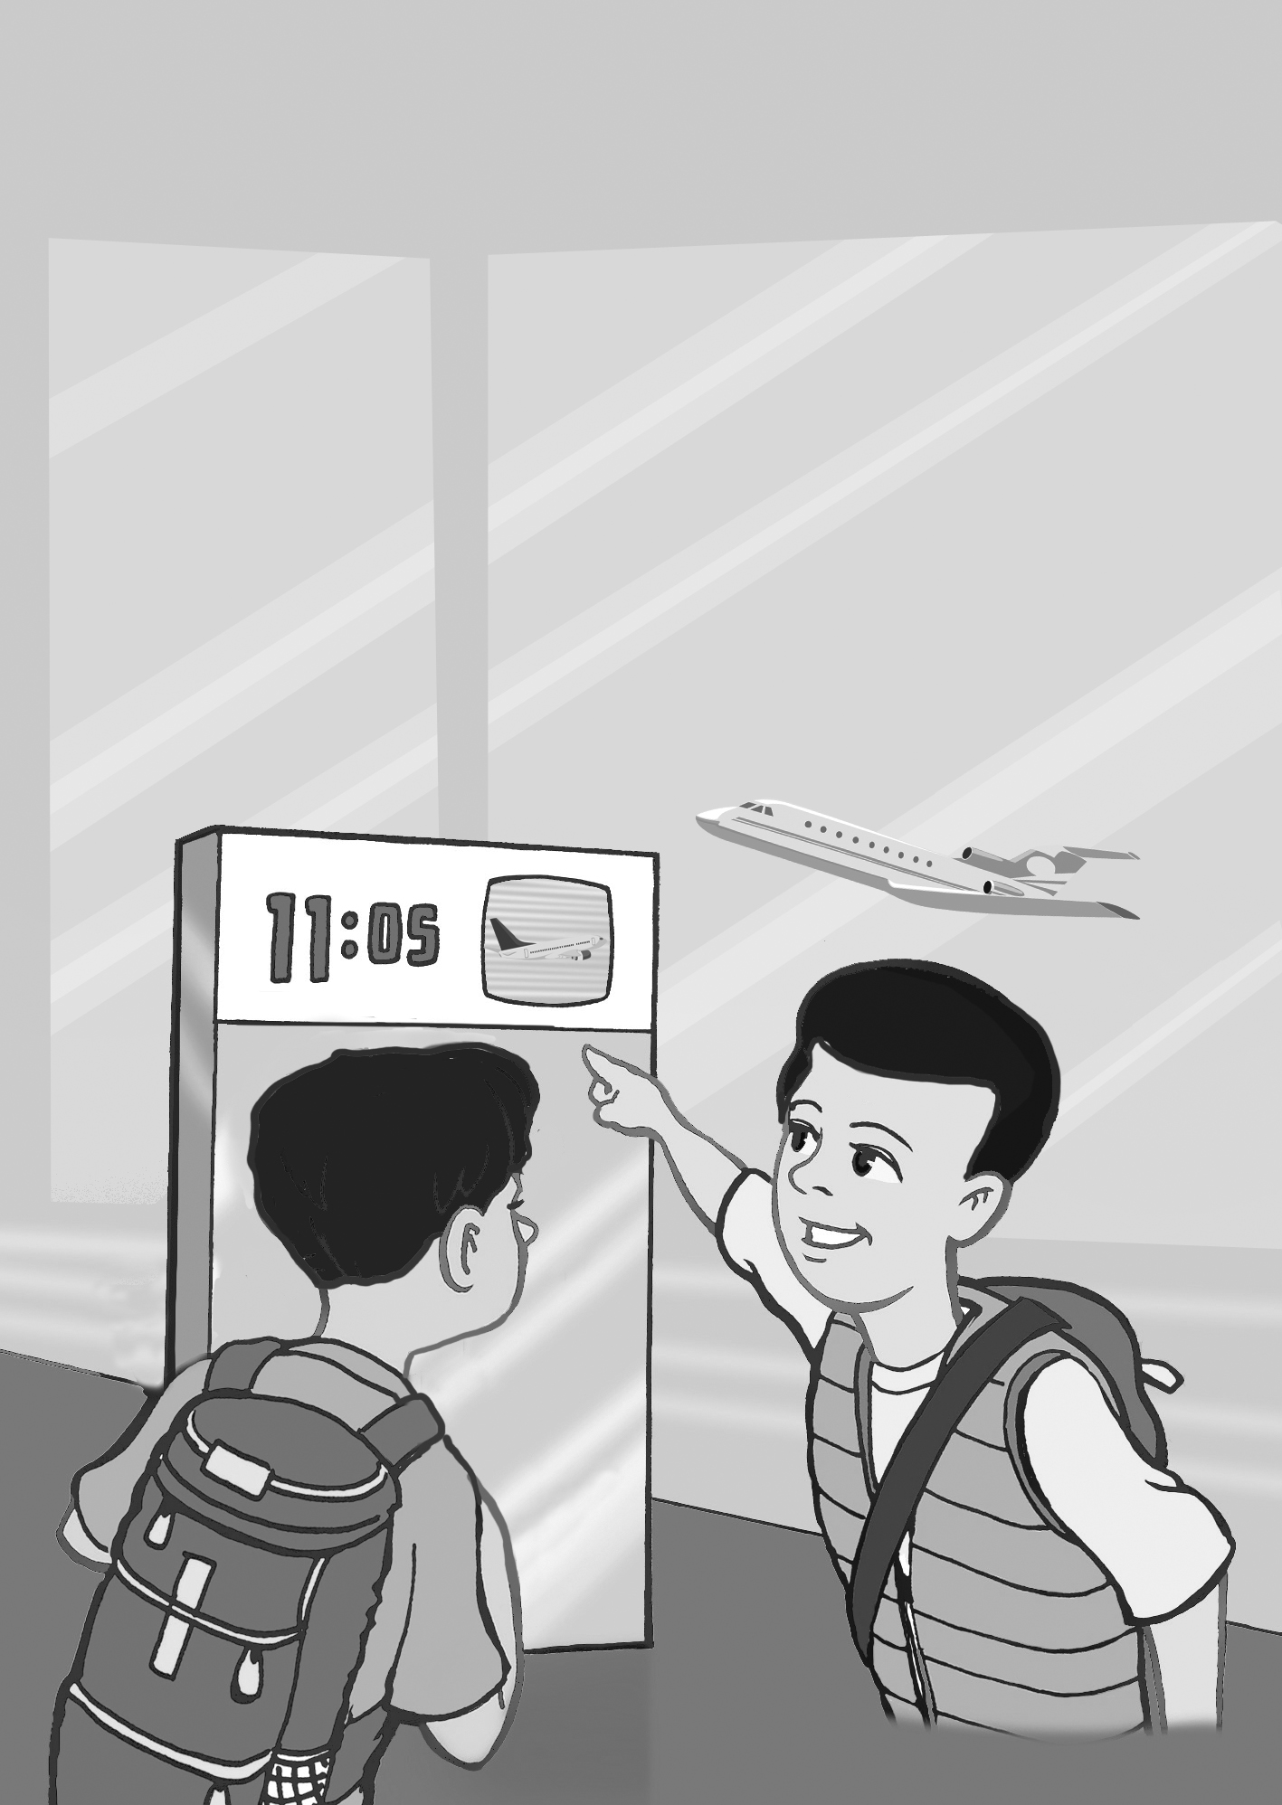
__ __ __

1)
A: Where are you going?
B: I’m going to Sydney / Paris / Seattle.
2)
A: How long does it take to get there?
B: It takes about fifteen / sixteen / thirteen hours.
3)
A: What are you going to do there?
B: I’m going to go sightseeing/ skiing / stay at an English camp.

2. Read and answer the questions.

What are you going to do on the weekend?
________________________________________
Where are you going to go?
________________________________________
How long does it take to get there?
________________________________________

3. Read and put the sentences in the correct order.

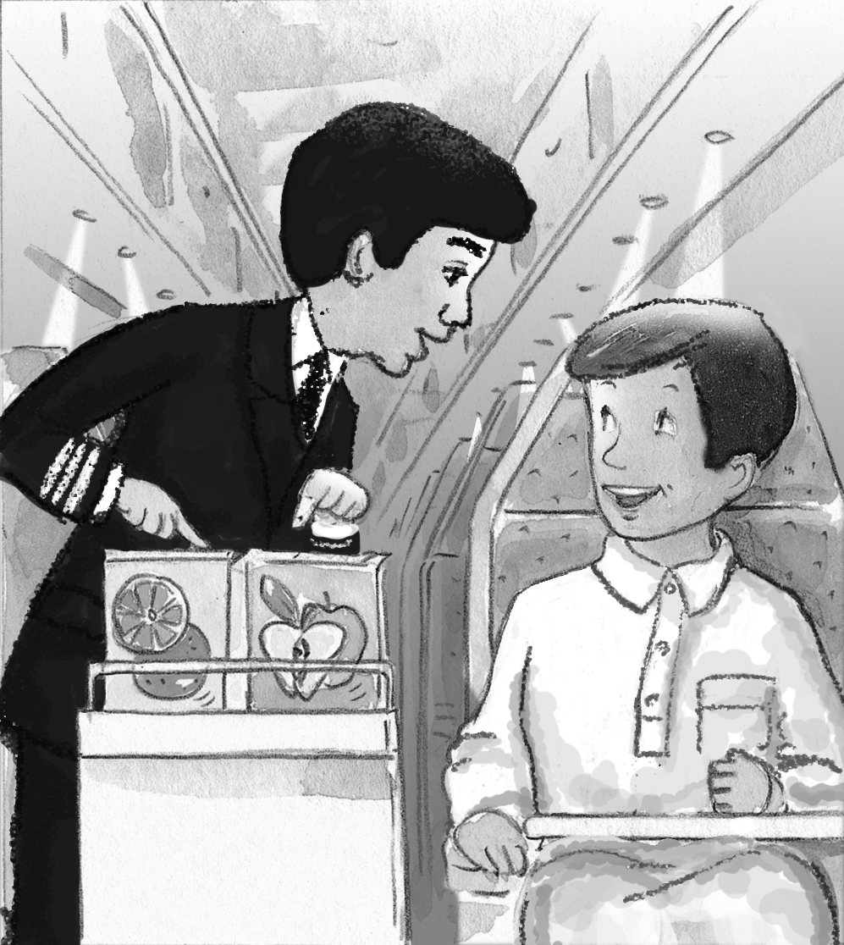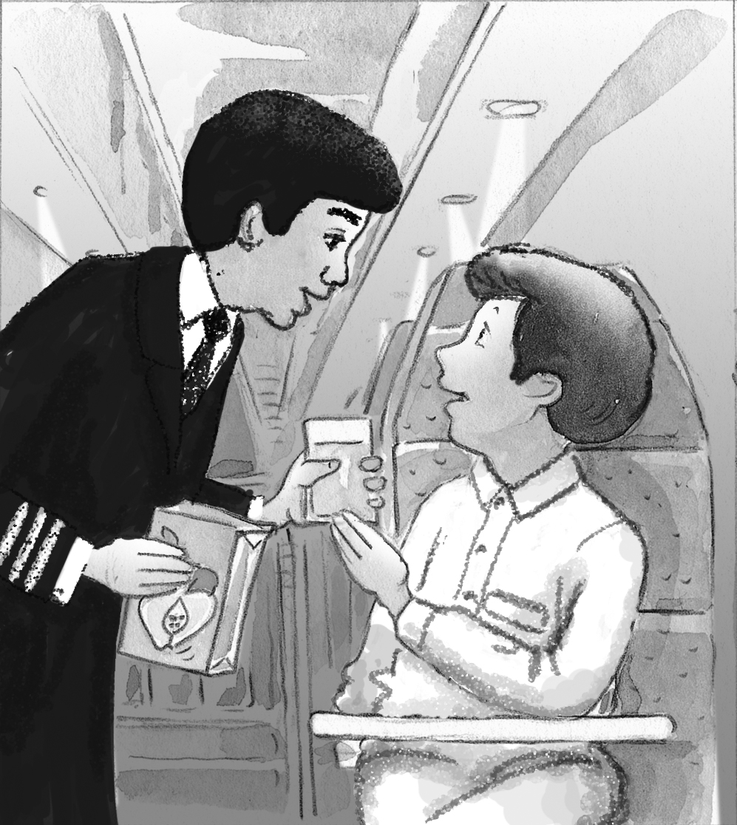

(A: flight attendant B: passenger)
__ A: Here you go.
__ A: You’re welcome.
__ B: Hi. I’d like some juice, please.
__ A: Good evening. What would you like to drink?
__ A: Apple or orange juice?
__ B: Thank you.
__ B: Apple juice, please.
4. Write where they are going and what they plan to do there.

Example: Amal/ Dubai - shop/ for new clothes
Amal is going to Dubai. She’s going to shop for new clothes.

Jake/ Sydney – have / job interview
1. _______________________________________
_________________________________________

Imad / Oman – swim / with the huge turtles
2. _______________________________________
_________________________________________

Aisha / Lebanon – eat / traditional dishes
3. _______________________________________
_________________________________________

5. Write about your plans for the weekend.

Next weekend, I ____________________________
_________________________________________

Next summer, we ____________________________
_________________________________________

6. Write about a place you want to travel to and what you plan to do there.
_________________________________________
_________________________________________
_________________________________________
_________________________________________
_________________________________________

