We Can! Book 6 Unit 5: Hanging Out in Town

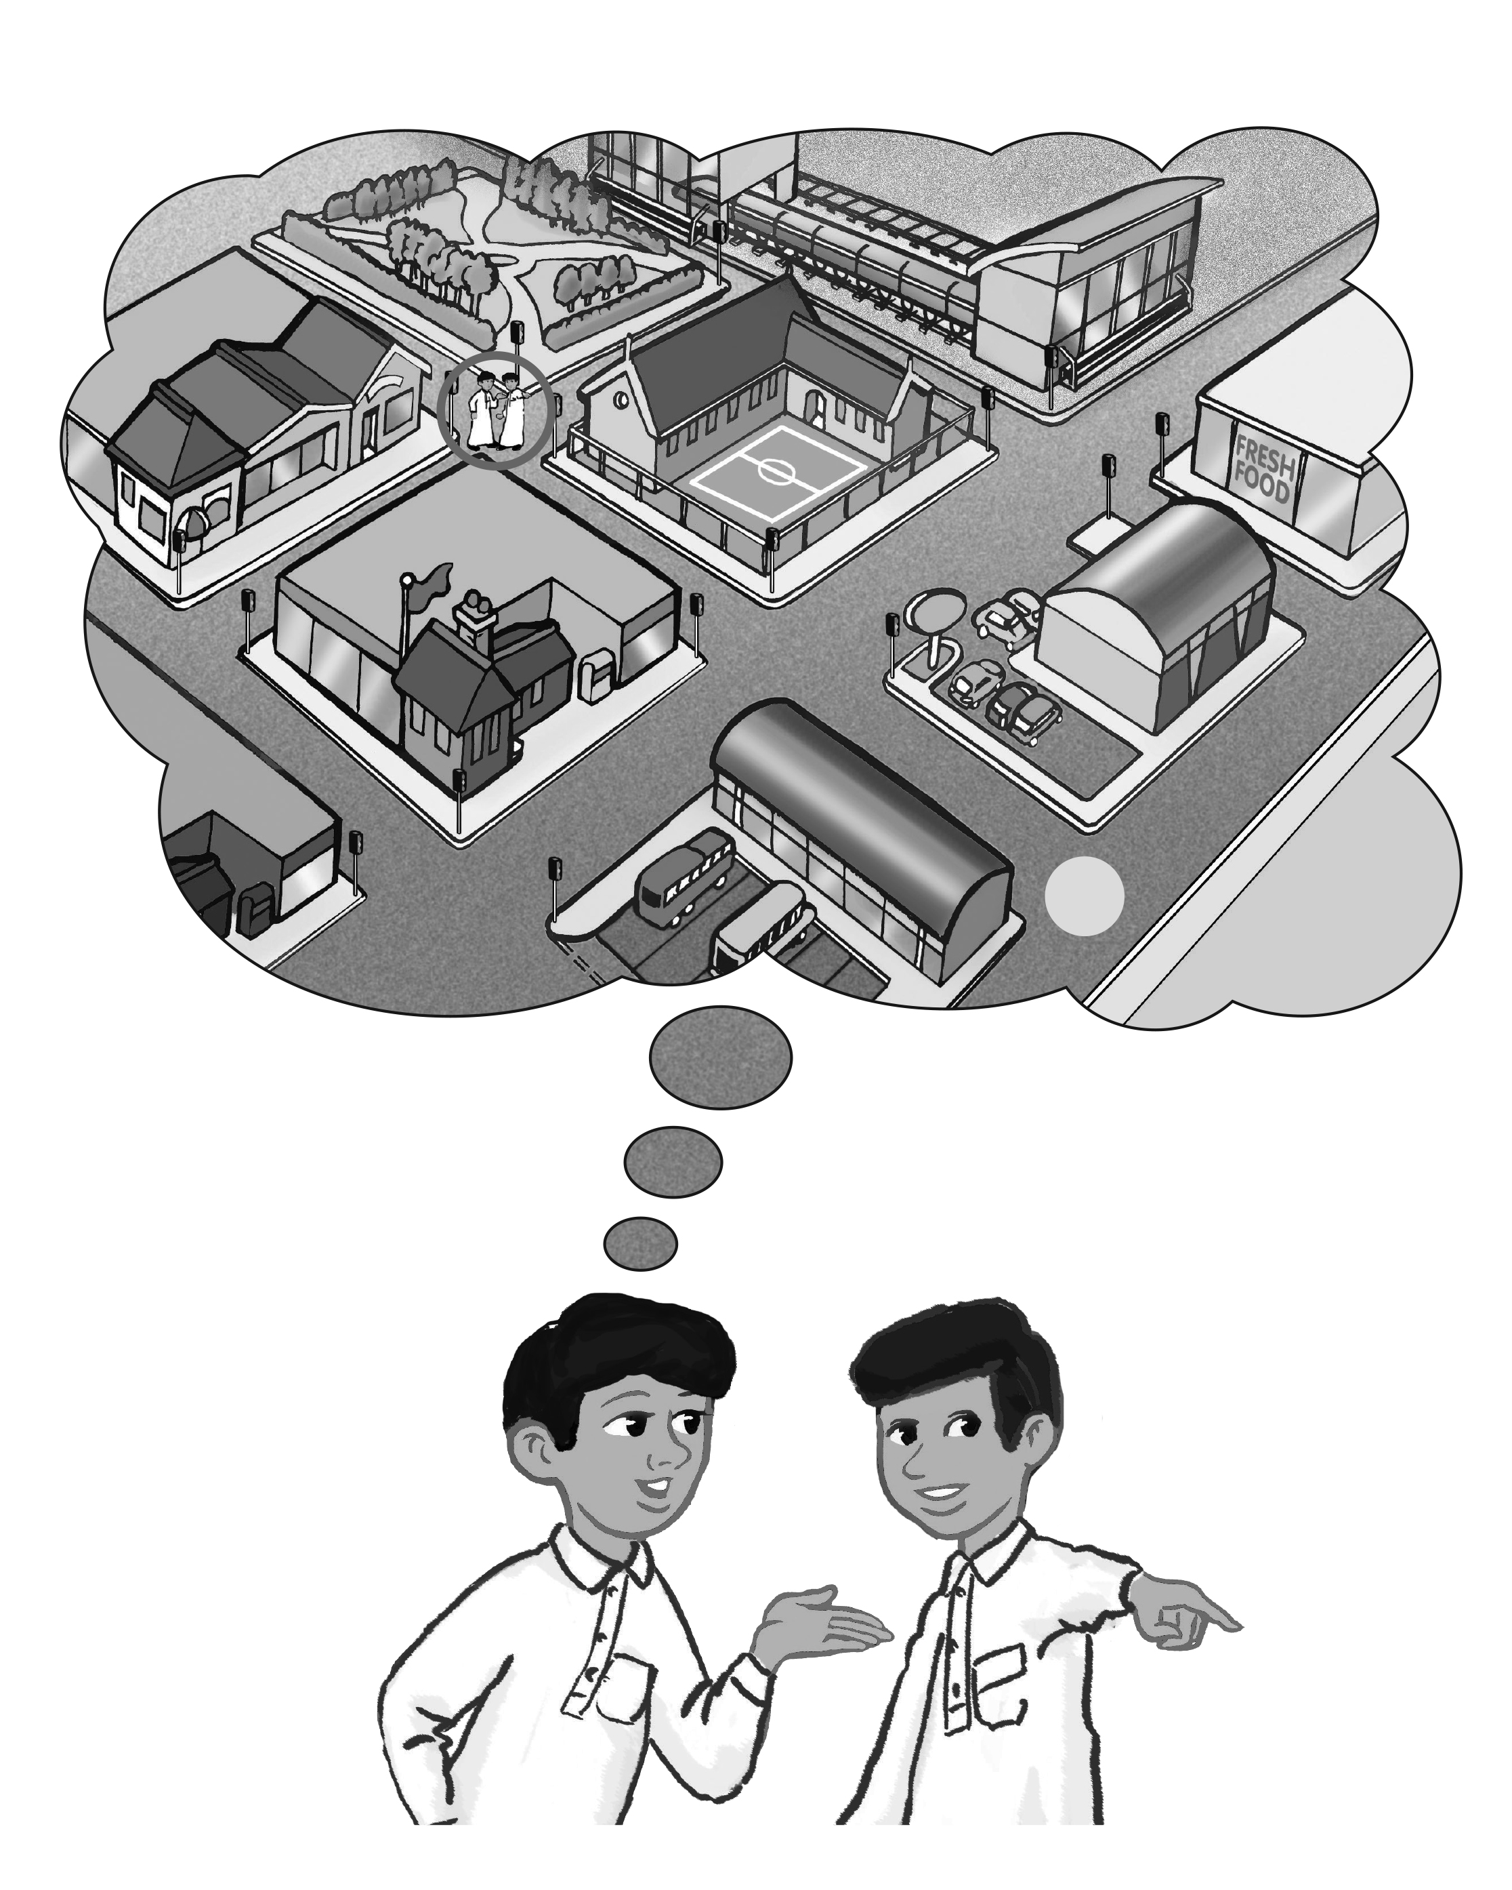
1. Match the words with the places on the map.

3

2
4

1 5

6
train station __ |  | supermarket __ | convenience store __
post office __ | bus stop __ |  | elementary school __

2. Listen, and fill in the missing words.
A: Excuse me. Where’s the ____________________?
B: Go straight, turn ____________, and you’ll find it on your ____________.
A: Is it far from __________?
B: It’s only a _____________.
A: Thank you.
B: You’re ____________.
3. Write how to get there using the map. Start at the circle.
1. Where’s the train station?
_________________________________________
_________________________________________
2. Where’s the bus stop?
_________________________________________
_________________________________________
3. Where’s the elementary school?
_________________________________________
_________________________________________
4. Read and write the missing words.
1. I need some pens and paper. I’m going to the
s _________ s _________.
2. I want to buy some candy. I’m going to the
c _________ s _________.
3. She wants to buy bread. She’s going to the
b__________________.
4. We want to buy some books. We’re going to the
b __________________.
5. They want to buy some flowers. They’re going to the
f__________ s ________.
6. We want to find a new DVD. We’re going to the
D__________ s ________.

