

الصف ...............
الاسم ثلاثي: |  | الفصل | / | الدرجة | / 20
اختبار تشخيصي

I. Choose

- How many students are there in your school?
- No, I am not . | - About 500
- What is that?
- Lion | - Seal .



222
II. Choose OR

Our school has a school bus . | It is seven o'clock. | The whale is small.
 | 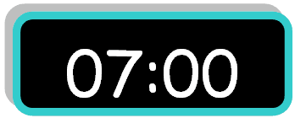 | 

III. Do as shown between brackets:

................................................................................................... |  |  | 1- in – live – I - Riyadh . ( rearrange )
thirty | hundred | thousand |   2– One _______. ( choose )

going | goes | go | 1 – I ___ shopping.
have | has | is | 2. I _____ a box
go | came | come | 3- yesterday, I ____ home at 1:00 .
IV. Choose :
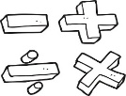 | 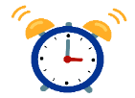 |  | 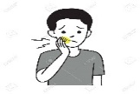 |   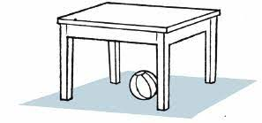
Math | Clock | Doctor | Headache | Starfish
Engilsh | Book | Firefighter | toothache | Crab
V. Choose :

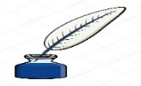  i  I _ _ |   Ri_ _ t |   C _ _ |   M_ _ se |   b_ _ger
ng | ai | er | ou | ar
nk | gh | ar | ow | ur
VI. Choose the correct letters :

TEACHER :

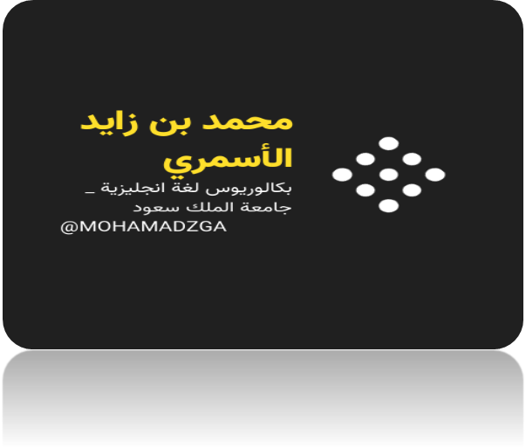


قناتي


MOHAMADZGA


M_zaid0

لا تنسوني من صالح دعائكم

الصف ...............
الاسم ثلاثي: |  | الفصل | / | الدرجة | / 20
اختبار تشخيصي

I. Choose

- How many students are there in your school?
- No, I am not . | - About 500
- What is that?
- Lion | - Seal .

222
II. Choose OR

Our school has a school bus . | It is seven o'clock. | The whale is small.

III. Do as shown between brackets:

I live in Riyadh |  |  | 1- in – live – I - Riyadh . ( rearrange )
thirty | hundred | thousand | 2– One _______. ( choose )

going | goes | go | 1 – I ___ shopping.
have | has | is | 2. I _____ a box
go | came | come | 3- yesterday, I ____ home at 1:00 .
IV. Choose :
Math | Clock | Doctor | Headache | Starfish
Engilsh | Book | Firefighter | toothache | Crab
V. Choose :

i  I _ _ | Ri_ _ t | C _ _ | M_ _ se | b_ _ger
ng | ai | er | ou | ar
nk | gh | ar | ow | ur
VI. Choose the correct letters :

TEACHER :

توزيع الدرجات

درجة كل فقرة | السؤال
درجة لكل فقرة | 1
درجة لكل فقرة | 2
درجة لكل فقرة | 3
درجة لكل فقرة | 4
درجة لكل فقرة | 5
درجة لكل فقرة | 6

قناتي

MOHAMADZGA
M_zaid0

لا تنسوني من صالح دعائكم

