** perfect Not Perfect**

**A)Rearrange :**

**Sixth / fourth / second / third / first / fifth**

**…………….. ………………. …………… ……………… ……………. …………..**

Ali

Sami

Ahmad

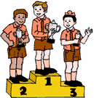

***A) Fill in the spaces:-***

**( First – second – third )**

..........................................................................................................................................................................................................................................................................................................................................................................................................

1. **Sami is the**

**.**

..........................................................................................................................................................................................................................................................................................................................................................................................................

1. **Ahmad is the**

..........................................................................................................................................................................................................................................................................................................................................................................................................

**Ali is the**

** perfect Not Perfect**

**A ) Write the suitable word under each picture:-**

Jeans - Sunglasses- Skirt- T-shirt – Shoes – Cold – Jacket - Dress

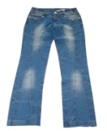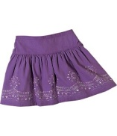

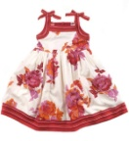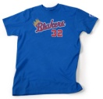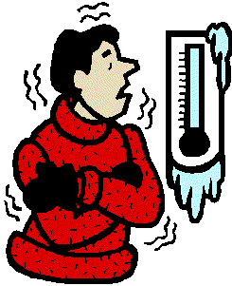

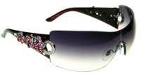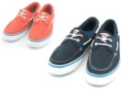

..........................................................................................................................................................................................................................................................................................................................................................................................................

..........................................................................................................................................................................................................................................................................................................................................................................................................

..........................................................................................................................................................................................................................................................................................................................................................................................................

..........................................................................................................................................................................................................................................................................................................................................................................................................

..........................................................................................................................................................................................................................................................................................................................................................................................................

..........................................................................................................................................................................................................................................................................................................................................................................................................

..........................................................................................................................................................................................................................................................................................................................................................................................................

**B) Fill in the missing letters:**

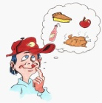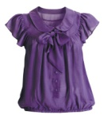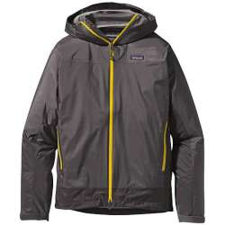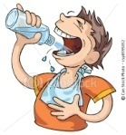

1. –hirsty 2 . J---cket 3. Bl---use 4. Hun---ry

( T – S – H ) ( u – a – e ) (i - w - o) (j - g – q)

** perfect Not Perfect**

**A) Fill in the First letters:**

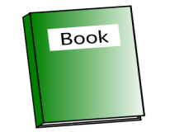

..........................................................................................................................................................................................................................................................................................................................................................................................................

..........................................................................................................................................................................................................................................................................................................................................................................................................

..........................................................................................................................................................................................................................................................................................................................................................................................................

..........................................................................................................................................................................................................................................................................................................................................................................................................

..........................................................................................................................................................................................................................................................................................................................................................................................................

..........................................................................................................................................................................................................................................................................................................................................................................................................

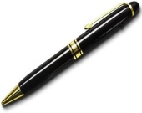

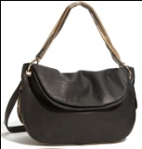

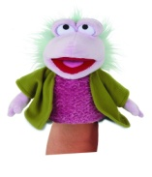

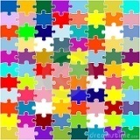

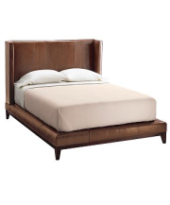

** perfect Not Perfect**

**B - Give the plural:**

..........................................................................................................................................................................................................................................................................................................................................................................................................

..........................................................................................................................................................................................................................................................................................................................................................................................................

..........................................................................................................................................................................................................................................................................................................................................................................................................

..........................................................................................................................................................................................................................................................................................................................................................................................................

** perfect Not Perfect**

G- Circle the odd word :

Cap - Hat - Tape - Time

pin - pine - Cape - Tap.

j0104954[1]