**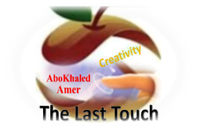****المملكة العربية السعودية**

**Kingdom of Saudi Arabia**

**Ministry of Education**

**------- Educational Directorate**

**------- Educational Schools**

**2nd grade intermediate 2022**

**1st Term – Final Exam**

**وزارة التعليم**

**الإدارة العامة للتعليم بن**

**مدارس م ن التعليمية**

**الصف الثاني المتوسط**

**الاختبار النهائي للفصل الدراسي الأول 1444هـ**

|  |  |  |  |  |  |  |  |
| --- | --- | --- | --- | --- | --- | --- | --- |
| **Total**  **written** | **5 spelling** | **4 Vocabulary** | **3 Grammar** | **2 Comprehension** | | **1 Composition** | **Q. NO.** |
|  |  |  |  |  | |  | **Mark Given** |
| **30** | **4** | **7** | **7** | **6** | | **6** | **Mark** |
|  | | | **Reviser** | |  | | **Corrector** |
|  | |

**زمن الاختبار: ساعتان**

**اسم الطالب: ------------------------------------ رقم الجلوس: ------------- الصف الثاني المتوسط**

**6**

1) **Composition**

**1- Write a paragraph about: (Your Hobby or Pastime)**

**1- What is your hobby? 2- What equipment do you need?**

**3- How often do you do it? 4- Where do you do it?**

**5- Why do you like it?**

…………………………………………

……………………………………………………………………………………………………………………………………………………………………………………………………………………………………………………………………………………………………………………………………………………………………………………………………………………………………………………………………………………………………………………………………………………………………………………………………………………………………………………………………………………………………………………………….

**2) Comprehension**

**6**

**2- Read the following passage then answer the questions:**

**Planning a vacation now is relaxing and funny. In the past people used to plan their vacation through travel books and magazines. But now we can plan them using travel-planning applications on our smart phones or computers such as Tripit, Minube, Booking and Tourist Eye. First, decide where to go then book your tickets early to keep costs low. Then book a room in a hostel. Hostels are cheaper than hotels. But many people like apartments because they are more comfortable.**

**A- Put ( ) or ( x ):**

**1. Planning a vacation now is not relaxing. ( )**

**2. We can plan vacations using travel-planning applications. ( )**

**3. Decide where to go then book your tickets late. ( )**

**4. Hostels are more expensive than hotels. ( )**

**5. Apartments are more comfortable. ( )**

**B- Choose the correct answer:**

**1. (** Playing – Planting – Planning **) a vacation is funny.**

**2. People used to plan their vacation through (**clothes– magazines – schools)

**3. Book your tickets early to keep costs (** low – high – slow ).

**4. Hotels are more expensive than (** hostels – shops – colleges ).

**C- Answer the following questions:**

**1. What is relaxing and funny?**

----------------------------------------------------

**2. How can you book a vacation now?**

----------------------------------------------------

**3. What is the opposite of “high”?**

----------------------------------------------------

**3) Grammar**

**7**

**A: Choose the correct answer:**

**1. I’d like (** a – an – some **) cup of coffee, please.**

**2. (** Who – How – Why **) often does she go shopping?**

**3. I don’t know how to (** ski – skis – skiing **).**

**4. What (** do – does – are **) you do?**

**5. He is a teacher. He (** teach – teaches – teaching **) at school.**

**6. (** What – Who – Where**) does he work?**

**7. What are you (** doing – do – does **)? At school.**

**8. Are they from Egypt? Yes, (** he is – I am – they are **).**

**B: Do as shown between brackets:**

**1- There is some juice. [** Make **Negative** **]**

--------------------------------------------------------

**2- I watch TV every day. [** Ask using: **How long** **]**

--------------------------------------------------------

**3- I know how to ski. [** Rewrite using: **can** **]**

--------------------------------------------------------

**4- He works in a hospital. [** Ask Yes/No **Question** **]**

--------------------------------------------------------

**5- I’m (go) to the park now. [** Correct the verb **]**

--------------------------------------------------------

**6- you – on – Are – here – vacation? [** Unscramble **]**

--------------------------------------------------------

**4) vocabulary:**

**7**

**A- Write the number under its pictures:**

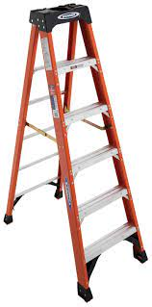**1.Karate – 2.steak – 3.hobby – 4.ladder – 5.hotel – 6.nurse**

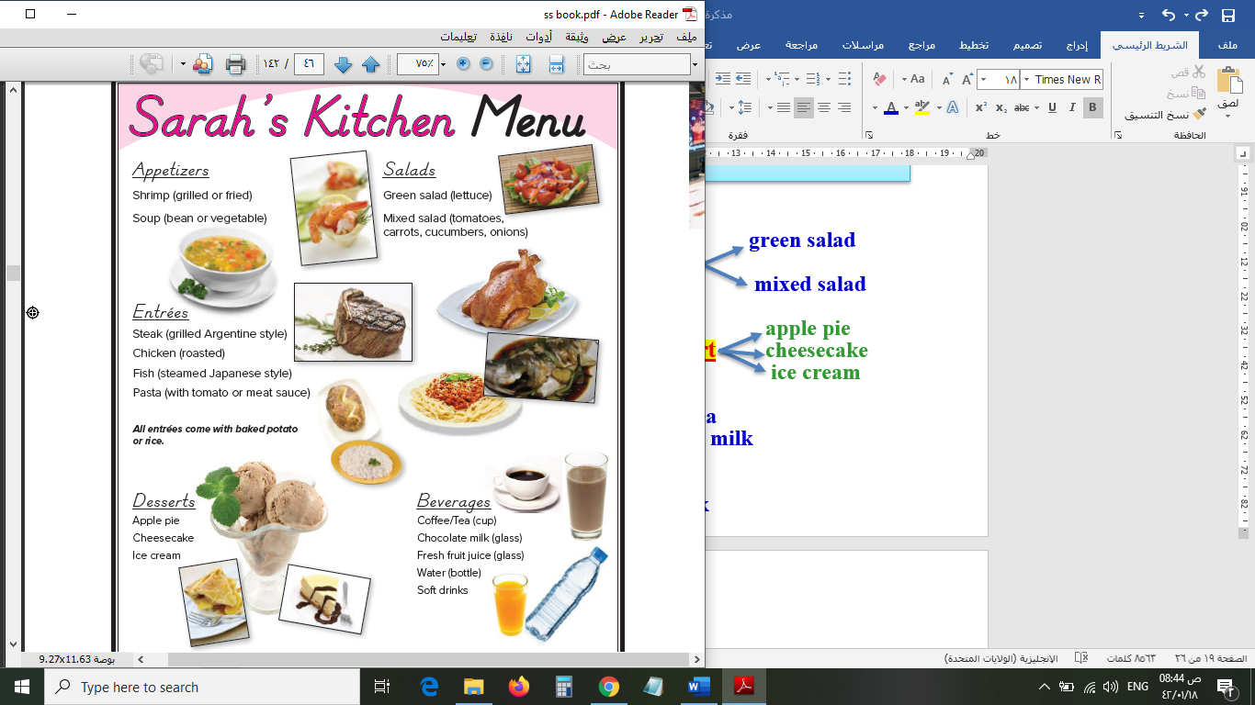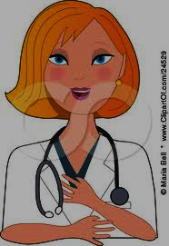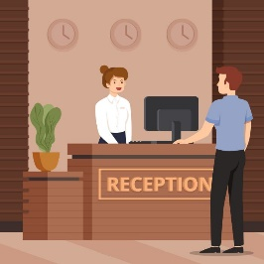

**( ) ( ) ( ) ( ) ( ) ( )**

**B- Match the answers:**

|  |  |  |
| --- | --- | --- |
| a. I understand. | **1. How do you spell your name?** | **-----** |
| b. Yes, please | **2. The director** | **-----** |
| c. is telling the **actors** what to do. | **3. An engineer works** | **-----** |
| d. A-L-I | **4. Would you like some mustard?** | **-----** |
| e. in a company. | **5. I see.** | **-----** |

**C- Circle the correct spelling:**

**1. airplan - aerplane – airplane**

**2. elevator – elvator - elevtor**

**3. meno – menu – manu**

**4**

**5) Orthography**:

**A- Fill in the missing letters:**

**1. kar__te**

**w – a – p – t**

**2. hos__el**

**3. sales__erson**

**4. sand__ich**

**B- Choose the odd one out:**

**1. Good morning Going Good evening Good night**

**2. soup ice cream steak participant**

**3. tractor actor director editor**

**4. always often usually friend**

**End of Questions**

**Best of Luck https://t.me/abokhaledamer**

**ABOKHALEDAMER**

**0557325813**