Test Based on Unit 2 اختبار الوحدة
Choose the correct word:
1- Did you (drink – drank – drinks – drinking) coffee?
2- She always (eat – eating – ate – eats) pizza.
3- How (often – much - many – long) does she arrive at work on time? Always.
4- I used to (played – play – plays – playing) football.
Match:
1. exercise freak ………… to appear unexpectedly
2- gave to charity ………… a word to interduce a change of topic.
3- Any way …………. infant.
4- a baby …………. donation.
5- turn up …………. who exercise a lot
6- always work ………….. devoted employee
7- got together / met …………. gathered
Choose the correct words:
- I don’t like science, it turns me (to – off –on).
- Prince Salman worked with many (humanitarian –educational – medical).
Write the correct number under the correct picture:
1- coach 2- rock climbing 3- prince 4- King 5- swimming
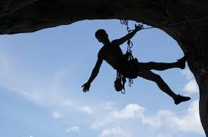
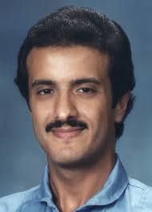
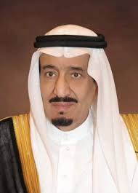

Fill in the missing letters: 1- tw……..n 2- employ……..e
Choose the correct letters:
1-ad…………….t ( dic – dac – - duc - dec ) 2-ex………..se ( irci – arci - rcici – erci )
Choose the correct word:
1-(bloud – blood – blaod – plood) 2- (crown – crawn – croun – krown)
Answer True or False :
1.Most of the cell phone usage is for text massages. ------ 2. A metropolis is a small city. ---
Change to past form:
- Play __________ b. study _________ c. go ________ d. read ________
Complete the following dialogue:
A: Do you still have the original team members?
B: --------------------------.
A: -------------------------------------------------?
B: The center forward joined us last year.
A: -------------------------------------------------?
B: We practice in the school gym.
A: When did your first big break come?
B: ---------------------------.
Answer the questions:
a. Where were you born and raised? ----------------------------------------------------
b. What games did you use to play as a child? ----------------------------------------------------
c. Did you use to live in another town or city? ----------------------------------------------------

