Faculty of Education and Arts
Department of Languages and Translation

Department of Languages and Translation

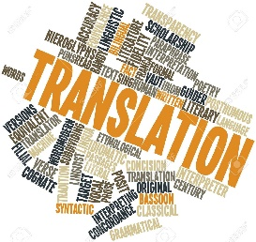
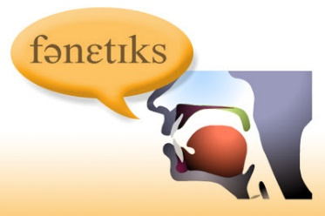
Student Guide

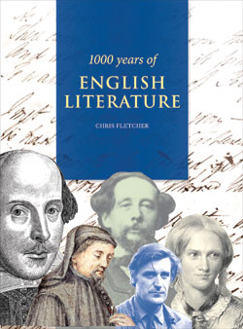

About the Department of Languages and Translation:
The Department of Languages ​​and Translation began as the Department of English Language in 1424 within the academic departments at the Teachers' College in Tabuk. In 1429, the college was restructured to become the Faculty of Education and Arts and the name of the English Department changed to its current name, Department of Languages ​​and Translation. Since its inception and until now, the department has had on its staff members from eight Arab and non-Arab countries; this diverse cultural environment has helped to enrich its offerings in the fields of literature, linguistics and translation. Endeavoring to meet the best national and international standards in the field of English language, the English Language Program, which is offered by the Department of Languages and Translation, was accredited by the Commission on English Language Program Accreditation (CEA) in August 2018.
Vision:
The department has the ambition to achieve integration in the field of languages ​​between Arab culture and other cultures and achieve a balance between the study of English language and the study of literature and translation, as well as studies supporting these major braches of English.
Mission:
At the Department of Languages and Translation, we are dedicated to providing students with the highest level of education and support utilizing a variety of teaching and assessment techniques. An integral part of our mission is to cultivate a culture conducive to teaching, life-long learning, research, critical thinking, innovation, and community serving. Every student is offered an equal opportunity for success.

Goals and Objectives
- To provide students with distinctive education and support.
- To foster creativity, critical thinking, and innovation among students.
- To support effective teaching, life-long learning, and research activities.
- To sustain student achievement through a variety of teaching and assessment techniques.
- To support fruitful interaction with the local community.
- To increase students' awareness of the role of language, literature and translation in development of human civilization.
- To enable students to interact with the international community by the use of a foreign language.
- To train students on analytical and critical thinking skills.
- To develop students' language skills through the study of a variety of courses.
- To train students on conducting research and linguistic and literary studies.
- To offer special service courses to meet the diverse needs of the community.
- To familiarize students with Western culture through the study of western languages ​​and literature and human sciences.
- To identify and practice literary theory and criticism.
- To provide training on the translation of all types of texts: literary, journalistic, scientific, and cultural.
- To supply sectors of the local community with well-trained graduates who possess the foreign language skills.

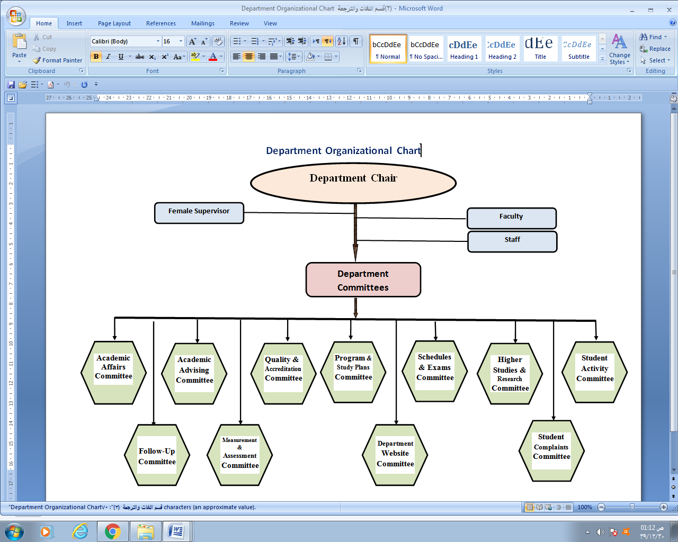

Study Plan (BA in English)

LEVEL 3
No | Course | Code | C. H.* | T. H.** | Prerequisites
1 | Islamic Culture 2 | ISLM 201 | 2 | 2 | Islamic Culture 1
2 | Arabic Writing | ARB 201 | 2 | 2
3 | Essay Writing 1 | ENG 201 | 2 | 2
4 | Phonetics 1 | ENG 203 | 2 | 2
5 | Advanced Grammar 1 | ENG 205 | 3 | 4
6 | Introduction to Linguistics | ENG 207 | 3 | 4
7 | Introduction to English Literature | ENG 208 | 2 | 4
8 | Language Acquisition | ENG 209 | 4 | 4
Total |  |  | 20 | 24

LEVEL 4

No | Course | Code | C. H.* | T. H.** | Prerequisites
1 | Islamic Culture 3 | ISLM 301 | 2 | 2 | Islamic Culture 2
2 | Essay Writing 2 | ENG 202 | 2 | 2 | Essay Writing 1
3 | Phonetics 2 | ENG 204 | 2 | 2 | Phonetics 1
4 | Advanced Grammar 2 | ENG 206 | 3 | 4 | Advanced Grammar 1
5 | History of English Language | ENG 210 | 3 | 4
6 | Basics of Translation | ENG 211 | 3 | 4
7 | Introduction to American Literature | ENG 212 | 3 | 4
Total |  |  | 18 | 22

LEVEL 5

No | Course | Code | C. H.* | T. H.** | Prerequisites
1 | Islamic Culture 4 | ISLM 401 | 2 | 2 | Islamic Culture 3
2 | Novel 1 | ENG 301 | 3 | 4
3 | Drama 1 | ENG 303 | 3 | 4
4 | Poetry 1 | ENG 305 | 3 | 4
5 | Syntax & Morphology | ENG 307 | 3 | 4 | Intro to Linguistics
6 | Translation 1 | ENG 309 | 2 | 2 | Basics of Translation
7 | Civilization 1 | ENG 311 | 2 | 2
Total |  |  | 18 | 22

LEVEL 6
No | Course | Code | C. H.* | T. H.** | Prerequisites
1 | Novel 2 | ENG 302 | 3 | 4 | Novel 1
2 | Drama 2 | ENG 304 | 3 | 4 | Drama 1
3 | Poetry 2 | ENG 306 | 3 | 4 | Poetry 1
4 | Stylistics | ENG 308 | 3 | 4 | Intro to Linguistics
5 | Translation 2 | ENG 310 | 2 | 2 | Translation 1
6 | Civilization 2 | ENG 312 | 2 | 2 | Civilization 1
Total |  |  | 16 | 20

LEVEL 7
No | Course | Code | C. H.* | T. H.** | Prerequisites
1 | Novel 3 | ENG 401 | 3 | 4 | Novel 2
2 | Drama 3 | ENG 403 | 3 | 4 | Drama 2
3 | Poetry 3 | ENG 406 | 3 | 4 | Poetry 2
4 | Semantics | ENG 407 | 3 | 4 | Intro to Linguistics
5 | Translation 3 | ENG 409 | 2 | 2 | Translation 2
6 | Theoretical Criticism | ENG 411 | 2 | 2
Total |  |  | 16 | 20

LEVEL 8
No | Course | Code | C. H.* | T. H.** | Prerequisites
1 | Novel 4 | ENG 402 | 3 | 4 | Novel 3
2 | Drama 4 | ENG 404 | 3 | 4 | Drama 3
3 | Poetry 4 | ENG 406 | 3 | 4 | Poetry 3
4 | Error Analysis | ENG 408 | 3 | 4 | Intro to Linguistics
5 | Translation 4 | ENG 410 | 2 | 2 | Translation 3
6 | Applied Criticism | ENG 412 | 2 | 2 | Theoretical Criticism
Total |  |  | 16 | 20

Brief Course Description

Course Title | Essay Writing I
Code | ENG 201
Credits | 2
Level | 3
Prerequisites | -
Description | Essay Writing 1 develops students' skills to write well-structured and meaningful paragraphs. The course begins by covering pre-writing techniques and moves onward to more defined paragraph-related elements including topic sentences, supporting sentences, concluding sentences, and paragraph coherence and unity. A review of appropriate grammatical structures is also provided where necessary. Five kinds of paragraphs are highlighted in this course: descriptive, example, process, narrative, and opinion paragraphs.

Course Title | Introduction to Linguistics
Code | ENG 207
Credits | 3
Level | 3
Prerequisites | -
Description | This course is an introductory survey of linguistics, focusing on natural language phenomena and the methods used to understand them. It addresses the following sub-domains of linguistics during the course:  - Phonetics: The physical properties of language forms (e.g., sounds)  - Phonology: The psychological representation of language sounds- Morphology: How language forms combine to form words -Syntax: How words combine to form phrases and sentences -Semantics: The meanings of words, phrases, and sentences -Pragmatics: How sentences are used in context

Course Title | Introduction to English Literature
Code | ENG 208
Credits | 3
Level | 3
Prerequisites | -
Description | This course introduces students to English Literature, its key concepts in literature and its genres. The course offers a short survey of periods of English literature. Then it covers the three main literary genres, which are poetry, fiction and drama, and introduces students to the technical and analytical tools related to these genres; students study selected examples of each genre and acquire the skills of reading and analyzing them.

Course Title | Language Acquisition
Code | ENG 209
Credits | 4
Level | 3
Prerequisites | -
Description | This course seeks to introduce students to the field of language acquisition. It is designed to familiarize students with basic concepts and technical terms of language acquisition and it provides them with solid background knowledge about the main theories of first language acquisition as well as the main theories of second language acquisition.

Course Title | Advanced Grammar 1
Code | ENG 205
Credits | 2
Level | 3
Prerequisites | -
Description | The course is designed to teach intermediate to advanced-level language structures and skills necessary for accurate and meaningful writing and speaking. It does not focus on theory, the teaching of grammar as such, but rather on practice, the use of fundamental grammatical elements underlying the production of effective sentences and good compositions, short reports, oral presentations and so on. The course also aims at making the learners develop a sound understanding of the form, meaning and usage of intermediate to advanced English structures. Offering a mixture of grammar-based and communicative approaches, it places them in real interactive situations. Through intense classroom practice, it leads the learners to have an effortless command over both the written and the spoken word. This course covers the following grammatical constructions: tense, aspect, nouns, pronouns and modals.

Course Title | Advanced Grammar 2
Code | ENG 206
Credits | 2
Level | 4
Prerequisites | Advanced Grammar 1
Description | The course is designed to teach intermediate to advanced-level language structures and skills necessary for accurate and meaningful writing and speaking. It does not focus on theory, the teaching of grammar as such, but rather on practice, the use of fundamental grammatical elements underlying the production of effective sentences and good compositions, short reports, oral presentations and so on. The course also aims at making the learners develop a sound understanding of the form, meaning and usage of intermediate to advanced English structures. Offering a mixture of grammar-based and communicative approaches, it places them in real interactive situations. Through intense classroom practice, it leads the learners to have an effortless command over both the written and the spoken word. This course continues where its prerequisite course, Advanced Grammar 1, stops by covering the following grammatical constructions: passive voice, (noun, adjective and adverb) clauses, gerunds, infinitives, coordinating conjunctions, connectives, conditional sentences and wishes

Course Title | Phonetics I
Code | ENG 203
Credits | 2
Level | 3
Prerequisites | -
Description | This course aims at training students to distinguish between correct and incorrect pronunciation of the English sounds, before proceeding to develop their pronunciation skills. In addition to a revision of the organs of speech, the course deals with vowel classification (tongue height, tongue part, lip shape and length). There will be vowel oral practice and phonemic transcription of words.

Course Title | Basics of Translation
Code | ENG 211
Credits | 3
Level | 4
Prerequisites | -
Description | The course deals with the principles of translation. Contrastive analysis, stylistics and lexical problems are discussed within the context of translating from English to Arabic and vice versa. Types of translation are discussed .Basic techniques in translation are used to produce supervised translations of various types of texts. Moreover, the course looks at the translation of meaning beyond the level of the sentence. It examines the roles of notions such as background knowledge, cohesion and coherence to achieve a better understanding of how language works as a communication medium in texts and conversational interaction.

Course Title | Essay Writing II
Code | ENG 202
Credits | 2
Level | 4
Prerequisites | -
Description | Essay Writing 2 develops students' skills to write academic essays. This covers the organization, structure, coherence and unity of short essays and emphasizes the use of pre-writing techniques like brainstorming, outlining, and graphic organizers. The essay types highlighted in this course include descriptive essays, narrative essays, opinion essays, comparison and contrast essays, and cause and effect essays. A review of appropriate grammatical structures and common writing mistakes is also provided where necessary. Extensive practice in college-level writing and reading is necessary. Students will write and peer-review a variety of essays through a process-oriented approach to writing.

Course Title | Introduction to American Literature
Code | ENG 212
Credits | 3
Level | 4
Prerequisites | -
Description | Introduction to American Literature examines major figures in American literature, beginning in the colonial period till the 19th century, and explores the cultural complexities of an emerging and changing nation as revealed by great American authors, such as Irving, Hawthorne, Melville, Poe, James, Dickinson, Whitman, Twain, Harte, Chopin, Cather, Wright, Hughes, Hemingway, Faulkner, Fitzgerald, and Steinbeck. At least one novel by a 19th century writer is studied closely. In addition, a sampling of fictional and non-fictional prose and a representative selection of poetry from the Colonial period up to the end of the 19th century is discussed.

Course Title | History of the English Language
Code | ENG 210
Credits | 2
Level | 4
Prerequisites | -
Description | This course provides students with the basic information about the development of the English language since Geoffrey Chaucer's time till the end of the eighteenth century.

Course Title | Phonetics II
Code | ENG 204
Credits | 2
Level | 4
Prerequisites | -
Description | This course aims at training students to distinguish between correct and incorrect pronunciation of the English sounds, before proceeding to develop their pronunciation skills. The course deals with the aspects of connected speech, problems in phonemic analysis, Stress and intonation.

Course Title | Civilization I
Code | ENG 311
Credits | 2
Level | 5
Prerequisites | -
Description | This course is a general survey and analysis of the history of Western civilization from the beginning up to the Enlightenment. Primary emphasis is placed on the development of human political, religious, and social institutions, together with the literature that accompanied such developments. The course begins with an interdisciplinary introduction (through texts and images) to early medieval England from the 5th century to Norman Conquest, with a brief survey of Anglo-Saxon history (c.600-1200). The language and Literature of the Anglo-Saxons (C. 600-1200) will be studied in detail, based mainly on texts in translation, with a glance at the neighboring and related literatures of Ireland and Scandinavia. The course moves then to discuss the influence of the Greek and Roman civilization on English Language and Literature, stopping particularly at Sophocles, Aeschylus and Euripides, and discussing their influence on English drama as a whole. The Normans are the next station which the course will stop at to explain how they added colorful touch of lightness and joy to the literature and culture of the English people. Fundamental figures such as Wyatt, Sidney, Spenser, Milton and Done who greatly influenced the sixteenth and seventeenth century English culture, life, and literature will be discussed, before we move finally to talk about The Age of Enlightenment that ultimately gave way to 19th-century Romanticism. Fundamental figures such as Wyatt, Sidney, Spenser, Milton and Done who greatly influenced the sixteenth and seventeenth century English culture, life, and literature will be discussed, before we move finally to talk about The Age of Enlightenment that ultimately gave way to 19th-century Romanticism.

Course Title | Drama I
Code | ENG 303
Credits | 3
Level | 5
Prerequisites | -
Description | This is an introductory course to drama. It aims to familiarize students with the evolution and the fundamental historical stages of drama. It provides a critical and comprehensive understanding of the academic discipline of the theory of drama, and introduces literary terms used in the analysis of the assigned plays. It explains also the different dramatic modes of writing used in writing drama such as realism and naturalism exemplifying from dramatic masterpieces such as Ibsen's A Doll's House (1879) and August Strindberg's Miss Julie (1888). Major writers we are sure to cover include Sophocles, Shakespeare, Marlowe and Johnson. The course will be a fast-paced, reading-intensive introduction to the beginnings of English Drama and its evolution from Medieval to Elizabethan, and through Renaissance to Modern and Postmodern. It will certainly use any available web based-reference material to enhance the students' understanding. Lively class discussions, oral presentations, and short-response papers will also be encouraged as an outlet for students' innovative thoughts and speculations. Recent research relevant to the topics at hand will be given significant attention and will be raised in class discussions. The focus will be on creativity and innovation in writing and analyzing selected dramatic texts.

Course Title | Syntax & Morphology
Code | ENG 307
Credits | 3
Level | 5
Prerequisites | -
Description | This course introduces the students to the main concepts in morphology and syntax and applies these concepts to English words and structures. The morphology part of the course focuses on basic distinctions in word structure, such as the different types of morphemes and word formation processes. The student will also be able to represent the (hierarchical) structure of words using tree diagrams. The syntax part of the course introduces parts of the Minimalist approach - the current widely used syntactic theory. The students will be introduced to the basic concepts of this theory and they will be trained to apply these concepts in analyzing English sentences.

Course Title | Novel I
Code | ENG 301
Credits | 3
Level | 5
Prerequisites | -
Description | This course focuses on studying the history and development of the English novel and its evolution as a relatively new literary genre. It investigates the uses and boundaries of fiction in a range of novels and narrative styles, traditional and innovative, western and non-western, and raises questions about the pleasures and meanings of verbal texts in different cultures, times, and forms. The course will explore also concepts and analytical tools for reading and interpreting fiction in general. It emphasizes formal concerns about narrative voice (omniscience, irony, unreliability, and free indirect discourse) alongside socio-historical and literary-historical perspectives on the uses and pleasures of narrative art. To foreground the problem of narrative itself, the course considers texts from a variety of time periods for exemplification, with widely varied approaches to the form. Authors will likely include Jane Austen, John Bunyan, Daniel Defoe, Eliza Haywood, Ernest Hemingway, James Joyce, Herman Melville, and Patrick McCabe.

Course Title | Poetry I
Code | ENG 305
Credits | 3
Level | 5
Prerequisites | -
Description | The course mainly focuses on the elements of English prosody and English poetry written in the sixteenth and seventeenth centuries. Examples of the major figures in English poetry during that time, together with examples of their poems are given.

Course Title | Translation I
Code | ENG 309
Credits | 2
Level | 5
Prerequisites | Basics of Translation
Description | The material of this course is to be derived from a variety of simple texts:, literary ,historic ,economic .etc. It is mainly designed for translation practice. This course introduces students to linguistics and cultural differences which impinge on the process of translation. The course is designed to enable students to master the specialized terminology of the selected types via using specialized dictionaries. . Different approaches for solving translation problems are also practiced. It is also improves the students' ability to identify the nature of texts and explains the common mistakes occurring in translation.

Course Title | Civilization II
Code | ENG 312
Credits | 2
Level | 6
Prerequisites | Civilization I
Description | Civilization II course is a completion of Civilization I course. It covers major events that have impacted the West from the Enlightenment to the present. The course will use engaging short video lessons to present and analyze the significant political and philosophical revolutions that the Western culture had undergone from the 18the century up to the present day. The course also explains how the political and philosophical revolutions that affected Western Society shaped the culture and the literature and (literary movements) of the period: Realism, Naturalism, Existentialism, Decadence, Modernism, as well as Postmodernism.

Course Title | Drama II
Code | ENG 304
Credits | 3
Level | 6
Prerequisites | Drama I
Description | This course focuses exclusively on Shakespeare as an Elizabethan dramatist. It will read a selection of Shakespeare’s tragedies and comedies (namely Macbeth and Hamlet) as exemplary of Elizabethan drama. A general background of Shakespeare’s era is provided by way of developing an advanced study and a deeper understanding of his plays. Much emphasis will be laid on the development of Shakespeare’s art as a dramatist. Autobiographical notes will also be introduced to help students come to terms with elements at work in the different plays. Shakespeare’s universality and the canonic features of his works are some of the issues to be underscored. Criticism on Shakespearean plays as developed throughout the different ages will also be included. Modern trends in the study and the production of his plays are to be emphasized.

Course Title | Novel II
Code | ENG 304
Credits | 3
Level | 6
Prerequisites | Novel I
Description | The course involves intensive theoretical examination and discussion of the early seventeenth and eighteenth century English novel. The approach to the novels will be threefold: 1) a close readings of important individual works with an eye for authorial style, narrative structure, character...etc.; 2) examining these novels within their socio-historical contexts; for example, what does a novel from the 18th century tell us about its time values?; 3) exploring how these novels fit into the trajectory of literary history, how they contributed to the evolution of narrative fiction and our established expectations. Influences such as the rise of philosophical rationalism, Puritanism, Methodism, together with books such as “Don Quixote,” which was one of the books that provided a model for 18th century writers, will be thoroughly studied. Novels to be selected for reading in the course will include Moll Flanders or Robison Crusoe by Daniel Defoe, Pamela by Samuel Richardson, as well as Tristram Shandy by Lawrence Sterne.

Course Title | Poetry II
Code | ENG 306
Credits | 3
Level | 6
Prerequisites | Poetry I
Description | This course focuses on four significant periods of English poetry: the Elizabethan, the Metaphysical, the Neoclassical and the Pre-Romantic. The students should trace the impact of the historical, social, and political features of these periods on poetry. Moreover, they will learn the similarities and differences between the literary trends under study. Examples of the major figures in English poetry during these periods, together with examples of their poems are given.
Course Title | Stylistics
Code | ENG 308
Credits | 3
Level | 6
Prerequisites | -
Description | This course introduces students to the theory and practice of stylistics, the concepts of style and stylistics , the nature and goals of stylistics as well as types of stylistics. Moreover, this course takes the students through essential levels of linguistic description of a text. These include the phono-graphological, the syntactic and the lexico-semantic levels. It also introduces them to cohesion and coherence as well as foregrounding.

Course Title | Translation II
Code | ENG 310
Credits | 2
Level | 6
Prerequisites | Translation I
Description | In this course, students will practice translating political and journalistic texts. In addition, they will be able to recognize linguistic problems in these texts and provide solutions to these problems. Students will also be able to recognize and analyze both the cultural and semantic component of the TT. They will learn how decrease any difficulties they encounter in translation. This course will also introduce student to interpretation.

Course Title | Drama III
Code | ENG 304
Credits | 3
Level | 5
Prerequisites | Drama II
Description | Did you know that when writing his novels Dickens was known to act out his characters in front of a mirror? Were you aware that Dickens’s novels were adapted for the stage even before they were completed? Have you heard of the popular play Jane Eyre or the Secrets of Thornfield Manor? Did you know that Queen Victoria went to see Boucicault’s melodrama The Corsican Brothers five times in 1852? We often think of the nineteenth century as the age of the novel—the century that produced great novelists, such as Austen, the Brontës, Eliot, and Dickens. However, as these anecdotes illustrate, the novel was not the only show in town. This course shines the spotlight on that often upstaged but nevertheless central character in nineteenth-century literature and culture: the theatre. With an eye toward socio-cultural contexts and concerns, we will examine the thematic and technological changes of nineteenth-century theatre. In what ways do changes in dramatic style reflect social changes? What aspects of identity, in terms of class, gender, and race, are destabilized or re-inscribed by the nineteenth-century stage? What can theatrical adaptations tell us about the cultural and historical moments in which they are produced? We will pursue these questions and more through an exploration of Romantic verse drama, comic opera, farce, melodrama, and dramatic “realism.” Readings will include works by Joanna Baillie, Gilbert and Sullivan, Dion Boucicault, Netta Syrett, J.M. Barrie, George Bernard Shaw, and Oscar Wilde.

Course Title | Novel III
Code | ENG 401
Credits | 3
Level | 7
Prerequisites | Novel II
Description | This course familiarizes students with concepts and conventions of the 19th century novel in contrast to the 18th century novel. We will be looking at realistic novels as bearers of social values, especially around questions of property, class, marriage, work, bureaucracy and the state, and selfhood. Novels by Jane Austen, Charles Dickens, and Henry James will be selected and thoroughly studied in the course.

Course Title | Poetry III
Code | ENG 405
Credits | 3
Level | 7
Prerequisites | Poetry II
Description | This course focuses on the English Romantic literary movement and its main figures and literary characteristics. Students are to analyze the intellectual, historical, political and social background relevant to an understanding of English Romanticism. They are to read and Analyze a large selection of Romantic poems, discuss several critical approaches to poetry, and write short research papers (on poetry). Additionally, students are to identify Victorian literary tradition, its main figures and literary characteristics. They are to discuss intellectual, historical, political and social issues relevant to understanding Victorian poetry. Students are to analyze a large selection of Victorian poems.

Course Title | Semantics
Code | ENG 407
Credits | 3
Level | 5
Prerequisites | -
Description | This course is designed for BA students. It offers a comprehensive treatment of semantics for students who have little or no knowledge of semantics. The course provides students with a solid understanding of key concepts in semantics and methods of semantic analysis. The course also aims to encourage an active approach on the part of students toward the subject matter. Students successfully completing the course will be able to identify and explain concepts which are central to the study of communication. They will be able to describe and discuss the semantic structure of lexemes and relationships between them. They will also have an enhanced knowledge of the semantic structure of sentences. The course will enable students to proceed to more specialized aspects of semantic analysis.

Course Title | Theoretical Criticism
Code | ENG 411
Credits | 2
Level | 7
Prerequisites | -
Description | Theoretical Criticism is a survey of Western literary theory and criticism with an emphasis on the most prominent theorists, texts, schools, and ideas. It is a course in the history of ideas—specifically, ideas related to the theory and criticism of literary texts. The course begins with a survey of major figures in the development of a critical theory of literature. The emphasis will be on the careful reading of primary theoretical texts, with attention as well to historical and social contexts. This survey will include Plato, Aristotle, Longinus, Augustine, Maimonides, Sidney, Coleridge, Arnold, Freud, Nietzsche, and more. This survey should provide a basic frame of reference from which to understand and assess the contemporary theoretical and critical scene.

Course Title | Translation III
Code | ENG 409
Credits | 2
Level | 7
Prerequisites | Translation II
Description | This course is an extension of course 310 and aims at training the students to deal with various syntactic and textual problems that face them during the process of translating from English to Arabic and vice versa. The student is now expected to gain more skills of analyzing and rendering different structural systems. By becoming more aware of the ways sentences are structured and texts are organized into coherent wholes, the students are expected to develop more command of English and Arabic structure.

Course Title | Error Analysis
Code | ENG 408
Credits | 3
Level | 8
Prerequisites | -
Description | This course introduces the students to the concept of error in language learning. It also covers the following topics: error vs. mistake, significance of errors, attitudes towards errors, sources of errors, the process of analyzing errors, inter-language, and types of errors (inter-lingual, intra-lingual, developmental, and teacher-induced errors).

Course Title | Novel IV
Code | ENG 402
Credits | 3
Level | 8
Prerequisites | Novel III
Description | This course introduces students to the modern novel and the variety of technical, stylistic and thematic innovations developed in the fiction. It explains how free thinkers such as Charles Darwin, Sigmund Freud and Carl Marx influenced the modern era and modern literature. Themes of individuality, randomness of life, mistrust in government and religion will be studied in the selected novels. Further, the course explains how the modern fiction is characterized by tremendous ambition, radical experimentation, the questioning of old conventions and the creation of new ones. Selected novels to be read in the course will be by Scott Fitzgerald, Virginia Wolf as well as Ernest Hemingway.

Course Title | Poetry IV
Code | ENG 407
Credits | 3
Level | 8
Prerequisites | Poetry III
Description | In this course, the focus will be on the outstanding poets of the modern and postmodern British poetry. The works of the representative poets are examined in the context of the poems as well as their historical, literary, and aesthetic. Students are to be introduced to the major trends in modern British poetry with special orientation in the modern and post-modern movement. Students will develop a facility in discussing the literary techniques and devices, with an emphasis on the power and the qualities of effective and expressive language in the selected poems which represent specific distinctiveness of each poet's art, philosophy and his significant contribution to the age.

Course Title | Drama IV
Code | ENG 404
Credits | 3
Level | 8
Prerequisites | Drama III
Description | "Modern drama” signifies a tumultuous period of theatrical experimentation allied closely with the broader framework of “modernism,” a movement in the arts commencing in the late 19th century and drawing to a close by the mid-to-late 20th century (i.e., with the onset of “postmodernism”). In this class, we’ll explore a range of drama coming out of Europe and the United States as part of this modernist phenomenon: naturalism, symbolism, Dada, constructivism, and the theater of the absurd. We will be limiting the number of plays we read so that we will also be able to consider changes in architecture, lighting and sound technologies, and theories of acting, directing and design for the stage that influenced innovations in dramatic literature. We will also place the plays in conversation with parallel developments in painting, photography, film, poetry and the novel. In addition to thinking drama through the lens of the avant-garde and modernism, we will also think about modern drama as a component of modernity: a historical condition of cultural dislocation, rapid urbanization and industrialization, and rising global consciousness and conflict. In that manner, we will explore the ways modern drama galvanized the relationship between aesthetic experimentation and social change. Plays that we will read in the course are Beckett's Waiting for Godot as an example of the absurd drama in modernism and Kane's Psychosis as an example of postmodern drama.

Course Title | Practical Criticism
Code | ENG 412
Credits | 2
Level | 8
Prerequisites | Theoretical Criticism
Description | Practical criticism is treated in this course as an ancillary skill rather than the foundation of a critical method. After being introduced to the most common approaches used in literary criticism (as well as the methods and vocabulary of practical criticism), students will be trained to use their own impressions and understanding of an art work to critique it using the most common glossary of critical terms used in practical criticism. They should also determine the most suitable critical approach applicable to a text based on their own understanding of the literary text. The course is designed to test students' responsiveness to what they read, as well as their knowledge of verse forms and of the technical language for describing the way prose and poetic works create their effects.

Course Title | Translation IV
Code | ENG 410
Credits | 2
Level | 8
Prerequisites | Translation III
Description | This course aims at applying the theoretical principles already introduced in course 309 to translation from Arabic into English and vice versa. This course will also concentrate on improving the students' command of English at the level of the word (i. e., increasing their vocabulary), then the sentence (i. e., improving their grammar), and finally the paragraph (i. e., training them on the components of discourse unity), and longer discourse. Special emphasis should be laid on the rhetorical/ textual and stylistic differences between English and Arabic. Topics for translation will become more varied and difficult and will include journalistic literary, scientific, legal as well as some literary, i.e., prose and poetry texts.

