KINGOM OF SAUDI ARABIA …………………………………. Education directorate
MINISTRY OF EDUCATION ……………………………. Elementary school

12/5 _ 16/5 1st week |  |  |  |  |  | Unit 6  What Was It Like?
Conversation  About you | Listening Pronunciation | Grammar |  | Listening and discuss + pair work | L
2nd week 19/5 _ 23/5
Form, Meaning and Function | Project | Writing |  | Reading | L
3rd week 26/5 _ 1/6 |  |  |  |  |  | Unit 7  What Happened?
Conversation  About you | Listening Pronunciation | Grammar |  | Listening and discuss + pair work | L
Sunday 4th week 4/6 _ 8/6
Form, Meaning and Function | Project | Writing |  | Reading | L
11/6 _ 15/6 5th week |  |  |  |  |  | Unit 8  What's Wrong?  Unit 9  LET’S GO OUT
Conversation  About you | Listening Pronunciation | Grammar |  | Listening and discuss + pair work | L
18/6 _ 22/6 6th week
Grammar | (U9) Listening and discuss + pair work | Writing +Project+ Form, Meaning and Function |  | Reading | L
7th week 2/7 _ 6/7 |  |  |  |  |  | Unit 9  LET’S GO OUT  Unit10  IT’S A BARGAIN
Writing +Project+ Form, Meaning and Function | Reading | Conversation  About you |  | Listening  Pronunciation | L
8th week 9/7 _ 13/7
Conversation  About you | Listening Pronunciation | Grammar |  | (U10) Listening and discuss + pair work | L
9th week 16/7 _ 20/7 Sunday |  |  |  |  |  | Unit 10  IT’S A BARGAIN  Unit 11  THERE’S NO COMPARISON
Grammar | (U11) Listening and discuss + pair work | Writing +Project+ Form, Meaning and Function |  | Reading | L
10th week 23/7 _ 27/7
Writing +Project+ Form, Meaning and Function | Reading | Conversation  About you |  | Listening  Pronunciation | L
11th week 1/8 _ 5/8
Oral exams |  |  | Expansion units 6 -11
12th week 8/8 _ 12/8
Final Exams
Thursday
SYLLABUS DISTRIBUTION FOR 2nd INTERMEDIATE GRADE (SUPER GOAL2) (SECOND TERM) 1445

إجازة مطولة إجازة يوم التأسيس
Teacher…………….… Headmaster………………. Supervisor ……………….

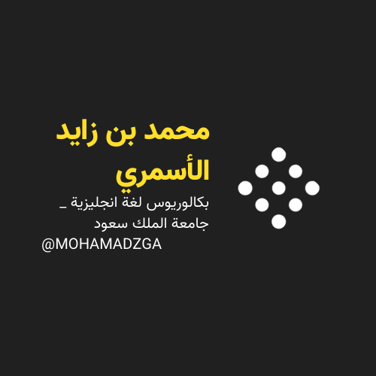

MOHAMADZGA M_zaid0

لا تنسوني من صالح دعائكم

