We Can! Book 6 Unit 3: My School is Cool!

1. Read and match with the pictures.

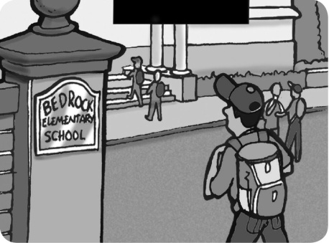  1 | 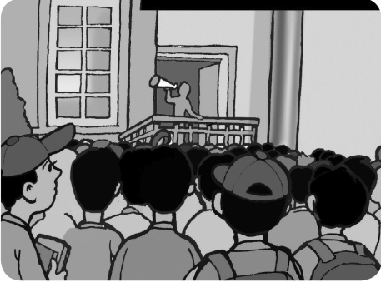  2 | 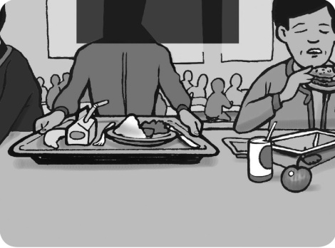  3
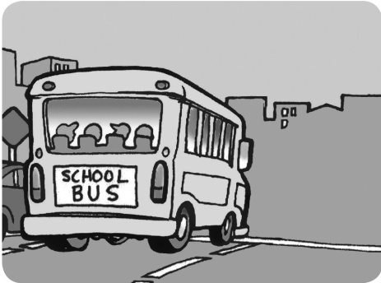  4 | 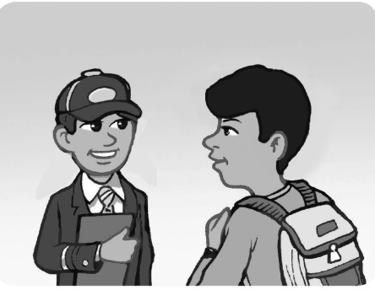  5 | 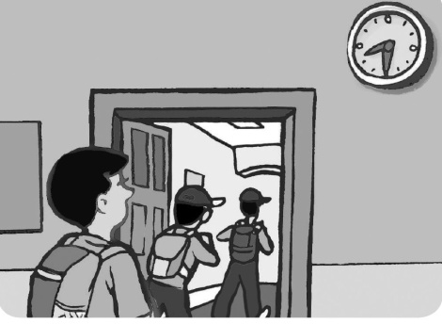  6

Do you have school lunch at your school?  Yes, we do. Every day. 3 | What time does your school start?  It starts at 8.30. 6
Do you have a school uniform?  Yes, we do. 5 | How many students are there in your school?  About 1,000. 2
What’s the name of your school?  Bedrock Elementary School. 1 | Does your school have a school bus?  Yes it does. It has a big yellow bus. 4

2. Read and underline the correct word.

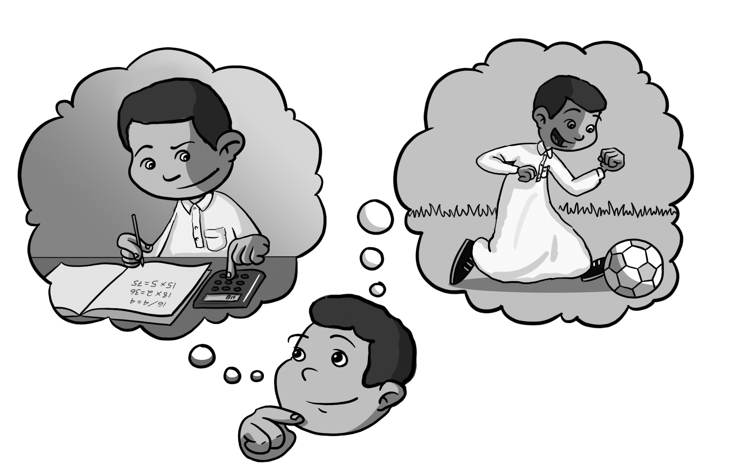
1. Which subject do / did you like most this year?
This year I like/ liked math.
2. Which subject do / did you like most last year?
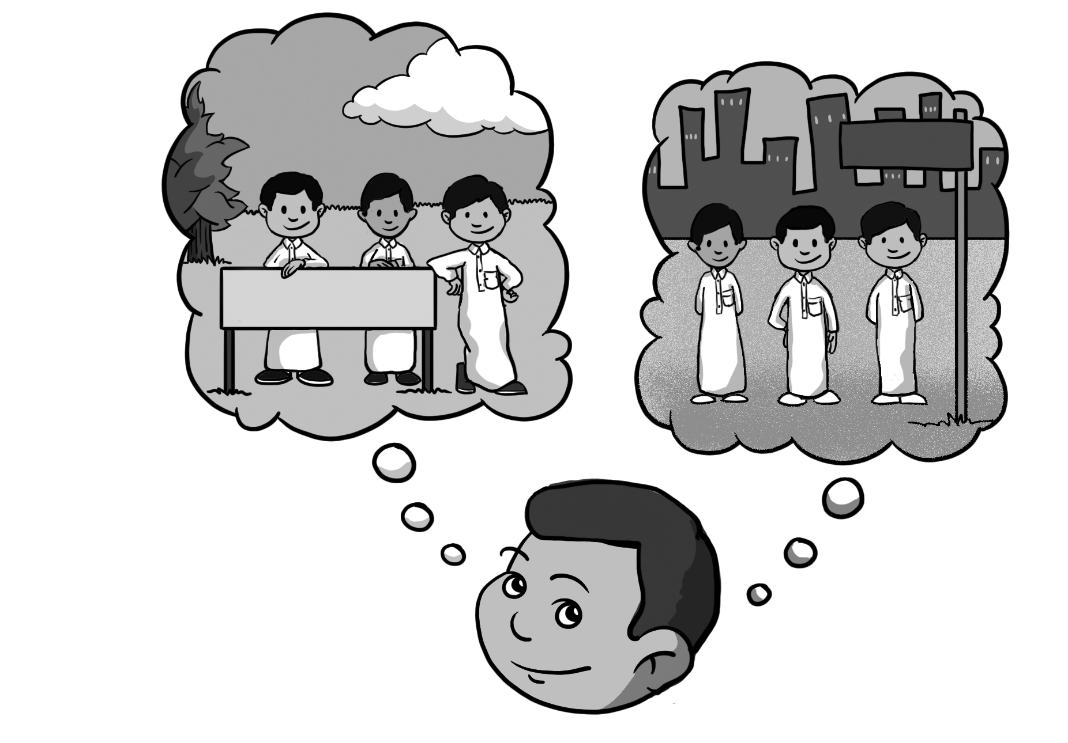
Last year I like/ liked PE.
3. Which grade are / were you in this year?
This year I am / were in the 6th grade.
4. Which grade are / were you in last year?
Last year I am/ was in the 5th grade.
5. Which city does / did Saeed live in?
He lives/ lived in Najran.
6. Where do/ did Saeed’s family go last summer?
Last summer they go/ went to Jazan.
3. Write about your school.

The name of my school is ______(answers will vary)__
There are about _________________students in my school. We __________________ school lunch at our school. Our school starts at ___________________.
My English teacher is Mr. / Mrs. / Miss ___________.
The best place in our school is the _______________.
My favorite school subject is __________________.
My best friend at school is __________________.

4. Fill in the missing words. Begin with a capital letter. Our English Class Rules

ask for help don’t make don’t shout don’t forget

use stand up speak listen

Listen to the teacher.
Ask for help when you have a problem.
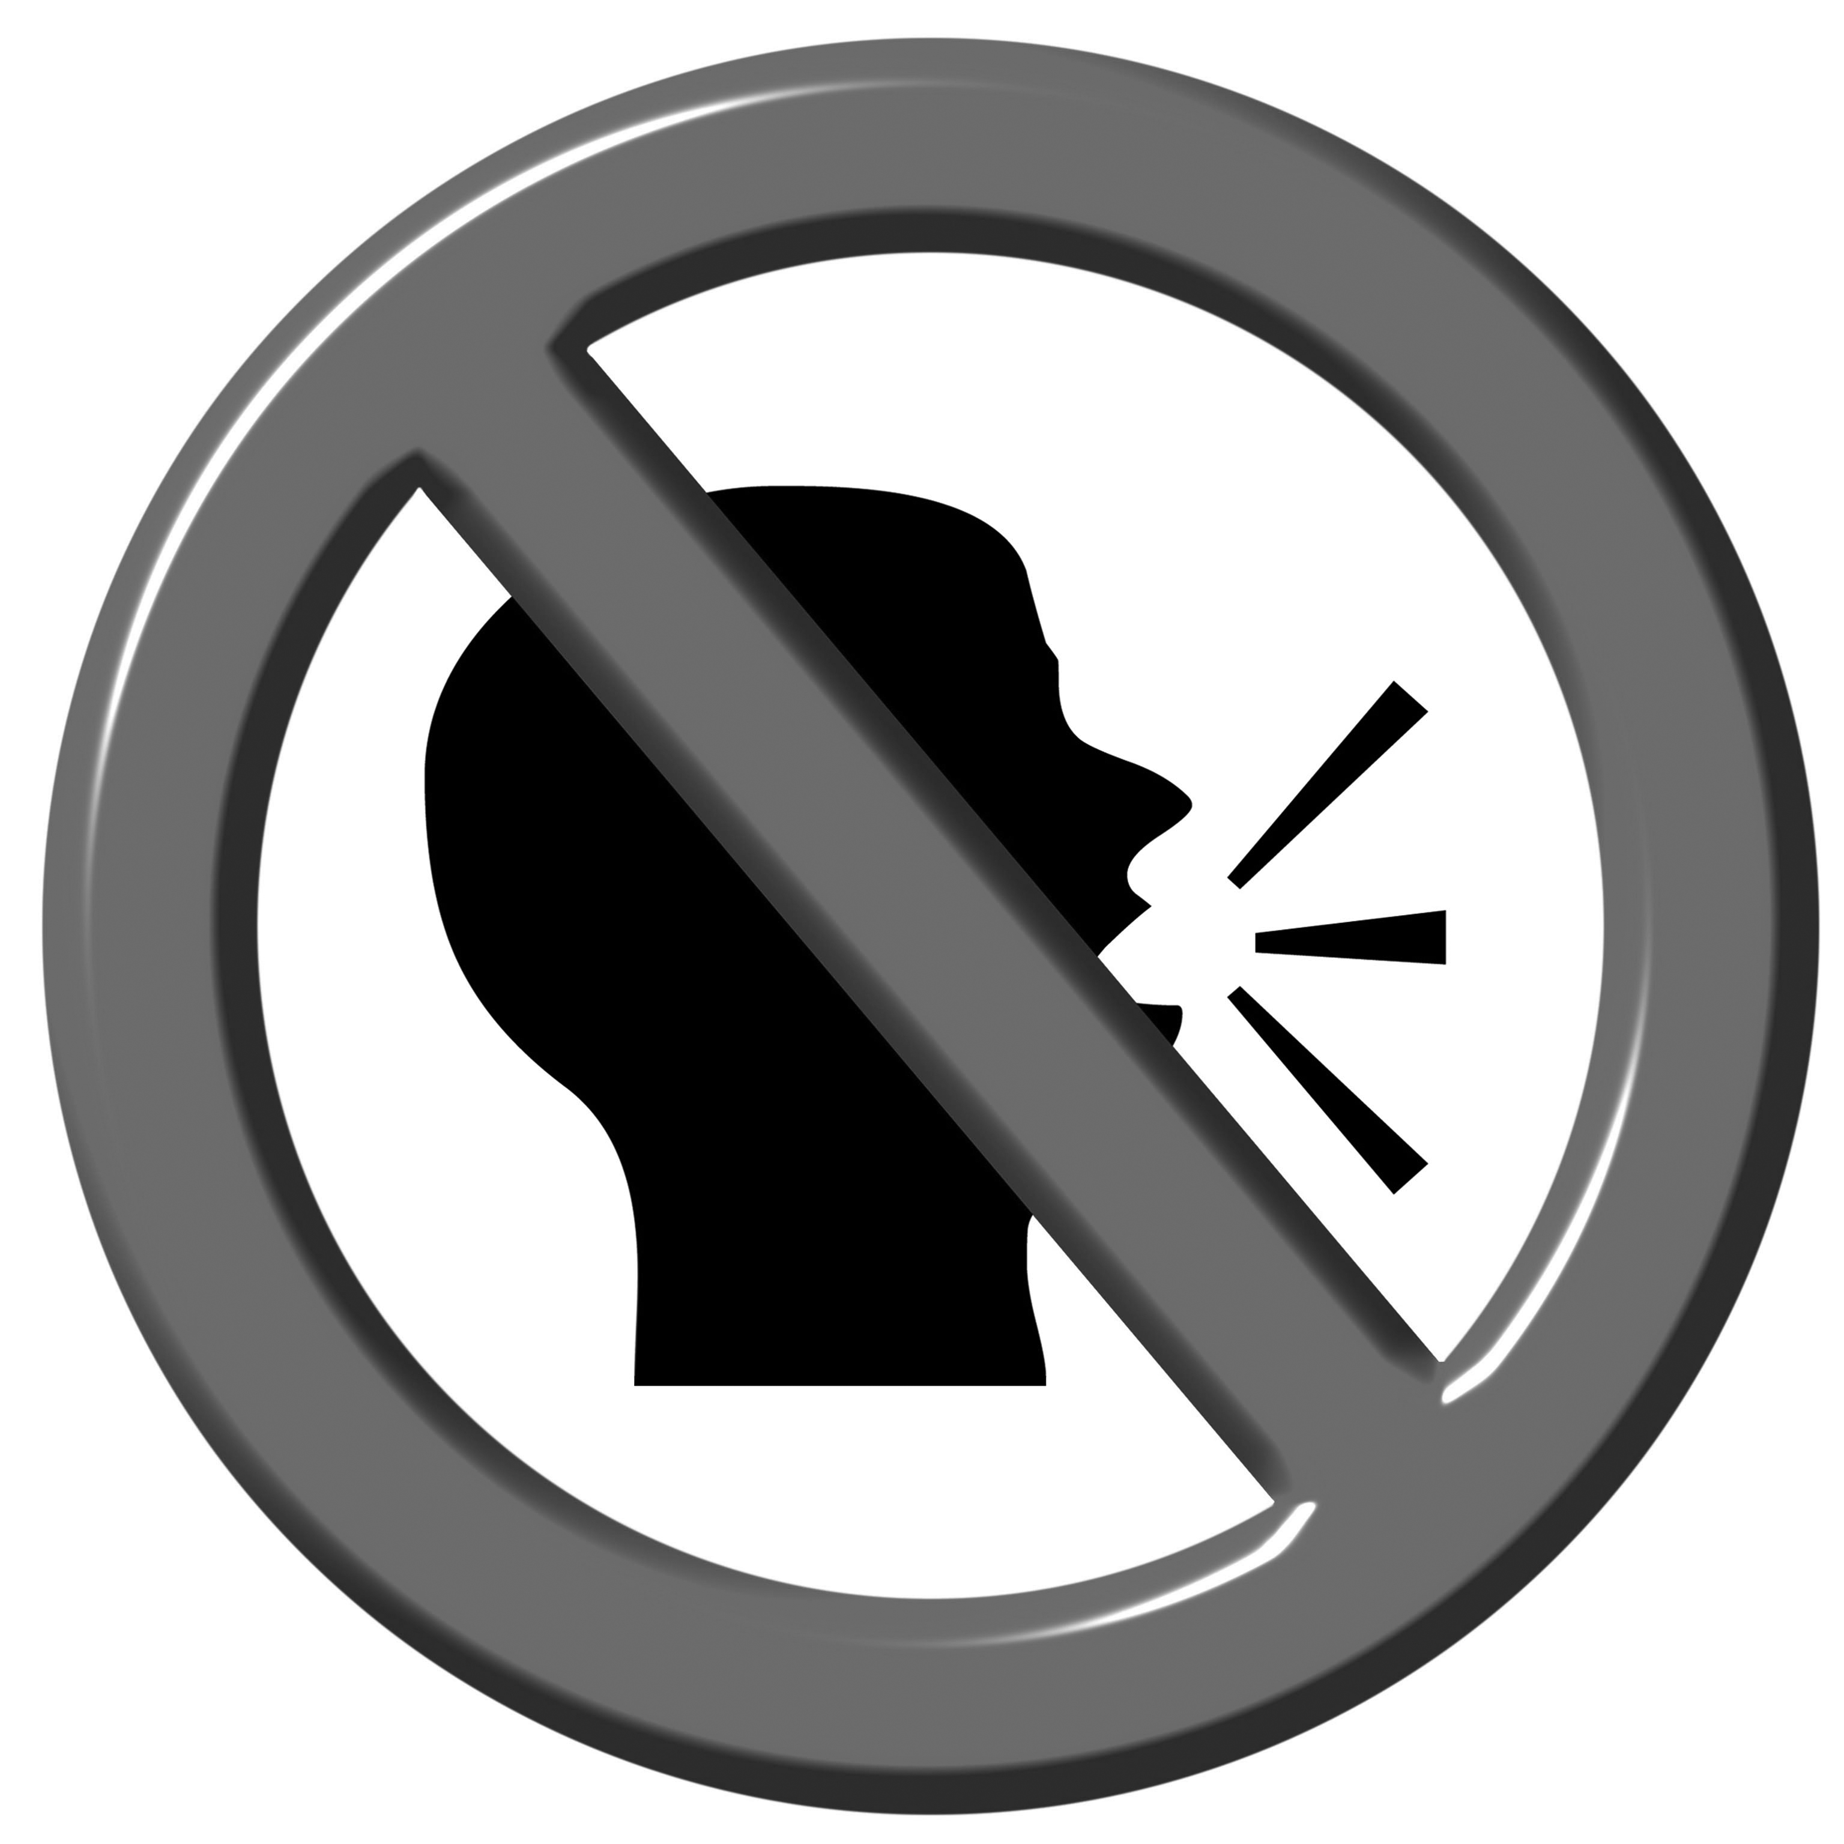
Stand up when you present.
Don’t forget to do your homework.
Use your CD when you study English.
Don’t make too much noise when you work in groups.
Speak English in class!
Don’t shout, speak clearly.

