**Kingdom of Saudi Arabia**

**Subject**: English

**Date** : - 4 -1445H

**First term Exam**

**Period** :

**Time** : two hours

**عدد أوراق الاختبار : ( 3 )**

**Ministry of Education**

**General Directory of Education in Gizan**

**…………………………. School**

**اسئلة اختبارالفصل الدراسي الأول لمادة اللغة الإنجليزية الصف ثاني متوسط لعام1445هـ ( الدور الأول)**

**اسم الطالبة :**.......................................................................

**رقم الجلوس :** .............................................**الصف ثاني متوسط _( )**

| **المجموع الكلي** | **Listening and speaking** | **Total** | **5th**  **orthography** | **4th**  **Vocabulary** | **3rd**  **Grammar** | **2nd**  **comprehension** | **1st composition** | **Question** |
| --- | --- | --- | --- | --- | --- | --- | --- | --- |
| 40 | .**+**  10marks | **30 marks**  **only** | **4 marks only** | **7marks only** | **7 marks**  **only** | **6 marks only** | **6 marks**  **only** |
|  |  | **Teacher:..** | | | | | | **Corrector** |
|  |  | **Teacher..** | | | | | | **Reviser** |
|  |  | **مديرة المدرسة:** | | | | | |  |

**1-Composition**

Write a short paragraph a bout your pastime or hobby .Use the answers to the questions below:

**6**

1. What's your favorite hobby ?/ 2- What equipment do you need for it ?

3-How often do you do it and where do you do it ? 4- Why do you like it ?

……………………………………………………..

……………………………………………………………………………………………………………………………………………………………………………………………………………………………………………………………………………………………………………………………………………………………………………………………………………………………………………………………………………………………

**اسم الطالبة : .................................................................رقم الجلوس: ............................**

**اسم الطالبة : ..................................................**

**6**

**2-Comprehension**

**Read the following passage, then answer the questions:** 

Ali is at home with his family. He is sitting in the kitchen and he is having breakfast. He usually plays football on Saturday mornings, but today it’s raining outside. Everyone in the house is busy. His mother is cleaning the kitchen. His sister is talking on her cell phone. His father is washing the car. And his brother is playing video games. Later his whole family is going to his grandmother’s house. They always have dinner there on Saturdays. Then they usually watch TV. Sometimes they fight over what to watch. Ali and his father like documentaries, but his mother and his sister like detective stories. Ali likes spending time with his family on the weekend.

**A) Write "√ " or "X" :**

1. Ali is at the supermarket with his family ( )
2. He usually plays football on Saturday mornings ( )
3. His mother is cleaning the kitchen ( )
4. Ali and his father like movies. ( )

**B) Choose the correct answer:**

**1-** They always have dinner there on………. **a**-Fridays **b**- Mondays **c**-Saturdays

**2-** His father is washing the………… **a**- car **b**- clothes **c**- room



**3-Grammar**

**7**

**A)** **Choose the correct answer:**



* 1- I am **( write - writing - writes )** a story.
* 2-The ball is **( across - between – far )** the two squares.
* 3-They **( plays – playing – play )** football every day .
* 4-- I don't have **( some - any - many )** milk .
* 5- I love the teacher **( who - which - where )** is kind
* 6- Are you here for the festival? Yes, **( I am - he is - I am not )**



**B) Do as shown between brackets**:

1- She is from Egypt . { Change into **negative** }.

………………………………………….

2- She always read books. ( ) {Say if the place of the adverb in the following sentences is **correct √** or **not correct**× }

اقلبي الصفحة

**اسم الطالبة : .................................................................رقم الجلوس: ............................**

**4-Vocabulary**

**7**

**A ) Match the words to its meaning :**

| 1 | I see |  | yes |
| --- | --- | --- | --- |
| 2 | Yeah |  | I I understand . |
| 3 | I'll have |  | a strong ( No ) |
| 4 | not at all |  | I want – I'd like |
|  |  |  | All by my self |



**B) Write the number of words under the pictures:**

( 1- policeman 2- cook 3- reporter - 4- salad - 5- watch TV

6- doctor 7- painting )



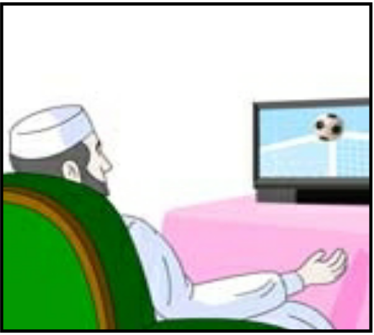





****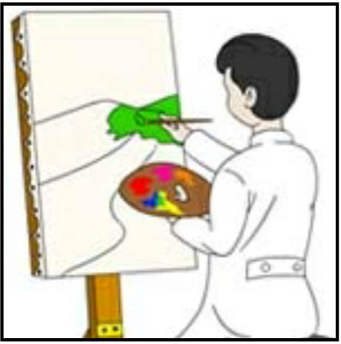

**5-Orthography :**

**4**

1. ***Fill in the missing letter*** :

1- co__fee ( f - d ) 2- jo_ ( b – p )

3- g_eet ( r – n ) 4- fe__tival ( s - h )

5- fi__m ( j – l ) 6- pas__ime ( t – d )



B- Unscramble the letters to form words :

1- enmu………………….. 2- oock…………….

Best Wishes

Teacher ; Amal

|  |  |  |  |  |
| --- | --- | --- | --- | --- |
| **المملكة العربية السعودية**  **وزارة التعليم**  **الإدارة العامة للتعليم ...... .......** | **http://tabuk2day.com/wp-content/uploads/IMG_3362.jpg**  **اختبار الفصل الدراسي الأول**  **للعام الدراسي 1445 هـ** | **المادة** | لغة انجليزية | |
| **الصف** | الثاني المتوسط | |
| **الزمن** | ساعة ونصف | |
| **الدور** | الأول | |
| **الاسم: .............................................................................................................** | | | | |

**30**

1. **Composition**

***Write a paragraph about (* yourself *) not less than 6 sentences using the following words .***

**6**

***( name – age – favorite sport – live –like )***

…………………………………………………………………………………………………………………………………………………………………………………………………………………………………………………………………………………………………………………………………………………………………………………………………………………………………………………………………………………………………………………………………………………………………………………………………………………………………………………………………………………………………………………………………….

**6**

**2. Reading Comprehension**

**Read the passage and answer the questions below :**

**Every Thursday, Mr. Saleh goes shopping. He likes to buy things from the supermarket near his house. It is a big supermarket. He buys meat, fruit, milk and vegetables for the week. Today, two of his children are going with him, Maram and Basil. Maram wants to buy biscuits for her sister Hanan. Basil wants to buy ice-cream. Basil does not have much money. He asks his father to give him some money.**

**Answer :**

**1- What does Mr. Saleh like to buy ? .....................................................................**

**2- Where is the supermarket ? ...............................................................**

**Choose :**

**3- Mr. Saleh likes to…………… things from a supermarket. ( buy - drink - eat )**

**4- Basil asks his father to give him some ( money - milk - ice-cream )**

**5- Today, two of his ……… are going with him. (children - friends teachers)**

**6- It is a ……………… supermarket. ( good - big - small )**

**7**

**3. GRAMMAR**

**Choose the correct words :**

**1- ( who - when - why ) is the tall man?**

**2- he is ( playing - plays - play ) football now .**

**3-she doesn't ( work - works - worked ) in hosbital.**

**4- I am good in math ( and - but - because ) English .**

**5- The book ( which - who ) I read is good .**

**6- sorry we don’t have ( any - some ) juice.**

**7- I know how to ( reads - read - reading ) stories.**

**7**

**4. Vocabulary**

**A-Match the meaning and the responses to the situations :**

|  |  |  |  |
| --- | --- | --- | --- |
| **1** | **How are you?** |  | **I am from Saudi Arabia** |
| **2** | **what are you doing?** |  | **3 books** |
| **3** | **How many books?** |  | **I am playing football** |
| **4** | **Where are you from?** |  | **I fine** |

**B-Match the picture with words:**

**( coffee - shrimp - elevator )**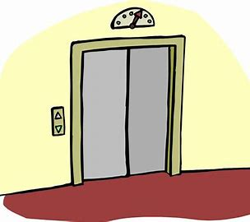

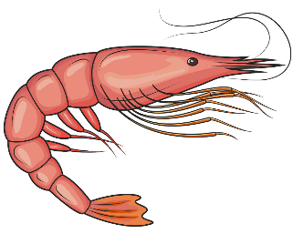

………………………………. ………………………… ....................................

**5. orthography**

**Write the missing letters :**

**4**

**1-comp_ny ( o – a ) 2- j_b ( o - m )**

**3- spo_t ( r- m) 4- vis_on ( i - f)**

**انتهت الاسئله**

|  |  |  |  |  |  |  |
| --- | --- | --- | --- | --- | --- | --- |
| |  | | --- | | **المملكة العربية السعودية** | | **وزارة التعليم** | | **تبوك** | | **المتوسطة الحادية والعشرون** | |  | **اختبار الفصل الدراسي الأول**  **عام 1445**  **اللغة الإنجليزية**  **للصف الثاني متوسط**  **الزمن: 45 دقيقه** |

|  |
| --- |
| اسم الطالبة: الفصل: |

20

**1- Write at least 4 sentences about your last vacation. Use guide words.**

20

**[ went to Abha – with my family – stayed in a hotel – hiking – visited – Asir National Park –]**

**……………………………………………………………………………………**

**…………………………………………………………………………………….**

**……………………………………………………………………………………..**

**…………………………………………………………………………………….**

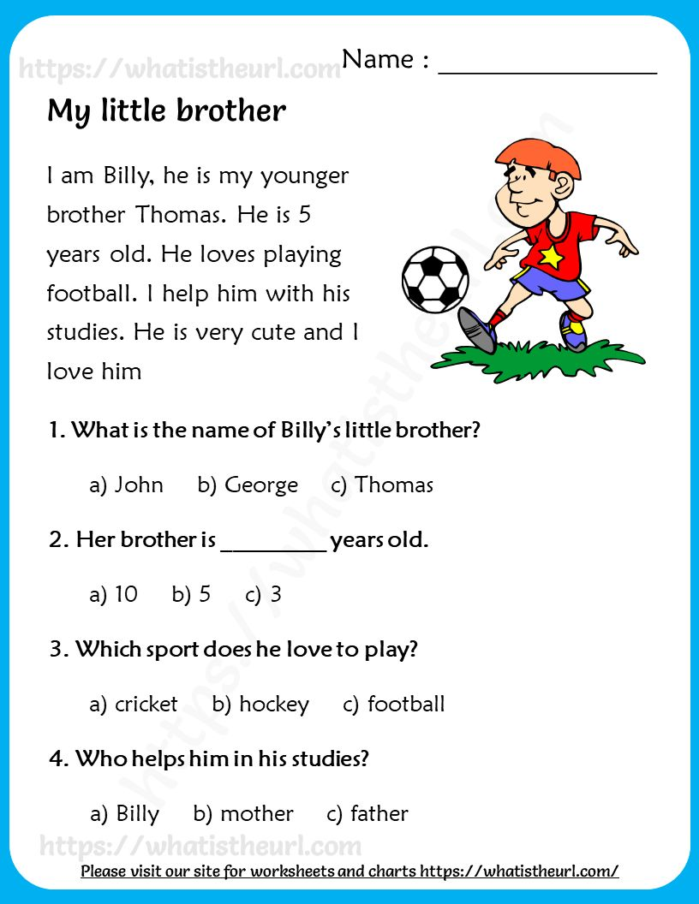***2-Read the following passage and choose the correct answers:***

3-GRAMMAR/A. Choose the correct answer.

1-Riyadh (is – are – am) in Saudi Arabia.

2-(How – what – where ) old are you?

3-Are you (reads – reading – read) the story ?

4-Don't (eat – ate – eating ) the lunch.

B. Do as shown between brackets. [ Correct]

a-Dubai aren't in Egypt. ……………

. b- when is your name? ………………

…………………………………………………………………………………………

4- VOCABULARY: A-Write the opposite:

1- inside x……………………. 2- in front of x …………………..

3- over x ……………… ……. 4- easy x ………………………

Ee elevator credit card hotel castle passport

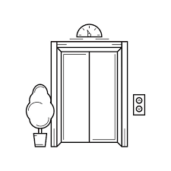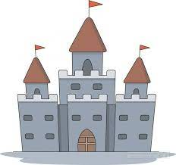صورة تحتوي على قصاصة فنية, لقطة شاشة, التصميم

تم إنشاء الوصف تلقائياً

……………….. ……………………. ………………….. ………………….

**5- Fill in the missing letters:**

1-act….r [ t – o -y] 2- d…rector [ i - a -y]

3- fi….m [ L – e -h] 4- stu…io [ u – o -d]

***T.AFAF Salem***