

المملكة العربية السعودية
وزارة التعليم
الادارة العامة للتعليم بمنطقة ----------------
مدرسة ------------------ المتوسطة
Second Term- Second Session Test
Name: ------------------------------------------------------ Grade: 2nd Inter.
ABOKHALEDAMER
0557325813
1. Write the correct number under its picture: (6M)
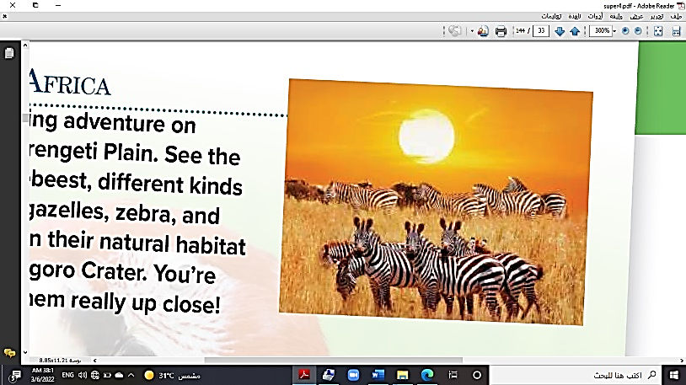
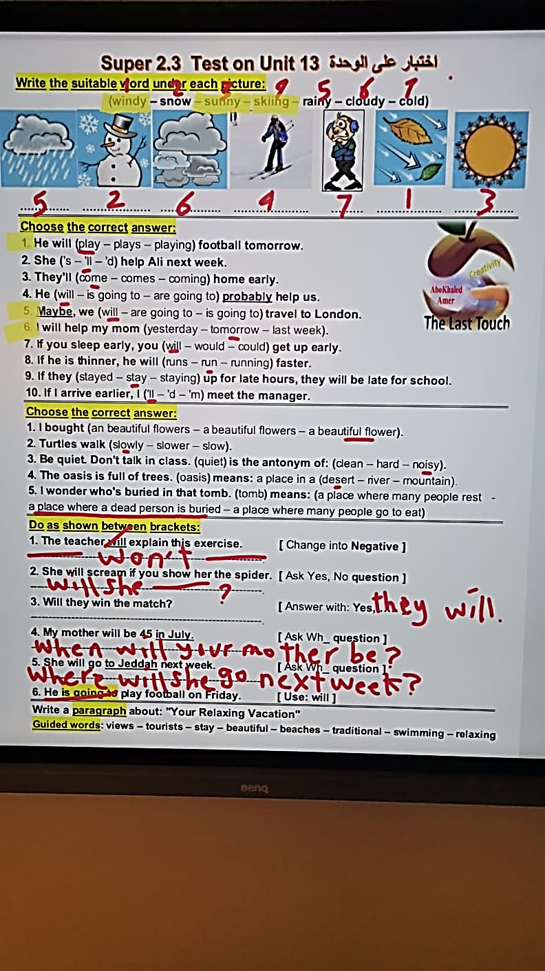
1.sunny 2.skiing 3.mosque 4.zebra 5.windy 6.rainforest
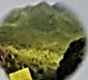
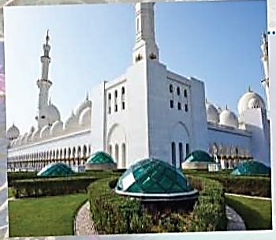

( ) ( ) ( ) ( ) ( ) ( )
2. Choose the correct answer: (6M)
1. She's not (going – goes – go) to visit Petra.
2. We're not going (too – to – toe) visit London.
3. Are you going to (travel – travels – traveling) to Jordan?
4. He will (play – plays – playing) football tomorrow.
5. Maybe, we (will – are going to – is going to) travel to London.
6. I will help my mom (yesterday – tomorrow – last week).
3. Rearrange the following: (4 M)
1. Is she – travel – going to – to Rome? -----------------------------------------------------------
2. take – They – are going to – a bus. -----------------------------------------------------------
3. long – w ill – How – you – stay? ------------------------------------------------------------
4. arrive in – You're – are going to – the morning. -----------------------------------------------
4. Match the Real Talk: (4M)
1. Will you do me a favor? A. lose one’s job.
2. I have no idea. B. shout loudly.
3. be fired C. I don't know.
4. shriek D. Will you help me?
(2) Top Goal - YouTube End of Questions https://t.me/abokhaledamer

