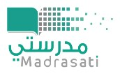
اختبار منتصف الفصل الدراسي الثالث للصف ........... ابتدائي
/20 الدرجة / 6الصف الإسم

- Match : General Questions 3 /

1 – How many students are there in your school?

2- Does your school have a school bus ?

3- Do you have a school uniform?
About 1000 I don't know.

No, we don't.

Yes, it does. It has a big yellow bas.

- Rearrange : controlled Writing 3 / shouldn't / I / computer games / play / too / many /.

………………………………………………………………………………………………………

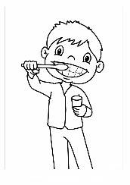
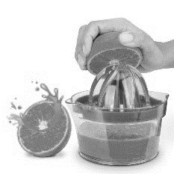
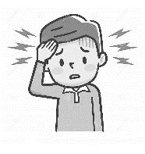
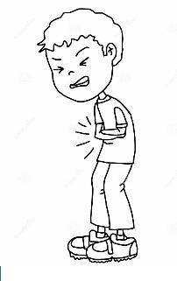
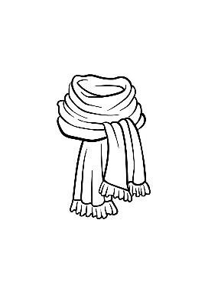
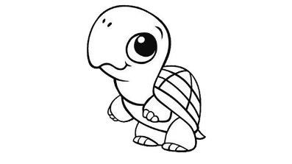
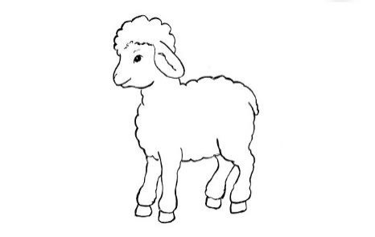
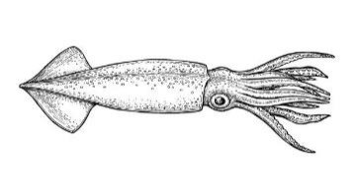
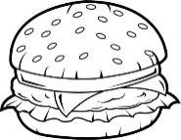
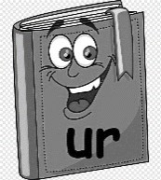
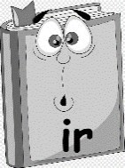
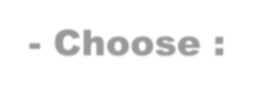
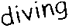
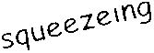
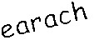
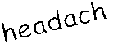
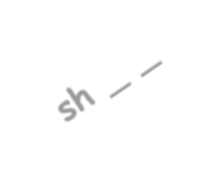
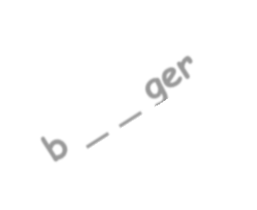
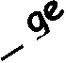
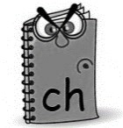
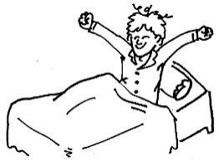
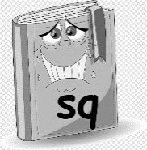
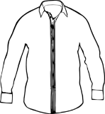
- Choose : Grammar 3 / 1- Did you ………… breakfast this morning ? eat ate play

2 – Last year I ………… in the 5th grade. were was did

3- Which subject do you ………… most this year ? like liked went

Circle : Reading 1-I should get up early .

2 /

2-I should brush my teeth well.

#.Write :

#. Match :

Fill in :

Vocabulary
1-I have a ……………………………………..

2-He's ………………………………… oranges.

Vocabulary stomachache

turtle lamb scarf
Orthography

2 /

4 /

3 /

Good luck… Fekry Bosubaih
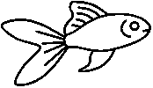
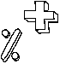
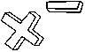
We Can 3 | Term 3 | Unit 9 : My School is Cool!
2
3

Name : _________________________________ Class : _______

Q1. Choose the correct answer :

1
What’ s the name of your school?

We bring our own. Bedrock Elementary School Yes, we do.

How many students are there in your school?

Every day. About 300 No, we don’ t. What time does your school start?
It starts at 7:00 No, it doesn’ t. It has a big yellow bus.

Q2. Read and choose ( T ) for true , ( F ) for false :

1 Rana had a little lamb. T F 2 I like math . T F

Q3. Write : English homework listen

1 Don’ t forget to do your

2 Speak in class! 3 to the teacher.

Q4 . Write about your school .

The name of my school is __________ Elementary School . There are about ______ students in my school. There are about ________
classrooms . Our school starts at ________
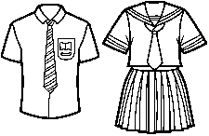
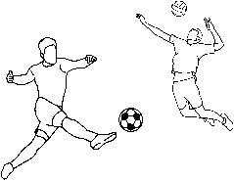
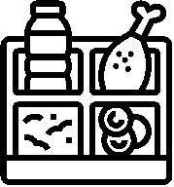
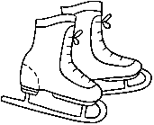
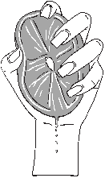
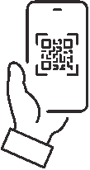
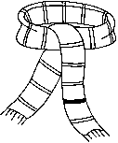
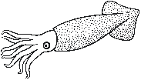
We Can 3 | Term 3 | Unit 9 : My School is Cool!

Name : _________________________________ Class : _______

Q5. Choose the correct answer :

1 Last year I _______ PE. like liked went 2 This year I _____ in the 6th grade. was are am 3 Do you have a school uniform ? ____ , we don’ t. Yes Is No

Q6. Choose the correct answer :

uniform PE math

bus Arabic art
lunch scan

library skirt

Q7: Write the missing letters. :

1 _ _ ate 2 _ _ ueeze
sc sk sq sc sk sq

3 _ _ uid 4 _ _ arf
sc sk sq sc sk sq
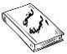
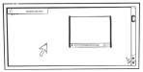
The 6th Grade Unit 9 Exam

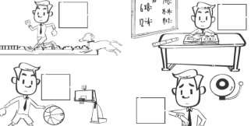
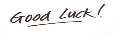
ةجردلا / 6 لصفلا :يثلاث مسلأا

A.Match: General Questions
1. What time does your school start?
2. How many teachers are there in your school? 3. Which city do you live in?

I don’t know. 3 I live in AlHasah.
It starts at 7:00.

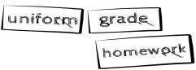
B.Complete: Writing

1. This year I am in the 6th ________________. 2. Don’t forget to do your _________________.
3. The clothes you wear it to school: ________________.

3

C.Match: Reading

1. The most subject I like is a math. 2. I can play in the school yard.
3. We finish school at one o'clock.
4. The dog follows me to home. 4

D.Match:

E.Choose:

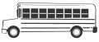
Vocabulary school bus
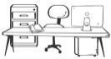
principal's office Arabic language
interactive board 4

Grammar

1. Yesterday I have – had a party.
2. Last year we are - were in the 5th grade. 3 3. Listen – Speak to the CD when you study English.

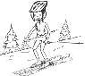
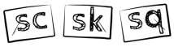
F.Complete: Spelling

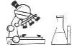
__ __ ate __ __ ience __ __ uare 3 _________ / ةدالما
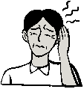
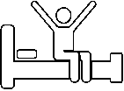
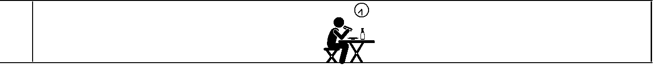
We Can 3 | Term 3 | Unit 9 : My School is Cool!
2
3
4

Name : _________________________________ Class : _______

Q1. Choose the correct answer :

1
What should you do to live a healthy life? - I should … … … …

drink a lot of water. watch too much TV. drink too much soda.

What‘s the matter? Welcome
How much is it?

Yes, thanks.

I have a toothache .

It’ s 30 SAR.

Here you go.

Good morning

Do you like Pizza ? - Yes ,… … … …

I didn’ t I do I doesn’ t

Q2. Read and choose ( T ) for true , ( F ) for false :

1 I have a stomachache. T F 2 Early to bed , makes you healthy . T F 3 She has a toothache because she never goes to the dentist. T F

Q3. Write : brush eat get up

1 I early.

2 I my teeth 3 I breakfast.
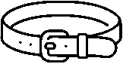
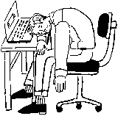
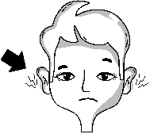
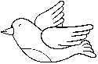
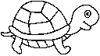
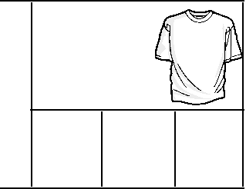
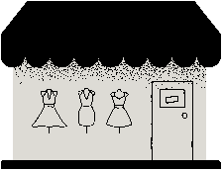
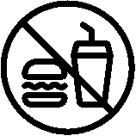
We Can 3 | Term 3 | Unit 10 : A Healthy Life
I

Name : _________________________________ Class : _______

Q4. Choose the correct answer :

1 Did you _______ your teeth ? brush brushing brushed 2 Did you drink milk ? - Yes, I … … … milk . drink drank drinking 3 Did you eat breakfast ? - No, I didn’ t… … .. breakfast. ate eat eats
Q5. Choose the correct answer :

should

shouldn’ t
belt

cardigan
stomachache

earache
tired

healthy
clothing store

DVD store

Q6. Write : should shouldn’ t

1 You do some exercise.

2 You play too many computer games. 3 You skip breakfast.

Q7: Write the missing letters. :

1 b _ _ d 2 b _ _ ger
ur ir or ur ir or
3 t_ _ tle 4 sh _ _ t
ur ir or ur ir or

