|  |  |  |
| --- | --- | --- |
|  | بسم الله الرحمن الرحيم    **الاسم رباعياً: ..................................................................... الصف : ............... رقم الجلوس : ..............** | المادة: اللغة الانجليزية  الصف الدراسي: السادس الابتدائي  القسم: الإبتدائي ( عام )  الفصل الدراسي: الثاني  الدور: الاول  العام الدراسي: 1443 / 1444 هـ  الزمن: ساعة ونصف |

**مستعينة بالله أجيبي عن الستة الأسئلة التالية**

**6**

**Q1 : Choose the right answer:**

|  |  |
| --- | --- |
| **A** . **I usually get up at 6:00.** **B**. **I got up at 6:00.** | **1 – What time do you get up in the morning?** |
| **A**.. **It is ten o'clock** **B**.  **It is ten thirty.** | **2 – What is the time? 10:30** |
| **A**. **I am playing.** **B**. **He is a doctor .** | **3- What does your dad do ?** |
| **A** . **He puts out fires .** **B. He flies plane** | **4- What does the firefighter do?** |
| **A**. **It is 10 SAR.** **B**.  **We need 2 cups.** | **5- How much flour do we need?** |
| **A**. **Sorry about that B**. **Congratulations** | **6- I won a table tennis game 21 to 3 .** |

**5**

**Q2:Do as shown between brackets:**

|  |  |  |  |
| --- | --- | --- | --- |
| **.......................................................** | | | **1 – breakfast – cooked – she (Rearrange)** |
| **..........................................................** | | | **2 –sick-I- was (Rearrange)** |
| **..........................................................** | | | **3 – one. ………….One To Hundred | Numbers Song | 123 ABC | Learning Numbers For Toddlers by  Kids Tv - YouTube (complete)** |
| **Ice cream** | **soup** | **cheese** | 36,849 Cartoon Soup Images, Stock Photos & Vectors | Shutterstock**(choose) 4- I'd like please .** |
| **grocer's** | **park** | **bank** | **5- I went to the to buy some milk ( choose )** |

2

**الاسم رباعياً: ..................................................................... الصف : ............... رقم الجلوس : ..............**

|  |  |  |
| --- | --- | --- |
| Using a digital clock**1. It is seven o'clock. .** | 🗸 | 🗴 |
| Free To Use & Public Domain People Clip Art - Page 10 | Nurse clip art, Nurse  cartoon, Nurse art**2. She works in a school.** | 🗸 | 🗴 |
| A boy playing soccer cartoon vector illustration. A boy playing soccer kick  a ball cartoon vector illustration. | CanStock**3. He kicked a ball.** | 🗸 | 🗴 |
| **She watched TV.** **Cartoon Cleaning Lady Images – Browse 42,413 Stock Photos, Vectors, and  Video | Adobe Stock. 4** | 🗸 | 🗴 |

**Q3: Choose (🗸) or (×):**

**4**

**5**

**Q4:Choose :**

|  |  |  |  |
| --- | --- | --- | --- |
| **go** | **came** | **come** | **1. yesterday, I ___ home at 1:00** |
| **talk** | **take** | **took** | **2- The PAST tense of (take) is ___** |
| **under** | **in** | **on** | **3- He works _____ a hospital** |
| **many** | **some** | **any** | **4- We don't have ____ oil .** |
| **some** | **many** | **much** | **5- How ___ tomatoes do you need ? .** |

3

**الاسم رباعياً: ..................................................................... الصف : ............... رقم الجلوس : ..............**

**Q5: Write the right word under its picture :**

**6**

**–** Three hundred **–** baker **–** firefighter **–** doctor **-** brushclock

|  |  |  |  |  |  |
| --- | --- | --- | --- | --- | --- |
| Toothbrush Cartoon Images – Browse 23,759 Stock Photos, Vectors, and Video  | Adobe Stock | Premium Vector | Baker cartoon character holding a bread. vector hand drawn  illustration |  | Cute doctor vector illustration isolated on white background. Doctor cartoon  illustration Stock Vector Image & Art - Alamy |  | Numeral 300, Three Hundred, Isolated on White Background, 3d Render Stock  Illustration - Illustration of sign, color: 87371819 |
| --------------- | ---------------------- | --------------- | -------------------------- | --------------- | --------------- |

**4**

**Q6 : Choose the correct letter :**

**( gh , cl , ph , kn , gh, f , nd ,nt )**

|  |  |  |  |  |  |  |  |
| --- | --- | --- | --- | --- | --- | --- | --- |
| Cartoon Light Stock Illustrations – 284,989 Cartoon Light Stock  Illustrations, Vectors & Clipart - Dreamstime |  |  |  |  | Premium Vector | Cute alarm clock cartoon character | Cartoon illustration of tent flat design. Vector illustration 2795138  Vector Art at Vecteezy |  |
| **li_ _ t** | **_ _ee** | **_rog** | **sta_ _** | **f_ _k** | **_ _ock** | **Te_ _** | **Lau_ _** |

**GOOG LUCk**

**T: Halah Aldowsary**

**4**

|  |  |  |  |
| --- | --- | --- | --- |
| **المملكة العربية السعودية**  **وزارة التعليم**  **الإدارة العامة للتعليم بـن مدرسة م ن الابتدائية** | http://tabuk2day.com/wp-content/uploads/IMG_3362.jpg***بسم الله الرحمن الرحيم***  **اختبار الفصل الدراسي الثاني**  **للعام الدراسي 1444 هـ**  **https://t.me/abokhaledamer** | **المادة** | **لغة انجليزية** |
| **الصف** | **السادس** |
| **الزمن** | **ساعة ونصف** |
| **الفصل** | **----- /6** |
| **اسم الطالب رباعيا: .............................................................................................................رقم الجلوس: ------------**   |  |  |  |  |  |  |  |  | | --- | --- | --- | --- | --- | --- | --- | --- | | **السؤال** | **1** | **2** | **3** | **4** | **5** | **6** | **المجموع** | | **الدرجة** |  |  |  |  |  |  |  | | **الدرجة** | 6 | 5 | 4 | 5 | 6 | 4 | 30 | | **المصحح** |  |  |  |  |  |  |  | | | | |

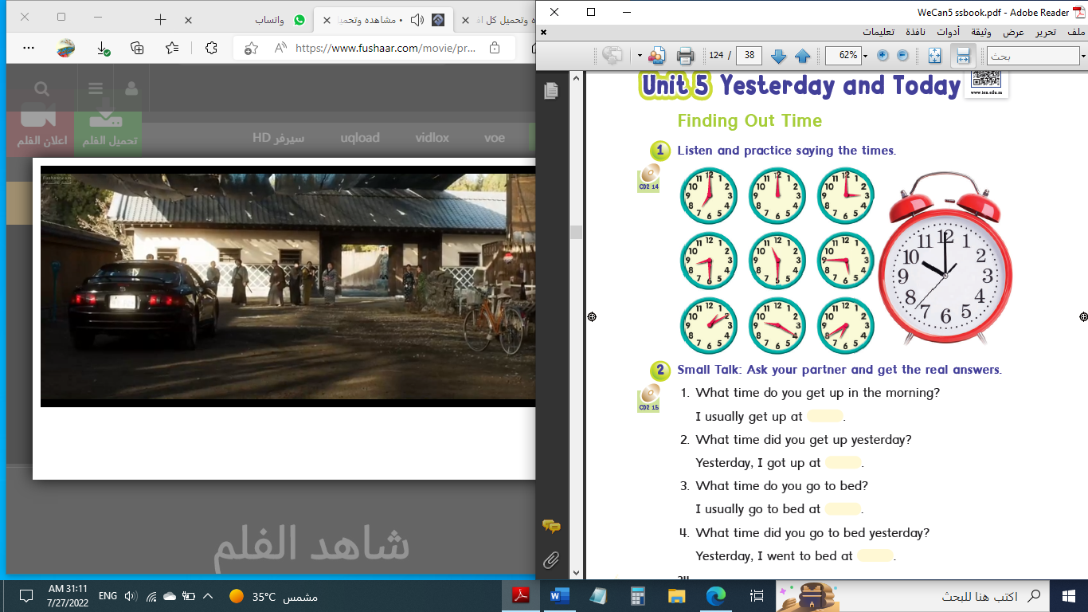

**6**

**I- General Questions:**

**Q1: A. Choose the suitable answer:**

**1. What time is it?**

****( It’s one o’clock. - It’s ten o’clock. - It’s twelve o’clock. )

**2. What do you do?**

( I’m a doctor. – I’m fine, thank you. – I’m Ali. )



**3. Ali cooked a nice ------------.**

( trampoline – sharks - breakfast )

**B. Answer these questions:**

**1.What is the past of “make”? _______________.**

**2. What time do you get up?**  **____________________.**

**3. Where do teachers work? _______________________________.**

**5**

**II- Controlled Writing:**

**Q2: Do as shown between brackets:**

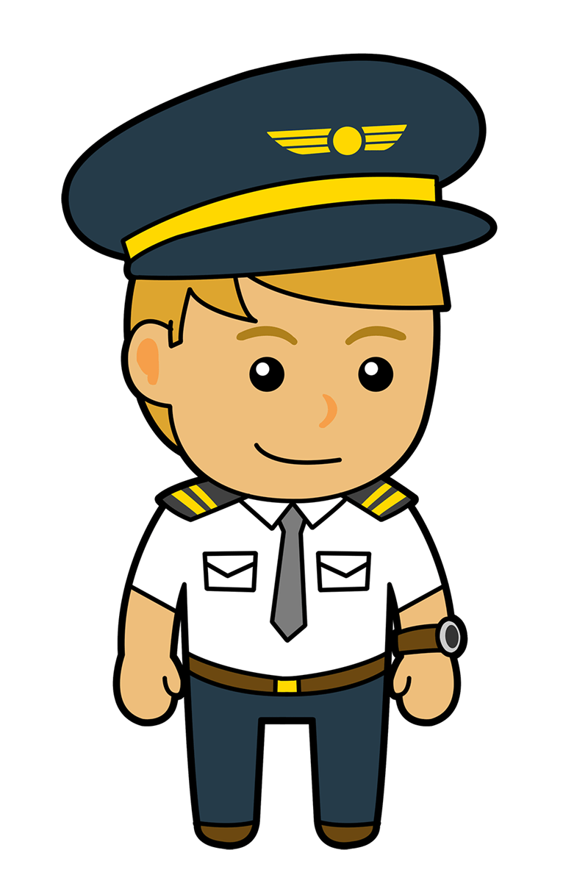**1. I – homework – do – at 4:00. (**Rearrange**) _______________.**

**2. When I grow up, I want to be a _______________.**  **(**Complete**)**

**3. How many tomatoes do we need? (**Answer**) _______________.**

**4. cleaned – my – I – room. (**Rearrange**) _______________.**

**5. went – Khaled – the cupboard. – to (**Rearrange**)__________________.**

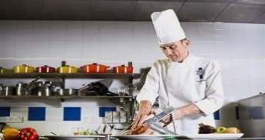**III- Reading Short Sentence:**

**4**

**Q3: Match the sentence with the picture:**

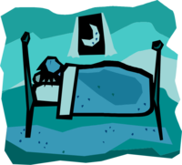**1. I go to bed at 10:00.**

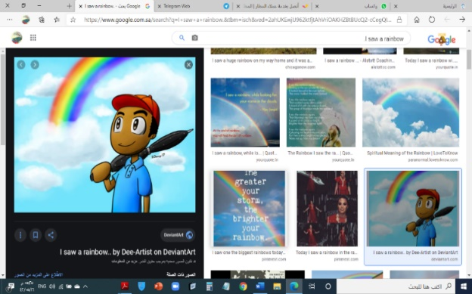**2. The cook works in a restaurant.**

**3. Fahad studied for 6 hours.**

**4. I saw a rainbow.**

**IV- Grammar:**

**5**

**Q4: Choose the correct answer:**

**1. What time (** do – does – did **) you go to bed yesterday?**

**2. I usually (** meet – meets – met **) my friends at the mall.**

**3. (** Where – When – What **) does a nurse work? She works in a hospital.**

**4. (** What – Who – When **) does he do? He is a student.**

**5. How (** many – much – old **) tea do you need?**

**6. We need (** some – any – not **) apples.**

**7. We don’t have (** some – any – no **) tomatoes.**

**8. Yesterday, we (** have – had – has **) some salad.**

**9. Yesterday, we (** don’t – doesn’t – didn’t **) have any ketchup.**

**6**

**10. Sorry (** on – to – about **) that.**

**V- Vocabulary:**

**Q5: Write the correct number under each picture:**

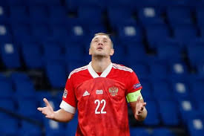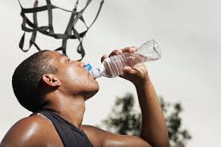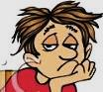 **1**- firefighter **2**- boring **3**- captain **4**- ring **5**- trampoline 6- drink

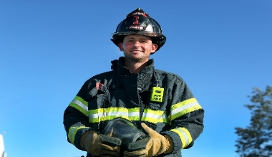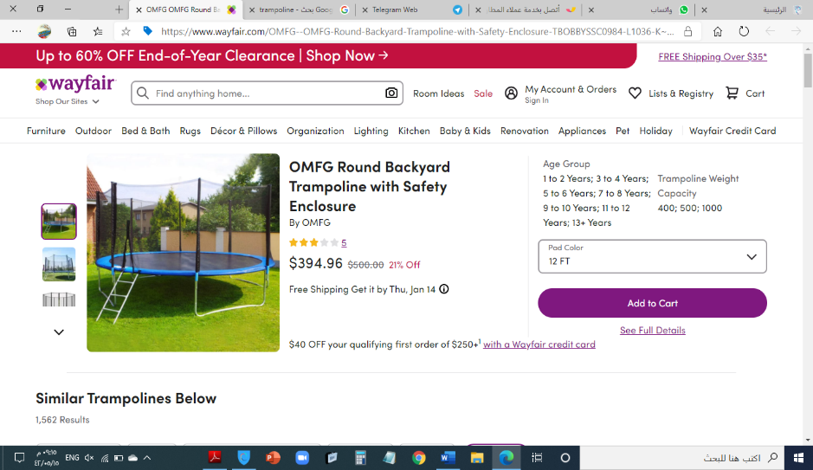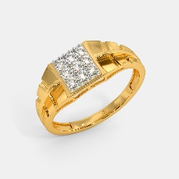

**4**

**( ) ( ) ( ) ( ) ( ) (** )

**VI- Orthography:**

**Q6: Fill in the missing letters: gh / sh / wh / fr / ph / nd / nt / kn**

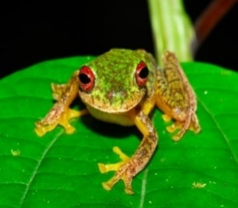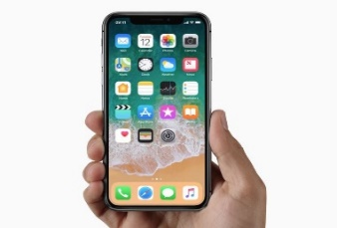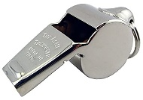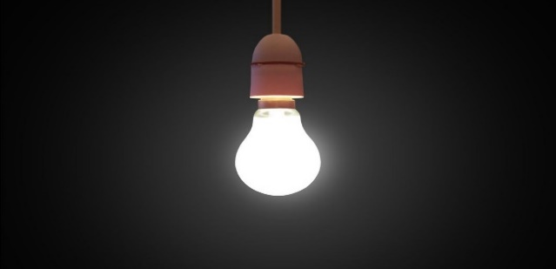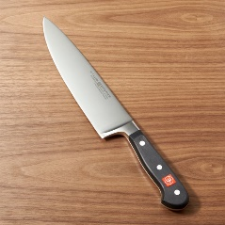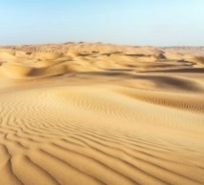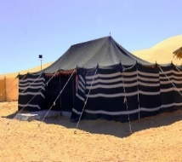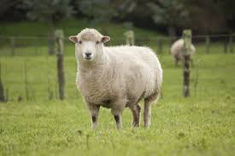

**_ _ eep _ _ istle li _ _ t _ _ ife sa_ _ te_ _ _ _ one _ _ og**

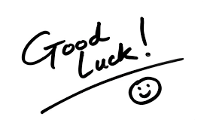

**End of Questions**

**ABOKHALEDAMER**

**0557325813**

|  |  |  |  |
| --- | --- | --- | --- |
| **المملكة العربية السعودية**  **وزارة التعليم**  **الإدارة العامة للتعليم بـن مدرسة م ن الابتدائية** | http://tabuk2day.com/wp-content/uploads/IMG_3362.jpg***بسم الله الرحمن الرحيم***  **اختبار الفصل الدراسي الثاني**  **للعام الدراسي 1444 هـ**  **https://t.me/abokhaledamer** | **المادة** | **لغة انجليزية** |
| **الصف** | **السادس** |
| **الزمن** | **ساعة ونصف** |
| **الفصل** | **----- /6** |
| **اسم الطالب رباعيا: .............................................................................................................رقم الجلوس: ------------**   |  |  |  |  |  |  |  |  | | --- | --- | --- | --- | --- | --- | --- | --- | | **السؤال** | **1** | **2** | **3** | **4** | **5** | **6** | **المجموع** | | **الدرجة** |  |  |  |  |  |  |  | | **الدرجة** | 6 | 5 | 4 | 5 | 6 | 4 | 30 | | **المصحح** |  |  |  |  |  |  |  | | | | |



**6**

**I- General Questions:**

**Q1: A. Choose the suitable answer:**

**1. What time is it?**

****( It’s one o’clock. - **It’s ten o’clock**. - It’s twelve o’clock. )

**2. What do you do?**

( **I’m a doctor**. – I’m fine, thank you. – I’m Ali. )



**3. Ali cooked a nice ------------.**

( trampoline – sharks - **breakfast** )

**B. Answer these questions:**

**1.What is the past of “make”? __made_.**

**2. What time do you get up?**  **__I get up at 6:00.__**

**3. Where do teachers work? __They work at school._**

**5**

**II- Controlled Writing:**

**Q2: Do as shown between brackets:**

**1. I – homework – do – at 4:00. (**Rearrange**) _I do homework at 4:00._**

**2. When I grow up, I want to be a __pilot.__**  **(**Complete**)**

**3. How many tomatoes do we need? (**Answer**) _We need 3 tomatoes._**

**4. cleaned – my – I – room. (**Rearrange**) _I cleaned my room._**

**5. went– Khaled– the cupboard.– to (**Rearrange**)Khaled went to the cupboard._**

**III- Reading Short Sentence:**

**4**

**Q3: Match the sentence with the picture:**

**1. I go to bed at 10:00.**

**2. The cook works in a restaurant.**

**3. Fahad studied for 6 hours.**

**4. I saw a rainbow.**

**IV- Grammar:**

**5**

**Q4: Choose the correct answer:**

**1. What time (** do – does – **did** **) you go to bed yesterday?**

**2. I usually ( meet** – meets – met **) my friends at the mall.**

**3. ( Where** – When – What **) does a nurse work? She works in a hospital.**

**4. ( What** – Who – When **) does he do? He is a student.**

**5. How (** many – **much** – old **) tea do you need?**

**6. We need ( some** – any – not **) apples.**

**7. We don’t have (** some – **any** – no **) tomatoes.**

**8. Yesterday, we (** have – **had** – has **) some salad.**

**9. Yesterday, we (** don’t – doesn’t – **didn’t ) have any ketchup.**

**6**

**10. Sorry (** on – to – **about ) that.**

**V- Vocabulary:**

**Q5: Write the correct number under each picture:**

 **1**- firefighter **2**- boring **3**- captain **4**- ring **5**- trampoline 6- drink



**4**

**(6) (4) (1) (5) (2) (3**)

**VI- Orthography:**

**Q6: Fill in the missing letters: gh / sh / wh / fr / ph / nd / nt / kn**



**Sheep whistle light knife sand tent phone frog**



**End of Questions**

**ABOKHALEDAMER**

**0557325813**

|  |  |  |  |
| --- | --- | --- | --- |
| **المملكة العربية السعودية**  **وزارة التعليم**  **الإدارة العامة للتعليم بـن مدرسة م ن الابتدائية** | http://tabuk2day.com/wp-content/uploads/IMG_3362.jpg***بسم الله الرحمن الرحيم***  **اختبار الفصل الدراسي الثاني**  **للعام الدراسي 1444 هـ**  **https://t.me/abokhaledamer** | **المادة** | **لغة انجليزية** |
| **الصف** | **السادس** |
| **الزمن** | **ساعة ونصف** |
| **الفصل** | **----- /6** |
| **اسم الطالب رباعيا: .............................................................................................................رقم الجلوس: ------------**   |  |  |  |  |  |  |  |  | | --- | --- | --- | --- | --- | --- | --- | --- | | **السؤال** | **1** | **2** | **3** | **4** | **5** | **6** | **المجموع** | | **الدرجة** |  |  |  |  |  |  |  | | **الدرجة** | 6 | 5 | 4 | 5 | 6 | 4 | 30 | | **المصحح** |  |  |  |  |  |  |  | | | | |

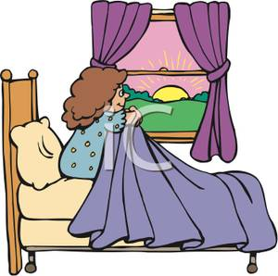

**6**

**I- General Questions:**

**Q1: A. Choose the suitable answer:**

**1. What time do you get up?**

( I get up at 5:30. - I got up at 5:30. – He got up at 5:30. )



**2. Where do you work?**

**I work** ( in a school – in the morning – in time.)



**3. You practiced on the ----------.**

( trampoline – sharks - breakfast )

****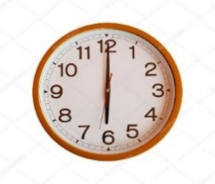**B. Answer these questions:**

**1. What time is it?**  **_______________.**

**2. What do you do?**  **____________________.**

**3. What is the past of “get”? _______________________________.**

**5**

**II- Controlled Writing:**

**Q2: Do as shown between brackets:**

**1. He – a bath – at 2:30. - took (**Rearrange**) ____________________.**

**2. They usually _________ lunch at 2:30. (**Complete**)**

**3. helps – people. – A doctor – sick (**Rearrange**) ___________________.**

**4. don’t – oil. – We – have – any (**Rearrange**) ____________________.**

**5. I (get) 200 points yesterday. ________________. (**Correct**)**

**III- Reading Short Sentence:**

**4**

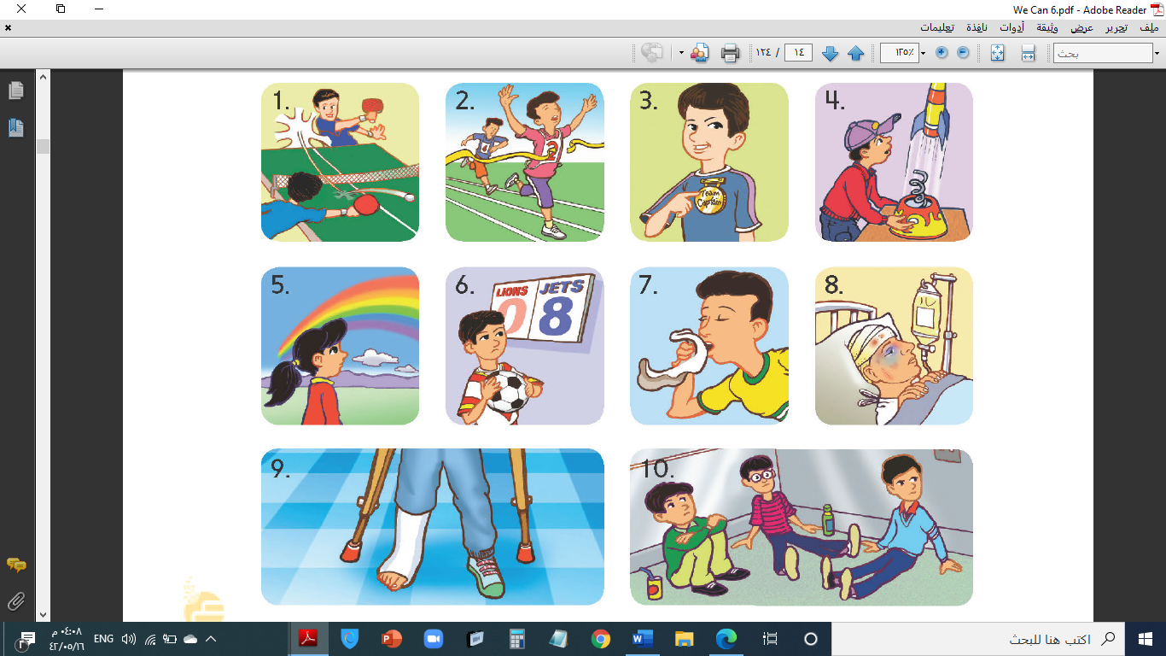**Q3: Match the sentence with the picture:**

**1. He brushed his teeth.**

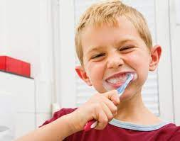**2. I want to be an astronaut.**

**3. Nora stayed home.**

**4. I got the first place in a race.**

**IV- Grammar:**

**5**

**Q4: Choose the correct answer:**

**1. She (** have – has – had **) a good dream yesterday.**

**2. (** When – What – Where **) time do you come home?**

**3. When I grow up, I (** wants – wanting – want **) to be an engineer.**

**4. (** Who – When – What **) is she? She is Nora.**

**5. How (** many – much – old **) mushrooms do we need?**

**6. We have (** some – any – not **) peppers.**

**7. How much (** apples – oil – tomatoes **) do you want?**

**8. We don’t have (** some – any – no **) oranges.**

**9. Yesterday, we (** have – had – has **) some salad.**

**6**

**10. We (** is – was – were **) happy.**

**V- Vocabulary:**

**Q5: Write the correct number under each picture:**

 **1**- rocket **2**- swing **3**- stay up **4**- clock **5**- rainbow 6- engineer

****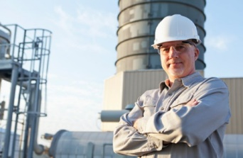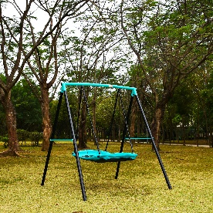

**4**

**( ) ( ) ( ) ( ) ( ) (** )

**VI- Orthography:**

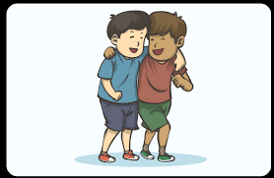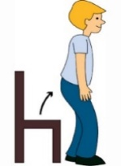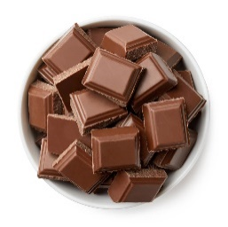**Q6: Fill in the missing letters: gh / sh / ch / fr / ph / nd / nt / kn**

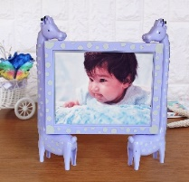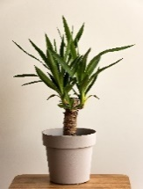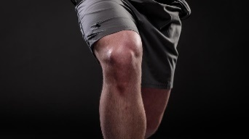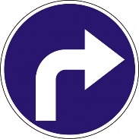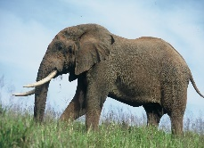

**_ _ocolate ele_ _ant ri_ _t _ _nee sta_ _ pla_ _ _ _iends _ _oto**



**End of Questions**

**ABOKHALEDAMER**

**0557325813**

|  |  |  |  |
| --- | --- | --- | --- |
| **المملكة العربية السعودية**  **وزارة التعليم**  **الإدارة العامة للتعليم بـن مدرسة م ن الابتدائية** | http://tabuk2day.com/wp-content/uploads/IMG_3362.jpg***بسم الله الرحمن الرحيم***  **اختبار الفصل الدراسي الثاني**  **للعام الدراسي 1444 هـ**  **https://t.me/abokhaledamer** | **المادة** | **لغة انجليزية** |
| **الصف** | **السادس** |
| **الزمن** | **ساعة ونصف** |
| **الفصل** | **----- /6** |
| **اسم الطالب رباعيا: .............................................................................................................رقم الجلوس: ------------**   |  |  |  |  |  |  |  |  | | --- | --- | --- | --- | --- | --- | --- | --- | | **السؤال** | **1** | **2** | **3** | **4** | **5** | **6** | **المجموع** | | **الدرجة** |  |  |  |  |  |  |  | | **الدرجة** | 6 | 5 | 4 | 5 | 6 | 4 | 30 | | **المصحح** |  |  |  |  |  |  |  | | | | |



**6**

**I- General Questions:**

**Q1: A. Choose the suitable answer:**

**1. What time do you get up?**

( **I get up at 5:30**. - I got up at 5:30. – He got up at 5:30. )



**2. Where do you work?**

**I work** ( **in a school** – in the morning – in time.)



**3. You practiced on the ----------.**

( **trampoline** – sharks - breakfast )

******B. Answer these questions:**

**1. What time is it?**  **_It's 6 o'clock._**

**2. What do you do?**  **_I'm a pilot.__**

**3. What is the past of “get”? ____got_______.**

**5**

**II- Controlled Writing:**

**Q2: Do as shown between brackets:**

**1. He – a bath – at 2:30. - took (**Rearrange**) _He took a bath at 2:30._**

**2. They usually _have_ lunch at 2:30. (**Complete**)**

**3. helps – people. – A doctor – sick (**Rearrange**) _A doctor helps sick people._**

**4. don’t – oil. – We – have – any (**Rearrange**) _We don't have any oil._**

**5. I (get) 200 points yesterday. __got_____. (**Correct**)**

**III- Reading Short Sentence:**

**4**

**Q3: Match the sentence with the picture:**

**1. He brushed his teeth.**

**2. I want to be an astronaut.**

**3. Nora stayed home.**

**4. I got the first place in a race.**

**IV- Grammar:**

**5**

**Q4: Choose the correct answer:**

**1. She (** have – has – **had** **) a good dream yesterday.**

**2. (** When – **What** – Where **) time do you come home?**

**3. When I grow up, I (** wants – wanting – **want ) to be an engineer.**

**4. ( Who** – When – What **) is she? She is Nora.**

**5. How ( many** – much – old **) mushrooms do we need?**

**6. We have ( some** – any – not **) peppers.**

**7. How much (** apples – **oil** – tomatoes **) do you want?**

**8. We don’t have (** some – **any** – no **) oranges.**

**9. Yesterday, we (** have – **had** – has **) some salad.**

**6**

**10. We (** is – was – **were ) happy.**

**V- Vocabulary:**

**Q5: Write the correct number under each picture:**

 **1**- rocket **2**- swing **3**- stay up **4**- clock **5**- rainbow 6- engineer



**4**

**(2) (4) (6) (3) (5) (1**)

**VI- Orthography:**

****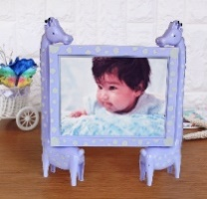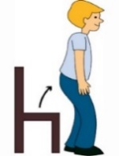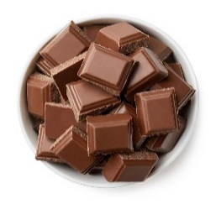**Q6: Fill in the missing letters: gh / sh / ch / fr / ph / nd / nt / kn**



**chocolate elephant right knee stand plant friends photo**



**End of Questions**

**ABOKHALEDAMER**

**0557325813**

**Q1_Choose.**

1. I usually [ take – took ] a bath in the morning.
2. Yesterday, I [ do – did ] my homework after school
3. I usually [ eat - ate ] lunch at 3 p.m
4. I usually [ get– do ] up at 5:00 .
5. HOW] much – many [ milk do you drink .
6. How ] much – many [eggs do you need .
7. How ]much – many [ apples do we have.
8. There are ] some – any [ chocolates .
9. We don’t have ] some – any [ bananas .

10. What is the time ? **10:30** it is ] three clock - ten thirty [

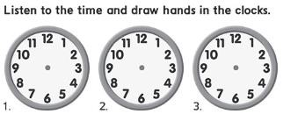**Q2_**

|  |  |  |
| --- | --- | --- |
| 8:15 |  | 1:30 |

|  |
| --- |
| 3:00 |

**Q3_ Read the sentences then put (T** ✓**) or ( F ×) :**

|  |  |  |
| --- | --- | --- |
| **1. It is seven o'clock.** | 🗸 | 🗴 |
| **2. I eat my lunch.** | 🗸 | 🗴 |
| **3-she is a teacher** | 🗸 | 🗴 |
| **4- He is a pilot.** | 🗸 | 🗴 |
| **5- He is a** **firefighter.** | 🗸 | 🗴 |
| A boy playing soccer cartoon vector illustration. A boy playing soccer kick  a ball cartoon vector illustration. | CanStock**6- He kicked a ball.** | 🗸 | 🗴 |
| **7- She watched TV Cartoon Cleaning Lady Images – Browse 42,413 Stock Photos, Vectors, and  Video | Adobe Stock** | 🗸 | 🗴 |

Q4_**Write the word under the correct picture.**

|  |  |  |  |  |  |
| --- | --- | --- | --- | --- | --- |
| Toothbrush Cartoon Images – Browse 23,759 Stock Photos, Vectors, and Video  | Adobe Stock | Premium Vector | Baker cartoon character holding a bread. vector hand drawn  illustration |  | Cute doctor vector illustration isolated on white background. Doctor cartoon  illustration Stock Vector Image & Art - Alamy |  | Numeral 300, Three Hundred, Isolated on White Background, 3d Render Stock  Illustration - Illustration of sign, color: 87371819 |
| --------------- | ---------------------- | --------------- | -------------------------- | --------------- | --------------- |

**1**-Three hundred **/ 2-** firefighter**/3-** doctor/ **4-** baker**/ 5 -**brush teeth **/6**- clockclock

**Q5_ Choose the correct letter .**

**( nd ,ng ,nt )**

|  |  |  |  |
| --- | --- | --- | --- |
|  | Cartoon illustration of tent flat design. Vector illustration 2795138  Vector Art at Vecteezy |  |  |
| Sta-- -- | Te-- -- | Ri -- -- | Ha-- -- |

<https://t.me/madty6/7679>