Test on unit 1 & 2 اختبار على الوحدة
1- Match questions with the right answers:
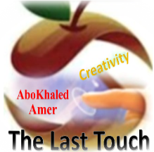
1-How old are you? 2-Where do you live? 3-Nice to meet you? 4-What’s your name?
( ) _____________________? My name’s Sara.
( )______________________? I’m eleven years old.
( ) ______________________? I live in Abha.
( )______________________? Nice to meet you, too.
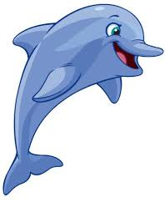
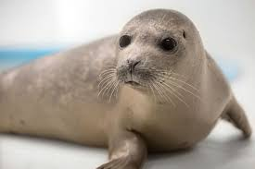
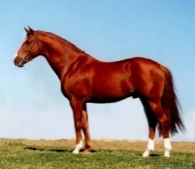
2- Choose : shark – horse – baby seal – dolphin
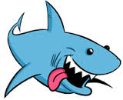

……………… ……………….. …………….. ……………..
3- Write the correct punctuations:
1. Do you have a sister

2. Yes I have

3. Seals are cute

4 - Choose the correct answer:
1- This is my dad. ( Her – His ) name is Ali.
2- He has two sisters. ( Their – His ) name are Fatimah and Sara.
3- Ahmad ( has – have ) a car.
4- I ( have – has ) a book.
5- Whose pencil is this? It's ( Rana – Rana’s ).
6- I think a seahorse is ( cute – cuter ) than a dolphin.
5- Unscramble the letters and write the words :
1. ( l - wh - a - e ) ……………………
2. ( o - l - ph - I - d - n ) …………………..
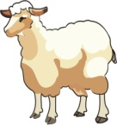
6- Fill in the missing letters : ee – ea – ow – ay – ai – ie
r_ _d d _ _ sh _ _ p wind_ _

Read & finish this rhyme: اقراء وأكمل القصيدة bunny - sunny - honey - tummy

The bear loves to eat _______
To fill his big _______
Then he plays with the _______
Outside when it is ________
First Term

WE CAN 5

Match: Based on Units 1 & 2اختبار الأوائل على الوحدات
1) dolphin a) scary
2) seal b) fat
3) shark c) fast
4) seahorse d) cute
5) walrus e) slow
Match:
1- What's your name? a) I live in Najran.
2- How old are you? b) Nice to meet you, too.
3- Where do you live? c) My name is Ali.
4- Nice to meet you. d) It is mine.
5- Whose book is it? e) I'm 12 years old.
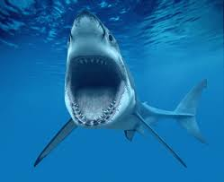
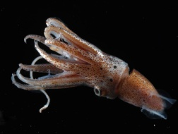
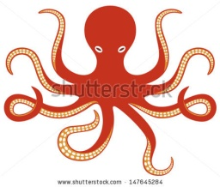
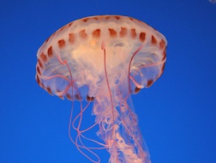
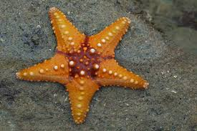
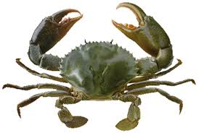
Write:
1. Octopus
2. Jellyfish
3. Starfish ----------------- ------------- ------------ --------------- --------------- ----------
4. Squid
5. Crab
6. Shark
Supply: ( ea – ee ) s – l ch—se r—d sl—p
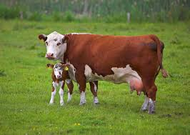
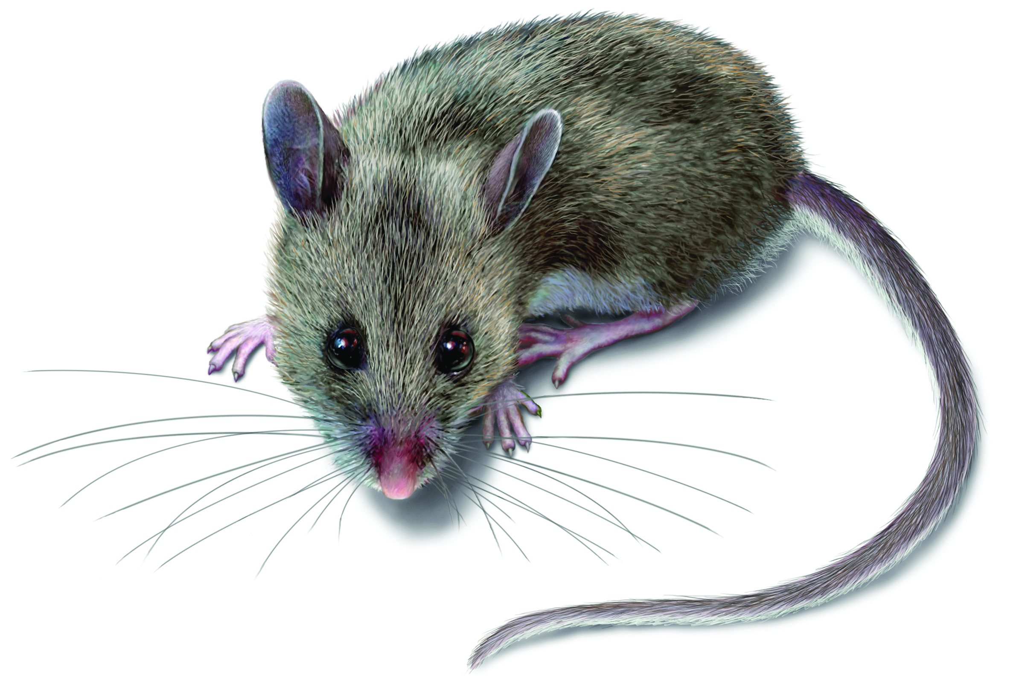
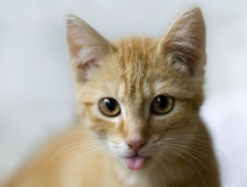
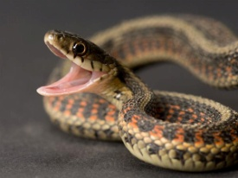
Write:
1) mouse
2) snake
3) cat
4) cow ------------------ ------------- ---------------- --------------- ----------------
5) horse
Answer about yourself:
1- Where do you live? ……………………………………………………
2- Can you walk to school? …………………………………………………
3- Do you have a computer? …………………………………………………
Write the correct number:
1. It’s scary. It has big teeth. It can bite! ------
2. It can walk and swim. It has suckers. It has eight legs.-----
3. It can sting. It’s not a fish. It’s like jelly. -------
4. It’s like an octopus. It has 10 legs. It can change color.-----
5. It has five arms. It can’t swim. It looks like a star. ------
6. It has a hard shell. It has two big claws. It can pinch. -----

