Lab 9: Assembling Housing Parts

1. Open the Housing and the small bush.

2. From ‘New’ open an Assembly File 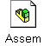 and select ‘Tile

Horizontally’. See Figures 1 & 2.

Figure 1
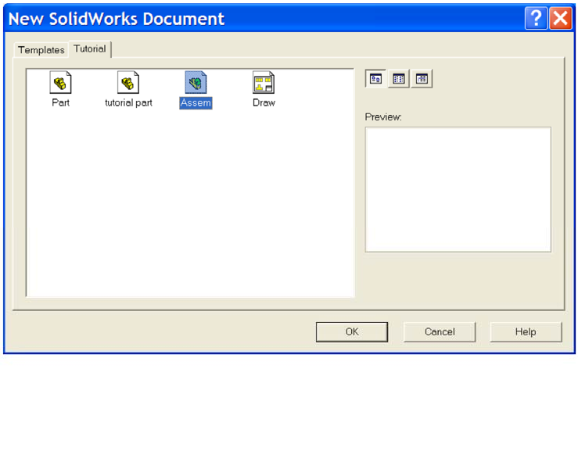

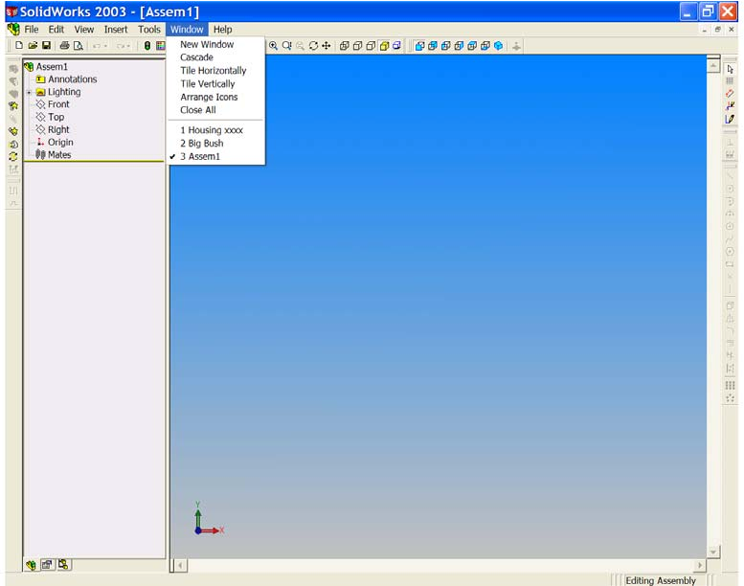
Figure 2

Notice the ‘Assembly Design Tree’ and the ‘Assembly Toolbar’. In Figure 3, the screen displays all three windows.

Figure 3
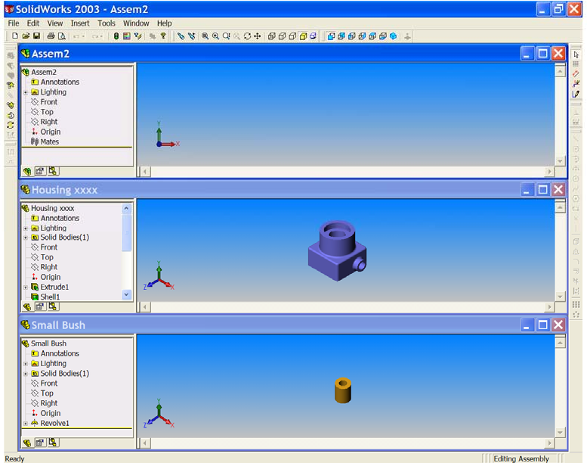

3. Drag the ‘Housing icon’ from the top of the HOUSING FEATURE MANAGER TREE in the Housing part window, and drop it in the FEATURE MANAGER DESIGN TREE OF THE ASSEMBLY WINDOW. See Figure 4.

Figure 4
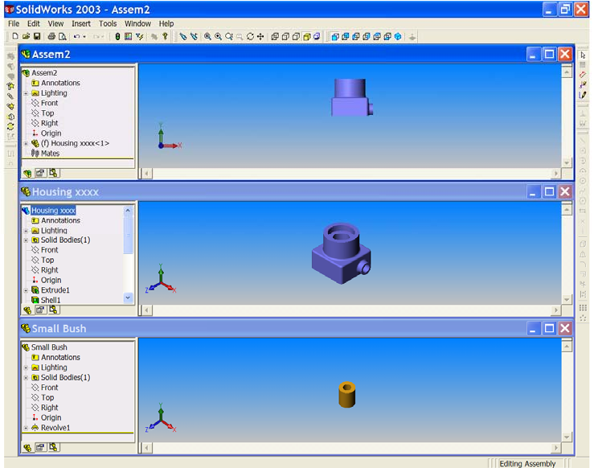

Notice the shape of the cursor as you move into the Feature Manager Design tree of the assembly. When the main part of an assembly is added this way, the part is fixed at the assembly file origin.

• The origin of the part coincides with the origin of the assembly origin.
• The part and assembly planes are aligned.

4. Drag the ‘small bush icon’ from the top of its FEATURE MANAGER DESIGN TREE window, and drop it in the GRAPHICS AREA of the assembly window close to the Housing. See Figure 5.
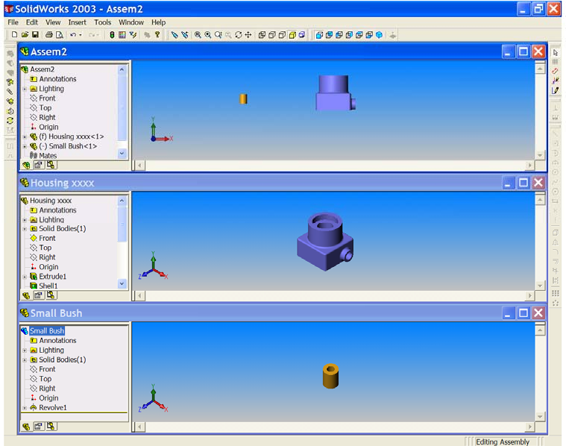
Figure 5

Notice the cursor symbol as the small bush is dropped in the assembly graphics area.

5. Save as ‘Housing Assembly xxx’. See Figure 6

Figure 6
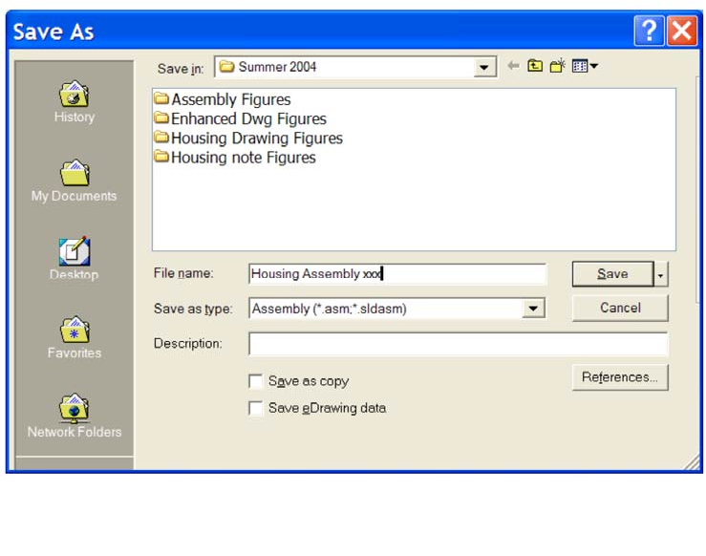

Notice that the file extension is now (*.sldasm) indicating an assembly file. We no longer need the part files, but it is useful to keep them open.

6. Maximise the assembly window and ‘Zoom to Fit’. See Figure 7. We must now create ‘Mate Relations’ between these two parts, first to align them and then to fit them together. Click ‘Isometric’ then click ‘Mate’ from the Assembly Toolbar. See Figure 8.

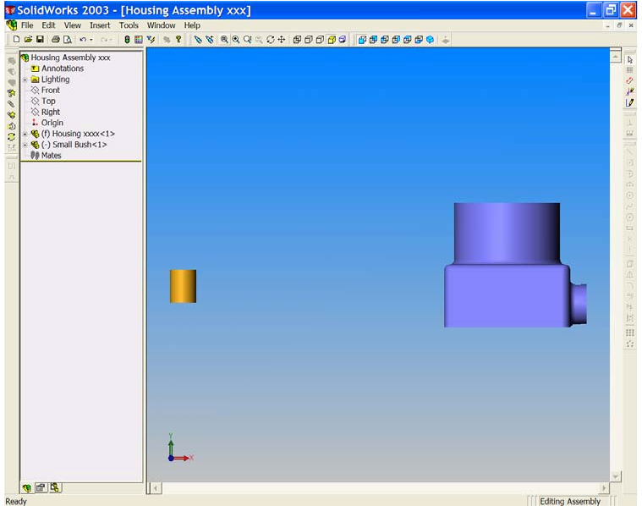
Figure 7
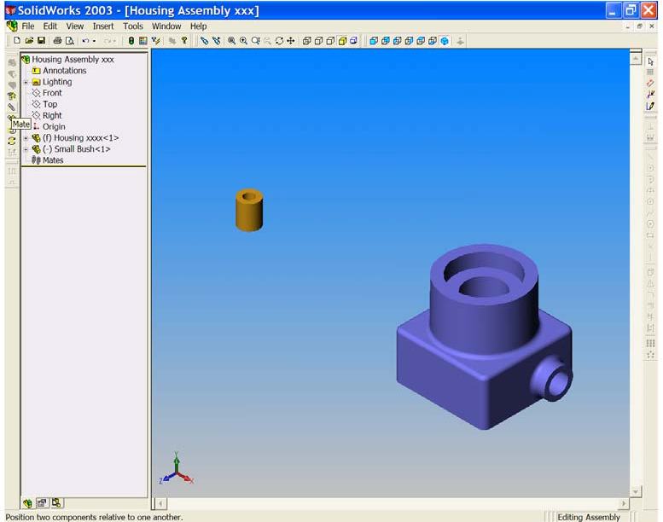
Figure 8

The ‘Mate Property Manager’ opens. Notice that the ‘Entities to Mate’ window is active (pink,) See Figure 9. We must now select the surfaces or edges that are to be ‘mated’.

Figure 9
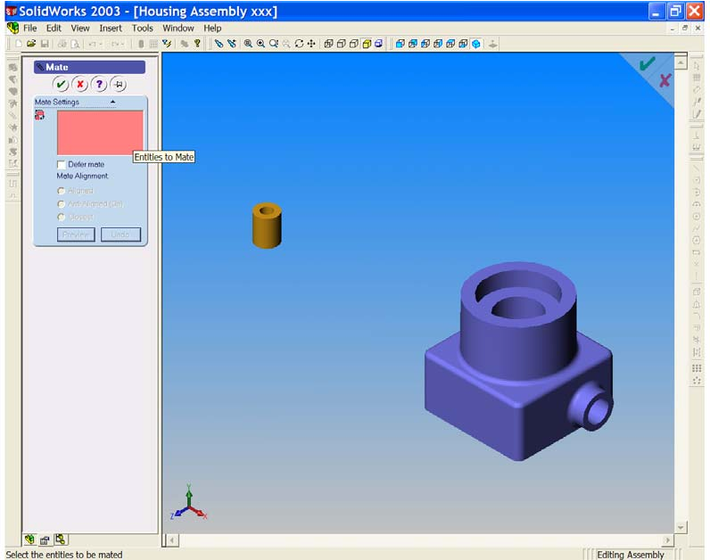

7. Place the cursor on the outer cylindrical surface of the small bush, and left click to select it. The surface is highlighted, the cursor flag is visible and the selected surface is added to the ‘Entities to mate’ window. Now place the cursor on the small bore at the right side of the housing. See Figures 10 & 11.

Figure 10
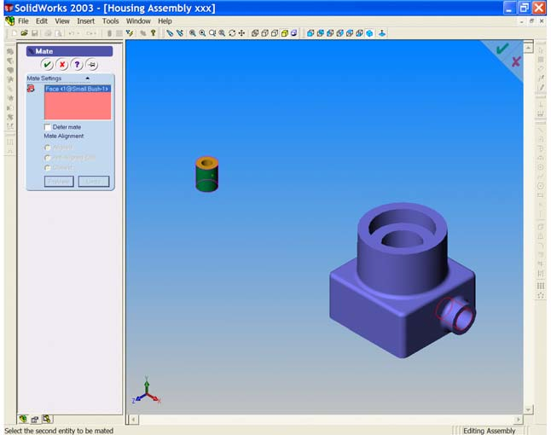

Figure 11
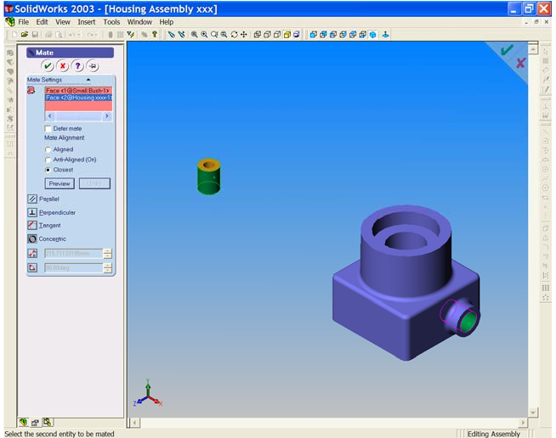

Select the bore surface as before. Notice that this second surface is added to the ‘Entities to mate’ window. All possible mate settings are now available.
Choose ‘Concentric’ as the mate type and ensure that ‘closest’ is selected as ‘Mate Alignment’. Click ‘Preview’ and watch the small bore align itself with the centre of the bore. See Figure 13.

Figure 12
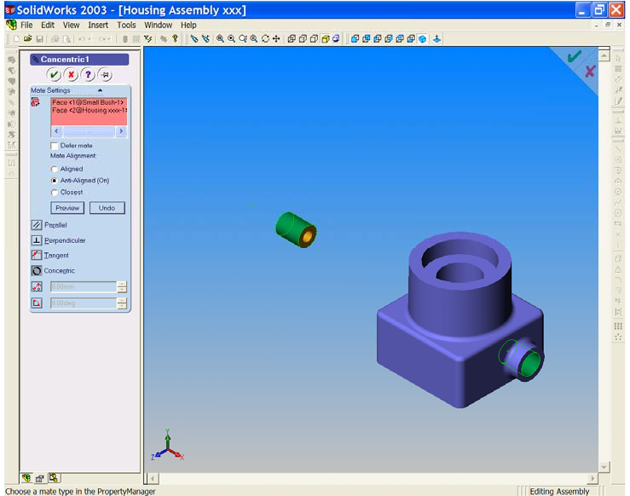

Click OK to accept the mate.

8. The position of the small bush is not fully defined, as indicated by the (-) sign in the Feature Manager Design tree. We must now lock the small bush in its final position.

Select ‘Mate’ once again; select the flat face at the right end of the bush.
Now, select the flat face at the right end of the small boss. Both of these faces are highlighted and the mate choices are available. See Figures 13 & 14.
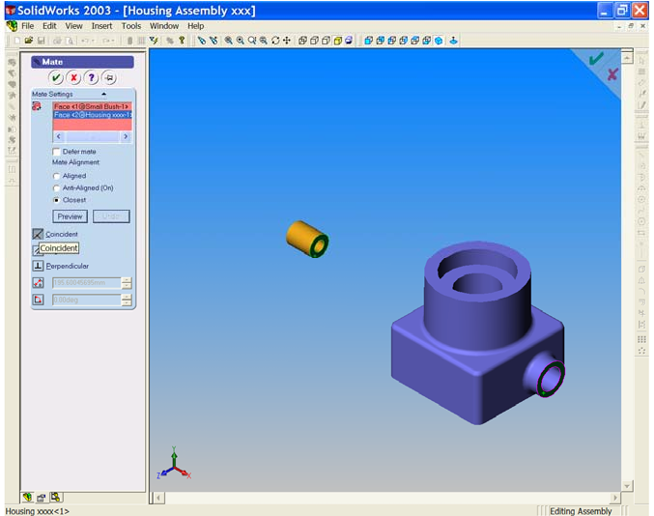
Figure 13

Figure 14
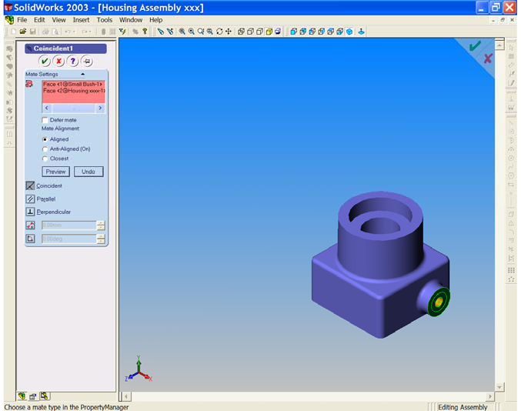

Choose ‘Coincident’ and watch as the bush moves into its final position. Click OK to end the command. See Figure 15.
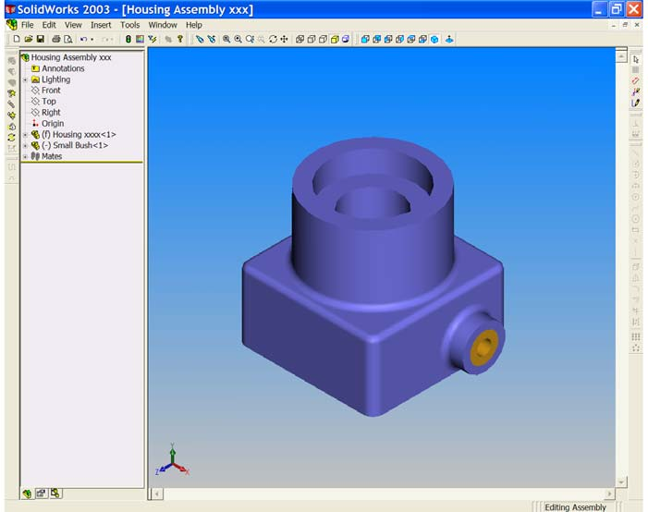
Figure 15

Save your work!!

9. We must now place the large bush in position.

From the ‘Insert’ drop down menu select ‘Component’ & ‘From File’. See
Figure 16.

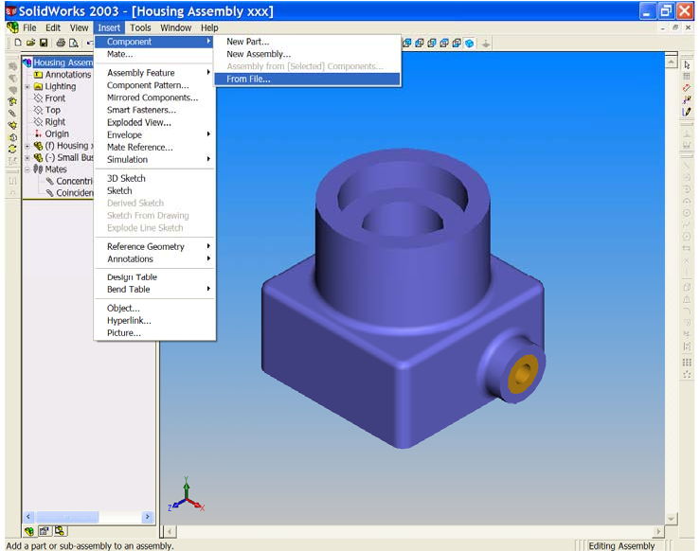
Figure 16
Drop the big bush in the graphics area of the screen.

Note the cursor symbol as you do this.

Now, on your own, mate the big bush to the counterbore of the Housing. When you are finished, your assembly should look similar to Figure 17.

Figure 17
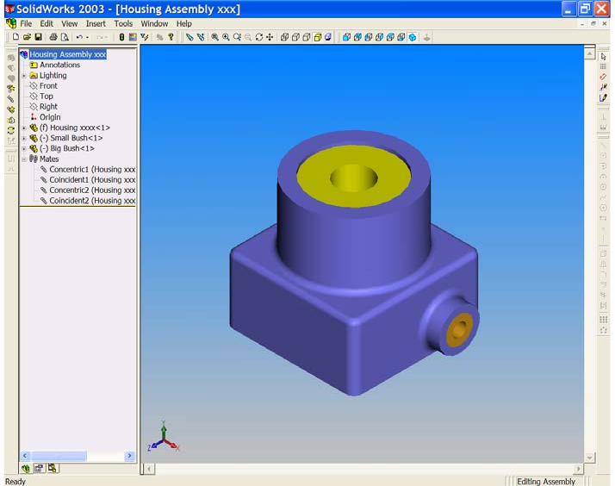

Notice that both bushes still have a (-) sign in the design tree. Why should this be? Which degree of freedom is still not constrained?

10. Save your work !!

