المملكة العربية السعودية المادة :



وزارة التعليم الصف :

إدارة التعليم بمحافظة

المدرسة :

أسئلة اختبار شهرية للفصل الدراسي الثالث

اسم الطالب :............................................................. معلم المادة : .................................

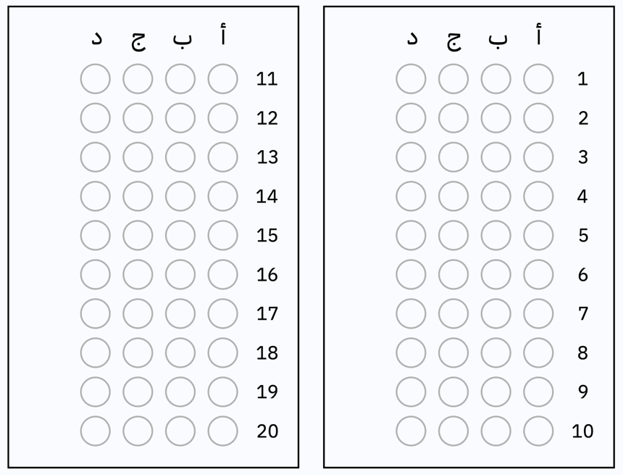

الأسئلة من 1 إلى ١٠ اختار

الإجابة الصحيحة وظلل الإجابة الصحيحة

في ورقة التظليل

١)

|  |  |  |  |  |  |  |  |
| --- | --- | --- | --- | --- | --- | --- | --- |
| أ |  | ب |  | جـ |  | د |  |

٢)

|  |  |  |  |  |  |  |  |
| --- | --- | --- | --- | --- | --- | --- | --- |
| أ |  | ب |  | جـ |  | د |  |

٣)

|  |  |  |  |  |  |  |  |
| --- | --- | --- | --- | --- | --- | --- | --- |
| أ |  | ب |  | جـ |  | د |  |

٤)

|  |  |  |  |  |  |  |  |
| --- | --- | --- | --- | --- | --- | --- | --- |
| أ |  | ب |  | جـ |  | د |  |

٥)

|  |  |  |  |  |  |  |  |
| --- | --- | --- | --- | --- | --- | --- | --- |
| أ |  | ب |  | جـ |  | د |  |

٦)

|  |  |  |  |  |  |  |  |
| --- | --- | --- | --- | --- | --- | --- | --- |
| أ |  | ب |  | جـ |  | د |  |

٧)

|  |  |  |  |  |  |  |  |
| --- | --- | --- | --- | --- | --- | --- | --- |
| أ |  | ب |  | جـ |  | د |  |

٨)

|  |  |  |  |  |  |  |  |
| --- | --- | --- | --- | --- | --- | --- | --- |
| أ |  | ب |  | جـ |  | د |  |

٩)

|  |  |  |  |  |  |  |  |
| --- | --- | --- | --- | --- | --- | --- | --- |
| أ |  | ب |  | جـ |  | د |  |

10)

|  |  |  |  |  |  |  |  |
| --- | --- | --- | --- | --- | --- | --- | --- |
| أ |  | ب |  | جـ |  | د |  |