Name :- ......................................................... Class :.................................................
Proficient Not proficient

Read and match :-

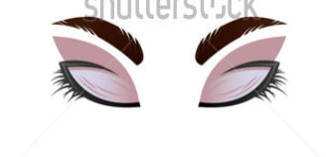
1 – Open your eyes .

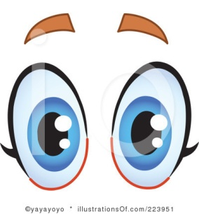
2- Raise your hands .

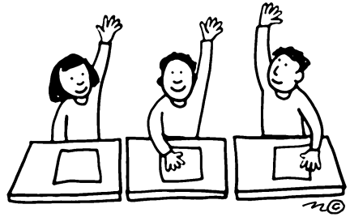
3- Close your eyes .

