|  |  |  |  |
| --- | --- | --- | --- |
| **المملكة العربية السعودية**  **وزارة التعليم**  **الإدارة العامة للتعليم بـن مدرسة م ن الابتدائية** | http://tabuk2day.com/wp-content/uploads/IMG_3362.jpgبسم الله الرحمن الرحيم **اختبار الفصل الدراسي الأول**  **للعام الدراسي 1444 هـ**  **https://t.me/abokhaledamer** | **المادة** | **لغة انجليزية** |
| **الصف** | **الخامس** |
| **الزمن** | **ساعة ونصف** |
| **الفصل** | **5 A** |
| **اسم الطالب رباعيا: ............................................................................................................رقم الجلوس:....................**   |  |  |  |  |  |  |  |  | | --- | --- | --- | --- | --- | --- | --- | --- | | **السؤال** | **1** | **2** | **3** | **4** | **5** | **6** | **المجموع** | | **الدرجة** |  |  |  |  |  |  |  | | **الدرجة** | 6 | 5 | 4 | 5 | 6 | 4 | 30 | | **المصحح** |  |  |  |  |  |  |  | | | | |

**I- General Questions:**

**6**

**Q1: A- Choose the correct answer:**

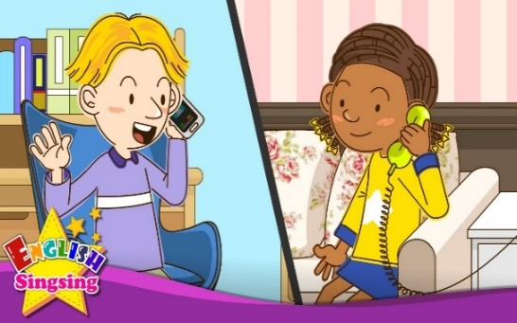**1. Can I speak to Ali?**

(I’m hot. – Speaking. - I’m great.)

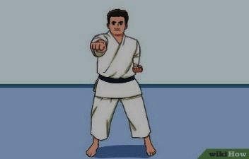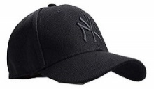**2. Whose cap is this?**

(It’s mine. – It’s nine. – It’s fine.).

**3. What are you doing?**

(I’m watching TV. – I’m doing karate. – I’m eating snacks.)

**B- Match the questions in column (A) with the correct answers in column (B):**

|  |  |
| --- | --- |
| **B** | **A** |
| **( ) Goodbye.**  **( ) “B” is the second letter.**  **( ) I’m fine, thank you.** | **1. How are you? 2. What is the second letter? 3. Goodbye.** |

**5**

**II- Controlled Writing:**

**Q2: Do as shown between brackets:**

**1. doing – I’m – homework.– my (Rearrange)>___ ____ ___ ______.**

**2. like – I – coat. – your (Rearrange) > __ ______ _____ _____.**

**3. Can I speak to Ali? (Answer)> _____________________.**

**4. What’s the matter? (Answer)> _______________________.**

**5. Whose jeans ____ they? (Complete)**

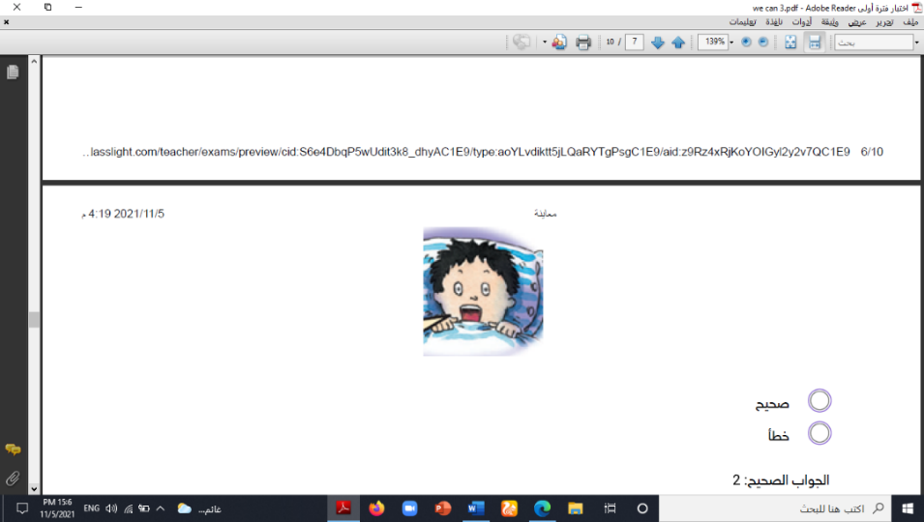**III- Reading Short Sentence:**

**4**

**Q3: Match the sentence with the pictures:**

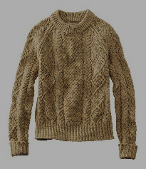**1. I’m wearing a sweater.**

**2. I’m playing computer games.**

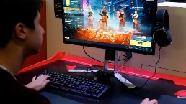

**3. The bird has two wings.**

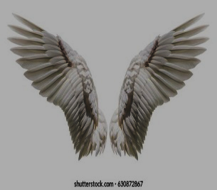

**4. I’m scared.**

**IV- Grammar:**

**5**

**Q4: Choose the correct answer:**

**1- What (**am – is – are**) the matter?**

**2- “A” is the (**first – second – third**) letter of the alphabet.**

**3- (**When – Where – Whose**) hat is this?**

**4- Can I (**speak – speaks – speaking**) to Ali?**

**6**

**5- She is (**eat – eats – eating**) snacks.**

**V- Vocabulary:**

**Q5: Write the number under picture:**

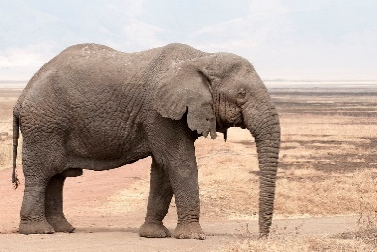**1. skirt 2. elephant 3. hungry 4. lock 5. ring 6. shirt**

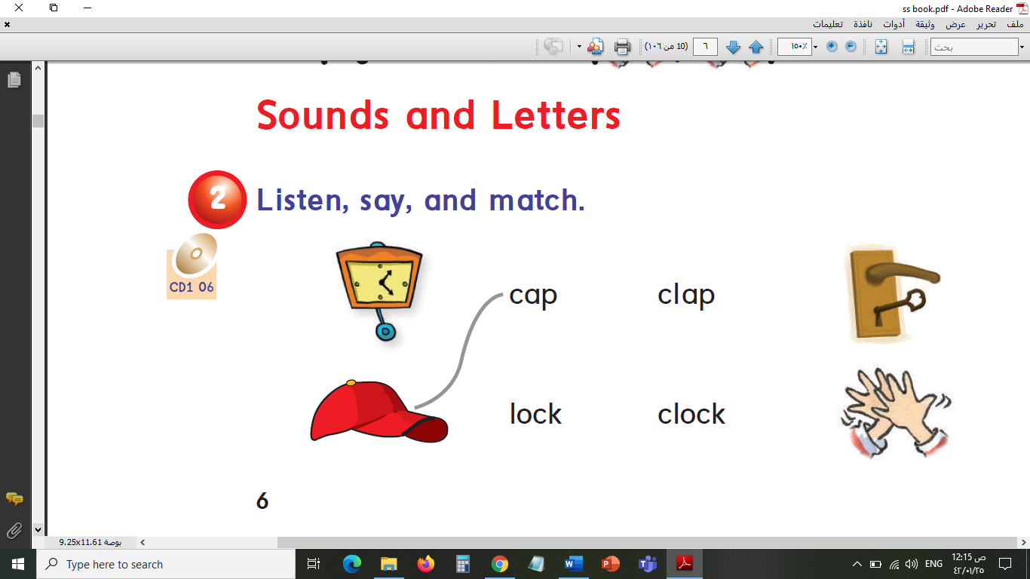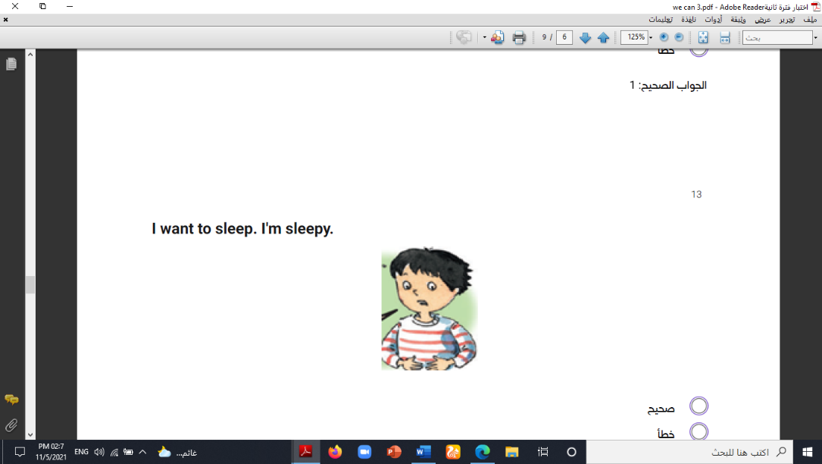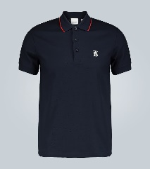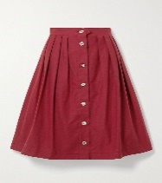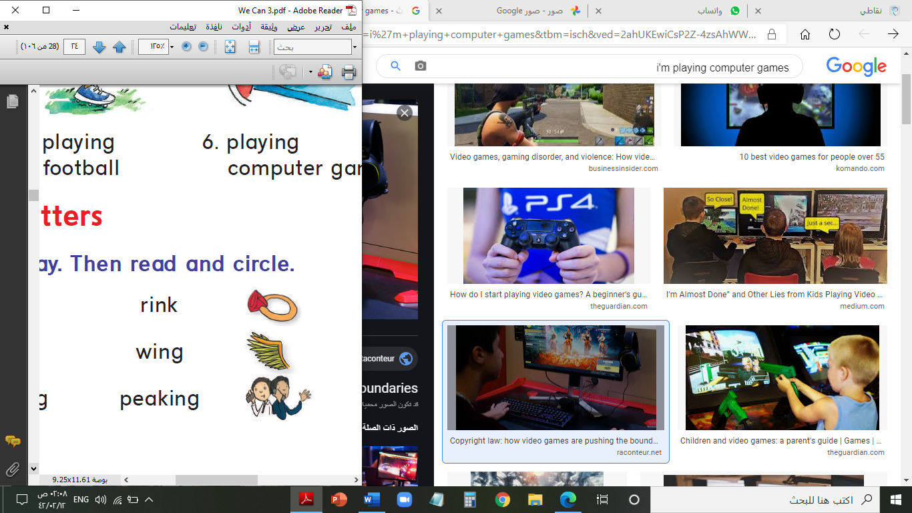

**( ) ( ) ( ) ( ) ( ) ( )**

**VI- Orthography:**

**4**

**Q6: Fill in the missing letters:**

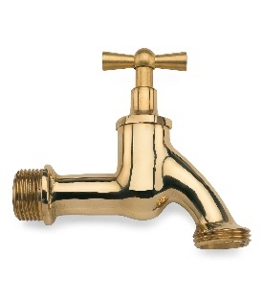**p / d / t / a-e / pl / a / b / i**

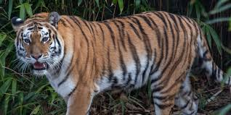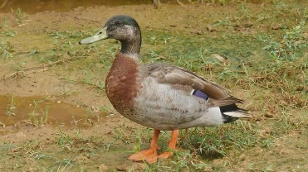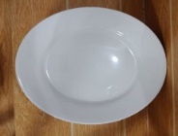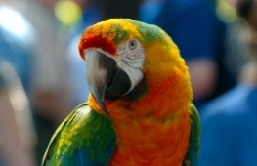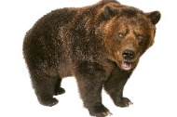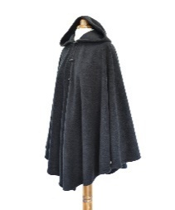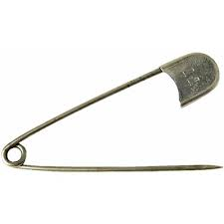

**t__p p__n c__p_ __ear __arrot __late __uck __iger**

**End of Questions**

**ABOKHALEDAMER**

**0557325813**

**Best of Luck**