

**PORTFOLIO**

**.........**

|  |
| --- |
| Content |
| Personal information |
| C.V. |
| Vision and Message |
| Courses Certificates |
| The Distribution of syllabus |
| General Objective of Teaching English |
| Weekly Timetable |
| Worksheets and Activities |
| Quizzes and Assessments |
| Students' performance tasks |
| Students' Projects |
| Notes |

البيانات الشخصية للمعلم / هـ

|  |  |
| --- | --- |
|  | الاسم رباعي |
|  | المؤهل |
|  | مصدره وتاريخه |
|  | التخصص |
|  | المستوى |
|  | تاريخ التعيين |
|  | رقم الوظيفة |
|  | مواد التدريس |
|  | الصفوف |
|  | رقم الجوال |
|  | البريد الالكتروني |

|  |  |  |
| --- | --- | --- |
|  | Personal information |  |
|  | | **Name** |
|  | | **University degree** |
|  | | **Its source and date** |
|  | | **Specialization** |
|  | | **The level** |
|  | | **Date of Appointment** |
|  | | **Job number** |
|  | | **Teaching Subjects** |
|  | | **Classes** |
|  | | **Mobile number** |
|  | | **E-mail** |

**CV**

السـيــرة الـذاتـيـة للـمعلمة



My Vision:

My Message:



الرؤية والرسالة للمعلم / هـ

*رؤيتي:

*رسالتي:

الدورات التي حصل عليها المعلم / هـ

|  |  |  |  |
| --- | --- | --- | --- |
| اسم الدورة | تاريخها | مدتها | مكانها |
|  |  |  |  |
|  |  |  |  |
|  |  |  |  |
|  |  |  |  |
|  |  |  |  |
|  |  |  |  |
|  |  |  |  |
|  |  |  |  |
|  |  |  |  |
|  |  |  |  |
|  |  |  |  |
|  |  |  |  |
|  |  |  |  |
|  |  |  |  |

**Teacher training courses**

|  |  |  |  |
| --- | --- | --- | --- |
| **course site** | **Date** | **Duration** | **Course name** |
|  |  |  |  |
|  |  |  |  |
|  |  |  |  |
|  |  |  |  |
|  |  |  |  |
|  |  |  |  |
|  |  |  |  |
|  |  |  |  |
|  |  |  |  |
|  |  |  |  |
|  |  |  |  |
|  |  |  |  |
|  |  |  |  |
|  |  |  |  |

The Distribution of syllabus

توزيع المنهج

**General Objective of Teaching English**

**The General Objectives of Teaching English Language in Saudi Arabia**

**Students should be able to :**

* **Develop their intellectual, personal and professional abilities.**
* **Acquire basic language skills (Listening, speaking , reading and writing) in order to communicate with speakers of English Language .**
* **Acquire the linguistic competence necessarily required in various life situations.**
* **Acquire the linguistic competence necessarily required in different professions.**
* **Develop their awareness of the importance of English as a means of international communication.**
* **Develop positive attitudes towards learning English.**
* **Develop the linguistic competence that enables them to be aware of cultural, economic and social issues of their society in order to contribute in giving solutions.**
* **Develop the linguistic competence that enables them, in the future, to present and explain the Islamic concepts and issues and participate in spreading Islam.**
* **Develop the linguistic competence that enables them, in the future, to present the culture and civilization of their nation.**
* **Benefit from English-speaking nations, in order to enhance the concepts of international cooperation that develop understanding and respect of cultural differences among nations.**
* **Acquire the linguistic bases that enable them to participate in transferring the scientific and technological advances of other nations to their nation.**
* **Acquire the linguistic bases that enable them to present and explain Islamic concepts and issues, and participate in the dissemination of them.**

**General Objective of Teaching English in the Primary Stage**

* **Learn the basics of the English language that would form the foundation for its mastery in the future.**
* **Use the basic structures of English sentences.**
* **Learn the core vocabulary assigned for this stage.**
* **Listen and understand simple English language.**
* **Express themselves orally using simple English language.**
* **Read and understand simple written English language materials.**
* **Write simple guided sentences in English language.**
* **Appreciate the importance of English language as an international language of communication, for introducing Islam, the Islamic nation's culture and the cultural achievements of Muslims to other nations.**
* **Appreciate the importance of English language as an international language of communication to benefit from the achievements of other cultures in accordance with Islam.**

**General Objectives of Teaching English in the Intermediate Stage**

* **Learn the basics of the English language that would form the foundation for mastering the English language in the future.**
* **Use the English language structures.**
* **Learn the assigned vocabulary for this stage that would enable them to express themselves in different life situations.**
* **Listen and understand English language.**
* **Express themselves orally using correct English.**
* **Read and understand English written material.**
* **Write a short-guided paragraph.**
* **Be aware of the importance of English –as an international language of communication- for benefiting from the achievements of other cultures in accordance with Islamic teaching; through texts representing various life situations.**
* **Be aware of the importance of English –as an international language of communication for introducing Islam, our culture and cultural achievements to the others**

**General Objective of Teaching English in the Secondary Stage**

* **Use English language structures and analyze them to understand the relationships among them**
* **Learn the assigned vocabulary, idioms, and expressions and understand their meanings in context**
* **Acquire the ability to listen to comprehend English language and to distinguish between different intonations**
* **Participate in conversations and discussions using proper English**
* **Acquire the ability to read and comprehend English texts through different reading types (i.e., loud reading) and reading strategies (i.e., scanning, pleasure and reading for all understanding**
* **Write a free-essay of three paragraphs using correct English**
* **Translate English text into Arabic and vice versa**
* **Realize the importance of English in the local job market**
* **Be aware of the importance of English as an international language of communication for introducing Islam, our culture, and our cultural achievements to others**
* **Be aware of the importance of English as an international language of communication for benefiting from achievements to others cultures in accordance with Islamic teaching; through texts representing various life situations**
* **Gain a reasonable command of English in order to be in a better position to defend Islam against adverse criticism and to participate in the dissemination of Islamic culture.**

Weekly Timetable

الجدول الاسبوعي

**Worksheets and Activities**

Quizzes and Assessments

Students' performance tasks

Students' Projects



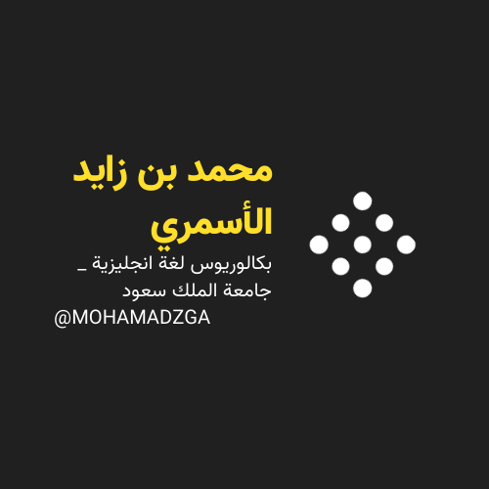

**لا تنسوني من صالح دعائكم**



**M_zaid0**