**Test 1-4**

**20**

TOTAL

# Name .

**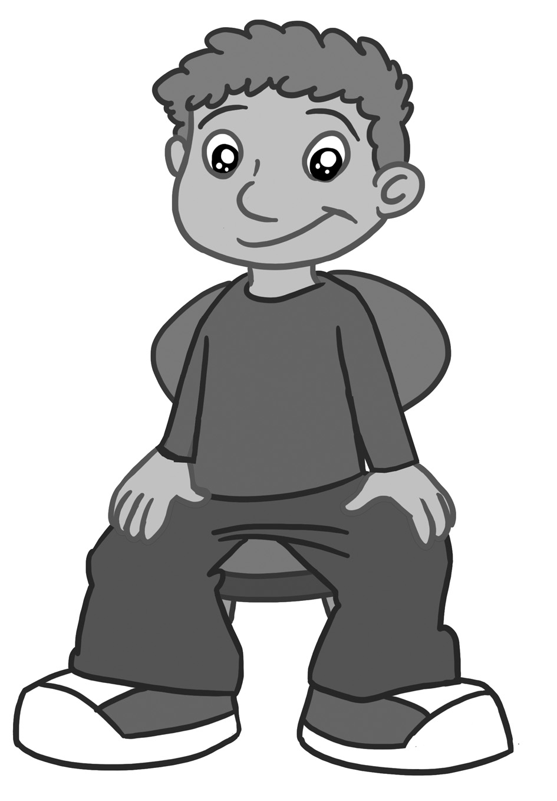1. Look and match.**

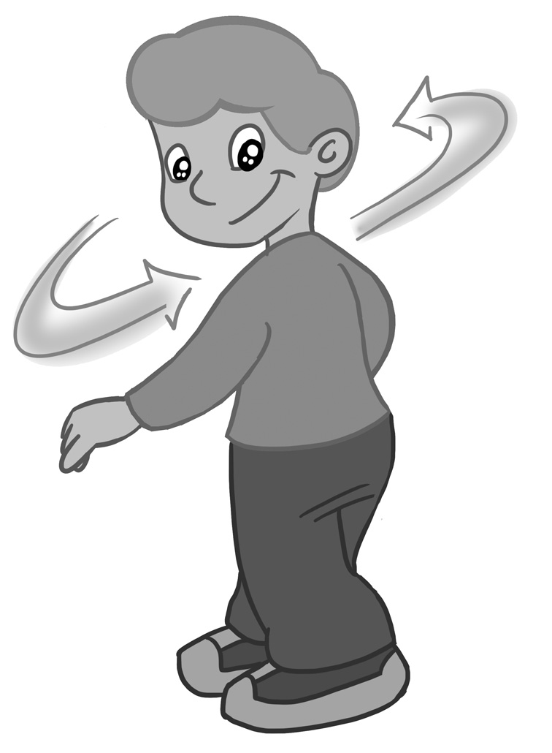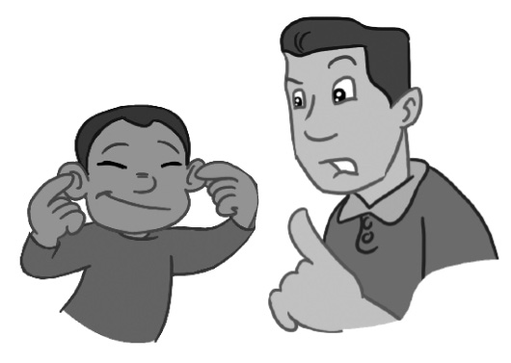

2.

3.

1.

Don’t touch your ears!

Turn around.

Sit down.



**6**

score

**2. Listen and tick (**✓**).**

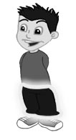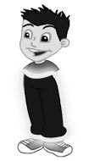

***red riding hood ex---2a_gray.tifred riding hood ex---2b_ME_gray.tif***

3.

2.

1.

b

a

b

a

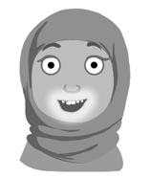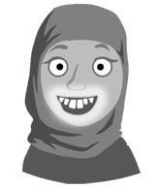module7_kids_ex2_big.tifmodule7_kids_ex2.tif

4.

**6**

score

**8**

score

b

a

a

b

**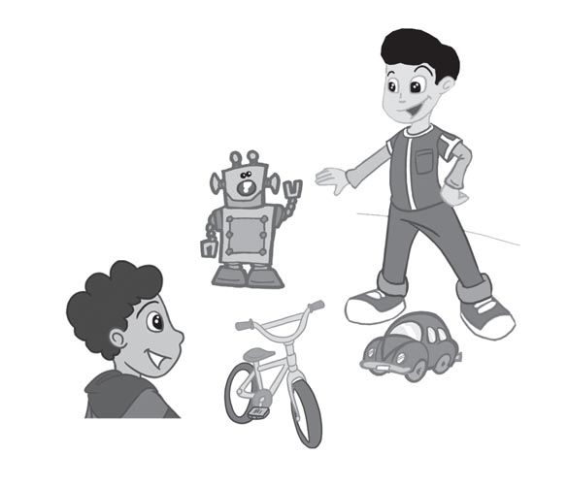**

**3. Look and circle.**

1. Have you got a car?  
 Yes, I have. / No, I haven’t.

2. Have you got a kite?  
 Yes, I have. / No, I haven’t.

3. Have you got a robot?

Yes, I have. / No, I haven’t.

Where’s the plane?

on in

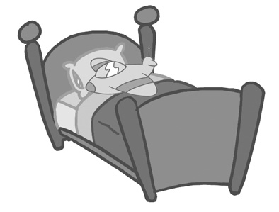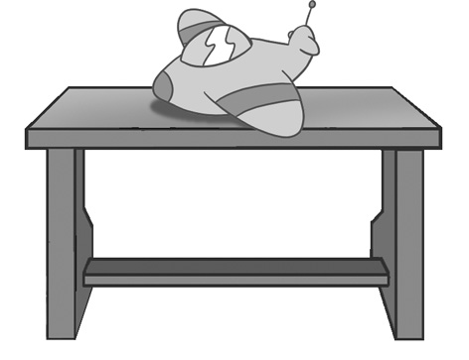plane in box_grey.tif**4. Look and complete.**

2. It’s the box.

1. It’s the bed.

3. It’s the desk.

**3**

score

**5. Look, read and circle.**

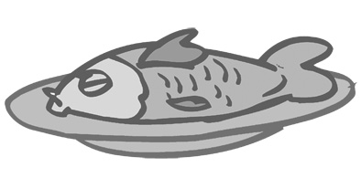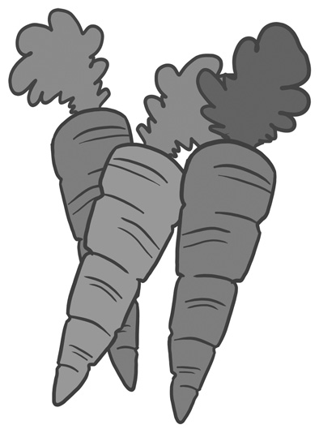

**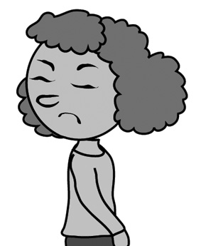**

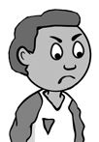

**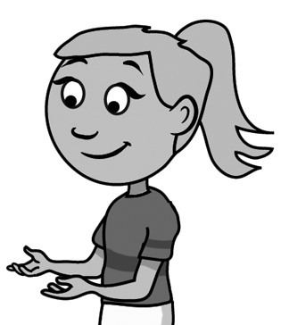**

2.

1.

3.

Do you like fish?

**Yes, I do./No I don’t.**

Do you like carrots?

**Yes, I do./No I don’t.**

Do you like beans?

**Yes, I do./No I don’t.**

**3**

score

****

**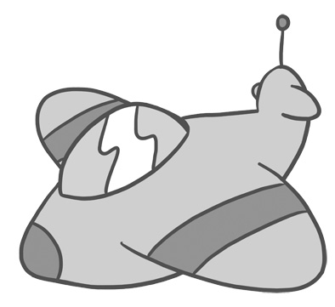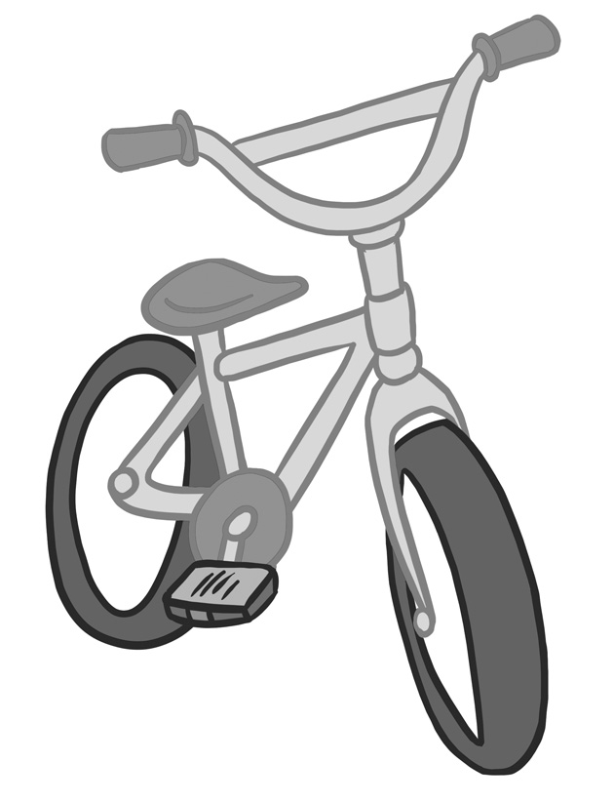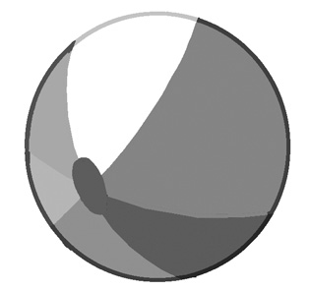6. Listen and match.**

**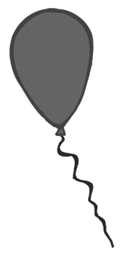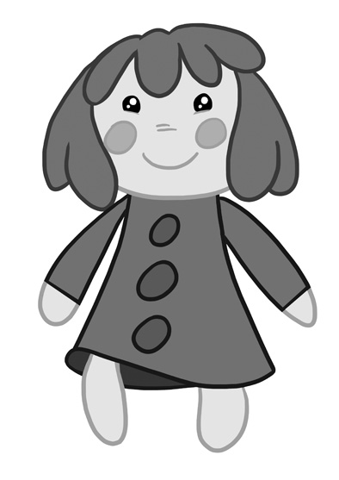**

**18**

**16**

**90**

**50**

**40**

**4**

score

**10**

score

Yes, they are. No, they aren’t.

**7. Look and write.**

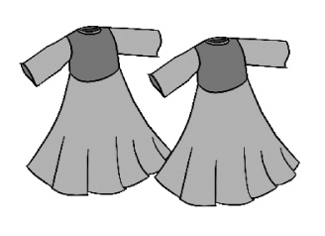1. Are they dresses? \_\_\_\_\_\_\_\_\_\_\_\_\_\_\_\_\_\_\_

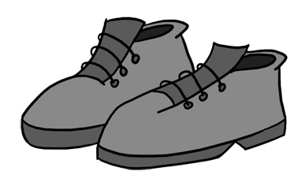2. Are they trousers? \_\_\_\_\_\_\_\_\_\_\_\_\_\_\_\_\_\_\_

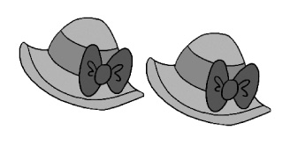3. Are they hats? \_\_\_\_\_\_\_\_\_\_\_\_\_\_\_\_\_\_\_

4. Are they jumpers? \_\_\_\_\_\_\_\_\_\_\_\_\_\_\_\_\_\_\_\_

