صورة تحتوي على نص, الخط, لقطة شاشة, شعار

قد يكون المحتوى الذي تم إنشاؤه بواسطة الذكاء الاصطناعي غير صحيح.صورة تحتوي على رمز, مستطيل, التصميم, الإبداع

تم إنشاء الوصف تلقائياً

كشف الحضور والغياب

الفصل الدراسي الأول

**1447هـ**

اسم المعلم/ة ..............................

**الفصل الدراسي الأول**

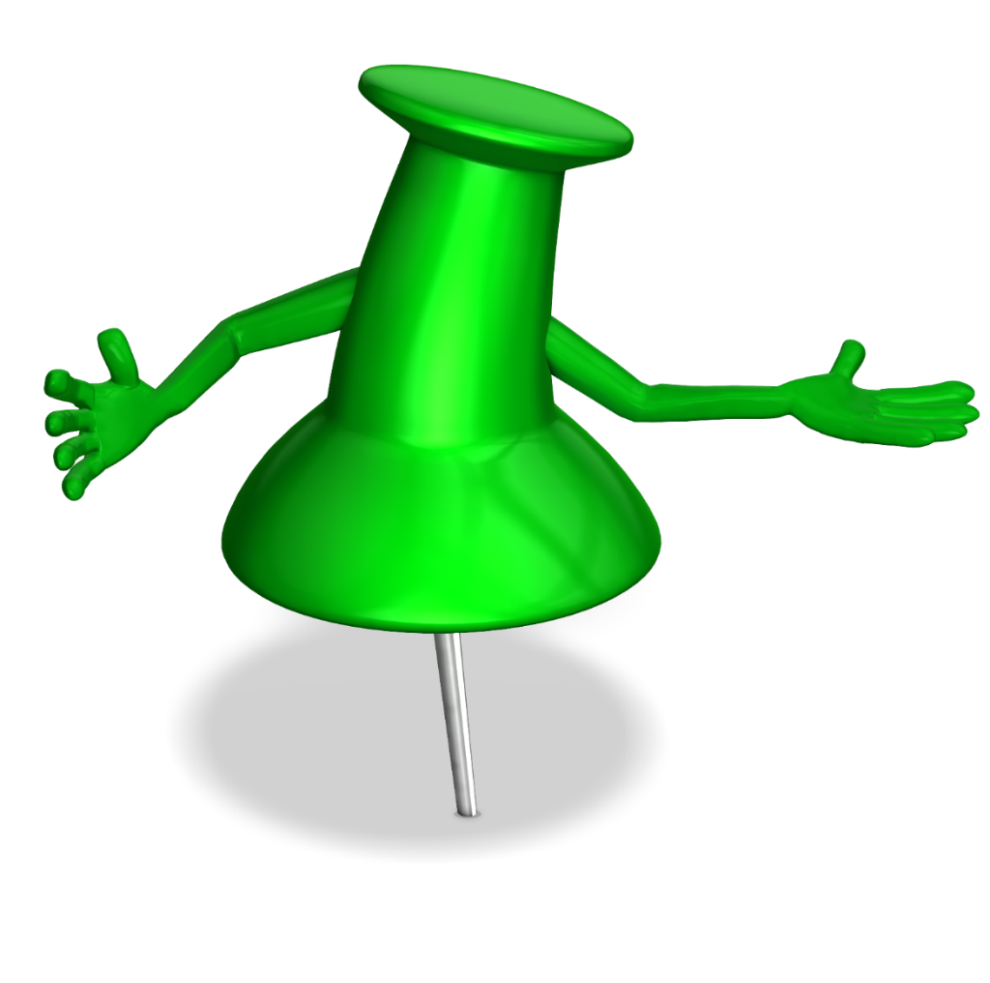

**كشف الحضور والغياب**

**الصف ........................................ الشهر / ربيع اول 1447 هـ معلم /ةالمادة / ..............................................**

|  |  |  |  |  |  |  |  |  |  |  |  |  |  |  |  |  |  |  |  |  |  |  |  |  |  |  |  |  |  |  |  |  |
| --- | --- | --- | --- | --- | --- | --- | --- | --- | --- | --- | --- | --- | --- | --- | --- | --- | --- | --- | --- | --- | --- | --- | --- | --- | --- | --- | --- | --- | --- | --- | --- | --- |
| **العدد** | **اسم المتعلم** | **الأسبوع الأول** | | | | | | | **الأسبوع الثاني** | | | | | | | **الأسبوع الثالث** | | | | | | | **الأسبوع الرابع** | | | | | | | | | |
| **الأحد** | **الإثنين** | **الثلاثاء** | **الأربعاء** | **الخميس** | **بعذر** | **بدون عذر** | **الأحد** | **الإثنين** | **الثلاثاء** | **الأربعاء** | **الخميس** | **بعذر** | **بدون عذر** | **الأحد** | **الإثنين** | **الثلاثاء** | **الأربعاء** | **الخميس** | **بعذر** | **بدون عذر** | | **الأحد** | **الإثنين** | **الثلاثاء** | | **الأربعاء** | **الخميس** | | **بعذر** | **بدون عذر** |
| **1** | **2** | **3** | **4** | **5** | **8** | **9** | **10** | **11** | **12** | **15** | **16** | **17** | **18** | **19** | **22** | **23** | **24** | | **25** | **26** | |
| **1** |  |  |  |  |  |  |  |  |  |  |  |  |  |  |  |  |  |  |  |  |  |  | |  |  |  |  | | |  |  |  |
| **2** |  |  |  |  |  |  |  |  |  |  |  |  |  |  |  |  |  |  |  |  |  |  | |  |  |  |  | | |  |
| **3** |  |  |  |  |  |  |  |  |  |  |  |  |  |  |  |  |  |  |  |  |  |  | |  |  |  |  | | |  |
| **4** |  |  |  |  |  |  |  |  |  |  |  |  |  |  |  |  |  |  |  |  |  |  | |  |  |  |  | | |  |
| **5** |  |  |  |  |  |  |  |  |  |  |  |  |  |  |  |  |  |  |  |  |  |  | |  |  |  |  | | |  |
| **6** |  |  |  |  |  |  |  |  |  |  |  |  |  |  |  |  |  |  |  |  |  |  | |  |  |  |  | | |  |
| **7** |  |  |  |  |  |  |  |  |  |  |  |  |  |  |  |  |  |  |  |  |  |  | |  |  |  |  | | |  |
| **8** |  |  |  |  |  |  |  |  |  |  |  |  |  |  |  |  |  |  |  |  |  |  | |  |  |  |  | | |  |
| **9** |  |  |  |  |  |  |  |  |  |  |  |  |  |  |  |  |  |  |  |  |  |  | |  |  |  |  | | |  |
| **10** |  |  |  |  |  |  |  |  |  |  |  |  |  |  |  |  |  |  |  |  |  |  | |  |  |  |  | | |  |
| **11** |  |  |  |  |  |  |  |  |  |  |  |  |  |  |  |  |  |  |  |  |  |  | |  |  |  |  | | |  |
| **12** |  |  |  |  |  |  |  |  |  |  |  |  |  |  |  |  |  |  |  |  |  |  | |  |  |  |  | | |  |
| **13** |  |  |  |  |  |  |  |  |  |  |  |  |  |  |  |  |  |  |  |  |  |  | |  |  |  |  | | |  |
| **14** |  |  |  |  |  |  |  |  |  |  |  |  |  |  |  |  |  |  |  |  |  |  | |  |  |  |  | | |  |
| **15** |  |  |  |  |  |  |  |  |  |  |  |  |  |  |  |  |  |  |  |  |  |  | |  |  |  |  | | |  |
| **16** |  |  |  |  |  |  |  |  |  |  |  |  |  |  |  |  |  |  |  |  |  |  | |  |  |  |  | | |  |
| **17** |  |  |  |  |  |  |  |  |  |  |  |  |  |  |  |  |  |  |  |  |  |  | |  |  |  |  | | |  |
| **18** |  |  |  |  |  |  |  |  |  |  |  |  |  |  |  |  |  |  |  |  |  |  | |  |  |  |  | | |  |
| **19** |  |  |  |  |  |  |  |  |  |  |  |  |  |  |  |  |  |  |  |  |  |  | |  |  |  |  | | |  |
| **20** |  |  |  |  |  |  |  |  |  |  |  |  |  |  |  |  |  |  |  |  |  |  | |  |  |  |  | | |  |

**كشف الحضور والغياب**

**الصف ........................................ الشهر / ربيع ثاني 1447 هـ معلم/ة المادة / ..............................................**

|  |  |  |  |  |  |  |  |  |  |  |  |  |  |  |  |  |  |  |  |  |  |  |  |  |  |  |  |  |  |
| --- | --- | --- | --- | --- | --- | --- | --- | --- | --- | --- | --- | --- | --- | --- | --- | --- | --- | --- | --- | --- | --- | --- | --- | --- | --- | --- | --- | --- | --- |
| **العدد** | **اسم المتعلم** | **الأسبوع الخامس** | | | | | | | **الأسبوع السادس** | | | | | | | **الأسبوع السابع** | | | | | | | **الأسبوع الثامن** | | | | | | |
| **الأحد** | **الإثنين** | **الثلاثاء** | **الأربعاء** | **الخميس** | **بعذر** | **بدون عذر** | **الأحد** | **الإثنين** | **الثلاثاء** | **الأربعاء** | **الخميس** | **بعذر** | **بدون عذر** | **الأحد** | **الإثنين** | **الثلاثاء** | **الأربعاء** | **الخميس** | **بعذر** | **بدون عذر** | **الأحد** | **الإثنين** | **الثلاثاء** | **الأربعاء** | **الخميس** | **بعذر** | **بدون عذر** |
| **29** | **30** | **1** | **2** | **3** | **6** | **7** | **8** | **9** | **10** | **13** | **14** | **15** | **16** | **17** | **20** | **21** | **22** | **23** | **24** |
| **1** |  |  |  | **إجازة اليوم الوطني** |  |  |  |  |  |  |  |  |  |  |  |  |  |  |  |  |  |  |  |  |  |  |  |  |  |
| **2** |  |  |  |  |  |  |  |  |  |  |  |  |  |  |  |  |  |  |  |  |  |  |  |  |  |  |  |  |
| **3** |  |  |  |  |  |  |  |  |  |  |  |  |  |  |  |  |  |  |  |  |  |  |  |  |  |  |  |  |
| **4** |  |  |  |  |  |  |  |  |  |  |  |  |  |  |  |  |  |  |  |  |  |  |  |  |  |  |  |  |
| **5** |  |  |  |  |  |  |  |  |  |  |  |  |  |  |  |  |  |  |  |  |  |  |  |  |  |  |  |  |
| **6** |  |  |  |  |  |  |  |  |  |  |  |  |  |  |  |  |  |  |  |  |  |  |  |  |  |  |  |  |
| **7** |  |  |  |  |  |  |  |  |  |  |  |  |  |  |  |  |  |  |  |  |  |  |  |  |  |  |  |  |
| **8** |  |  |  |  |  |  |  |  |  |  |  |  |  |  |  |  |  |  |  |  |  |  |  |  |  |  |  |  |
| **9** |  |  |  |  |  |  |  |  |  |  |  |  |  |  |  |  |  |  |  |  |  |  |  |  |  |  |  |  |
| **10** |  |  |  |  |  |  |  |  |  |  |  |  |  |  |  |  |  |  |  |  |  |  |  |  |  |  |  |  |
| **11** |  |  |  |  |  |  |  |  |  |  |  |  |  |  |  |  |  |  |  |  |  |  |  |  |  |  |  |  |
| **12** |  |  |  |  |  |  |  |  |  |  |  |  |  |  |  |  |  |  |  |  |  |  |  |  |  |  |  |  |
| **13** |  |  |  |  |  |  |  |  |  |  |  |  |  |  |  |  |  |  |  |  |  |  |  |  |  |  |  |  |
| **14** |  |  |  |  |  |  |  |  |  |  |  |  |  |  |  |  |  |  |  |  |  |  |  |  |  |  |  |  |
| **15** |  |  |  |  |  |  |  |  |  |  |  |  |  |  |  |  |  |  |  |  |  |  |  |  |  |  |  |  |
| **16** |  |  |  |  |  |  |  |  |  |  |  |  |  |  |  |  |  |  |  |  |  |  |  |  |  |  |  |  |
| **17** |  |  |  |  |  |  |  |  |  |  |  |  |  |  |  |  |  |  |  |  |  |  |  |  |  |  |  |  |
| **18** |  |  |  |  |  |  |  |  |  |  |  |  |  |  |  |  |  |  |  |  |  |  |  |  |  |  |  |  |
| **19** |  |  |  |  |  |  |  |  |  |  |  |  |  |  |  |  |  |  |  |  |  |  |  |  |  |  |  |  |
| **20** |  |  |  |  |  |  |  |  |  |  |  |  |  |  |  |  |  |  |  |  |  |  |  |  |  |  |  |  |

**كشف الحضور والغياب**

**الصف ........................................ الشهر / ربيع ثاني -جماد اول 1447 هـ معلم المادة / ..............................................**

|  |  |  |  |  |  |  |  |  |  |  |  |  |  |  |  |  |  |  |  |  |  |  |  |  |  |  |  |  |  |
| --- | --- | --- | --- | --- | --- | --- | --- | --- | --- | --- | --- | --- | --- | --- | --- | --- | --- | --- | --- | --- | --- | --- | --- | --- | --- | --- | --- | --- | --- |
| **العدد** | **اسم المتعلم** | **الأسبوع التاسع** | | | | | | | **الأسبوع العاشر** | | | | | | | **الأسبوع الحادي عشر** | | | | | | | **الأسبوع الثاني عشر** | | | | | | |
| **الأحد** | **الإثنين** | **الثلاثاء** | **الأربعاء** | **الخميس** | **بعذر** | **بدون عذر** | **الأحد** | **الإثنين** | **الثلاثاء** | **الأربعاء** | **الخميس** | **بعذر** | **بدون عذر** | **الأحد** | **الإثنين** | **الثلاثاء** | **الأربعاء** | **الخميس** | **بعذر** | **بدون عذر** | **الأحد** | **الإثنين** | **الثلاثاء** | **الأربعاء** | **الخميس** | **بعذر** | **بدون عذر** |
| **27** | **28** | **29** | **30** | **1** | **4** | **5** | **6** | **7** | **8** | **11** | **12** | **13** | **14** | **15** | **18** | **19** | **20** | **21** | **22** |
| **1** |  |  |  |  |  |  |  |  |  |  |  |  |  |  |  |  |  |  |  |  |  |  |  |  |  |  |  |  |  |
| **2** |  |  |  |  |  |  |  |  |  |  |  |  |  |  |  |  |  |  |  |  |  |  |  |  |  |  |  |  |  |
| **3** |  |  |  |  |  |  |  |  |  |  |  |  |  |  |  |  |  |  |  |  |  |  |  |  |  |  |  |  |  |
| **4** |  |  |  |  |  |  |  |  |  |  |  |  |  |  |  |  |  |  |  |  |  |  |  |  |  |  |  |  |  |
| **5** |  |  |  |  |  |  |  |  |  |  |  |  |  |  |  |  |  |  |  |  |  |  |  |  |  |  |  |  |  |
| **6** |  |  |  |  |  |  |  |  |  |  |  |  |  |  |  |  |  |  |  |  |  |  |  |  |  |  |  |  |  |
| **7** |  |  |  |  |  |  |  |  |  |  |  |  |  |  |  |  |  |  |  |  |  |  |  |  |  |  |  |  |  |
| **8** |  |  |  |  |  |  |  |  |  |  |  |  |  |  |  |  |  |  |  |  |  |  |  |  |  |  |  |  |  |
| **9** |  |  |  |  |  |  |  |  |  |  |  |  |  |  |  |  |  |  |  |  |  |  |  |  |  |  |  |  |  |
| **10** |  |  |  |  |  |  |  |  |  |  |  |  |  |  |  |  |  |  |  |  |  |  |  |  |  |  |  |  |  |
| **11** |  |  |  |  |  |  |  |  |  |  |  |  |  |  |  |  |  |  |  |  |  |  |  |  |  |  |  |  |  |
| **12** |  |  |  |  |  |  |  |  |  |  |  |  |  |  |  |  |  |  |  |  |  |  |  |  |  |  |  |  |  |
| **13** |  |  |  |  |  |  |  |  |  |  |  |  |  |  |  |  |  |  |  |  |  |  |  |  |  |  |  |  |  |
| **14** |  |  |  |  |  |  |  |  |  |  |  |  |  |  |  |  |  |  |  |  |  |  |  |  |  |  |  |  |  |
| **15** |  |  |  |  |  |  |  |  |  |  |  |  |  |  |  |  |  |  |  |  |  |  |  |  |  |  |  |  |  |
| **16** |  |  |  |  |  |  |  |  |  |  |  |  |  |  |  |  |  |  |  |  |  |  |  |  |  |  |  |  |  |
| **17** |  |  |  |  |  |  |  |  |  |  |  |  |  |  |  |  |  |  |  |  |  |  |  |  |  |  |  |  |  |
| **18** |  |  |  |  |  |  |  |  |  |  |  |  |  |  |  |  |  |  |  |  |  |  |  |  |  |  |  |  |  |
| **19** |  |  |  |  |  |  |  |  |  |  |  |  |  |  |  |  |  |  |  |  |  |  |  |  |  |  |  |  |  |
| **20** |  |  |  |  |  |  |  |  |  |  |  |  |  |  |  |  |  |  |  |  |  |  |  |  |  |  |  |  |  |

**كشف الحضور والغياب**

**الصف ........................................ الشهر / جماد اول -جماد ثاني 1447 هـ معلم المادة / ..............................................**

|  |  |  |  |  |  |  |  |  |  |  |  |  |  |  |  |  |  |  |  |  |  |  |  |  |  |  |  |  |  |  |
| --- | --- | --- | --- | --- | --- | --- | --- | --- | --- | --- | --- | --- | --- | --- | --- | --- | --- | --- | --- | --- | --- | --- | --- | --- | --- | --- | --- | --- | --- | --- |
| **العدد** | **اسم المتعلم** | **الأسبوع الثالث عشر** | | | | | | |  | **الأسبوع الرابع عشر** | | | | | | | **الأسبوع الخامس عشر** | | | | | | | **الأسبوع السادس عشر** | | | | | | |
| **الأحد** | **الإثنين** | **الثلاثاء** | **الأربعاء** | **الخميس** | **بعذر** | **بدون عذر** |  | **الأحد** | **الإثنين** | **الثلاثاء** | **الأربعاء** | **الخميس** | **بعذر** | **بدون عذر** | **الأحد** | **الإثنين** | **الثلاثاء** | **الأربعاء** | **الخميس** | **بعذر** | **بدون عذر** | **الأحد** | **الإثنين** | **الثلاثاء** | **الأربعاء** | **الخميس** | **بعذر** | **بدون عذر** |
| **25** | **26** | **27** | **28** | **29** | **إجازة منتصف الفصل الأول** | **9** | **10** | **11** | **12** | **13** | **16** | **17** | **18** | **19** | **20** | **23** | **24** | **25** | **26** | **27** |
| **1** |  |  |  |  |  |  |  |  |  |  |  |  |  |  |  |  |  |  |  | **إجازة اضافية** |  |  | **إجازة اضافية** |  |  |  |  |  |  |
| **2** |  |  |  |  |  |  |  |  |  |  |  |  |  |  |  |  |  |  |  |  |  |  |  |  |  |  |  |
| **3** |  |  |  |  |  |  |  |  |  |  |  |  |  |  |  |  |  |  |  |  |  |  |  |  |  |  |  |
| **4** |  |  |  |  |  |  |  |  |  |  |  |  |  |  |  |  |  |  |  |  |  |  |  |  |  |  |  |
| **5** |  |  |  |  |  |  |  |  |  |  |  |  |  |  |  |  |  |  |  |  |  |  |  |  |  |  |  |
| **6** |  |  |  |  |  |  |  |  |  |  |  |  |  |  |  |  |  |  |  |  |  |  |  |  |  |  |  |
| **7** |  |  |  |  |  |  |  |  |  |  |  |  |  |  |  |  |  |  |  |  |  |  |  |  |  |  |  |
| **8** |  |  |  |  |  |  |  |  |  |  |  |  |  |  |  |  |  |  |  |  |  |  |  |  |  |  |  |
| **9** |  |  |  |  |  |  |  |  |  |  |  |  |  |  |  |  |  |  |  |  |  |  |  |  |  |  |  |
| **10** |  |  |  |  |  |  |  |  |  |  |  |  |  |  |  |  |  |  |  |  |  |  |  |  |  |  |  |
| **11** |  |  |  |  |  |  |  |  |  |  |  |  |  |  |  |  |  |  |  |  |  |  |  |  |  |  |  |
| **12** |  |  |  |  |  |  |  |  |  |  |  |  |  |  |  |  |  |  |  |  |  |  |  |  |  |  |  |
| **13** |  |  |  |  |  |  |  |  |  |  |  |  |  |  |  |  |  |  |  |  |  |  |  |  |  |  |  |
| **14** |  |  |  |  |  |  |  |  |  |  |  |  |  |  |  |  |  |  |  |  |  |  |  |  |  |  |  |
| **15** |  |  |  |  |  |  |  |  |  |  |  |  |  |  |  |  |  |  |  |  |  |  |  |  |  |  |  |
| **16** |  |  |  |  |  |  |  |  |  |  |  |  |  |  |  |  |  |  |  |  |  |  |  |  |  |  |  |
| **17** |  |  |  |  |  |  |  |  |  |  |  |  |  |  |  |  |  |  |  |  |  |  |  |  |  |  |  |
| **18** |  |  |  |  |  |  |  |  |  |  |  |  |  |  |  |  |  |  |  |  |  |  |  |  |  |  |  |
| **19** |  |  |  |  |  |  |  |  |  |  |  |  |  |  |  |  |  |  |  |  |  |  |  |  |  |  |  |
| **20** |  |  |  |  |  |  |  |  |  |  |  |  |  |  |  |  |  |  |  |  |  |  |  |  |  |  |  |

**تبدأ إجازة منتصف الفصل الاول بنهاية دوام يوم الخميس 29 جماد الاول 1447هـ**

**كشف الحضور والغياب**

**الصف ........................................ الشهر / رجب 1447 هـ معلم المادة / ..............................................**

|  |  |  |  |  |  |  |  |  |  |  |  |  |  |  |  |  |  |  |  |  |  |  |  |
| --- | --- | --- | --- | --- | --- | --- | --- | --- | --- | --- | --- | --- | --- | --- | --- | --- | --- | --- | --- | --- | --- | --- | --- |
| **العدد** | **اسم المتعلم** | **الأسبوع السابع عشر** | | | | | | | **الأسبوع الثامن عشر** | | | | | | | **الأسبوع التاسع عشر** | | | | | | |  |
| **الأحد** | **الإثنين** | **الثلاثاء** | **الأربعاء** | **الخميس** | **بعذر** | **بدون عذر** | **الأحد** | **الإثنين** | **الثلاثاء** | **الأربعاء** | **الخميس** | **بعذر** | **بدون عذر** | **الأحد** | **الإثنين** | **الثلاثاء** | **الأربعاء** | **الخميس** | **بعذر** | **بدون عذر** | **تبدأ إجازة نهاية الفصل الدراسي الأول بتاريخ 19 /7/1447هـ** |
| **1** | **2** | **3** | **4** | **5** | **8** | **9** | **10** | **11** | **12** | **15** | **16** | **17** | **18** | **19** |
| **1** |  |  |  |  |  |  |  |  |  |  |  |  |  |  |  | **الإختبارات النهائية** | | | | | | |
| **2** |  |  |  |  |  |  |  |  |  |  |  |  |  |  |  |
| **3** |  |  |  |  |  |  |  |  |  |  |  |  |  |  |  |
| **4** |  |  |  |  |  |  |  |  |  |  |  |  |  |  |  |
| **5** |  |  |  |  |  |  |  |  |  |  |  |  |  |  |  |
| **6** |  |  |  |  |  |  |  |  |  |  |  |  |  |  |  |
| **7** |  |  |  |  |  |  |  |  |  |  |  |  |  |  |  |
| **8** |  |  |  |  |  |  |  |  |  |  |  |  |  |  |  |
| **9** |  |  |  |  |  |  |  |  |  |  |  |  |  |  |  |
| **10** |  |  |  |  |  |  |  |  |  |  |  |  |  |  |  |
| **11** |  |  |  |  |  |  |  |  |  |  |  |  |  |  |  |
| **12** |  |  |  |  |  |  |  |  |  |  |  |  |  |  |  |
| **13** |  |  |  |  |  |  |  |  |  |  |  |  |  |  |  |
| **14** |  |  |  |  |  |  |  |  |  |  |  |  |  |  |  |
| **15** |  |  |  |  |  |  |  |  |  |  |  |  |  |  |  |
| **16** |  |  |  |  |  |  |  |  |  |  |  |  |  |  |  |
| **17** |  |  |  |  |  |  |  |  |  |  |  |  |  |  |  |
| **18** |  |  |  |  |  |  |  |  |  |  |  |  |  |  |  |
| **19** |  |  |  |  |  |  |  |  |  |  |  |  |  |  |  |
| **20** |  |  |  |  |  |  |  |  |  |  |  |  |  |  |  |

