NAME:………………………………..……………….

CLASS: ………………………

------------------------------------------------------------------------------
1-Comprehension
Read the following paragraph then answer the questions below:
Let me tell you about my best friend, Huda. Huda and I went to the same elementary school. She was born in Jeddah. She was grew up in Abha. She was educated in a privet school. She has three sisters. She used to play with dolls when she was nine years old. We started going to the intermediate school in 1991. She likes reading so, She usually spends most of her free time reading short stories.

A) QUESTIONS:

- Where was Huda born?
...........................................................................................................................................
- What did she use to do when she was nine years old?
...........................................................................................................................................
B) Put in [ √ ] or [ X ] :
- She likes swimming. ( )
- She was grew up in Abha. ( )
-----------------------------------------------------------------------------------
2- Vocabulary

A) Match a term in Column 1 with a description in Column 2:

Column 1 | Column 2
A- exercise freak | gave to charity ( )
B- metropolis | to be interested in/to like ( )
C- gathered | got together/met ( )
D- Donate | a big city ( )
E- humanitarian | exercise a lot ( )
F- to be into something | a person who helps others ( )

B) Write the correct word under each picture:
infant - Rock climbing - shopping – team - bulletin board

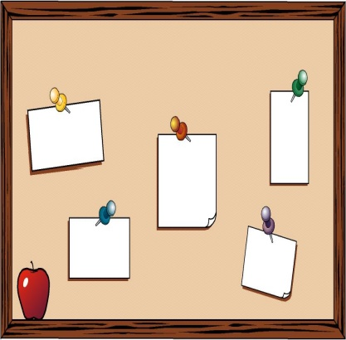

-----------------------------------

-----------------------------------

-----------------------------------
-----------------------------------

---------------------------------------------------------------------------------------------------------------------

3- Grammar
A) Do as shown between brackets :

1- She watched TV yesterday. [Make the sentences negative by using "not" ]
-------------------------------------------------------------------------------------
2-Sara eats chocolate. [ put in " never " in the correct place ]
----------------------------------------------------------------------------
B) Change to past form:

- think __________ c. study __________
- go __________ d. eat __________

