We Can! Book 6 Unit 3: My School is Cool!

1. Read and match with the pictures.

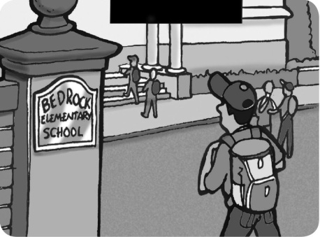  1 | 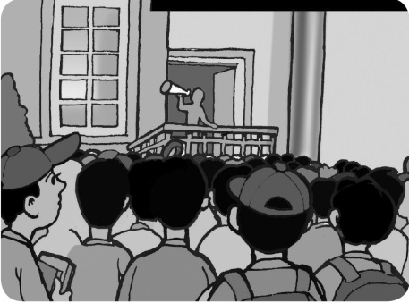  2 | 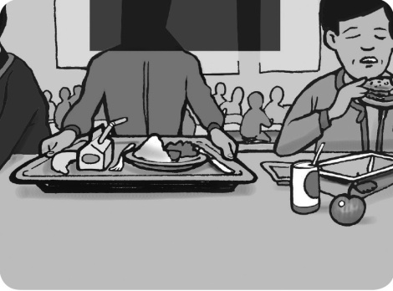  3
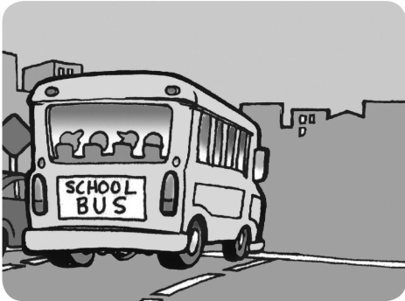  4 | 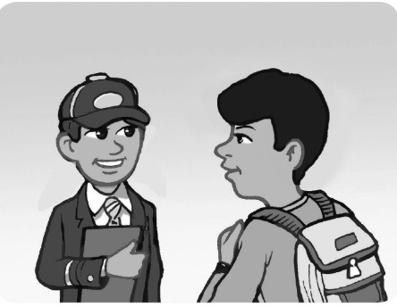  5 | 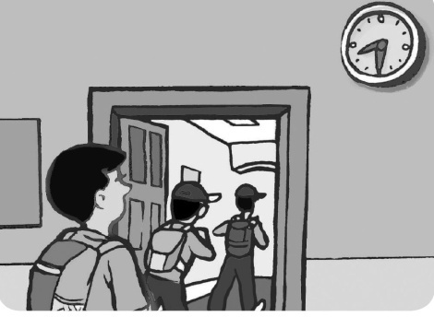  6

Do you have school lunch at your school?  Yes, we do. Every day. ___ | What time does your school start?  It starts at 8.30. ___
Do you have a school uniform?  Yes, we do. ___ | How many students are there in your school?  About 1,000. ___
What’s the name of your school?  Bedrock Elementary School. ___ | Does your school have a school bus?  Yes it does. It has a big yellow bus. ___

2. Read and underline the correct word.

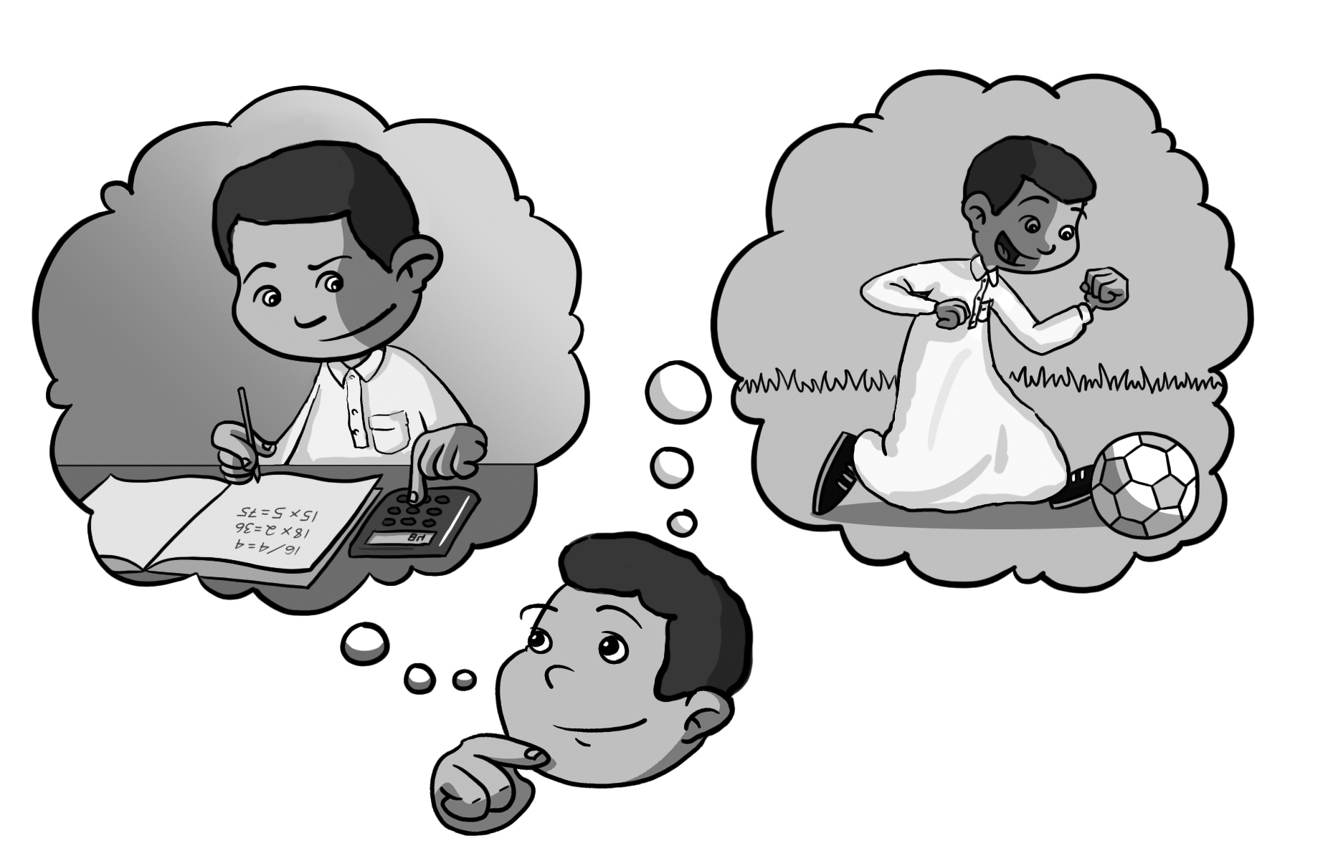
1. Which subject do / did you like most this year?
This year I like/ liked math.
2. Which subject do / did you like most last year?
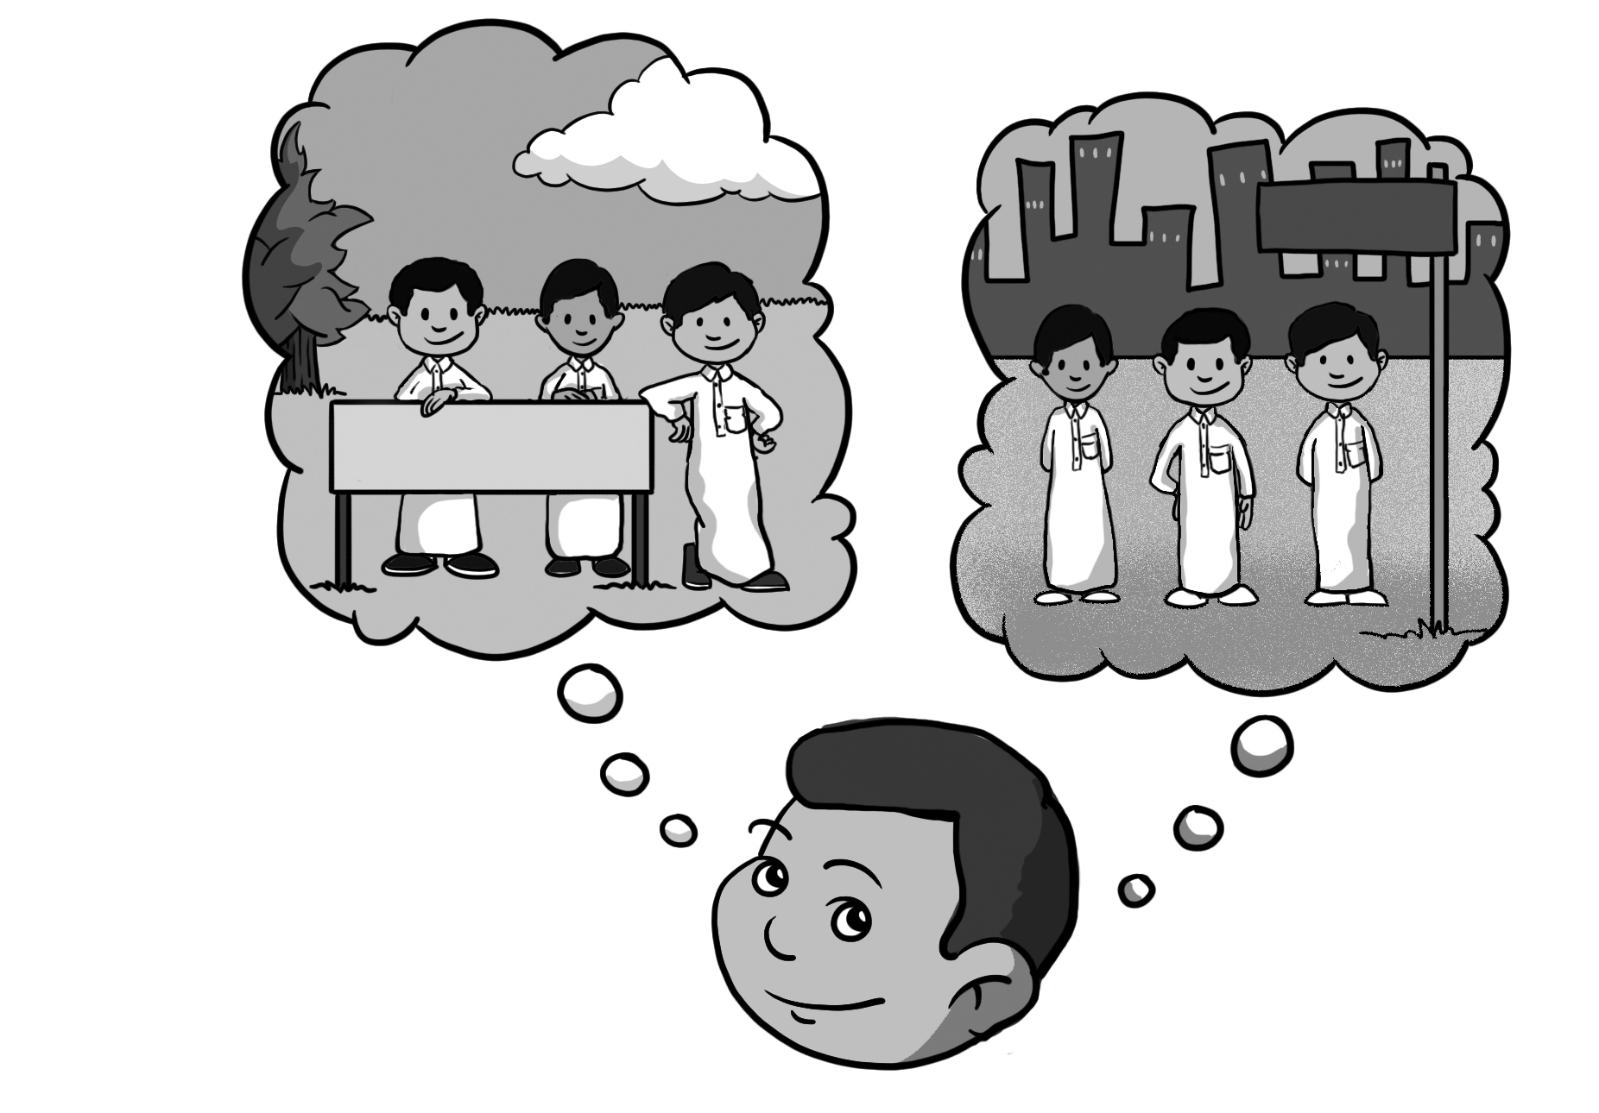
Last year I like/ liked PE.
3. Which grade are / were you in this year?
This year I am / were in the 6th grade.
4. Which grade are / were you in last year?
Last year I am/ was in the 5th grade.
5. Which city does / did Saeed live in?
He lives/ lived in Najran.
6. Where do/ did Saeed’s family go last summer?
Last summer they go/ went to Jazan.
3. Write about your school.

The name of my school is _____________________.
There are about _________________students in my school. We __________________ school lunch at our school. Our school starts at ___________________.
My English teacher is Mr. / Mrs. / Miss ___________.
The best place in our school is the _______________.
My favorite school subject is __________________.
My best friend at school is __________________.

4. Fill in the missing words. Begin with a capital letter. Our English Class Rules

ask for help don’t make don’t shout don’t forget

use stand up speak listen

__________ to the teacher.
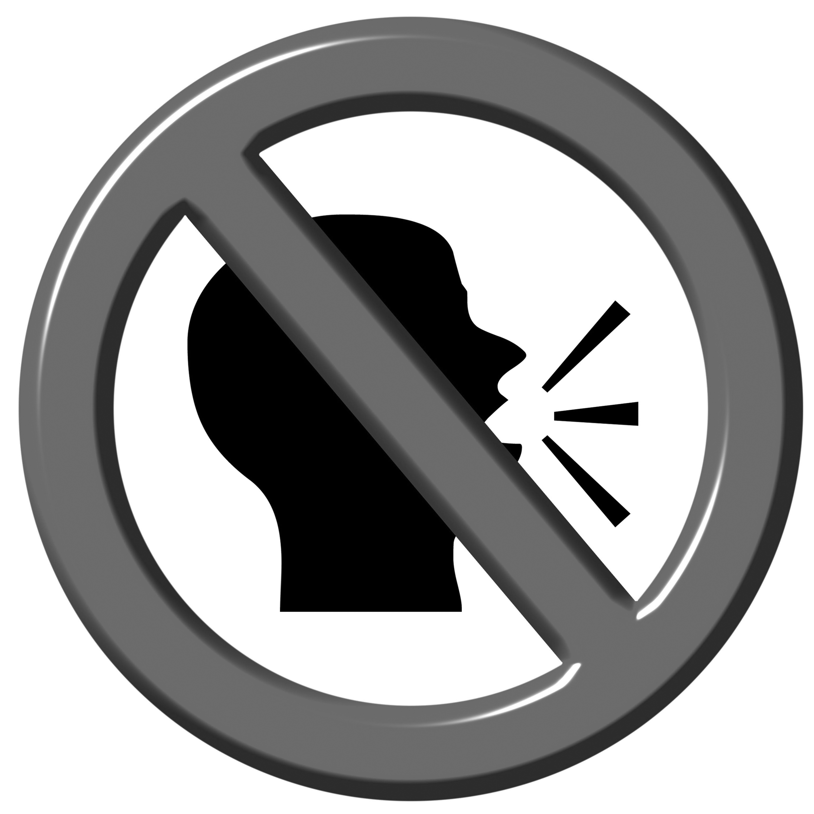
__________ when you have a problem.
__________ when you present.
__________ to do your homework.
__________ your CD when you study English.
__________ too much noise when you work in groups.
__________ English in class!
__________, speak clearly.

