How is your result ?
Name : …………………………… Class : ………………
worksheet : ( 18 )
1 ) Fill in with ( a - an ) :
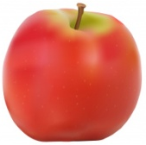
- What is this ?
- It is ___ apple .
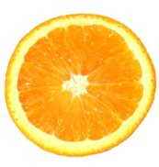
- What is that ?
- It is ___ orange .

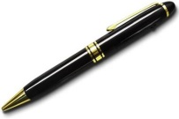
- What is this ?
- It is ___ pen .

Remember
an | a
a - e - i - o - u | Before rest of the letters

