

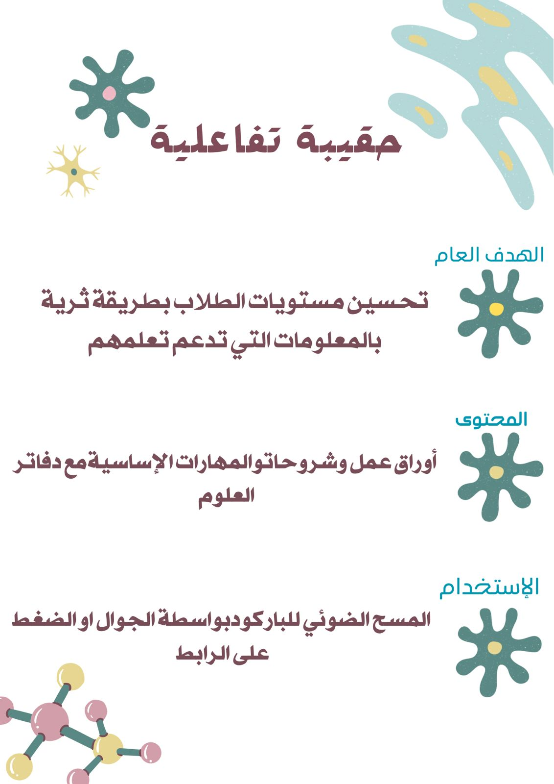

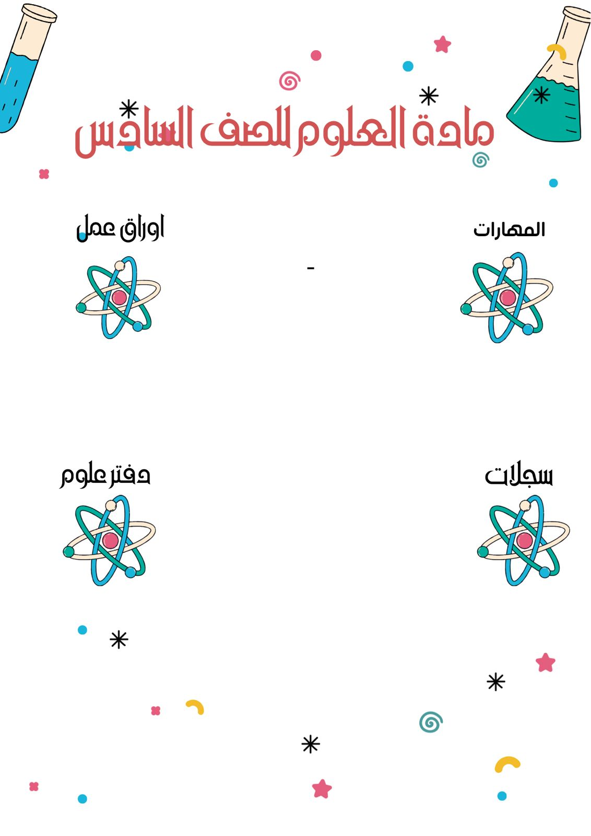

[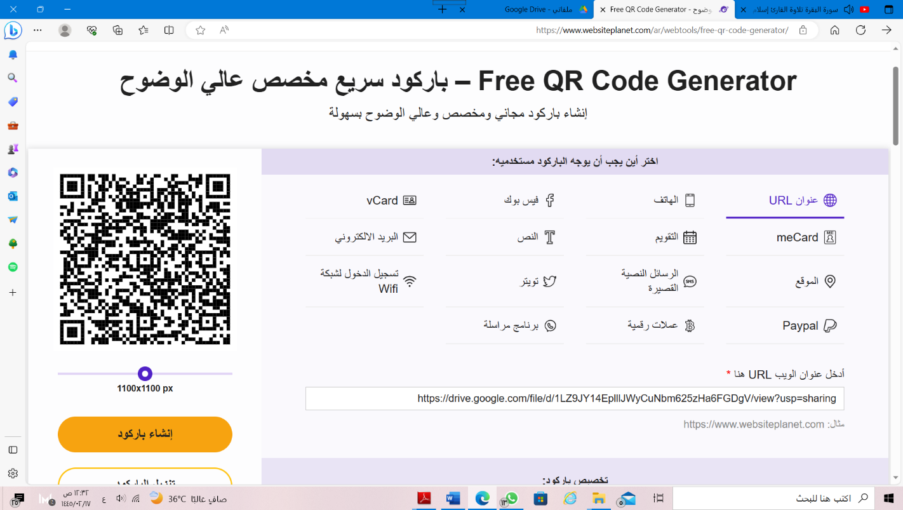](https://drive.google.com/file/d/1LZ9JY14EplllJWyCuNbm625zHa6FGDgV/view?usp=sharing)[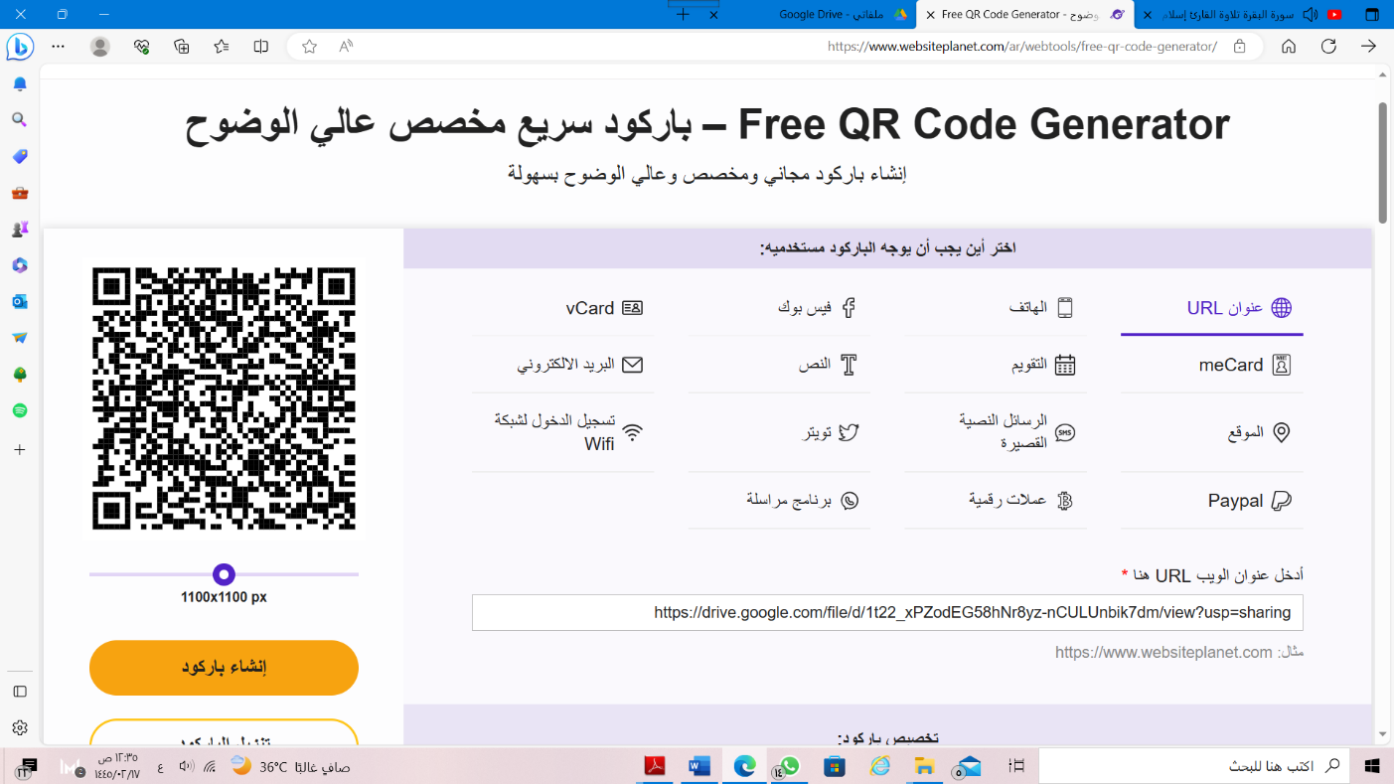](https://drive.google.com/file/d/1t22_xPZodEG58hNr8yz-nCULUnbik7dm/view?usp=sharing)

[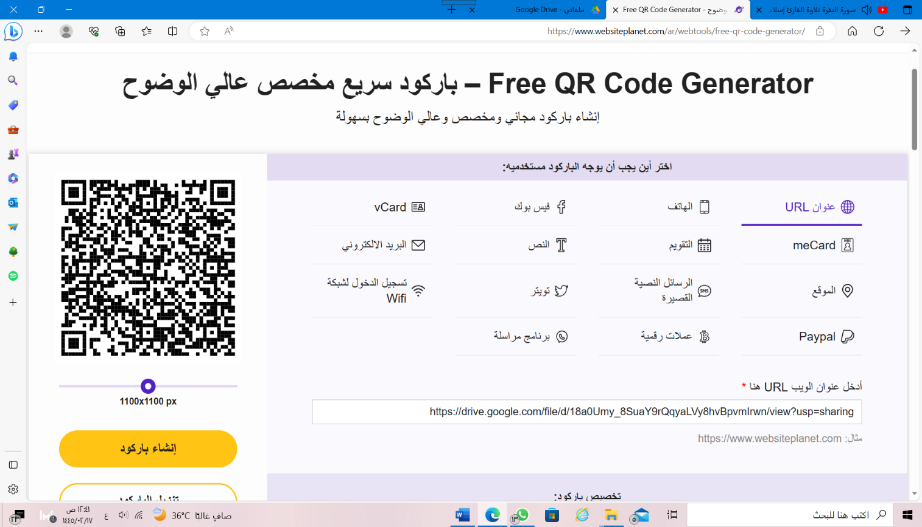](https://drive.google.com/file/d/18a0Umy_8SuaY9rQqyaLVy8hvBpvmIrwn/view?usp=sharing)[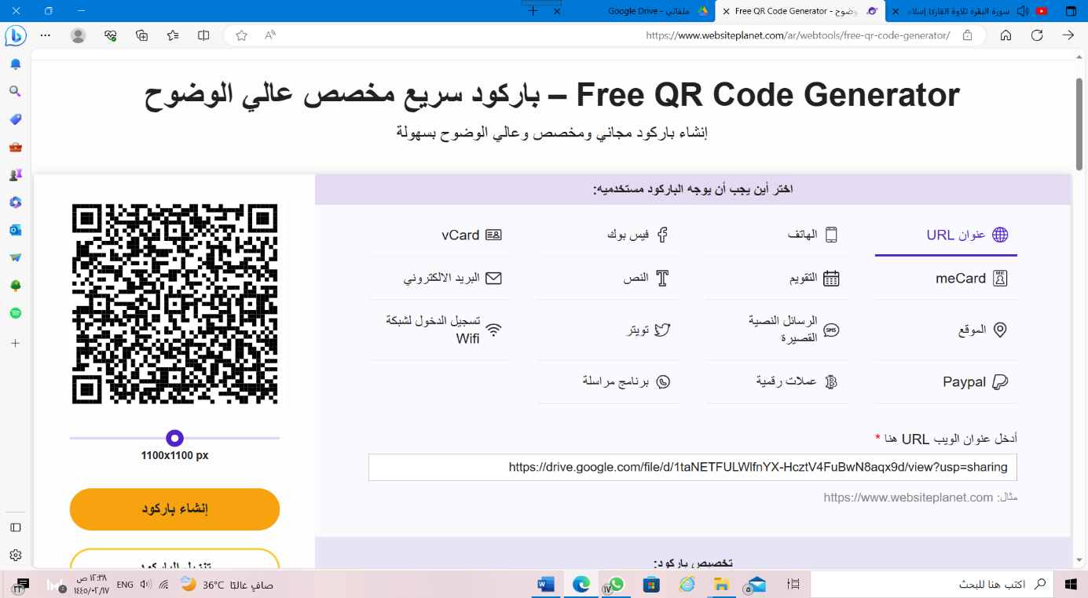](https://drive.google.com/file/d/1taNETFULWlfnYX-HcztV4FuBwN8aqx9d/view?usp=sharing)