

Department of Biomedical Technology

BASIC MECHANICAL SKILLS
BMT 221 Lab Manual

Lab 3: Basic Sketching II
2nd Semester 1438-1439

Biomedical Technology
King Saud University
Riyadh, Kingdom of Saudi Arabia

In this tutorial, you will draw the basic sketch for the revolved solid model shown in Figure
1. The sketch for the revolved solid model is shown in Figure 2.

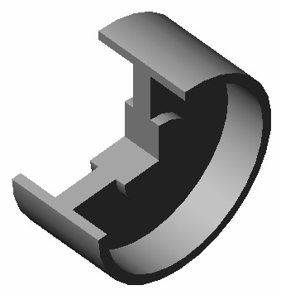
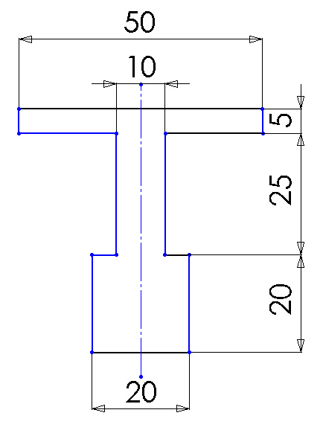

Figure 1 Revolved model. Figure 2 Sketch for the revolved model.

The steps that will be followed to complete this tutorial are listed below. Start a new part document.
Maximize the part document and then switch to the sketching environment.

Modify the settings of the snap and grid so that the cursor jumps through a distance of 5 mm instead of 10 mm.

Draw the sketch of the model using the Line tool, refer to Figure 3. Save the sketch and then close the document.
Create a 3-D Model using Revolved Boss/Base Feature. Save the model and close the document.
Starting a New Document

1. Choose the New button from the Standard toolbar to invoke the New SolidWorks
Document dialog box.

2. The Part 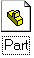 button is chosen by default in the New SolidWorks Document dialog box. Choose OK.

A new SolidWorks part document is opened. But the part document window is not maximized in the SolidWorks window.

3. Choose the Maximize button available on the upper right corner of the part document window to maximize the docun1ent window.
As mentioned earlier, when you open a new part document, the part modeling environment is active by default. But because you first need to draw the sketch of the revolved model, you need to invoke the sketching environment.

4. Select the Front plane. Choose the Sketch button from the Standard tool bar.

A red color origin is displayed and the Sketch Toolbar is displayed. Also, the confirmation corner is displayed with the Exit Sketch and the Delete Sketch options on the upper right corner of the drawing area. This suggests that the sketching environment is activated.

Modifying the Snap and Grid Settings and the Dimensioning Units

Before you proceed with drawing the sketch, you need to modify the grid and snap settings so that you can make the cursor jump through a distance of 5 mm instead of 10 mm, which is the default value.

1. Choose Tools> Options from the menu bar to invoke the System Options-General
dialog box. Choose the Document Properties tab.

2. Select the Grid/Snap option from the area on the left to display the options related to linear and angular units. Set the value of the Major grid spacing spinner to 50. Make sure the value of the Minor-lines per major spinner is 10. Choose OK to close the dialog box.

The coordinates close to the lower left comer of the SolidWorks window will show an increment of 5 mm instead of the default increment of 10 mm when you exit the dialog box.

3. Make sure the Snap to points check box in the Snap area is selected.

If you selected a unit other than millimeter to measure the length while installing
SolidWorks, you need to change the unit for the current drawing.

4. Select the Units option from the area on the left of the Document Properties - Grid/Snap dialog box.

5. Select millimeters from the drop-down list available in the Length units area and Degrees from the drop-down list available in the Angular units area. Choose the OK button after making the necessary settings.

Drawing the Sketch

As evident from Figure 2, the sketch will be drawn using the Line tool. You will start drawing the sketch from the lower left corner of the sketch.

1. Choose the Line button from the Sketch toolbar. The arrow cursor will be replaced by the line cursor.

2. Move the line cursor to a location whose coordinates are 40 mm 0 mm 0 mm. An inferencing line originating from the origin is displayed.

3. Press the left mouse button down at this point and move the cursor horizontally toward the right. Press the left mouse button again when the length of the line above the line cursor shows a value of 20.

4. Move the line cursor vertically upward and press the left mouse button when the length of the line on the line cursor displays a value of 20.
5. Move the cursor horizontally toward the left and press the left mouse button when the length of the line on the line cursor displays a value of 5.

6. Move the line cursor vertically upward and press the left mouse button when the length of the line on the line cursor displays a value of 25.

7. Move the line cursor horizontally toward the right and press the left mouse button when the length of the line on the line cursor displays a value of 20.

8. Move the line cursor vertically upward and press the left mouse button when the length of the line on the line cursor displays a value of 5.

9. Move the line cursor horizontally toward the left and press the left mouse button when the length of the line on the line cursor displays a value of 50.

10. Move the line cursor vertically downward and press the left mouse button when the length of the line on the line cursor displays a value of 5.

11. Move the line cursor horizontally toward the right and press the left mouse button when the length of the line on the line cursor displays a value of 20.

12. Move the line cursor vertically downward and press the left mouse button when the length of the line on the line cursor displays a value of 25.

13. Move the line cursor horizontally toward the left and press the left mouse button when the length of the line on the line cursor displays a value of 5.

14. Move the line cursor vertically downward to the start point of the first line. Press the left mouse button when the red circle is displayed.

The length of the line at this point will be 20 mm.

15. Right-click and choose Select from the shortcut menu.

The sketch is completed but does not fit the screen. Therefore, you need to modify the display area such that the sketch fits the screen.

16. Choose the Zoom to Fit button from the View toolbar to fit the sketch on the screen. The completed sketch for this Tutorial is shown in Figure 3.

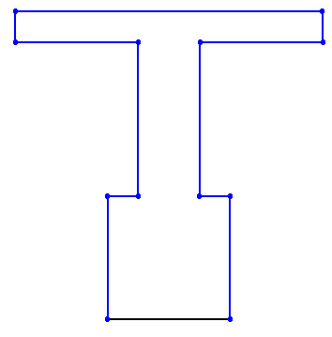

Figure 3 Base sketch for the revolved model
Saving the Sketch

1. Choose the Save button from the Standard toolbar to invoke the Save As dialog box.

2. Enter the name of the document as tutorial2.sldprt in the File name edit box and choose the Save button.

The document will be saved in the selected folder.

Creating Revolved model

To create a 3-D Model from the Base sketch shown in Figure 3, we will first draw an axis of revolution and then revolve the sketch around the axis.

1. Choose the Centerline button from the Sketch toolbar.

2. Move the line cursor to a location whose coordinates are 35 mm 0 mm 0 mm. An inferencing line originating from the origin is displayed.

3. Press the left mouse button down at this point and move the cursor horizontally toward the right. Press the left mouse button again when the length of the line above the line cursor shows a value of 30.

4. Right-click and choose Select from the shortcut menu.

5. Select Revolved Boss/Base on the Feature toolbar. The Base-Revolved PropertyManager appears as shown in Figure 4. The One-Direction is the default type of the revolved feature. The Angle box is filled with 360 deg automatically.

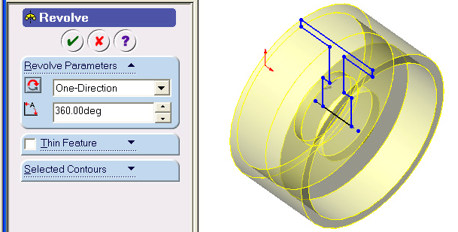

Figure 4 Base- Revolved PropertyManager.

6. Clock OK  to accept default setting to create the wheel model shown in Figure 1.

7. Save and close the file.
An alternate approach to draw the Base sketch shown in Figure 2.

In SolidWorks we may complete the sketch following different approaches. The same sketch shown in Figure 2 will be drawn using another approach.

1. Choose the New button from the Standard toolbar to invoke the New
SolidWorks Document dialog box.

2. The Part button is chosen by default in the New SolidWorks Document dialog box. Choose OK.

3. Select the Front plane. Choose the Sketch button from the Standard tool bar.

A red color origin is displayed and the Sketch Toolbar is displayed. Also, the confirmation corner is displayed with the Exit Sketch and the Delete Sketch options on the upper right corner of the drawing area. This suggests that the sketching environment is activated.

4. Click Centerline on the Sketch toolbar and draw a vertical line approximately
60 mm in length starting at the origin as shown in Figure 5.

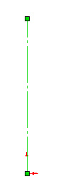

Figure 5 Centerline for the Base sketch.
5. Click Line and complete one side of the sketch starting at the origin as shown in Figure 6. All line segments should be Horizontal or Vertical.

Do not worry about the sizes of the lines. We will adjust them later.

6. Select centerline and all other lines by making a window around

the sketch as shown in Figure 7. Figure 6 Right half of the sketch.

7. Click Sketch Mirror on the Sketch toolbar. Sketch profile is complete and is shown in Figure 8.

Figure 7 All line segments selected.
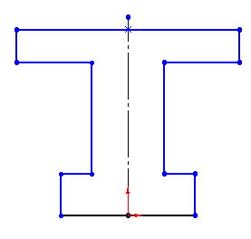

Figure 8 Sketch profile without sizes.

Now we will adjust the sizes of the sketch.

8. Select Dimension on the Sketch Relation toolbar.

9. Click the bottom line. Move the mouse below the bottom line. Click to place the dimension.

10. Change the dimension to 20 mm.

11. Click the lower right line. Move the mouse to the right. Click to place the dimension.

12. Change the dimension to 20 mm. (Figure 9).

13. Click the middle vertical lines on the right of the center line then click the similar vertical line on the left of the centerline. Move the

mouse upward. Click to place the dimension.

14. Change the dimension to 10 mm.
Figure 9 Editing dimension.

15. Similarly place the remaining dimensions. The sketch should look like as shown in Figure 10.

16. Choose the Centerline button from the Sketch toolbar and draw a horizontal line passing through

the origin and extending in both sides of the sketch as shown in Figure 11.

Figure 10 Final sketch with sizes.

Figure 11 Base sketch with Axis of revolution.

17. Select Revolved Boss/Base on the Feature toolbar. The Base-Revolved PropertyManager appears as shown in Figure 12. The One-Direction is the default type of the revolved feature. The Angle box is filled with 360 deg automatically.

Figure 12 Base- Revolved PropertyManager.

18. Clock OK to accept default setting to create the wheel model shown in Figure 1.

19. Save and close the file.

