الملكة العربية السعودية العام الدراسي 1443 هـ
وزارة التعليم الفصل الدراسي : الثاني
إدارة تعليم صبيا الزمن : ساعتان

متوسطة وثانوية البظاظة

أسئلة اختبار مادة اللغة الإنجليزية للصف الأول المتوسط الفصل الدراسي الثاني 1442_1443
اسـم الطالبة : ........................................................................ رقم الجلوس : ................ اليوم :...................... التاريخ : / /1443

رقم السؤال  Questions | الدرجة  Mark | الدرجة المكتسبة للطالبة  Student’s Mark |  | المصححة | المراجعة | المدققة
 |  | Number | Written
I-Guided Composition | 6
II- Reading comprehension | 6
III- Grammar | 7
IV- Vocabulary | 7
V- Orthography | 4
Total | 30

1. Guided Composition
استماع و تحدث :
10
Complete the following text to describe your friend.

6
6
استماع و محادثة :
( tall - short - thin – fat - black - brown - friendly – kind – playing )
………………….. is my friend . She is ……….……and ……… She has ……….….….hair and ……………eyes . She likes everyone. She is ……………… and ……………… She interested in …………. Video games .

Name ……………………………………….

6
6
2. Reading Comprehension

-Read the following passage then answer the questions:
Mark is a student. He is tall and thin. He is athletic. He usually gets up early at 6:00 a.m . He interested in playing football, so he wants to be a football player. He always plays football in the school. Also, he plays football with his friends in the neighborhood. Mark will be a professional player one day.
- Chose the correct answer :
- Mark is a ( student - teacher ) .
- He is ( tall - short ) .
- He interested in playing ( football - tennis ).
- He wants to be a ( football player - doctor ).
- He ( always - sometimes ) plays football in the school.
- he plays football with his ( friends – parents ) in the neighbourhood.
- Mark will be a professional ( player _ teacher ) one day.
- He usually gets up early at ( 6:00 a.m - 7:00 p.m )

3. GRAMMAR

7
6

- Choose the correct words :
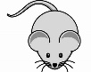
1-There ( is - are ) a table in the kitchen .
2- The mouse is ( in - behind ) the box .
3- There is a sofa , an armchair ( and - but ) a table in the living room .
4- I live ( in - on ) Jeddah.
5- The bank is ( between - far from ) the post office and the restaurant .
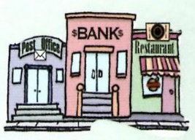
6- I am ( study - studying ) now .
7- He ( speak – speaks ) English .
8- He is taking a nap ( so _ because ) He is tired .
9- I get up ( in – at ) six o'clock 6:00 in the morning .
10- We ( doesn't - don't ) speak English .

Name ……………………………………….

7
6
4. Vocabulary

A- Chose the correct word under the picture:
 | 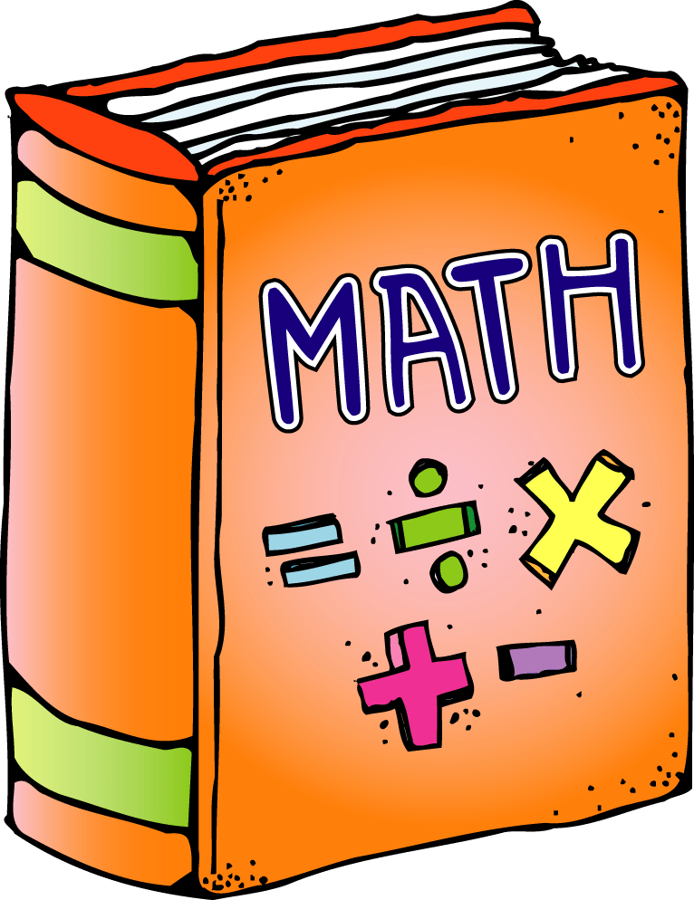 |  | 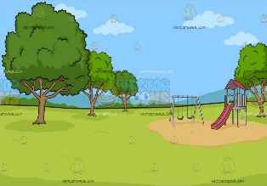 | 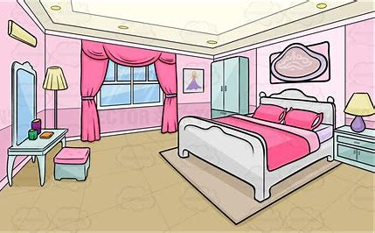
tired | science | chef | Health club | bedroom
confused | math | waiter | park | kitchen
B: Match :
a – a place to buy a book ( ) 1 – Difficult .
b – teaches at school ( ) 2 – teacher .
c – hard ( ) 3 –bookstore .

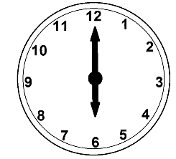
C : What time is it ? ( 1:15 – 6:00 )
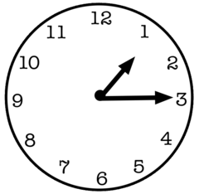
It is …………… It is …………………..

5. orthography

4
6

Chose the missing letters :
1-des……. ( c – k ) 5-scie……ce ( o – n )
2- mal….... ( l - m ) 6-Lapto……. ( p – d )
3- ……amera ( c - k ) 7-clo…..et ( o – s )
4- Ar…….. ( d - t ) 8-B……okstore. ( o – a )

انتهت الأسئلة بحمدالله..

Good luck..♥

