Kingdom of Saudi Arabia 1st Intermediate Grade

Ministry of Education Time: An hour and a half

Hefar Intermediate & Secondary School Number of papers: 3

Final Exam – Third Term - 1445 AH

1. **Guided Composition:**

**6**

Complete the following paragraph about ***Saudi National Day*** with the following

words in the box.

flag – September – cultural – celebrates – fireworks – Families

Saudi National Day

Everyone in Saudi Arabia (1) …………………………. the National Day on 23rd of (2) …………………………. . (3) ……..…………… celebrate together by flying the national (4) …………………………. and joining the celebrations in the streets. Many people attend performances and (5) …………………………. events. At night, everyone is excited to watch the (6) …………………………. light up the sky.

**6**

1. **Reading Comprehension:**

***Read the passage and answer the questions below:***

My name is Helen and I'm nine years old. I am a student. I've got blond hair. I get up at seven o'clock every morning. I take off my pyjamas, I wash my face and I **put on** my clothes. I like my pink T-shirt, my yellow trousers and my blue shoes and my red hat. Then I have breakfast: I eat biscuits, I drink milk with cocoa and a glass of orange juice. I brush my teeth and I go to school by bus. At school I read and write. I have lunch at the school canteen. I go home at four o'clock. I play basketball with my friends, and I do my homework. I have dinner with my family in the evening. I watch TV with my family, then I put on my pyjamas, and I go to bed.

1. **Choose the correct answer:**
2. Helen is …… years old.

|  |  |  |  |
| --- | --- | --- | --- |
| 1. 7 | 1. 8 | 1. 9 | 1. 10 |

1. ‘put on’ means ………….

|  |  |  |  |
| --- | --- | --- | --- |
| 1. play | 1. wear | 1. go | 1. visit |

1. How does she get to school?

|  |  |  |  |
| --- | --- | --- | --- |
| 1. by bus | 1. by car | 1. by bike | 1. on foot |

1. She has hunch at the ………...

|  |  |  |  |
| --- | --- | --- | --- |
| 1. restaurant | 1. home | 1. canteen | 1. cafeteria |

1. She watches TV with her ………….

|  |  |  |  |
| --- | --- | --- | --- |
| 1. friends | 1. family | 1. cousins | 1. grandparents |

1. Which sport does she like to play with her friends?

|  |  |  |  |
| --- | --- | --- | --- |
| 1. football | 1. tennis | 1. basketball | 1. volleyball |

1. **Grammar:**

**7**

1. **Choose the correct answer:**
2. I **can** ……... English fluently.

|  |  |  |  |
| --- | --- | --- | --- |
| 1. speak | 1. speaks | 1. spoke | 1. speaking |

1. He ……….. his uncle **next** week.

|  |  |  |  |
| --- | --- | --- | --- |
| 1. visit | 1. visit | c--is going to visit | d-- visiting |

1. She **wants** ………… a smartphone.

|  |  |  |  |
| --- | --- | --- | --- |
| 1. buy | 1. buys | 1. to buy | 1. bought |

1. There ………… **a** party in my uncle’s house **last night**.

|  |  |  |  |
| --- | --- | --- | --- |
| 1. was | 1. were | 1. is | 1. are |

1. …………. he sleep early **yesterday**?

|  |  |  |  |
| --- | --- | --- | --- |
| 1. Do | 1. Does | 1. Doing | 1. Did |

1. He **usually** ………… pizza.

|  |  |  |  |
| --- | --- | --- | --- |
| 1. eat | 1. eats | 1. eating | 1. ate |

1. **Do as shown between brackets:**
2. Sara watched TV last night.  **(Change into negative)**

…………………………………….

1. There was a tree in the park. **(Change to the plural form)**

…………………………………….

1. **(Complete the sentences using must or mustn’t)**
2. We ……………… drive too fast.
3. We ……………… listen to the teacher.
4. **Vocabulary**:

**7**

1. **Write the words under the pictures:**



**race – vendor – sneakers – rollerblade – donate**

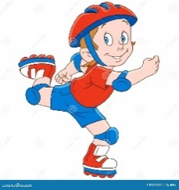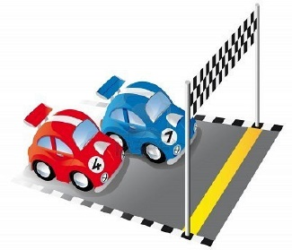

_____________ ______________ _____________ ______________

1. **Choose the correct answer to fill in the blank in each question:**
2. I will ………….. my cousins for Eid.

|  |  |  |  |
| --- | --- | --- | --- |
| 1. invite | 1. study | 1. hit | 1. borrow |

1. Omar was the best boxer in the ………………..

|  |  |  |  |
| --- | --- | --- | --- |
| 1. rice | 1. tournament | 1. drive | 1. boss |

1. **‘looking for’** means:

|  |  |  |  |
| --- | --- | --- | --- |
| 1. assignment | 1. homework | 1. playing | 1. searching |

**4**

1. **Orthography:**
2. **Choose the correct missing letters:**
3. An **air__ort** is a place where airplanes can land or take off.

|  |  |  |  |
| --- | --- | --- | --- |
| 1. b | 1. d | 1. p | 1. t |

1. Samar went to the **s__permarket** to buy some eggs and milk.

|  |  |  |  |
| --- | --- | --- | --- |
| 1. a | 1. o | 1. u | 1. y |

1. My father wore a new pair of **glo__es** yesterday.

|  |  |  |  |
| --- | --- | --- | --- |
| 1. b | 1. f | 1. d | 1. v |

1. I have a small **g__ft** for you.

|  |  |  |  |
| --- | --- | --- | --- |
| 1. a | 1. e | 1. i | 1. o |

1. Today, some **s__yscrapers** have 100 floors or more.

|  |  |  |  |
| --- | --- | --- | --- |
| 1. c | 1. k | 1. j | 1. g |

1. We need to **pro__ect** Earth because it is our home.

|  |  |  |  |
| --- | --- | --- | --- |
| 1. t | 1. r | 1. u | 1. l |

1. A **co__sole** is an equipment for video game.

|  |  |  |  |
| --- | --- | --- | --- |
| 1. m | 1. n | 1. o | 1. j |

1. If you warm ice, it will **me__t** into water.

|  |  |  |  |
| --- | --- | --- | --- |
| 1. r | 1. l | 1. i | 1. h |

**END OF QUESTIONS**

**BEST OF LUCK**

**Ms. Tahani AlGhamdi ☺**

# نتيجة بحث الصور عن شعار الوزارة شفاف

Super Goal 1 - English Language

**First Intermediate Grade**

Third Term Final Exam 1444-2023

**First Round** | Time: 1.5 hour

Kingdom of Saudi Arabia

Ministry of Education

………. Education Directorate

……………Intermediate School

**المراجع**

**checker**

**أ /..........**

**الدرجة كتابه**

**Written**

**المجموع**

**Total / 30**

**المصحح**

**corrector**

**أ / راشد السلمي**

**Q16**

**Q26**

**Q37**

**Q4**

**4**

**Q57**

اسم الطالب

رقم الجلوس

Composition

**اللهّم لا سَهلَ إلا ما جعلتُه سَهلاً فإنكَ تَجعَلُ الحزنَ إذا شِئتَ سَهلاَ " "**

**Write about what you are going to do on your next vacation.**

Guide words:

**( enjoy – exploring – new food – activities – the weather – the place – language – relaxing – city – trip )**

..................................................................................................................................................................................................................

..................................................................................................................................................................................................................

..................................................................................................................................................................................................................

..................................................................................................................................................................................................................

..................................................................................................................................................................................................................

..................................................................................................................................................................................................................

..................................................................................................................................................................................................................

..................................................................................................................................................................................................................

..................................................................................................................................................................................................................

..................................................................................................................................................................................................................

**6**

**اقلب الصفحة**



Comprehension

**6**

* **Read the following passage and answer the questions below:**

Ali usually has a relaxing Saturday. He doesn’t have work, so he always wakes up late on Saturdays—usually at 10 A.M. Then he has a cup of coffee and makes a big breakfast. He eats breakfast and then reads the news online. Sometimes he goes to visit his cousin on Saturday afternoons, and sometimes he goes for a long walk with his brother. He usually watches a football game on Saturday evenings. Sometimes he meets his family at a restaurant to have dinner. He watches TV at night, and then goes to bed at 10 P.M. so that he’s ready for work on Sunday.

**A. Choose the correct answer:**

1. The text is about Ali’s ____________ .

**a**. Saturdays  **b**. Sundays **c**. weekends **d.** Mondays

1. Ali _____________ wakes up late on Saturdays.

**a**. never **b** sometimes **c** usually **d.** always

1. Ali usually eats a big _____________ on Saturdays.

**a**. food  **b**. breakfast **c**. lunch **d.** dinner

**B. Write (T) for True or (F) for False:**

|  |  |
| --- | --- |
| **4.**  Ali sometimes goes for a long walk with his brother . |  |
| **5.** Ali usually watches a football game on Saturday mornings . |  |
| **6.** Ali goes to bed at 10 P.M |  |

**اقلب الصفحة**



**7**

Grammar

* **Choose the correct answer**

1. He can’t surf, but he _____ water-ski.

**a**. can’t **b**. can  **c**. not can **d.** don’t can

1. **Aisha:** Do they like to relax on the beach? **Lucy:** Yes, _____.

**a**. they do **b**. do they  **c**. not they  **d.** they don’t

1. I _____ play volleyball, but I can play tennis.

**a**. can **b**. am can  **c**. can’t  **d.** am can’t

1. I’m not going to buy jeans. ____________ pants.

**a**. I’m going to buy **b**. I buying  **c**. I’m going buying **d.** I going to buy

1. Susan ____________ a dress. She’s going to wear a skirt and blouse.

**a**. isn’t wear **b**. not wearing  **c**. isn’t going to wear **d.** isn’t going to wearing

1. They ____________ suits. They’re going to wear jeans.

**a**. not wearing **b**. not going to wearing **c**. aren’t going wear **d.** aren’t going to wear

1. _____ Bob to our house!

**a**. We invite **b**. Let invite  **c**. Let’s invite **d.** Let’s us invite

1. Do you _____ a film on TV tonight?

**a**. want to watch **b**. want watch  **c**. want watching **d.** want to watching

1. You _____ the street when the light is red.

**a**. mustn’t cross **b**. should cross not **c**. must not to cross **d.** should cross

1. My grandfather _____ a car salesman.

**a**. was **b**. were  **c**. not **d.** be

1. Majed Ahmed Abdullah _____ in Jeddah.

**a**. is born **b**. are born  **c**. was born **d.** were born

1. When I was a child, I _____ a good student.

**a**. wasn’t be **b**. not **c**. wasn’t **d.** weren’t

1. We didn’t go to the football game yesterday. We_____ to the museum.

**a**. go **b**. went  **c**. are **d.** going

1. Sally didn’t drink coffee. She _____ water.

**a**. is drink **b**. drinking  **c**. drink **d.** drank

Orthography

**4**

* **Choose the correct letters :**

1. You can go sho…..ping and meet friends. ( v – p – r )
2. You can fly to pla…..es. ( n – o – c )
3. Nawal is going to buy aba…..a ( y – o – r )
4. You need warm clothes it’s …..old in Abha ( n – o – c )
5. I don’t have an in…itation to the party ( y – v – r )
6. Let’s get some ca…ds for the National Day ( r – o – c )
7. Balad, the old pa…t of Jeddah ( y – v – r )
8. Ahmed was pleased with his prese…tation ( o – t – n )

**اقلب الصفحة**



Vocabulary

* **Choose the correct answer:**

**7**

1. You can _____ at the pool.

**a**. swim **b**. surf  **c**. rollerblade **d.** sail

1. My friends like to _____. They enjoy looking at underwater attractions.

**a**. swim **b**. sail  **c**. surf  **d.** snorkel

1. He’s going to wear a shirt and a ____________.

**a**. shoes **b**. tie  **c**. shorts **d.** white

1. Do you need to buy new ____________ to play basketball?

**a**. suit **b**. shirt  **c**. sneakers  **d.** blouses

1. On December 2nd, they _____ Federation of the Emirates in the UAE.

**a**. parades **b**. decorate  **c**. celebrate **d.** share

1. In Saudi Arabia, people fly _____ on September 23rd.

**a**. flags **b**. streets  **c**. fireworks  **d.** celebrations

1. In old Riyadh, many houses were made from ____ bricks.

**a**. ruins **b**. town  **c**. mud **d.** city

1. In modern Riyadh, you can see many ______.

**a**. skyscrapers **b**. walls  **c**. population  **d.** areas

1. **Adel:** What did you do last night? **Ali:** I went to a friend’s house and watched _____.

**a**. a car race **b**. the zoo  **c**. a computer club **d.** home

1. **Peter:** Do you have any clean clothes? **Andy:** Yes, I do. I did my _____ yesterday.

**a**. closet **b**. laundry  **c**. home  **d.** house

1. **Chang:** What did you do yesterday? **Todd:** I went to the _____ and played volleyball.

**a**. car race **b**. beach  **c**. museum  **d.** zoo

1. **Sabah:** What did you do yesterday? **Aisha:** I went to a _____. I love history.

**a**. restaurant **b**. closet **c**. mall **d.** museum

* **Write the correct word under the picture.**



Graduation day – Gym – calendar

صورة تحتوي على نص, نافذة, مبنى

تم إنشاء الوصف تلقائياً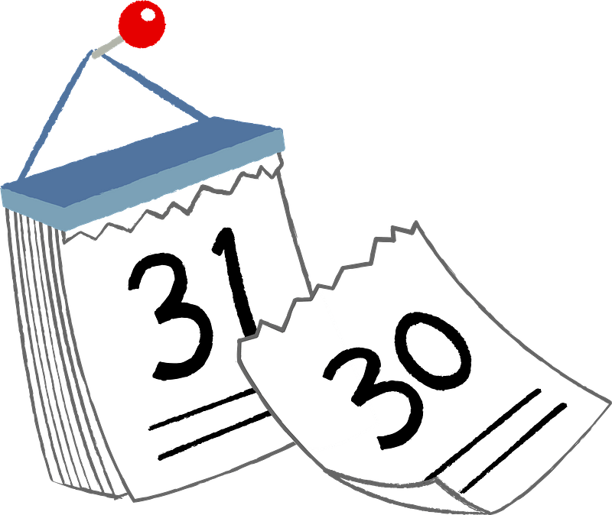

**14.**

**13.**

**12.**

………………………….…

………………………….…

………………………….…

**انتهت الأسئلة .. ..**

**وبالله التوفيق والنجاح ..**

**الأستاذ / راشد السلمي**

**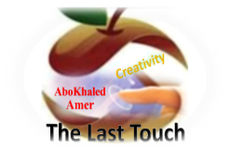****المملكة العربية السعودية**

**Kingdom of Saudi Arabia**

**Ministry of Education**

**------- Educational Directorate**

**------- Future Educational Schools**

**1st grade intermediate 2022**

**3rd Term – Final Exam**

**وزارة التعليم**

**الإدارة العامة للتعليم بن**

**مدارس م ن التعليمية**

**الصف الاول المتوسط**

**الاختبار النهائي للفصل الدراسي الثالث1445**

|  |  |  |  |  |  |  |  |
| --- | --- | --- | --- | --- | --- | --- | --- |
| **Total**  **written** | **5 spelling** | **4 Vocabulary** | **3 Grammar** | **2 Comprehension** | | **1 Composition** | **Q. NO.** |
|  |  |  |  |  | |  | **Mark Given** |
| **30** | **4** | **7** | **7** | **6** | | **6** | **Mark** |
|  | | | **Reviser** | |  | | **Corrector** |
|  | |

**زمن الاختبار: ساعتان**

**اسم الطالب: ------------------------------------ رقم الجلوس: ------------- الصف الأول المتوسط**

**6**

1) **Composition**

**1- Write a paragraph about “Eid Al Adha"**

**Give your opinion about it. Use the questions below to guide you:**

1.What do Muslims celebrate on the (10th) of Hajj? 2.Who do you celebrate with?

3.What activities do you do? 4. Why is it important to Muslims?

…………………………………………

………………………………………………………………………………………………………………………………………………………………………………………………………………………………………………………………………………………………………………………………………………………………………………………………………………………………………………………………………………………………………………………………………………………………………………………………………………………………….

**6**

**2) Comprehension**

**2- Read the following passage then answer the questions:**

**Ryan Brown is ten years old. He lives in a big house in London with his happy family. His father, Mr. Brown, his mother, Laura and his little sister, Claire. His father is a bank clerk, and his mother is a travel agent. Claire is a baby. Every morning they get up early. At 7.20 Ryan has a quick shower. Then he goes to the dining room where they have an enormous breakfast. The Browns go to work by car. Mr. Brown drives it. Ryan goes to school on foot with his best friend Mum and Claire stays at home with the baby-sitter. At noon Ryan has lunch in the school canteen with his friends.** **The Browns go back home after tea. Ryan does his homework, and his mother works in the garden. She likes planting and watering trees. Mr. Brown goes to the library. They have dinner at 7.30 p.m. They talk a lot during dinner. Then, they watch their favourite TV programme, and they go to bed.**

**A- Put ( T ) or ( F ):**

**1. Ryan Brown is ten years old. ( )**

**2. His father is a policeman. ( )**

**B- Choose the correct answer:**

**1. The main idea of the passage is -------**

a. Rayan's friends b. Rayan's family c. Rayan's uncle d. Rayan

**2. In line 1 (happy) is the opposite of -------**

a. sad b. lazy c. quick d. cold

**3. In line 8 (his) refers to -------**

a. Claire b. Bill c. Laura d. Rayan

**4. The family have dinner at ------ p.m.**

a. 3:30 b. 5:30 c. 7:30 d. 1:30

**3) Grammar**

**7**

**A: Choose the correct answer:**

**1. Let's …………………… our bedroom.**

a. clean b. cleaned c. cleaning d. cleans

**2. He is a generous man. Do you know …………………?**

a. us b. him c. it d. me

**3. They ………………………. buy a new car tomorrow.**

a. went to b. go to c. are going to d. goes to

**4. -……………Ali eat his breakfast every day?.**

a. Did b. Does c. Done d. Doing

**5. I ……………………… there a year ago.**

a. studying b. studied c. studies d. study

**6. They …………………..in the park yesterday.**

a. been b. are c. were d. was

**7. Can Sara …………………… poems?**

a. to read b. reading c. reads d. read

**4) vocabulary:**

**7**

**Pairing Questions:**

|  |  |  |
| --- | --- | --- |
| **1. We played basketball in the gym.** |  | **a. the opposite of formal.** |
| **2. She wears casual clothes.** |  | **b. platform outside the building.** |
| **3. I got chatting with my neighbor.** |  | **c. a place where you exercise in.** |
| **4. We had drinks on the hotel balcony.** |  | **d. to change into liquid.** |
| **5. Don't let your ice cream melt.** |  | **e. the opposite of sell.** |
| **6. You should buy a new bag.** |  | **f. someone who lives near you.** |

**Choose the correct Answer:**

**1. Monkeys ……………………..the trees.**

a. dive b. climb c. fly d. run

**2. She watched the children ………………………… in the pool.**

a. riding b. driving c. fishing d. swimming

**3. Saudi man is dressed in …………………… and ghotra.**

a. thobe b. tie c. jeans d. scarf

**4. Indian food is ………………….**

a. sour b. spicy c. sweet d. bitter

**5. My mother likes to ……………………. rooms with flowers.**

a. clean b. paint c. decorate d. wash

**6. People used to build their houses of ………………… bricks.**

a. iron b. concrete c. glass d. mud

**7. The ……………………… scored 35 goals.**

a. coach b. goalkeeper c. striker d. defender

**8. There was a lot of snow last ……………….**

a. summer b. spring c. fall d. winter

**5) Orthography**:

**4**

**Choose the correct letters:**

**1. She went to the bookst__re.** ( o – a – e – u )

**2. I really like this re__taurant.** ( c – s – t – m )

**3. She was dressed in a lively p__nk.** ( s – f – i – k )

**4. There is a bridge below the w__terfall.** ( f – a – n – u )

**5. The soldier raised the f__ag.** ( i – d – k – l )

**6. I was in__ited to dinner.** ( v – f – t – k )

**7. This town is increasing in pop__lation.** ( f – a – o – u )

**8. Today is a na__ional holiday.** ( s – t – e – g )

**End of Questions**

**Best of Luck https://t.me/abokhaledamer**